PASSWD: Prediction of applications and systems security Within development
(how to create a model that will help in predicting and monitoring the security of an application)

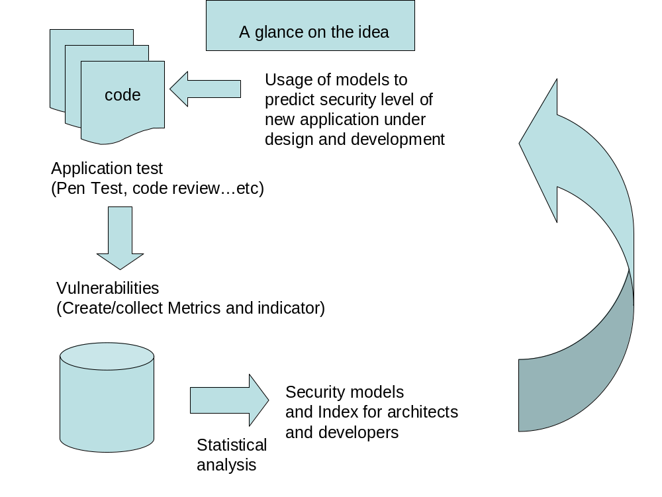

The main idea behind the project is to try to create a predictive model that can help in foreseeing the possible risk of an application in the early stage, already in the designing phase.
There are different steps that have to be taken:
- take some applications and test them looking for vulnerabilities ( i.e. using top ten owASP);
- classifying them according to the kind of language, the systems, etc…and the number of vulnerabilities found;
- analyzing the existing metrics ( security, quality, etc….) and choose those that can be used to measure the application that have already been tested;
- measure the values of those metrics, for the applications that have been tested and then create a rank of those applications;
- try to make a kind of correlation using those results just knowing that, for new applications, those value for those metrics will lead at a certain level of risk for the application;
- measure the metrics for new applications
- monitor the development of new application and keep measuring those metrics at the key points of the SDLC in order to see if they are in line or not.

