

Thick Client Application Security

Author: Arindam Mandal

www.paladion.net

Table of Contents

A1 Thick Client Application Security 1
A2 Unvalidated Input 2
A2.1 Risk 2
2.1.1 Sample Exploit – Authentication Bypass 2
2.1.2 Sample Exploit – Application Malfunction 3
A2.2 Solution 4
A3 Weak Authentication Method 5
A3.1 Risk 5
3.1.1 Sample Exploit – Password Compromise 5
3.1.2 Sample Exploit – Privilege Escalation 6
A3.2 Solution 8
A4 Critical data in files & registry 10
A4.1 Risk 10
4.1.1 Sample Exploit – Database credential in file 10
A4.2 Solution 11
A5 Sensitive data in memory 12
A5.1 Risk 12
5.1.1 Sample Exploit – Password in memory 13
A5.2 Solution 13
A6 Impersonating a high privilege user 14
A6.1 Risk 14
6.1.1 Sample Exploit – Password Change 14
A6.2 Solution 16
A7 Mitigating Risks 17
About the Author 19

Thick Client Application Security
This paper discusses the critical vulnerabilities and corresponding risks in a two tier thick client application along with the measures to mitigate risks. Thick client is defined as an application client that processes data in addition to rendering. An example of thick client application can be a Visual Basic, JAVA or VB.NET application that communicates with a database.
The risks observed in thick client applications generally include information disclosure, unauthorized access, authentication bypass, application crash, unauthorized execution of high privilege transactions or privilege escalation. It is interesting to note that most of the Open Web Application Security Project (OWASP) Top 10 vulnerabilities are as applicable to Thick client applications as they are to web applications. The table below provides a mapping.
Serial No. | OWASP Top Ten Most Critical Web Application Vulnerabilities | Thick Client Most Critical Application Vulnerabilities
 | Unvalidated Input | Unvalidated Input
 | Broken Access Control | Broken Access Control
 | Broken Authentication and Session Management | Weak Authentication and Session Management
 | Cross Site Scripting (XSS) Flaws | Not Applicable
 | Buffer Overflows | Buffer Overflows
 | Injection Flaws | Injection Flaws
 | Improper Error Handling | Improper Error Handling
 | Insecure Storage | Insecure Storage
 | Denial of Service | Denial of Service
 | Insecure Configuration Management | Insecure Configuration Management

In the following sections, we shall discuss in detail few of the critical vulnerabilities in thick client applications including unvalidated input, weak authentication method, sensitive data in memory, critical data in files & registry and impersonating a high privilege user.

Unvalidated Input
User requests are not validated before being used by the application. Attackers can use this flaw to launch SQL injection attack. SQL injection attack is possible when application does not validate user input for special characters and codes. An attacker can exploit this vulnerability by supplying specially crafted SQL statement to the application.

Risk
This attack can result in authentication bypass, viewing unauthorized data, application malfunction, data deletion or malicious command injection including database shutdown.

Sample Exploit – Authentication Bypass
An application uses the following SQL query to validate user credentials.
SELECT *
FROM USER_TABLE
WHERE USER_ID=' ' AND PASSWORD=' ';
Application will authenticate a user if the database returns a row of data against this query. A valid user supplies the following credential to the application:
USER_ID: ADMIN
PASSWORD: test123
Then the query will be:
SELECT *
FROM USER_TABLE
WHERE USER_ID='ADMIN' AND PASSWORD='test123';
The attacker knows the USER_ID i.e. ADMIN and he crafts the query:
USER_ID: ADMIN'--
So the new SQL query will be:
SELECT *
FROM USER_TABLE
WHERE USER_ID='ADMIN'--' AND PASSWORD=' ';
This query will comment out password checking logic and database will execute only uncommented query portion. This will return entire row of user ADMIN. Application assumes it as valid user and will grant the access.

Sample Exploit – Application Malfunction
Many two tier applications have the following authentication process: When a user enters the Login ID and password, application sends a query to the database to retrieve user’s credentials.
The application sends following query to retrieve the password hash.
SELECT HASHED_PASSWORD
FROM USER_TABLE
WHERE USER_ID=' ';
The user enters his USER_ID
USER_ID: ADMIN
Application will send following query to the database:
SELECT HASHED_PASSWORD
FROM USER_TABLE
WHERE USER_ID='ADMIN';
Normally, database will respond with following data.
..... HASHED_PASSWORD ..... f85fcb8456edb3824f4e32a56cdb76cd .....
Now, instead of giving proper USER_ID in this field, malicious user gives the following as input.
USER_ID: '
So application will now send following query to the database:
SELECT HASHED_PASSWORD
FROM USER_TABLE
WHERE USER_ID=''';
Database will not be able to understand the query and will send a syntax error to the application. Now, if the application is not designed to handle this kind of database error, it will crash.
To avoid this type of application crash; developers usually restrict users to type-in ' (single quote) in any form field of the application. But a malicious user can type special characters like ' (single quote) in a text file and copy & paste them in the input form field of the application and crash it.
An application uses the following SQL query to validate user credentials.
SELECT *
FROM USER_TABLE
WHERE USER_ID=' ' AND PASSWORD=' ';
Application will authenticate a user if the database returns a row of data against this query. A valid user supplies the following credential to the application:
USER_ID: ADMIN
PASSWORD: test123
Then the query will be:
SELECT *
FROM USER_TABLE
WHERE USER_ID='ADMIN' AND PASSWORD='test123';
The attacker only knows the USER_ID i.e. ADMIN and he crafts the query:
USER_ID: ADMIN'; SHUTDOWN WITH NO WAIT; --
So the new SQL query will be:
SELECT *
FROM USER_TABLE
WHERE USER_ID='ADMIN '; SHUTDOWN WITH NO WAIT; -- ' AND PASSWORD=' ';
This query will comment out password checking logic and database will execute only uncommented query portion. After executing the SELECT query database will move to next query and execute the statement i.e. SHUTDOWN WITH NO WAIT and will immediately shutdown the database.

Solution
The solution to this problem is input validation. The application should check for any special character and code in the user input. In case any special character like ' (single quote) or command code is present; application should ignore the input and throw appropriate error message to the user.

Weak Authentication Method
Attackers can compromise the application if account credentials and session IDs are not protected. Our experience shows that many applications use weak authentication method. For example, when a user enters his Login ID and password, the hashed or clear text password of corresponding Login ID is retrieved from the database and brought to the client. The entered password is hashed at the client and the two passwords are compared. Therefore, even on entering a wrong password for a known login ID, the actual hashed or clear text password comes to the client. The attacker can sniff hashed or clear text password on transit and use it for man in the middle attack or to login into the application.

Risk
Attackers can steal passwords, gain access to the application and escalate privilege by sniffing and man in the middle attack.

Sample Exploit – Password Compromise
An example of password compromise by sniffing attack using Ethereal is shown below:
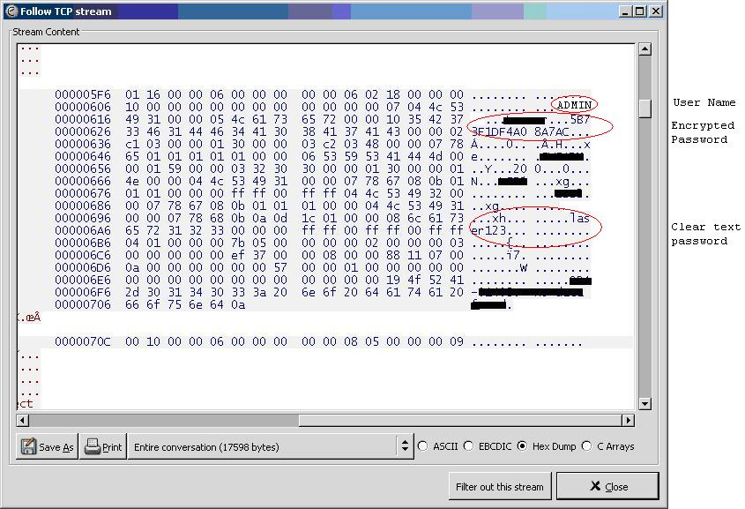
Figure 1: Sniffing password using Ethereal
Using this technique an attacker can get the username and password of other users.

Sample Exploit – Privilege Escalation
A low privileged user, who has the valid password and its hash for his account can intercept the traffic using Interactive TCP Relay (ITR) for man in the middle attack, can replace the actual hash of the high privileged user which is coming from the database server with known hash, usually hash of his own password. Then he can supply any high privilege user account name but with his own password to the application. The application will generate the hash for his password and compare it with the modified hash. The authentication will be successful since both the hash values are now the same and authenticate him as a high privilege user.
A snapshot of man in the middle attack using ITR is shown below.
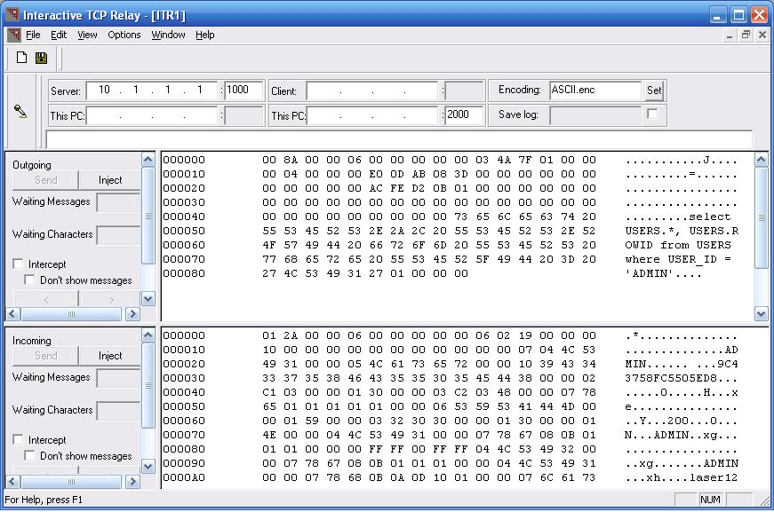
Figure 2: Man in the middle attack using ITR
Let’s see an example of privilege escalation:
User ADMIN has password sensitiveaccount. Its MD5 hash is stored in the database as f85fcb8456edb3824f4e32a56cdb76cd. The malicious user knows that MD5 for password hackaccount is b2eb5537c26694bbb8e7ea80ceb398ca. He supplies username as ADMIN and password as hackaccount to application’s authentication page and starts intercepting the traffic using ITR. The application will send a query to database like:
SELECT HASHED_PASSWORD
FROM USER_TABLE
WHERE USER_NAME='ADMIN';
Database will send the response:
..... HASHED_PASSWORD ..... f85fcb8456edb3824f4e32a56cdb76cd .....
Now, the malicious user will intercept the traffic and alter the hash with a known hash, i.e. hash of hackaccount. The modified response will be:
..... HASHED_PASSWORD ..... b2eb5537c26694bbb8e7ea80ceb398ca .....
Application will now convert the user supplied password hackaccount to MD5 hash, compare it with modified database response and authenticate the malicious user as admin to the application.

Solution
The solution to this problem is the application should send the Login ID and the password hash from the client to the database server. The server should compare the received hash with the one stored in the database using a stored procedure and then authenticate the user. To prevent man in the middle attack the traffic between client and server should be encrypted.
For Oracle database the following solution can be applied for data confidentiality and integrity:
Oracle advanced security feature provides data encryption and integrity facility. It supports DES, 3DES, AES and RC4 algorithms for data encryption and SHA-1 & MD5 for data integrity. It uses Diffie-Hellman Based Key Management.
To use 3DES and MD5 algorithms for confidentiality and integrity between client and server, following settings can be used:
In sqlnet.ora file of the Oracle Server following lines can be added:
SQLNET.CRYPTO_CHECKSUM_TYPES_SERVER= (MD5)
SQLNET.ENCRYPTION_TYPES_SERVER= (3DES168)
SQLNET.ENCRYPTION_SERVER = required
SQLNET.CRYPTO_CHECKSUM_SERVER = required
SQLNET.CRYPTO_SEED = serverkeyseed
SQLNET.CRYPTO_SEED can be changed with a suitable value.
In sqlnet.ora file of the Oracle Client following lines can be appended:
SQLNET.CRYPTO_CHECKSUM_TYPES_CLIENT= (MD5)
SQLNET.AUTHENTICATION_SERVICES= (NTS)
SQLNET.CRYPTO_CHECKSUM_CLIENT = required
SQLNET.ENCRYPTION_TYPES_CLIENT= (3DES168)
SQLNET.ENCRYPTION_CLIENT = required
SQLNET.CRYPTO_SEED = clientkeyseed
SQLNET.CRYPTO_SEED can be changed with a suitable value. But it must not be same with the Server’s SQLNET.CRYPTO_SEED value.
sqlnet.ora file in client and server should be protected against any unauthorized use. Except administrator, no body should have permission to view or access the file.
Similarly in MSSQL database environment; data can be protected using SSL security at client and server end. To know more about “How to Use SSL to Secure Communication with SQL Server 2000” check the following link:
http://msdn.microsoft.com/library/default.asp?url=/library/en-us/secmod/html/secmod33.asp

Critical data in files & registry
Application stores critical information in files and registry. These files generally contain cryptographic keys, username, password of application and database. If these files are not secured, a malicious user can delete, modify or read data from the files. Assume that the application fetches the data from a file to connect to a remote database using service name, IP address, port name, user ID and password. Now, if the permission on this file is not secured, anybody can access the file to get user ID and password of the database. Again only an access control list (ACL) cannot prevent a clear text stored password from disclosure. A malicious user can use username and password to connect the database directly with admin privileges.

Risk
An attacker can retrieve user passwords and cryptographic keys from files and registry. Attacker can use the same to decrypt password, gain access to the application and access sensitive data in the database.

Sample Exploit – Database credential in file
An example of database credential is stored in a file in clear text format is shown below.
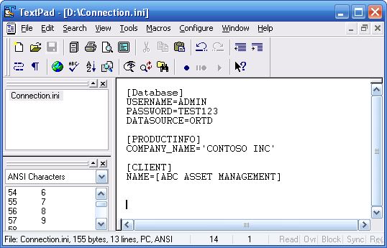
Figure 3: Database credential stored in clear text format

Solution
There are various solutions for these problems:
- Secure the permission on application program files. Give full control permission only to application service account and administrator account. Other users and groups can be given only read permission.
- Restrict the permission on user and password file (if present). Store the password in one way hash format (e.g. MD5) in the file.
- Restrict the permission on database credential file. If database username and password are stored in this file then store them in encrypted or one way hashed format (e.g. MD5).
- If the application stores database and user credentials in the OS registry, secure the registry as well. Access permission to the sensitive registry hive should be restricted to normal user and user password should be stored in one way hashed format.

Sensitive data in memory
Application temporarily stores data into the memory from different environments like users or network for further processing. This type of data includes user passwords, cryptographic keys or sensitive data. Thick client application generally has a user authentication form, where user supplies username and password as credentials. These credentials are stored in the memory for future processing by the application. To validate these credentials, application fetches correct username & password from the database. This actual username & password is also stored temporarily in the memory. These credentials stay in the memory until they get overwritten by any other data. A malicious user can run tool like WinHex in the machine and can see the entire memory content used by the application process. From this dump he can find out the username, password and other sensitive data used by the previous user.

Risk
An attacker can retrieve user passwords and cryptographic keys from memory. Attacker can use the same keys to decrypt password, gain access to the application and access sensitive data in the database.

Sample Exploit – Password in memory
An example of password in memory is shown below.
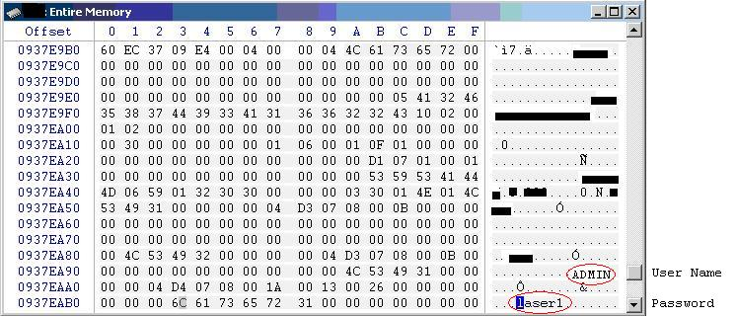
Figure 4: Password in memory

Solution
Clear the memory area that contains critical data after a sensitive transaction. This means application should clear the username and password from the memory after authentication process. This will ensure that later on a malicious user cannot retrieve any sensitive data from the memory.

Impersonating a high privilege user
Normally data from the application are sent in clear text format at default port of the database (e.g. Oracle uses port 1521 for listener service). A malicious user can intercept the traffic using ITR and perform transactions with database with high privileged user’s context.

Risk
A malicious user can intercept the traffic using ITR, read and modify the data or password with high privileged user ID and perform transaction with the database on that user’s context.

Sample Exploit – Password Change
A low privileged user can change the password of a high privileged user. All SQL statements are sent from client to database server in clear text. When a user changes his password, an UPDATE query of password change with reference of user attribute (e.g. USER_ID) goes to database server.
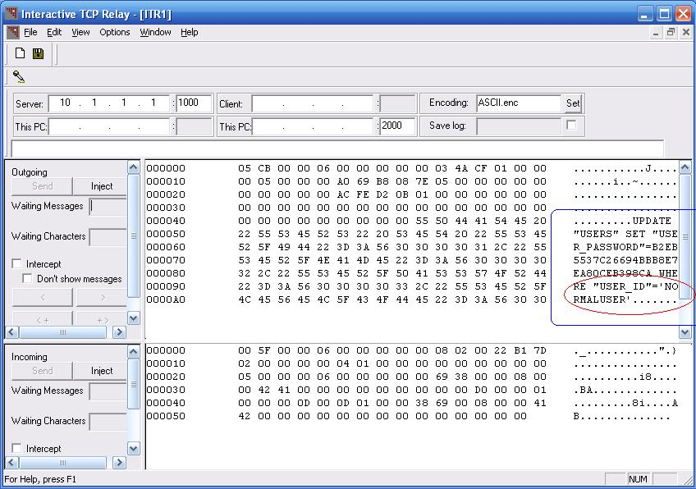
Figure 5: ITR as Interceptor

A malicious low privileged user can intercept the traffic using ITR; modify the query to reflect the reference attribute of high privilege user USER_ID. The database will update the password field of high privileged user with the supplied password of the malicious low privileged user. The malicious user can now log in to the application as high privileged user and view/modify important information.
In the following example a malicious user has modified the USER_ID portion of the UPDATE statement by replacing NORMALUSER with ADMIN and updated the password of the ADMIN with a known password hash.
A snapshot of impersonation is shown below.

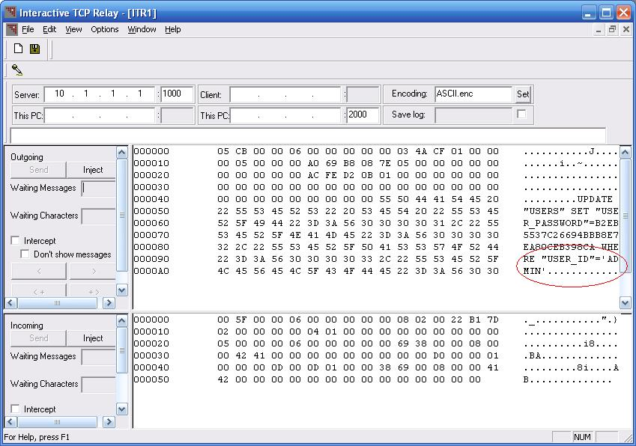
Figure 6: ITR as Interceptor for Impersonation

Solution
To solve this issue, database listener service should not run at default port. It can run at a non guessable port other than the default one. Client server traffic should be encrypted to protect from man in the middle attack. In three tier architecture this can be achieved by maintaining session ID between client user interface and application server. Physical access to the application server should be restricted and only application server should be permitted to communicate with the database. Application server should maintain and keep track of every transaction with highly random & non guessable session IDs.

Mitigating Risks
We have discussed a few critical vulnerabilities associated with a thick client application. To address these issues secure application architecture should be designed. The following security best practices can be considered during development as described in above sections.
- Thick client application can be conceptualized as three tier architecture. Application user interface (UI) will reside at 1st tier. Application server which will perform the entire processing job will reside at 2nd tier. Database server will come at 3rd tier to store data.
- Application UI to Application Server and Application Server to Database server traffic should be protected to maintain confidentiality and integrity. Confidentiality can be maintained using encryption algorithm like DES or 3DES and integrity by MD5. SSL can also be used to achieve the same.
- Application should validate all user inputs for length, special characters & code.
- Application should have provision to enforce proper authorization level to users on a need to know basis.
- Adequate audit and logging feature should be present and enabled in the application to log all transaction events including login attempts.
- Application should not store sensitive information like user password in computer memory, files, registry or database in clear text format. It should rather be stored in one way hash format. Critical file and registry permission must be secured. Application should clear the data in the memory after its usage.
- Application should have the provision to enforce strong password policy to the users.
- Application must use strong authentication technique. In this 3-tier structure all the user credentials can be verified at application server itself. It must not pass any credential like actual password to UI.
- Application should uniquely identify and maintain sessions. Session IDs used should be random and unbreakable.
- Application should handle the errors without disclosing critical system information.
- Database should not run on a default port. A non guessable port should be used to connect the database.
- Database, application server and OS should be configured with secure setting and updated with the latest software or patch levels.
- Database should accept the connections only from the application server.

About the Author
Arindam Mandal is a Certified Information Systems Security Professional (CISSP), associated with information security for past 4 years. Currently, he is employed as an Associate Security Consultant at Paladion Networks. Paladion Networks is an information security organization providing security services for corporates in India, Malaysia, Middle East and USA. The mission of Paladion is to harness global technologies to deliver trusted solutions for creating secure business environment.

OWASP Top Ten Most Critical Web Application Vulnerabilities details is available at: http://www.owasp.org/documentation/topten.html
Ethereal is a sniffer that can capture the traffic in a network and also decode certain protocols. It is available for download at http://www.ethereal.com/download.html
Interactive TCP Replay is a tool that acts as a proxy for non-HTTP applications and also allows modifying the traffic. It allows editing of the messages in a hex editor. ITR also logs all the messages passing between the client and the server. It can use different types of character encoding like ASCII or EBCDIC for editing and logging. More information on this can be found at http://www.webcohort.com/web_application_security/research/tools.html
MD5 one way hashing algorithm is described in RFC 1321. It can be found at http://www.ietf.org/rfc/rfc1321.txt
WinHex is a tool used to view the contents of the memory. It can be used to view the memory content per process basis and search within the content. The trial version is available for download at http://www.winhex.com/winhex/index-m.html

