Threat modelling of pharming
Cheong Kai Wee
ckw214@yahoo.com

Abstract
Phishing is evolving into a new type of attack called pharming. Pharming redirects users to fraudulent websites seamlessly without any suspicious activity such as spam mail that asks a user to login at a website. Everything works perfectly normal and users feel comfortable as they have visited the same websites a few days ago without any problem and they are just repeating the same activity now. But this time, they are redirected to a fraudulent website, due to DNS poisoning or other attacks. This paper analyses possible vectors of pharming and creates a threat model for it with attack tree.

Keyword
Pharming, attack tree, life cycle, vector

Introduction
The objective of this paper is to create a threat model for pharming. Firstly, the life cycles of users visiting a website are identified. Each stage in the life cycle is then analysed to identify possible attacks on it. Threat model is created based on these attack vectors. Finally, comparison of attack vectors and analysis of pharming will be presented.

Definition
There are a few different definitions of pharming. A research paper in Gartner defines pharming as an attack on DNS (Domain Name System) that redirects users to harmful website (Wheatman et. al., 2005). In this paper, however, pharming is defined in a broader sense, as an attack that steals users’ credential by redirecting users to fraudulent websites. The reason for this is that although DNS attack is the major vector for pharming, there are also other non DNS related vectors, such as page rank escalation and man-in-the middle attack (Ollmann, 2005).

Background of pharming
Phishing that uses email spam to trick users into surrendering confidential information to fraudulent websites soon becomes ineffective as more and more people recognise this attack and becomes particular careful in handling emails (Vamosi, 2005). This attack is evolving into another type of attack called pharming, which redirects users to fraudulent site to steal their credentials seamlessly (Fleming, 2005). This attack is successful because there is no activity that would raise suspicion of users. Everything works perfectly normal and users feel comfortable as they have visited the same websites a few days ago without any problem and they are just repeating the same activity now (Korzeniowski, 2005). This time, however, due to some poisoned DNS entries or other attacks performed by pharmers, they are redirect to a fraudulent website ready to steal sensitive information such as password.

Life cycle of users visiting a website
Understand the detailed life cycle of a system is important as threat model is created based on it. If you accidentally miss out a step in the life cycle, you would not be able to identify threats for this particular step. As an example, an attacker wants to steal money from slot machine can meet his objective by introducing flaw in its design, modify it during installation or break into it when it is in the casino (Schneier, 2004, p. 286). If you do not understand the life cycle of slot machine and have the thought that attacks can only happen after the slot machines are in the casino, you have a wrong threat model and an attacker who has introduced flaw in its design can simply come into the casino and steal money “legitimately” by winning the jackpot of the slot machine (Schneier, 2004, p. 303-305). The following section discusses the life cycle of users visiting a website. There are 4 methods identified as possible ways for a user to visit a website
- Users memorise the URL and enter URL manually in browser
- Users get the URL from a static hyperlink
- Users get the URL from search engine or auto complete function
- Users get the URL from non-computer related source

First method: Memorise the URL and enter URL manually in browser
Figure 1 shows the detailed process of users visiting a website by typing the URL manually.
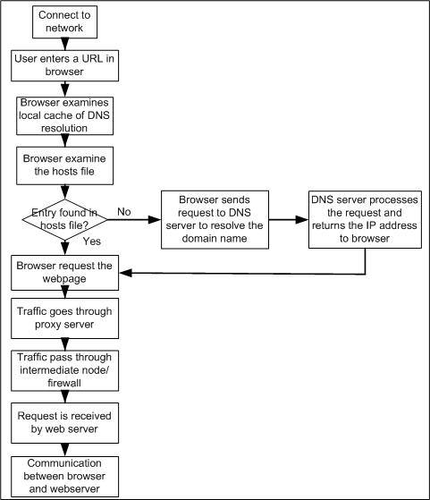
Figure 1: Life cycle of users retrieve a webpage by entering the URL manually
- User computer connects to the network, either with static IP or dynamic IP. For static IP, user configures the host IP address, subnet mask, gateway IP and DNS server IP manually. For dynamic IP, these settings are configured automatically with DHCP (Dynamic Host Configuration Protocol)
- User enters the URL in the browser
- Browser searches local cache of DNS resolution
- If resolution record of the domain cannot be found in the local cache, browsers examine the hosts file.
- If the browser cannot resolve the domain name with hosts file, it will send request to primary DNS server based on the network setting.
- DNS servers usually implement a mechanism called caching, which store resolution information temporarily to speed up the resolution process. For example, after DNS servers resolve www.google.com, it is cached so that any further resolution about www.google.com can be replied straight away (Aitchison, 2005). A value called TTL (time to live) is assigned to each entry in cache. An entry is removed when its TTL is expired. To resolve a domain name, first local DNS checks whether it is the authoritative DNS server to answer the request. If it is, it checks its own database to resolve the domain name. If it is not, it examines the domain name in its cache. If there is an entry for this domain in the cache and its TTL is not expired, its IP address is returned to the requesting browser. If it is not, local DNS server starts sending requests to other DNS servers to resolve the domain name until it gets the IP address from the authoritative DNS server (Carli, 2003). The domain name resolution sequence is operating system dependent. For example, Microsoft Windows resolve a domain name following the list shown below (Microsoft, 2003a). This sequence can be changed in registry with the key HKEY_LOCAL_MACHINE\ SYSTEM\ CurrentControlSet\Services\Tcpip\ServiceProvider (Philip, 2002)
  - Verify whether the name is alias of local machine
  - hosts file lookup
  - DNS lookup
  - WINS lookup (Microsoft, 2003b)
  - NETBIOS broadcast
  - LMHOSTS file lookup

Domain name resolution sequence for Linux can be configured with file /etc/host.conf. The default sequence is usually as following (Maurani, 2001).
- Lookup in file /etc/hosts
- DNS query

An example of how DNS resolves domain name of www.google.com is shown in figure 2. Below are the steps to preform recursive query on www.google.com (the highlighted step in figure 2).
- Local DNS server first queries the root DNS server for the IP address of DNS server for .com.
- From the result of root DNS, Local DNS server queries .com DNS server for IP address of DNS server for google.com.
- Local DNS server then queries DNS server of google.com for IP address of www.google.com and get the resolution record from it.
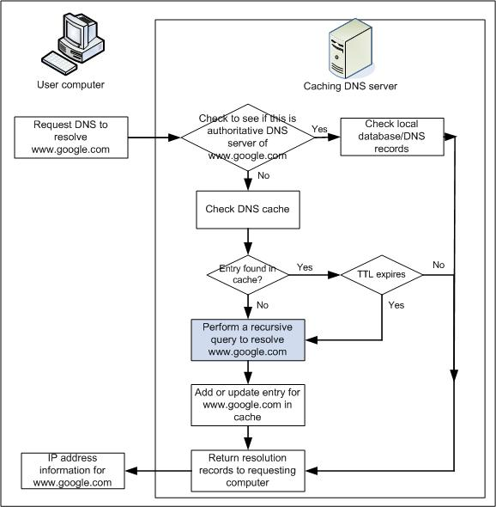
Figure 2: How a caching DNS server answers a lookup request

- After the browser gets the IP address, it sends a HTTP request to the web server
- The packets pass through proxy server (if any)
- The packets pass through intermediate routers/firewalls
- The packets is received by the web sever
- The web server processes the request
- User communicates with the web server using browser. User can login to the website, download file or performs any permitted actions on the website.

Second method: Get the URL from a static hyperlink
This method involves users clicking on a static hyperlink at other webpages or messages of messenger program to visit a website. The detail process from establishing network connection to retrieving webpages from web server is not shown as it is similar to the first method. The same applied to third and fourth method.

Third method: Get the URL from search engine and auto complete function
Users get to a website by clicking the URL returned in a search result. It is usually used when a user want to search webpages related to certain keywords. However, search engines are an increasingly popular method to get the URL of a website, where users who know the URL of a website might still use search engine to locate it in stead of typing the URL manually as they think it is faster to do so (Ollmann, 2005).

Autocomplete is a feature in browser that suggests possible entries for address bar and form elements such as textbox (Dow, 2004). Its functionality is browser dependent. Example of its functionalities:
- List possible matches for URL you are typing
- Submit a query to nominated search engine and list the result (Internet Explorer) (Ollmann, 2005)
- Submit a query to nominated search engine and automatically follow the top link (Mozilla Firefox)

Fourth method: Get the URL from non-computer related source
Users might also get the URL of a website from other non-computer related sources such as newspapers, magazines, SMS messages, friends or other sources. Users then type the URL manually in the browser to get to the website.

Threat model
Figure 3 and 4 shows that attacks can occur at different states of the lifecycle.
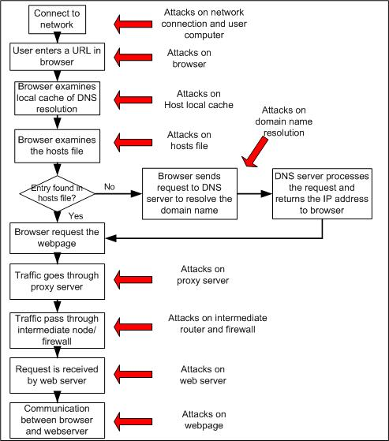
Figure 3: Possible attacks on different stages of life cycle
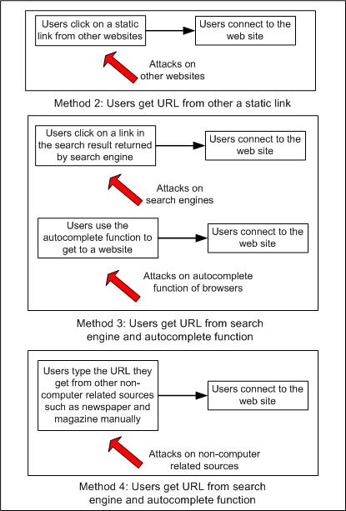
Figure 4: Possible attacks on different stages of life cycle

Below are lists of possible attacks in the life cycle and vectors to perform these attacks:
- Attacks on local network connection
- Rogue DHCP server
- Rouge access point/free access point
- Fake instructions on network setup
- Man-in-the-middle-attack with ARP poisoning or other methods
- Attacks on browsers
- Trojaned browser
- Attack on local cache of the host
- Poison the local DNS cache
- Attacks on host file
- Modification on host file
- Attacks on domain name resolution
- Domain name hijacking
- Similar domain name registration
- DNS spoofing
- Compromise the DNS servers
- Attacks on proxy servers
- Free proxy servers
- Rogue WPAD services
- Compromise the proxy server
- Attacks on the intermediate routers/firewalls
- Compromise the router/firewall
- Attacks on the web servers/webpages
- Compromise the web server
- Cross site scripting
- Attacks on other webpages that link to the target website
- Compromise the web server
- Cross site scripting
- Attacks on search engines
- Page rank escalation
- Attacks on the autocomplete functions
- Attacks are browser dependent
- Attack on the non-computer related source
- Give false information about the URL

Threat model of pharming is shown with attack tree in figure 5. This attack tree only shows until second level. The sub attack trees will be included in the discussion of individual vector.

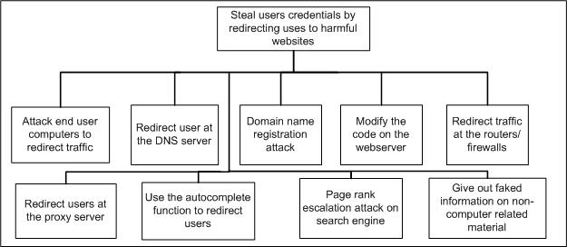
Figure 5: Attack tree to steal users’ credential with pharming attack

Attack end users’ computers to redirect traffic

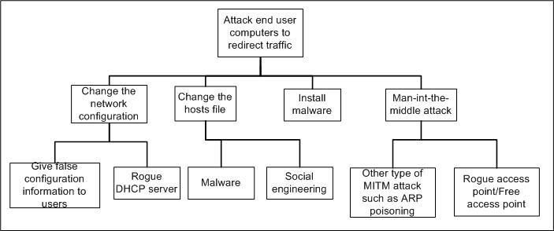
Figure 6: attack tree to redirect traffic at end user computers

Rogue DHCP (Dynamic Host Configuration Protocol) server
The function of DHCP servers is to assign network configuration information such as IP address, default gateway and DNS server to DHCP clients. By setting up a rogue DHCP server, a pharmer can send faked network configuration information and assign a DNS server under pharmer’s control to all DHCP clients (Payton, 2003). The Pharmer can then redirect traffic with configuration in his DNS server.

Modification on hosts file
Most operating systems perform hosts file lookup in resolving a domain name before sending query to DNS server. By compromising the hosts file to add extra entries in it, pharmers can redirect users to fraudulent websites. There are many ways pharmers can change the settings in hosts file. Pharmers can create worms, share trojaned files in peer-to-peer sharing network or use other methods. For example, there is a worm called W32.Peerload.A that modifies hosts file to redirect users to fraudulent websites such as faked Google (Symantec, 2005). In addition, pharmers can also create some malicious webpages with codes that can exploit vulnerability of certain unpatched browsers to modify the hosts file (Ollmann, 2005).

Give false configuration information to user
Pharmers can carry out a social engineering attack, by sending a mail with letter head of the ISP to users and instruct them to input some false network configuration to their computers. For example, users are asked to manually set the DNS server IP address to a DNS server controlled by pharmers.

Malware such as trojaned browser
Pharmers can create malwares that infect users and redirect them to fraudulent websites. Possible ways to achieve this goal include creating worms and share trojaned version of browser in peer-to-peer network or websites.

Rogue wireless access point/Free wireless access point
A typical attack on wireless network with rogue AP (access point) is to send deauthentication message to the wireless client and then establish a malicious access point with the same ESSID and MAC address but different channel with the legitimate AP (Edney & Arbaugh, 2003). Usually attacker also launch some DoS attack on legitimate access point and establish the rogue access point with higher power so that the client would re-associate with the rogue AP but not the legitimate AP (Vladimirov, Gavrilenko & Mikhailovsky, 2004). By acting as the access point for the clients, pharmers can perform man-in-the-middle attack and redirect users to fraudulent websites. This vector, however, is only possible if the wireless network is not protected with security mechanism such as WPA.

Wireless LAN is ubiquitous nowadays. A survey in Taiwan shows that the amounts of users connect to Internet with wireless technology increase from 4% to 10.5% over year 2004 (Find, 2004). As many home users now prefer to use wireless network to connect all computers to Internet, there are many malicious users scanning for unprotected wireless network for free Internet access (Harden, n.d.). Pharmers can take advantage of this activity to setup some insecure wireless access points to provide “free” internet service to them. By acting as the access point for these users, pharmers can redirect them to fraudulent websites.

Other man-in-the-middle attacks such as ARP poisoning
Man-in-the-middle attack can also be carried out in Ethernet environment with ARP poisoning attack (Kazunori, 2005).

Redirect users by attacking DNS servers

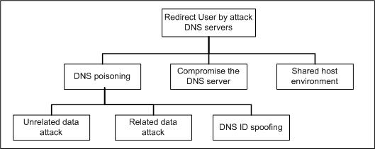
Figure 7: Attack tree to redirect users by attacking DNS servers

DNS cache poisoning
By poisoning the cache of DNS server, pharmers can insert some faked entries to redirect users to fraudulent websites. A survey shows that there are still 10% of DNS servers vulnerable to DNS poisoning attack (Evers, 2005). This attack can be performed on different level of DNS server such as root DNS servers, top level domain DNS servers or DNS servers of ISP. The higher the level of attack, the more users would be affected and the faster it would be detected (Ollmann, 2005). There are 3 different ways DNS poisoning can be carried out:
- Unrelated data attack
- Related data attack
- DNS ID spoofing
To perform unrelated data attack, pharmers query victim’s DNS server to resolve a domain managed by another DNS server under control of the pharmer. The pharmer then set his DNS server to return additional/unrelated resolution records besides the original resolution. In the example shown in figure 8, a pharmers query victim’s DNS server for the IP address of www.hacker.org. Victims DNS server then performs a recursive query and finally queries the authoritative DNS server for www.hacker.org (under control of pharmers) to resolve the domain name. This malicious DNS server returns other unrelated resolution records such as resolution of www.mybank.com and www.buysomething.com to poison the cache of victim’s DNS server (Carli, 2003).

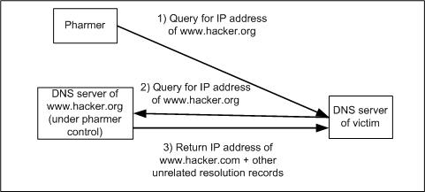
Figure 8: Unrelated data attack
A variant of unrelated data attack is called related data attack, which does exactly the same to poison the cache but through MX, CNAME or NS records that related to the requested domain (Erdfelt, 1997). While most of the patched DNS servers are not vulnerable to related and unrelated data attack, this type of vulnerability is still found on different DNS server products from time to time. For example, certain versions of Symantec Gateway Products are found to be vulnerable to these attacks in 2004 (Symantec, 2004).

DNS servers rely sorely on source IP address, source port and DNS transaction ID to authenticate a DNS resolution transaction (Sainstitute, 2003). If a pharmer can get this information, he can spoof a reply easily with faked information to poison its cache. The reply from the legitimate server would be discarded by the client as he has already received a “valid” reply from pharmer as shown in figure 9.

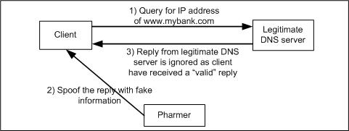
Figure 9: Spoof DNS reply by sniffing for transaction ID and other information

There are many ways a pharmer can get the transaction ID. For example, the pharmer can sniff for this information from the network. Pharmers can also perform brute force attack on the transaction ID, which is 2 bytes long with 65535 possible values (Ollmann, 2005). At the same time, a distributed denial of service attack on the legitimate DNS server can be launched with botnet to delay its response time, in order to increase the number of spoof replies sent to client, and thus the possibility of success (Sainstitute, 2003). Pharmers can also increase the chance of success by sending multiple recursive queries to a DNS server simultaneously to resolve the same domain name. As certain implementation of DNS servers would also send multiple requests to the authoritative DNS server to resolve the same domain using multiple transaction ID, brute force attack on the transaction ID have a higher chance of success (BlueCat Network, 2005). This is usually called Birthday Paradox phenomena. This attack is shown in figure 10.
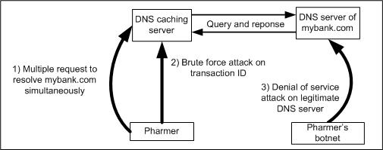
Figure 10: Brute force attack on transaction ID

Compromise DNS server
Pharmers can also compromise a DNS server by exploiting vulnerabilities on the DNS service, its underlying operating system other running services on the system.

Shared host Environment
This attack is only possible on a DNS server that is shared among many users. Pharmers can create zone file for other domain such as www.mybank.com and users that configure this DNS server as their primary DNS server would be redirected to a faked site when trying to visit www.mybank.com. This is not a specific vulnerability to certain DNS server but an abuse on the trust relationship (Sainstitute, 2003).

Attack the domain name registration system

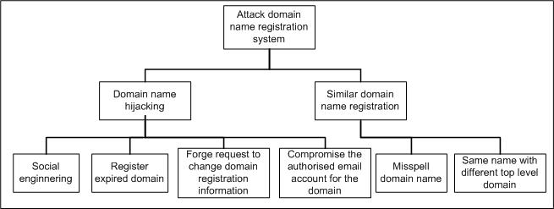
Figure 11: attack tree to attack domain name registration system

Domain name hijacking
Domain name hijacking is an attack that steals a domain from its legitimate owner. The ultimate goal of pharmers who hijack a domain is to modify its DNS configuration so that Pharmers can set a DNS server under pharmers’ control as the authoritative DNS for that domain. The pharmer can then use this DNS server to redirect users’ traffic to a fraudulent website that looks identical to the original site. There are many ways domain hijacking can be performed:
- Persuade the customer support agent of a registrar to modify registrant information with social engineering attack (ICANN, 2005)
- Register the domain after the domain expired (Ollmann, 2005)
- Forge a faxed request or a mailed request to modify registrant information. Hijackers may even steal or copy the letter head of a company to abet the fraud (Fiore & Francios, 2002)
- Compromise the authorised email contact of an administrative contact

Similar domain name registration
In this attack, pharmers take advantage of slightly misspelled domain name to trick users into visiting pharmers website. For example, pharmers can register anybnk.com and try to steal credentials of users from anybank.com (Lee, 2005). Other variations include registering a name with different top level domain. For example, register foo.org, foo.net, foo.web and foo.firm to steal users credential from legitimate website foo.com (Klein, 1999). This attack exploits users’ typing error and their inability to memorise the whole domain name. This can be avoided if users check the domain name carefully and cross check with other sources if they forget part of the URL. A more advance technique is called homograph spoofing, where pharmers register the domain with non-English-alphabet that looks identical to certain English character. For example, a pharmer can register www.mybank.com with the alphabets a and o in Russian letter, that looks identical to English letter (Gabrilovich & Gontmakher, n.d.).

To make it harder to close down the pharm site, pharmers can list multiple DNS servers during domain name registration and use botnet to host multiple copies of the fraudulent website at several IP addresses (Ollmann, 2005). When one of these fraudulent sites is closed by its ISP, the pharmer just need to modify his DNS to point to alternative location. The lack of central point of contact and cross international boundaries nature of botnet makes it difficult to close down all pharm sites (Honeynet, 2005). By ensuring the listed DNS servers are spread across different ISPs and countries, no single ISP can shutdown the DNS service. The only solution to the victim is to contact the registrar of the malicious domain but most registrars do not have procedure for dealing with this kind of request (Ollmann, 2005).

Redirect user at proxy server

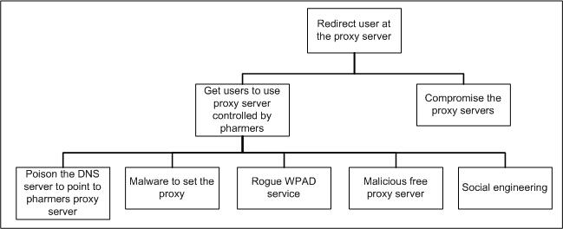
Figure 12: Attack tree to redirect user at proxy server

Rogue WPAD service
WPAD (Web Proxy Auto-Discovery Protocol) is a protocol that enables web clients to find and load proxy configuration information from a single server. Browsers such as Internet Explorer have this option enabled by default (Microsoft, n.d.). The searching algorithm adds wpad to the full-qualified domain name and progressively removes sub domain until it finds the WPAD server or it reach the fourth-level/third-level domain. For example web clients in the a.b.microsoft.com would try to query wpad.a.b.microsoft.com, wpad.b.microsoft.com and wpad.microsoft.com for proxy configuration (Microsoft, 2004).
Pharmers can take advantage of the search algorithm to install a rogue WPAD server at the lower level of a domain. For example, if the legitimate WPAD server for abc.com is wpad.abc.com, pharmers can install rogue WPAD server at wpad.othersubdomain.abc.com and users in othersubdomain.abc.com would retrieve configuration script from the rouge WPAD server in stead of the legitimate server.

Malicious free proxy server
Public proxy servers are proxy servers usable by any user in the Internet. Privacy concerned users usually use them to hide their IP address. Resourceful users or organisations can setup their free/anonymous proxy servers and share them to Internet users. Certain websites such as www.freeproxy.ru even maintain a list of usable free proxy servers (Freeproxy, n.d.). These lists are usually maintained by small organisation and there is not policy regarding how the proxies are tested before it is included in the list.

A Pharmer may setup his own free/anonymous proxy servers and advertise them to Internet users. By acting as proxy server, pharmers can perform man-in-the-middle attack to redirect users’ to fraudulent sites. This attack vector is not currently seen in the wild. The major reason might be it only affects a small number of users that use free public proxy servers.

Compromise the proxy server
Pharmers can also compromise the proxy server in order to redirect users’ traffic.

Attack web servers/webpages
Pharmers can attack the web server/webpages of the target domain and modify its code to redirect users’ traffic. On the other hand, pharmers can also attack other websites that link to the legitimate site to change the hyperlink so that it points to fraudulent site. For example, there is a hyperlink at www.abc.com to www.mybank.com, pharmers can attack www.abc.com to change the hyperlink to point to www.pharmers.com. Attack tree of this vector is shown in figure 13.

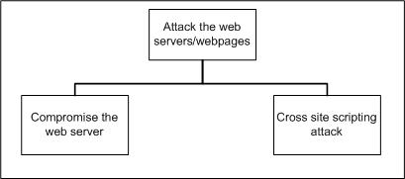
Figure 13: Attack tree to redirect users by attacking webservers/webpages

Compromise the web server
By compromising a web server, pharmers can modify web server configuration or coding of the webpages to redirect users to fraudulent webpage. Pharmers can either redirect users with HTTP redirect method or refresh META tag.

XSS (Cross site scripting)
Cross site scripting happens when attackers embed malicious scripts in a dynamic generated webpages and execute the script on machine of users that view that webpage (Spett, 2002). There are 2 types of XSS: active and passive. Active XSS attacks require victim interaction, in which attackers construct a malformed URL with an injection string, and send it to victims using an email or messenger program, subsequently luring the victim to click the link (Rafail, 2001). Passive XSS attacks require no user interaction, and may be carried out automatically and silently (Zimmer, 2004). Passive attacks are particular dangerous and usually happen at forum, bulletin board and guest books, where an attack script may run automatically when users view the webpages (CGISecurity.com, 2003).

In the context of pharming, pharmers can perform passive cross site scripting on a webpage and insert refresh META tag to redirect users to a fraudulent website. This vector is not possible for all websites, but only dynamic websites that generate webpages from users’ inputs.

Redirect traffic at the router/firewall
Pharmers can compromise router or firewall and redirect users’ traffic to fraudulent websites from these devices.

Exploit autocomplete feature of browsers
Pharmers can exploit autocomplete feature of a browser to redirect users to fraudulent websites. Implementation of autocomplete feature is browser dependent. For example, when a user type “nba” in the address bar of Internet Explorer, it lists search result from msn search engine with keyword “nba”. For Firefox, it would connect automatically to the top result returned from Google search engine.

It is due to autocomplete feature is browser dependent, pharmers need different techniques to redirect users of different browsers. For example, to redirect Firefox users that only types “citybank” in the address bar, pharmers need to perform page escalation attack on Google so that the fraudulent site is at the top of search result.

Page rank escalation attacks on search engines
The amounts of affected users of this vector are huge as many users rely on search engines to find a website and they are confident about the results of search engines. A survey shows that 84% of Internet users use search engines and 92% of them confident about search engines’ abilities to return accurate result (Fallows, 2005). In this attack, pharmers abuse the page ranking system in search engines to get their fraudulent link appears at the top of search result, which users would expect the real or more relevant link (Ollmann, 2005). Google, the most popular search engine, has a function called “I’m Feeling Lucky” which would automatically connect to the top link of the search result. This feature make page rank escalation attack to be more effective. Other variations include paying the search engines for sponsored link or submitting the fraud sites to directories such as Yahoo! directory and Open directory.

Social engineering
Social engineering is an attack on human factor of a system. Pharmers, for example, can give out some faked URL in magazine or forum messages. Users that do not know about the legitimate domain name might be tricked to visit the fraudulent websites. For example, a pharmer setup an advertisement of mybank.com in magazine but give the faked URL. Some users who read the magazine might enter the faked URL and directed to the fraudulent site.
Social engineering can be used as vector on most attacks discussed before. For example, in DNS attack, pharmers can bribe an administrator to modify the resolution records to redirect users to fraudulent sites. For attack on web servers, pharmers can bribe/social engineering a web master to change its configuration. The possibilities of how social engineering can be used are unlimited.

Comparison of attack vectors

Table 1 shows the comparison of attack vectors of pharming in terms of users that would be affected, anomaly that might raise suspicion of users and risk of pharmers to perform this attack. Assumptions made include:
- Pharmer perform man-in-the-middle attack in pharming, where the pharm site that act as “front end” for the legitimate site, and this pharmer just redirect the traffic between the users and the legitimate website (Anti-phishing working group, 2005).
- The risk is assessed on the likeliness of pharmers being caught and prosecuted

Table 1: Comparison of attack vectors
Attack vector | Users affected | Anomaly that might raise suspicion | Risk of pharmer
Malware | Users affected by malware | Depends on how the malware works  For example, a trojaned browser might not show any anomaly | Low
Modify on hosts file | Users affected by modified hosts file | No | Low
Give false configuration information to user | Users in a particular network. | A user can detect anomaly if he knows the legitimate configuration or the way configuration information sent is not convincing. E.g: no letter head of company | Low
Rogue DHCP server | Users in a particular network. | Possible IP conflict if rogue DHCP server assigns an IP already assigned to another host by the legitimate DHCP server | Medium
ARP poisoning | Users in a particular network. | No | Medium
Rogue access point/Free access point | Users in a particular wireless network. Only possible on unprotected wireless network | No | Low to Medium
DNS poisoning | Depends on the DNS server that is compromised.  Compromised root DNS server would have greater impact than lower level DNS server | No | Low to medium
Compromise DNS server |  | No | Medium to high
Share host environment |  | No | Medium
Domain name hijacking | Users that visit a particular domain | No | Medium
Similar domain name registration | Users that visit a particular domain | URL is slightly different from the legitimate domain but only users that know about the legitimate domain would be able to detect this | Medium
Rogue WPAD service | Users in a particular network | No | Medium
Compromise the proxy server | Depends on the proxy server that is compromised | No | Medium to high
Malicious free proxy server | Users of free public proxy servers | No | Low
Cross site scripting | Users that visit a particular website | Users might be able to notice a flicker at the browser and the URL has been changed (if META refresh is used) | Low
Compromise the router/firewall | Depends on the router/firewall that is compromised | No | Medium to high
Exploit autocomplete function | Users that use the autocomplete function of browser  This attack is browser dependent | URL is different from the legitimate website but only users that know about the legitimate domain would be able to detect this | Low to medium
Page rank escalation | Users of a particular search engines.  This attack is search engines dependent. | Same with Exploit autocomplete function | Low
Social engineering | Depends on the target of social engineering attack | Would be detected if the target is cautious and aware of social engineering | Low

Analysis of attack vectors

Phishing is one of the most popular frauds as it entails low risk of getting caught while offering high reward (Morphy, 2004). When phishing evolves to pharming, the same characteristics remain and pharmers prefer low risk vectors. While some of the discussed vectors such as compromising router, firewall or proxy server are capable to achieve to goal of redirecting users to fraudulent sites, the risk is simply too high for pharmers. As a result, it is not likely these vectors would be adopted by them. Some vectors such as compromising web server, proxy or others to redirect users to fraudulent sites might also seem to be unrealistic as an attacker would simply install a sniffer to steal sensitive information in stead of redirecting them, as it would be easier to do so. These attacks are included for the sake of completeness.

Below are some trends of pharming:
- DNS cache poisoning is currently the most popular vector
- Emerging vectors for pharming include similar domain name registration and page rank escalation attack on search engine (Anti-phishing working group, 2005).
- The use of peer-to-peer networks and instant messengers to spread malware in redirecting users to fraudulent sites is gaining popularity.
- The use of botnet to hosts the pharm sites

Conclusion
As there are many entities involve in the life cycle of users visiting a website, which include users, ISP, domain registrar, domain registrant and website administrator, it is impossible to have one security mechanism to secure the whole process. To mitigate pharming attack, it is important to take the whole process into consideration. Failure to do so would only secure certain parts of the process but not security in total, as pharmers can simply change to another approach to redirect users. For example, focus on securing DNS server might cause pharmers to spread malware that can modify hosts file configuration through peer-to-peer network. Pharming need multiple security mechanisms at different stages of the life cycle to secure the whole process.

Reference

Aitchison R. (2005, August). Pro DNS and BIND. Apress.

Anti-phishing working group (2005b, April). Phishing Activity Trends Report April, 2005. Retrieved October 8, 2005 from http://antiphishing.org/APWG_Phishing_Activity_Report_April_2005.pdf

BlueCat Network (2005, January 1). Pharming: Cache Poisoning Raise Cash Crop for DNS Pharmers. http://productfinder.cio.com/shared/write/collateral/WTP/51132_53170_61989_BlueCat.pdf?ksi=1103704&ksc=1227558837

Carli F. (2003). Security Issues with DNS. Retrieved October 3, 2005 from http://www.sans.org/rr/whitepapers/dns/1069.php

CGISecurity.com (2003, August). The Cross Site Scripting FAQ. Retrieved April 26, 2005 from cgisecurity.com: http://www.cgisecurity.com/articles/xss-faq.shtml
Dow S. (2004, July). Protect your personal information by optimizing AutoComplete settings. Net Watchman, 11(7), 3-4, Retrieved October 3, 2005 from Proquest Database: http://0-proquest.umi.com.library.ecu.edu.au/pqdweb?did=659375311&sid=1&Fmt=4&clientId=7582&RQT=309&VName=PQD

Edney J. & Arbaugh W. A. (2003, July 15). Real 802.11 Security: Wi-Fi Protected Access and 802.11i. Addison Wesley.

Evers J. (2005, August 3). DNS servers--an Internet Achilles' heel. Retrieved October 7, 2005 from http://news.com.com/DNS+servers--an+Internet+Achilles+heel/2100-7349_3-5816061.html

Erdfelt J. (1997, July 25). Everything you ever wanted to know about DNS Spoofing. Retrieved October 7, 2005 from http://www.cs.rpi.edu/~kennyz/doc/unix/dns.spoof

Fallows D. (2005, January 23). Search Engine Users. Retrieved October 4, 2005 from http://www.pewinternet.org/pdfs/PIP_Searchengine_users.pdf

Fleming C. (2005, September). One Step Ahead of the Bad Guys. Credit Union Magazine, 71(9), 80-81. Retrieved October 7, 2005 from ProQuest Database: http://0-proquest.umi.com.library.ecu.edu.au/pqdweb?did=895505171&sid=1&Fmt=4&clientId=7582&RQT=309&VName=PQD

Find (2005, January 7). Mobile and Wireless Online in Taiwan 2004. Retrieved October 6, 2005 from http://www.find.org.tw/eng/news.asp?msgid=146&subjectid=4&pos=0

Fiore F. & Francios J. (2002, August 30). Unwitting Collaborators, Part 11: DNS Poisoning and Domain Hijacking. Retrieved October 7, 2005 from http://www.informit.com/articles/printerfriendly.asp?p=29015

Freeproxy (n.d.). Free Proxy Servers. Retrieved October 5, 2005 from http://www.freeproxy.ru/

Gabrilovich E. & Gontmakher A. (n.d.). The Homograph Attack. Retrieved October 10, 2005 from http://www.cs.technion.ac.il/~gabr/papers/homograph_full.pdf

Harden B. (n.d.). SECURITY IMPLICATIONS OF WIRELESS NETWORKING: Wireless Security Realized. Retrieved October 6, 2005 from http://www.datanamicsinc.com/White%20Papers/Wireless%20LAN%20Security%20White%20Paper.pdf

Honeynet (2005, May 16). Know your Enemy: Phishing Retrieved October 5, 2005 from http://www.honeynet.org/papers/phishing/

ICANN (2005, July 12). Domain Name Hijacking: Incidents, Threats, Risks and Remedial Actions. Retrieved October 5, 2005 from ICANN: www.icann.org/announcements/hijacking-report-12jul05.pdf

Kazunori F. (2005, February 21). DNS Monkey-in-the-middle Attack. Retrieved October 7, 2005 from http://www.psg.com/~mankin/200502dnsattack-fujiwara.pdf

Korzeniowski P. (2005, March 23). Hackers shifting their focus to pharming. Retrieved October 7, 2005 from http://software.itmanagersjournal.com/article.pl?sid=05/03/18/2328244&tid=104&tid=26

Klein D. V. (1999, April 12). Defending Against the Wily Surfer- Web-based Attacks and Defences. Retrieved October 5, 2005 from www.klein.com/dvk/publications/id99.pdf

Lee R. D. (2005, July 18). “PHARMING”: Guidance on How Financial Institutions Can Protect Against Pharming Attacks. Retrieved October 5, 2005 from http://www.fdic.gov/news/news/financial/2005/fil6405.pdf

Maurani G. (2001). Securing and Optimizing Linux: The Ultimate Solution. Open Network Architecture, Inc.

Microsoft (2003a, December 8). Microsoft TCP/IP Host Name Resolution Order. Retrieved October 2, 2005 from http://support.microsoft.com/default.aspx?scid=kb;EN-US;172218

Microsoft (2003a, December 5). NetBIOS over TCP/IP Name Resolution and WINS. Retrieved October 2, 2005 from http://support.microsoft.com/kb/119493/EN-US/

Microsoft (2004, June 15). Web Proxy Auto-Discovery "Spoofing" May Change Proxy Settings. Retrieved October 5, 2005 from http://support.microsoft.com/kb/q247333/

Microsoft (n.d.). Microsoft Security Bulletin (MS99-054):Frequently Asked Questions. Retrieved October 5, 2005 from http://www.microsoft.com/technet/security/bulletin/fq99-054.mspx

Morphy E. (2004, May 7). Report: Phishing Scam Hits 57 Million Users. Retrieved October 8, 2005 from http://www.cyota.com/news.asp?id=149

Ollmann G. (2005, August 31). The Pharming Guide. Retrieved October 2, 2005 from http://www.secinf.net/uplarticle/websecurity/ThePharmingGuide.pdf

Philip (2002, April 19). Host Resolution Priority Tweak. Retrieved October 2, 2005 from http://www.speedguide.net/read_articles.php?id=1130&print=friendly

Rafail J. (2001,). Cross-Site Scripting Vulnerabilities. Retrieved April 27, 2005 from CERT® Coordination Center: http://www.cert.org/archive/pdf/cross_site_scripting.pdf

Sainstitute (2003, October 29). Attacking the DNS Protocol – Security Paper v2. Retrieved October 7, 2005 from http://www.secinf.net/uplarticle/WebSecurity/AttackingtheDNSProtocol.pdf

Schneier B. (2004). Secret and Lies. United State: Wiley Publishing, Inc

Spett K. (2002). Retrieved October 5, 2005 from Cross Site Scripting: Are your web applications vulnerable? http://www.spidynamics.com/whitepapers/SPIcross-sitescripting.pdf

Symantec (2004, June 21). Symantec Gateway Security Products DNS Cache Poisoning Vulnerability. Retrieved October 7, 2005 from http://securityresponse.symantec.com/avcenter/security/Content/2004.06.21.html

Symantec (2005, September 18). W32.Peerload.A. Retrieved October 6, 2005 from http://securityresponse.symantec.com/avcenter/venc/data/w32.peerload.a.html

Wheatman V. Allan A., Girard J., Hallawell A., Litan A., MacDonald N., Mogull R. Orans L. Pescatore J. & Williams A. T. (2005, September 22). Hype Cycle for Cyberthreats, 2005. Retrieved October 2, 2005 from Gartner: http://www.gartner.com/resources/129100/129171/hype_cycle_for_cyberthreats__129171.pdf

Payton J. (2003, June 18). Tracking Down the Phantom Host. Retrieved October 6, 2005 from http://www.securityfocus.com/infocus/1705

Vladimirov A. A., Gavrilenko K. V. & Mikhailovsky A. A. (2004, June 28). WI-FOO: The Secrets of Wireless Hacking. Edison Wesley.

Vamosi R. (2005, February 18). Alarm over pharming attacks: identity theft made even easier. Retrieved October 6, 2005 from http://reviews.cnet.com/4520-3513_7-5670780-1.html

Zimmer D. (2004, February 18). Real World XSS. Retrieved April 18, 2005 from securityfocus.com: http://www.securitydocs.com/library/210

