AppSec

DRAFT -
Security Requirements for Business Applications
Version | 0.7

Product name | Security requirements for Business Applications
Product ref. | XX- SEC-XX
Purpose of this document
This document contains a list of security requirements and questions for the proposed product supplier for the XXXXX.

Revision history
Version | Issued | Summary of content and changes to previous version
0.7 | 28 Jan 04 | Initial issue for review
0.95 | 13 Feb 04 | First Draft Released
Review and distribution
Reviewer | Department/  position | Why you have received this document

Content
1. Security requirements for product Solution 4
1.1. Introduction 4
1.2. ‘Secure’ Applications 4
1.3. Objectives of Application Security Audit 5
1.4. Assumptions of Application Security Audit 6
1.5. Next Steps 6
1.6. Security Requirements diagram 8
2. Security Requirements table 9
3. Explicit Security Questions 11
4. Additional Documents for the supplier to provide 16
4.1. List Vulnerabilities discovered 17
4.2. List of internal Security incidents 17
4.3. What Operating System resources the software requires? 17
4.4. What changes are made to the operating system? 18
4.5. What are the installation requirements? 18
4.6. product Security Architecture 18
4.7. Security software recommendations 18

Security requirements for product solution

Introduction
Part of XXXXX Software Evaluation process is a detailed analysis of the proposed application’s security.
In order to make a fair and knowledgeable decision, a list of questions has been created which are designed to help the XXXXX to understand the security measures contained in the evaluated product and the security risks associated with its widely deployment and usage.
These questions (covering most areas of ‘Application Security’) must be answered in full by the prospective product supplier
The supplier must answer the questions in a direct and explicit way, and should provide as much detailed technical information as possible (when in doubt err on the side of complexity not on easy-to-understand concepts)
The evaluation process will be done by an Application Security Specialist appointed by the XXXXX for this project.
The Security consultant appointed is Mr. Dinis Cruz which can be contacted by email (dinis@cissp.co.uk).

‘Secure’ Applications
An application can be considered secure when the inherent security vulnerabilities and risks are lowered to a level considered acceptable by the business
Since there are no 100% secure applications or networks, the objective of this exercise is to identify vulnerabilities, evaluate threats and manage risk.
A secure application is one that:
- Only has the functionality that is publicly documented
- Does not contain any back doors, Trojans or ‘Viral Code’
- Does not lower the security of the host operating system or network
- Protects the integrity, confidentiality and authenticity of the data stored
- Contains robust authentication and authorization methods which cannot be bypassed
- Provides secure access to administrative tools
- Is designed under the principles of:
  - Defence in Depth
  - Least Privilege
  - Minimum access
- Is protected against common external attacks including as a minimun: Buffer Overflows, SQL injection, Cross Side Scripting
- Is fully supported and widely used
- Security vulnerabilities are fixed as soon as possible
- Security patches are distributed though quick and effective channels, are easy to install and have no side effects
- Client has access to the application’s source code.

Objectives of Application Security Audit
The objectives of the application security audit are to:
- Confirm the product supplier’s public security claims
- Confirm the product supplier’s answers to the questions included in this document
- Identify vulnerabilities within the proposed product implementation scenario (Theoretical analysis based on documentation supplied)
- Identify vulnerabilities within the proposed product implementation scenario (Practical analysis performed on a test environment created to the product supplier security recommendations)
- Rate the risks created by the vulnerabilitys found though a ‘Threat Modelling’ exercise
- Create a final document containing recommendations which will support the final decision to proceed (or not) with the deployment of the proposed product solution.

Assumptions of Application Security Audit
- The business (i.e. XXXXX) already accepts and approves the core functionality of the product
- The Domain Controllers have not been compromised and can be trusted to provide authentication and authorization details
- Although in principle all client workstations, member servers and PDAs can be trusted, given the wide spread of deployment of these networked devices, it must be assumed that occasionally they will be compromised by viruses, worms, trojans, backdoors or rootkits . They may also occasionally be operated by malicious employees
- There is no trust relationship between the XXXXX and the product supplier (apart from the Software purchase and Support contract).

Next Steps

- Product supplier to provide the XXXXX’s Security Consultant their responses to this document, including ALL relevant software and security patches
- The XXXXX’s Security Consultant to analyse the product supplier responses and to perform a security audit to the product software.
- The XXXXX’s Security Consultant will deliver to XXXXX a report containing:
  - an analysis of the product supplier responses
  - the results of the EDRAM software security audit
  - Recommendations
- Based on the XXXXX’s Security Consultant recommendations, the XXXXX will decide to:
  - Cancel the project
  - Conditionally start the pilot phase under an signed commitment by the product supplier to fix and patch the security problems considered high-risk before the solution goes live and highly sensitive data is stored and managed by the product
  - Unconditionally start the pilot phase whereby the XXXXX is happy with the product security and does not require any further changes or customizations

Security Requirements diagram
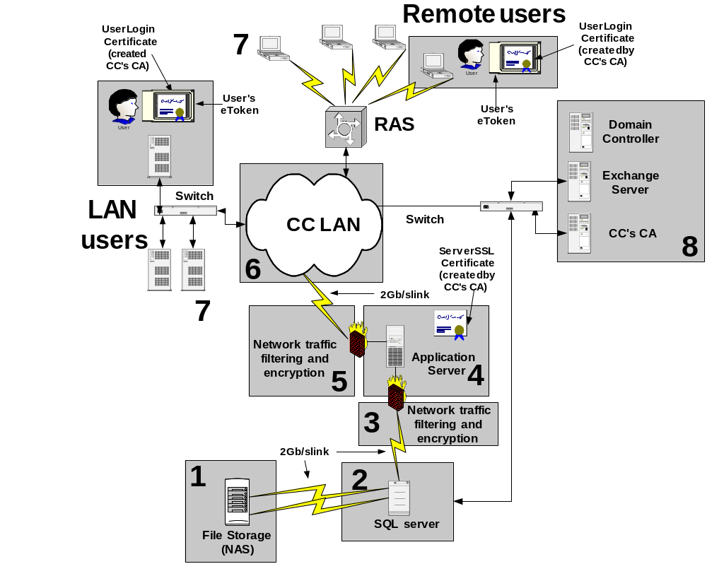

Figure 1: Solution Diagram with Security Areas Highlighted
Legend:
- NAS (Network Attached Storage)
- SQL Server – Hosting the Solution’s database and Business Logic (i.e. stored procedures)
- Firewall – Logical representation of data protection between the SQL Server and the Web Server
- Web Server
- Firewall – Logical representation of data protection between the Web Server and the LAN
- LAN - Local Network
- Client Computers (local and remote)
- Domain Controllers

Security Requirements table
Section | Security Requirement
1  (nas) | All data is stored in an encrypted format (if possible using ‘journal’) | Yes No
1 | The decryption keys are not stored anywhere inside the NAS box | Yes No
1 | All data authorization is done using Security Groups from Active Directory | Yes No
1 | Data is encrypted using public keys from the assigned Security Groups | Yes No
2  (database server) | The Vulnerability Assessment was performed by an independent security company | Yes No
2 | Can the SQL Application Code can be executed under a non-administrative account (i.e. under an account with no administrative priviledges) | Yes No
2 | All data stored in the SQL Server Database is encrypted | Yes No
2 | Are User Authentications (i.e. account details) or User Authorization details (i.e. what resources the user has access to) stored in the SQL Server Database | Yes No
2 | If User Authentication or User Authorization details are stored in the SQL Server Database, they are stored in an encrypted format | Yes No
2 | The decryption keys are not stored anywhere inside the SQL server box | Yes No
3  (Network traffic filtering and encryption) | The Solution supports the use of a Firewall between the SQL server and the Web Server | Yes No
3 | The Solution supports the use of IPSEC encryption between the SQL server and the Application Server | Yes No
4  (Application server) | All users are authenticated using their Windows (Active Directory) credentials | Yes No
4 | User Token Certificates are used for User Authentication | Yes No
4 | Users are impersonated by the web server and all data requests are done using the user’s credentials | Yes No
4 | Has a Vulnerability Assessment been performed by an independent security company | Yes No
5  (Network traffic filtering and encryption) | The Solution supports the use of a Firewall between the Application server and the LAN | Yes No
5 | The Solution supports the use of IPSEC encryption between the Application server and the LAN (i.e. Client computers and Domain Controllers) | Yes No
5 | The Solution supports the use of HTTPS (SSL encryption) for ALL Communications between the Web server and Client computers | Yes No
6  (lan) | Does the solution doesn’t allow anonymous users to connect to the web server (for example a malicious laptop connected to the network ) | Yes No
7  (clients) | Does the solution doesn’t use ActiveX Scripts on the local browser | Yes No
7 | Does the solution doesn’t install any software on the client computer | Yes No
7 | The solution works with XXXXX’s Internet Explorer’s ‘High Security Settings’ | Yes No
8 | The Active directory is the ONLY location where user Authorization and User Authentication data is stored | Yes No

Explicit Security Questions
XXXXX |  | Product SUPPLIER
Explicit Question |  | Explicit Answer | Additional Information
Security of the Application
Does the software generate any outbound connection to the internet |  | Yes no
If so, provide extensive details about:
- What type of connection is made?
- What information is transmitted?
- Can these communications be blocked?
- What are the side effects of blocking these communications?
- Is the data sent in an encrypted format? And if so, what encryption method is used?
Do you use Cookies? |  | Yes no
If you use Cookies what is the data stored?
Is the data stored in the cookies in an encrypted format? |  | Yes no
If so what encryption method is used?
What Operating System resources the software requires? Specify the DLLs, APIs, TCP/IP Ports |  |  | {Use Table provided }
What changes are made to the operating system? Include list of all:  - Folders and Files added  - Registry entries created  - Changes made to existent files (and folders)  - Changes made to the existent registry keys |  |  | {Use Table provided}}
Does the software make any changes to core operating system files (i.e. changing files protected by the WFP)? |  | Yes no
If so, which ones?
How secure is the client module
Is session hijacking possible? |  | Yes no
Are any ISAPI Extensions (i.e. DLLs) installed on the web server |  | Yes no
Is the code written in Asp.Net (i.e. using the .Net framework?) |  | Yes no
 | What is the minimum level of trust required? | Full  High  Medium  Low  Minimum  Custom Policy
 | Does the code make calls to Unmanaged code? | Yes no
 | Is Refection used? | Yes no
 | Are any assemblies sandboxed in the GAC? | Yes no
Source Code Access and Security Assessment
Do you provide the source code to your product? |  | Yes no
Do you provide the source code of all Non-Microsoft code used in your product? |  | Yes no
Has the software been inspected & securely validated by a 3rd party independent Security Company specialist in Application Security? |  | Yes no
Application Installation and run-time Requirements
Does the software need to be installed with administrative rights? |  | Yes no
What is the minimum amount of security privileges required to install the software on the web server?
What is the minimum amount of security privileges required to run the software?
What is the minimum amount of security privileges required to install the software on the SQL server?
What is the minimum amount of security privileges required to run the software’s SQL database?
What are the installation requirements? |  |  | {Use Table provided }
Can the software be installed on servers configured with Microsoft’s High-Security templates? |  | Yes no
Are any DLLs or executables considered to be un-trusted (and disabled in the XXXXX environment) required to be activated? |  | Yes no | If so, provided details.
Third Party Independent Vulnerability Assessment
Has the application been tested for the following type of vulnerabilities:
 | Invalidated input | Yes no
 | Broken Access Control | Yes no
 | Broken Authentication and Session management | Yes no
 | Cross-Side Scripting (XSS) | Yes no
 | Buffer Overflow | Yes no
 | Code Injection (namely SQL Server Injection) | Yes no
 | Improper Error Handling | Yes no
 | Insecure storage of sensitive data | Yes no
 | Denial of service attacks | Yes no
Can you give access to a secure test environment (as configured by you) to several the XXXXX approved Security consultants in order for them to perform a Vulnerability Assessment and Penetration tests?  The objective is to validate and confirm your security claims |  | Yes no
Do you have access to the source code of all non-Microsoft objects used by your software? |  | Yes no
Have all non-Microsoft objects used in your software been checked for: Backdoors, Trojans, Rootkits or flagrant security vulnerabilities? |  | Yes no
Have you had any vulnerability discovered in your software? |  | Yes no | {Use Table provided (see appendix X)}
Secure execution environment
If all internal network connections are protected by firewalls, what rules need to be added? |  | Put details in next box →
Can the traffic be protected using IPSec filters? |  | Yes no
What are the recommended IPSec filters for:  - Packet filtering  - Data encryption |  | Put details in next box →
Is HTTPS used to encrypt data between the web server and the client browser? |  | Yes no
Can all communication to and from the SQL server be authenticated using ‘Windows Integrated Security’ |  | Yes no
Can the stored procedures in the SQL database be executed by a low-privileged account (i.e. not ‘sa’)? |  | Yes no
Development Environment
Have your HR department done ‘personnel security checks’ on every member of your staff that had access to the software’s source code? |  | Yes no
Have you checked the source code for: Backdoors, Trojans, Rootkits or flagrant security vulnerabilities? |  | Yes no
Is your development environment securely configured? (i.e. separate from the rest of your normal business network and protected by firewalls, anti-virus and Intrusion Detection Systems?) |  | Yes no
Are you BS7799 Certified? |  | Yes no
Have you had any security incidents in your company in the last 5 years?  Example of security incidents: Virus, Trojans, Backdoors, rough employees, Server compromise by malicious hackers, etc… |  | Yes no | {Use Table provided (see appendix X)}

Additional Documents for the supplier to provide
In order to facilitate the security audit process and to effectively evaluate the security requirements of the proposed product solution it is requested that the following information is provided in the most relevant medium (Office Documents, Security Templates, GPCM backups, etc…)

Recommendation on how to build and configure secure servers dedicated to host your application
    - In the Web server
      - Security templates, GPOs and RSoP
      - MBSA V1.2 results
      - IISLockdown configuration file (highlight any changes from the default configuration file)
      - URLScan configuration file (highlight any changes from the default configuration file)
      - (If used) Code Access Security customizations
      - IPSec policies and filters (for Packet filtering and communication Encryption)
      - Firewall rules
    - In the SQL server
      - Security templates, GPOs and RSoP (results to be provided as GPMC reports)
      - MBSA V1.2 results
      - SQL Server Security Hardening methods
      - IPSec policies and filters (for Packet filtering and communication Encryption)
      - Firewall rules

List Vulnerabilities discovered
Vulnerability Title  (include VNE number) | Description | Found by | Solution

List of internal Security incidents
Date | Incident | Description | Post-Mortem

What Operating System resources the software requires?
DLLs
APIs,
TCP/IP Ports
Security Accesses

What changes are made to the operating system?
Folders and Files added
Registry entries created
Changes made to existent files (and folders)
Changes made to the existent registry keys

What are the installation requirements?
Provide details on all software and hardware requirements

Product Security Architecture
Provide a detailed and technical description on the product’s security architecture.
Including (within the information supplied) details about:
  - Where authorization and authentication information is stored (i.e. database’s tables)
  - How the management of the authorization and authentication works:
    - Which functions are able to change these details?
    - What is required to transform an account with normal user privileges into an account with administrative priviledges?
      - What checks are in place to avoid misuse of this built-in functionality?

Security software recommendations
Recommend what is the preferred and fully supported security products (software and hardware) in the following categories:
  - Anti-virus
  - Intrusion detection
  - Application Firewalls
  - Firewalls
  - Backups
  - Remote Administration

Versus the highly insecure ‘SQL authentication’ method
Assume that the web server is located in a separate DMZ and all commutation channels (Protocols, IPs and ports) must be identified
Assume that the SQL server is located in a separate DMZ and all commutation channels (Protocols, IPs and ports) must be identified

