The OWASP Testing Project
Draft Version 0.3

Quotes
Hoping to get quotes from the likes of

Gary McGraw
John Viega
Ken Van Wyk
Mike Howard
JD Meir
Eugene Spafford
Mark Curphey
Sverre Huseby
Jeff Williams
Jack Danahy (Ounce Labs)

Quotes 2
Chapter 1 – Introduction 5
About OWASP 5
About the OWASP Testing Project 5
The Economics of Insecure Software 5
OWASP Testing Project Parts 1 and 2 6
How to Use this Document 6
What Do We Mean By Testing? 6
The Software Development Life Cycle Process 7
Feedback and Comments 8
Chapter 2 – Principles of Testing 9
There is No Silver Bullet 9
Think Strategically, Not Tactically 9
The SDLC is King 9
Test Early and Test Often 9
Understand the Scope 10
Mindset 10
Know Thy Target 10
Use the Right Tools 11
The Devil is in the Details 11
Use The Source Code When Possible 11
Develop Metrics 11
Chapter 3 – The Scope of Testing 12
Threat Modeling 12
Chapter 4 – Testing Techniques Explained 15
Process Reviews 15
Policy and Standards Reviews 15
Source Code Review 15
Penetration Testing 17
Attack Trees 17
Operational Management Reviews 17
Chapter 5 - Which Techniques Should You Use 18
The Need for A Balanced Approach 18
A Note about Web Application Scanners 18
Chapter 6 – The OWASP Testing Framework Explained 20
Overview 20
Phase 1 - Before Development Begins 21
Phase 2 – During Definition and Design 21
Phase 3 – During Development 21
Phase 4 – During Deployment 21
Phase 5 – Maintenance and Operations 21
A Typical SDLC Testing Workflow 22
Appendix A – Testing Tools 23
Source Code Analyzers 23
Black Box Scanners 23
Other Tools 24
Appendix B – Suggested Further Reading 25
Whitepapers 25
Books 25
Articles 26
Useful Web Sites 26
Appendix C – Author Credits 27
Additional Contributions and Commentary 27

Chapter 1 – Introduction

About OWASP
The Open Web Application Security Project (OWASP) is a volunteer project that is dedicated to sharing knowledge and developing open source software that promotes a better understanding of web application security. The project was founded by Mark Curphey in Sept 2000 and has grown today to have participation from over 40 highly talented and enthusiastic participants from all around the world. OWASP is managed by the OWASP Foundation, a not-for Profit Company setup to oversee OWASP activities and projects. All OWASP Projects and work can be found at http://www.owasp.org

About the OWASP Testing Project
The Testing project has been a long time in the brew, in fact over two years. It has had several false starts and at one stage had a near complete first draft. However from the outset we wanted to help people understand the “What”, “Why”, “When”, “Where” and “How” of testing their web applications and not just provide a simple check list or prescription of issues that should be addressed. In essence we wanted to build a testing framework from which others can build their own testing programs and or quantify and qualify others peoples process.

This has proven to be a difficult task to get overall consensus and develop the appropriate content that allows people to apply the overall content and framework described here, whilst being extensible to work in their own environment and culture. The Testing Framework is presented as OWASP Testing Parts 1 and 2 has been validated by many industry experts and those responsible for software security at some of the largest companies in the world. This framework is very much aimed at helping organizations test their web applications in order to build more reliable and secure software rather than simply highlighting areas of weakness (although that is certainly incorporated). As such we have had to make some hard decisions about the appropriateness of certain testing techniques and technologies which we fully understand not everybody will agree with. However as with other projects OWASP is able to take the higher ground and hopefully change culture over time through awareness and education based on consensus and experience.

The Economics of Insecure Software
The cost to the world economy of insecure software is seemingly immeasurable. In June 2002 the National Institute of Standards published a survey that included data on the cost of Insecure Software to the US economy due to inadequate software testing. Most people understand the basic issues or have a deep technical understanding of the vulnerabilities. Sadly few are able to translate that knowledge into currency and therefore quantify the costs to their business. We believe that until this happens CIO’s will not be able to develop a return on security investment and therefore assign appropriate budgets for software security. This framework encourages people to measure security in their entire development process in order to relate the cost of insecure software back to the impact to their business and consequently to develop appropriate business decisions (resources) to manage the risk.

OWASP Testing Project Parts 1 and 2
The project deliverables are divided into two parts in order to enable us to cover the process related issues and then describe the procedures.

Part 1 (this document) – covers the processes involved in testing web applications

- The Scope of Testing
- Testing Techniques Explained
- Which Techniques Should You Use
- Principles of Testing
- The OWASP Testing Framework Explained

Part 2 (due for release summer of 2004) – covers how to test each of the phases of your software development lifecycle for issues that have been identified using the techniques described in this document. For instance it covers how to test for specific vulnerabilities such as SQL Injection through code inspection and penetration testing.

How to Use this Document
This document was designed to help organizations understand what a testing program should consist of and help them identify the steps that they need to undertake in order to build and operate that testing program or undertake specific testing on their applications. In short we believe the OWASP Testing framework can be used as a reference guide for organizations.

It can be used in order to understand the gap between your current practices today and industry best practices as described in this document. This will allow organizations to understand the magnitude of the resource needed and to compare themselves against other industry peers or help themselves prepare for an audit.

What Do We Mean By Testing?
A dictionary would describe testing as the following;
- A procedure for critical evaluation; a means of determining the presence, quality, or truth of something; a trial: a test of one's eyesight; subjecting a hypothesis to a test; a test of an athlete's endurance.
- A series of questions, problems, or physical responses designed to determine knowledge, intelligence, or ability.
- A basis for evaluation or judgment: “A test of democratic government is how Congress and the president work together” (Haynes Johnson).
It is important to note that no matter what your definition is, testing is a process of comparing the state of something against a set of criteria. Very often in the security industry people test against a mental set of criteria that is neither well defined nor complete. It could be argued that that is due to many factors but certainly one that seems to be inherent is that security has often been regarded as a black art.
If you look at the development lifecycle of a web application as it moves from inception to deployment it becomes clear that there are many things that need to be tested.

The Software Development Life Cycle Process
Whether you have and or follow a formal software development life cycle or not; it is clear that the only way to prevent security bugs from appearing in production applications is to improve the SDLC to include security. It is therefore one of the most effective things to consider when building a testing program.

Companies should test their overall SDLC to ensure that security is an integral part of the development process.

Testing an SDLC process should include tests to ensure that security is being addressed and effective at all stages of the development process.

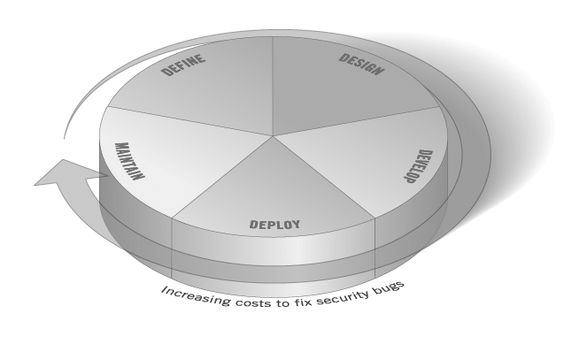

Placeholder for SDLC Diagram

- Define - Policy, Standards and Procedures
Design - Design and Architecture
- Develop - Code
- Deploy – Implementation
- Maintain – All of the Above

Feedback and Comments
As with all OWASP projects we welcome your comments and feedback. We especially like to know that our work is being used and that it is effective and accurate. We plan to update and revise this document as needed.

You can contact the project team via the following methods;

Project Leader – Mark Curphey mark@curphey.com
Project Team – testing@owasp.org

Please mark your email with the Subject [OWASP Testing]

Chapter 2 – Principles of Testing

There is No Silver Bullet
Whilst its is tempting to think that a security scanner or application firewall will provide either a multitude of defenses or identify a multitude of problems, in reality there are no silver bullets to the problem of insecure software. Application security assessment software is generally immature and effective to test for or protect against only a small subsection of the problems the average application is likely to be at risk from. The age old adage that if it sounds too good to be true, it probably is holds true. Despite the marketing (which sometimes borders on snake oil) insecure software is as much about bad process as it is about bad technology and so it is essential to test the software throughout the software development life cycle in order to improve the situation.

Think Strategically, Not Tactically
Over the last few years security professionals have come to realize the fallacy of the patch and penetrate model that was pervasive in information security in the nineties. Software security is even more prone to failing under this model as unlike a Microsoft Windows administration team who can wait for vendor to release a patch, it is the developers who must create and test their own security patches. Throughout this document we reference the economics of building insecure software. By only conducting tactical penetration tests companies will find themselves in a cyclical model of spirally costs. It is essential to build security into the software development life cycle by developing standards, policies and guidelines which fit and work with the development methodology. Testing should be conducted at ALL phases of the SDLC. Threat modeling and other techniques should be used to help assign appropriate resources to those parts of a system that are most at risk. Security testing should be incorporated as an integral part of software testing.

The SDLC is King

Importance of blending with existing process
Full lifecycle
Catch bugs early
Understood by developers

Test Early and Test Often

- Substantial cost savings
- Test in development, QA, and production environments
(limited access prior to "going live")
- Work closely with responsible teams during the development
process to remediate or mitigate issues
- Establish a Due Care process based on risk level
- Educate developers about Web App sec issues

Understand the Scope

- Governing regulatory requirements
- Level of security required i.e. sensitive, Top Secret
- Timeframe (schedule)
- Interviews with developers, involved teams, and project leads
- Complexity of project
- Approval requirements
- Proof of concept (yes or no)
- Cost limitations (time to market)
- Classification of data e.g. GLBA, Cardholder, CA SB1386, etc.

Mindset

- Think like a hacker or cracker
- Customize your approach and or methodology
- Think outside of the box
- Try the unexpected; be creative

Know Thy Target

- User & Administrative documentation
- Architectural diagrams and data flow charts
- Technical system and application documentation
- Disallowed functionality/intentions
- Understand the threat and known exploits
- Understand regulatory requirements
- Thoroughly research application & systems being used
- Conduct passive & active recon

Use the Right Tools

- Use a combination automated and manual techniques
- Frequently update tool & technique inventory
- Become intimately familiar with technology being used and
known/probable security issues
- Shouldn't bring a knife to a gun fight

The Devil is in the Details

- Weed out false positives
- Thoroughly explore logic in an attempt to expose flaws
- Look for the less obvious security issues
- Become intimate with the application
- Evaluate every aspect

Use The Source Code When Possible

- Allows for the identification of security holes and
vulnerabilities often missed by black or gray box testing
- Reinforce secure coding practices
- Should include User Interface development

Develop Metrics

Chapter 3 – The Scope of Testing

Threat Modeling
Threat modeling has become a popular technique that helps system designers think about the security threats that their systems will face and allows them to develop mitigation strategies. Threat modeling helps people focus their inevitably limited resources and attention on the parts of the system that most require it thus taking a pragmatic approach.

Threat models should be created as early as possible in the software development lifecycle and can evolve as the application evolves and development progresses.

Despite its name that has now become endemic in the industry thanks to the Writing Secure Code book (Mike Howard and David LeBlanc); threat modeling is really traditional Risk Assessment for applications. Threat modeling is an essential practice and we recommend all applications have a threat model developed and documented.

To develop a threat model we recommend taking a simple approach that follows the NIST 800-30 standard for risk assessment. This involves defining the assets, understanding the vulnerabilities (technical, operational and management) and examining the threats.

- Decompose Application
- Define Assets
- Explore Potential Vulnerabilities
- Explore Potential Threats
- Create Mitigation Strategies

Decomposing the Application
Unless you understand how the application works it is impossible to understand all of the potential ways an attacker is going to break it. We therefore recommend you decompose the application into its core components in order to understand exactly how it works.

In our experience the Unified Modeling Language or UML can be an exceptionally useful tool to help visually model applications. UML was developed as a modeling language to create unambiguous models of software. It has developed into a universally adopted way to model various things from business process to workflow.

UML defines various ways to develop models and whilst all maybe useful, the important most commonly used models are use cases, sequence diagrams and component models. Detailed models may involve state transition and other models such as collaboration models for authorization systems.

Your models will develop and evolve as you begin to understand more about your application and you should not become fixated on creating perfectly accurate models. As you develop the models you should list issues as they become obvious for examination in the vulnerabilities ad threat phases.

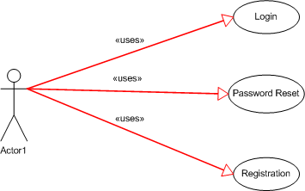

Figure X

The figure X above is a UML Use Case Diagram. This diagram would typically be supported by textual descriptions of the Use Cases that explain exactly how each user interaction occurs. Use cases are very important to understand which functions are available to the user.

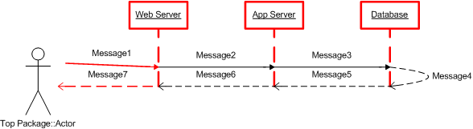

Figure X

The figure X is a UML sequence diagram. Sequence diagrams trace the data flow between system components. They are particularly useful for examining component to component communications and understanding the message transformations that occur at each component. The above diagram could be a simple model of a user logging in, where the user passes a username and password to the web server that forwards them to the application server. The application server then processes the variables and passes them to the database query that compares the username and password to that stored in the database and message 5 returns a Boolean answer. Message 6 generates a cookie which is passed to the browser in message 7.

As you can see sequence diagrams are extremely useful to question things like transport security for message 2? Is message 3 created with a prepared statement?

Defining Assets
When you have successfully decomposed the application you should define the assets. Assets can be both physical and virtual. As an example a physical asset maybe a web server and a virtual asset maybe sets of data. Assets are the things that an attacker wants to either steal or change. These are the things that your application should be protecting. Physical assets are usually fairly easy to define and will likely include, web servers, dynamic page code, source code, application servers, database servers, configuration files etc. Virtual assets are more difficult to define but typically focus on data. It is useful to break data down into types of data and data sets that you may feel have different requirements. An example is the password table in a database should be considered differently from say the page color preferences table.

You should create a matrix / list of assets that have been discovered.

Explore Potential Vulnerabilities
Vulnerabilities can be organized into three primary groups;
- Technical
- Management
- Operational

Whilst other areas of this testing framework will create tests specifically aimed at extracting these vulnerabilities (particularly technical) it is useful to explore them during the development of your threat model. Many

Explore Potential Threats

Create Mitigation Strategies

Chapter 4 – Testing Techniques Explained

Overview of some terms and terminology etc

Process Reviews

Policy and Standards Reviews

Advantages and Disadvantages

Source Code Review
SCR is one of the most efficient techniques to assess code for vulnerabilities, because it goes to the source of “trouble”. Every day companies around the world are making security code review important part of their software development processes and QA processes.
Security Code Review Is the process of “manually” checking your web application source code for security issues, it can be performed by programmer (self-testing) or a third party (co-worker, dedicated team or contractor). SCR is very versatile and can be performed at several stages in SDLC right after coding has begun. However as mentioned in Ten Principles for Security Testing, the earlier the better.

Advantages and Disadvantages
Advantage | Description
Versatile | Can be applies at any stage of SDLC after coding begun
Deep checking | There is no deeper checking than White box checking, neither gray nor black
(More elements go here)
Disadvantage | Description
Expensive | Many human resources are used, since is a mostly a “manual” testing. There is no ultimate tool for SCR.
Time Consuming
(More elements go here)

- First things first.
No matter if you are performing a self-testing or a third party testing, you as tester will need to gather at least the following documentation.
  - Enterprise Secure Programming Policy. Security programming practices that should be followed by SW architects, analysts and programmers when building software for that company.
  - Security Community Best Practices. Best practices provided by the software community for the actions performed in the application.
  - Application-wide Source Code (Programs source, pages, Configuration files, SQL stored procedures, etc.) access to source code in whole application.
- Third Party Testing.
For testing performed to or from a third party always it is recommendable to have or provide documentation that clearly explains the application components integration for an easier and faster understanding of application it self and application design issues related to components interaction. Here are some recommendations:
  - UML Use Cases. (or related) If they exist and are updated used to be the mayor information source.
  - Data Dictionary. Useful for input validation checks.
  - Site tree. Can be used as a second alternative to use cases.
- Web Application sensitive points.
This guide section is focused in the main sensitive points though a web application.
  - Authentication. The first point of contact in a corporate web application or at least med sized is the authentication facility; a secure channel as well as secure storage for credentials and a reliable user identity validation method. In login page and authentication components is the start line for SCR testing.
  - Authorization. It is not enough to know if a user is who he/she says he/she is (Authentication), appropriate access control to resources and information is a must in web applications as well. Initially selecting an appropriate authorization method selection according to application requirements and the correct application of it are our best allies against a wide range of security issues. For example in role-based authentication, It is hardly (not to say impossible) to have a “non authorizable” resource, therefore every access request to every resource should be authorized.
  - Input Validation. All information out of our application can be tainted, even if stored in same server, moreover if it is sent from other system, making our application to behave different from expected (a bug), this is especially risky if that information is sensitive or gets in touch with a system or sub-system that handles sensitive information (e.g. a Database or OS). All information received must be validated to be what we expected to get. Inputs coming from sources like configuration files, user input, other systems input, etc.
  - Sensitive Information Leakage (Privacy/Confidentiality/Export Control). All kind of information considered sensitive should not be showed to user without taking in account how appropriate is to show it, it is usually a big mistake to display programmers names, error dumps, etc. to users, but even “valid” information for some cannot be valid for others this is the case of private or confidential information and export control info as well.
  - Application’s Fall and Recovery. It is natural to have a distributed web application, especially in OOP environments, in addition to the fact that a “unknown” user is using it, make our web application behavior some kind unpredictable. This is why is so important to keep application modules atomic and with capacity to fall gracefully by handling errors and keeping all resources used intact or at least available for future use.
  - Session Management. Used to keep tracking of individual users activity and store for sensitive information in a safer way, sessions are common facilities now days. In “home made” session handling session identification randomness, expiration implementation and use of cryptography to keep information safe are some of the details to take in account to implement a strong session Management system.
  - Bad cryptography. Cryptography is one of the more important tools in our applications to keep information safe. Most of the times “home made” cryptography leads to insecure storage and insecure data transmission issues, because programmers are not security professionals, thus cryptography methods are rudimentary. Use of a suitable well-defined standard cryptography method is always recommendable.
- Security Issues Tracking.
(Empty by now)
- Use what you have learned.
SCR process in not only aimed to find & fix, but to better security in you company, if you do not take actions further than fix the tested application, then “history” will repeat for others in your company, information gathered from SCR processes is precious and is very useful to develop training plans, contingency plans, best practices and creation or improvement of secure programming policies. Learn from your mistakes or get ready to repeat your bad security history.

Penetration Testing

Advantages and Disadvantages

Attack Trees

Operational Management Reviews

Chapter 5 - Which Techniques Should You Use

The Need for A Balanced Approach

A Note about Web Application Scanners

Example 1 – Magic Parameters
Imagine a simple web application that accepted a name value pair of magic and then the value. For simplicity the GET request may be;

http://www.host/application.aspx?magic=value

To further simplify the example the values in this case may only be ASCII a-z (upper or lowercase) and integers 0-9. The designers of this application created a administrative backdoor during testing but obfuscated it to prevent the casual observer. By submitting the value sf8g7sfjdsurtsdieerwqredsgnfg8d (30 characters) then the user will be logged in and presented with an administrative screen with total control of the entire application.
The HTTP request now looks like;

http://www.host/application.aspx?magic= sf8g7sfjdsurtsdieerwqredsgnfg8d.
Given that all of the other parameters were simple two and three characters (i.e. it was not possible so start guessing combinations at say 28 characters, a web application scanner will need to brute force (guess) the entire key space of 30 characters. That is X billion HTTP requests! That’s an electron in a digital haystack!

The simplified pseudo code for this may have looked like the following;

INSERT CODE SAMPLE HERE

See how quick it was to find that bug in code!

Example 2 – Bad Cryptography
Cryptography is widely used in web applications. Imagine a developer decided to write his own simple cryptography algorithm to sign in a user from site A to site B automatically. In his wisdom he decides that if a user is logged into site A then he will generate a key using an MD5 hash function that comprises of

Hash { username : date }

When he passes a user to site B he will send the key on the query string to site B in an HTTP re-direct. Site B independently computes the hash and compares it to the hash passed on the request. If they match site B signs the user in as the user they claim to be.
Clearly as we explain the scheme you can work out the inadequacies and visualize how anyone that works it out (or is told it, or downloads it from bugtraq) can create there own log ins as any user. Manual inspection (interview) would have uncovered this security issue quickly; as would inspection of the code.

A black-box web application scanner would have seen a 128 bit hash that changed with any user and by the nature of hash functions did not change in any predicable way.

Chapter 6 – The OWASP Testing Framework Explained

Overview
This section describes a typical testing framework that can be developed in an organization. It can be seen as a reference framework which comprises of techniques and tasks that are appropriate at various phases of the software development life cycle. Companies and project teams can use this model to develop their own testing framework and to scope testing services from vendors. This framework should not be seen as prescriptive but as a flexible suggestive approach that can be extended and molded to fit an organizations development process and culture.

It is important to understand the reason why building an end to end testing framework is crucial to assessing and improving your software security. Studies such as the <Insert IBM survey > have shown that the economical justification for designing secure software is significant. In that survey the authors conclude that if a project can catch a security but at the design phase of development, the cost to address it will be 100 times less than if that bug had percolated into production. With economics like this it is little wonder why people must turn away from black box penetration testing that by its nature can only be performed on applications that have already been developed and concentrate on the early cycles of application development such as the definition, design and development. Many security practitioners still see security testing in the realm of penetration testing. As shown in the Testing Techniques Chapter and by the framework, whilst penetration testing has a place to play, it is generally inefficient at finding bugs and should only be considered as an implementation technique or to raise awareness of production issues. To improve the security of applications you have to improve the security quality of the software itself. That means testing the security at the define, design, develop, deploy and maintenance stages and not relying in a costly strategy of waiting until code is built.

As discussed in the introduction of this document, there are many development methodologies such as the Rational Unified Process, eXtreme and Agile development and traditional waterfall methodologies. Our intent with this Guide is neither to suggest a particular development methodology nor provide specific guidance that adheres to any one in particular. Instead we are presenting a generic development model and the reader should follow it as appropriate to his / her own process.

To recap that process is <insert circular graphic here>

Define
Design
Develop
Deploy
Maintain

Phase 1 - Before Development Begins

1A – SDLC Process Review

1B – Policies and Standards Review

1C – Develop Measurement and Metrics Criteria (Ensure Traceability)

Phase 2 – During Definition and Design

2A – Security Requirements Review

2B – Design and Architecture Review

2C – Create / Review Threat Models

2D – Create / Review UML Models

2E – Create / Review Attack Trees

Phase 3 – During Development

3A – Code Reviews

3B - Code Walkthroughs

Phase 4 – During Deployment

4D – Penetration Testing

4E – Configuration Management Testing

Phase 5 – Maintenance and Operations

5A – Conduct Operational Management Reviews

5B – Conduct Periodic Health Checks

5C – Ensure Change Verification

A Typical SDLC Testing Workflow

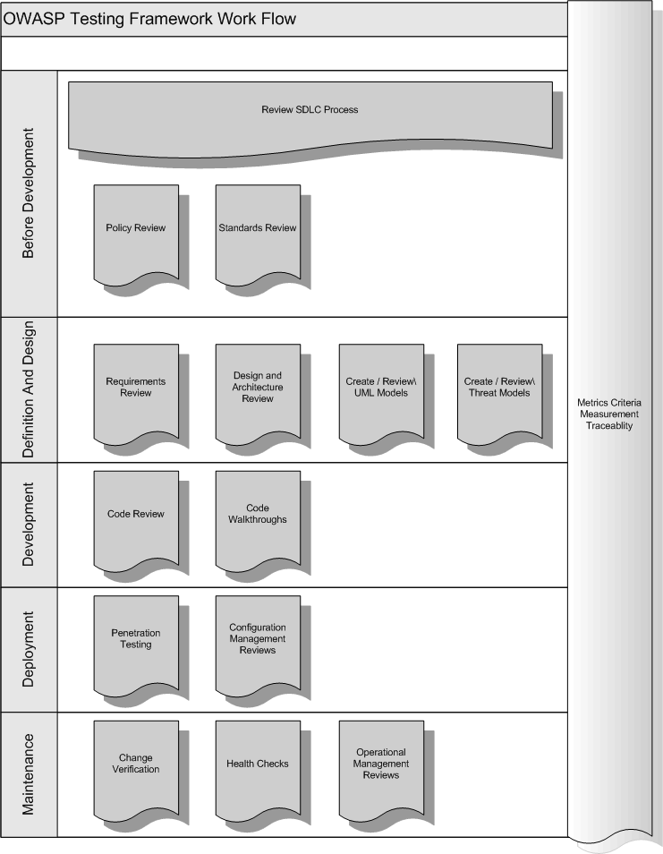
Appendix A – Testing Tools

Source Code Analyzers

Open Source / Freeware
RATS
http://www.securesoftware.com

FlawFinder
http://www.dwheeler.com/flawfinder

Microsoft’s FXCop
http://www.gotdotnet.com/team/fxcop

Commercial
Prexis / Insight
http://www.ouncelabs.com

GrammaTech
http://www.grammatech.com

ParaSoft
http://www.parasoft.com

Black Box Scanners

Open Source
SPIKE
http://www.immunitysec.com

WebScarab
http://www.owasp.org

Paros
http://www.proofsecure.com

Commercial
@Stake’s WebProxy
http://www.atstake.com

WebInspect
http://www.spidynamics.com

AppScan
http://www.sanctum.com

ScanDo
http://www.kavado.com

Other Tools

Runtime Analysis
Rational PurifyPlus
http://www-306.ibm.com/software/awdtools

Binary Analysis
BugScam
http://sourceforge.net/projects/bugscam

BugScan
http://www.hbgary.com

Requirements Management
Rational Requisite Pro
http://www-306.ibm.com/software/awdtools/reqpro

Appendix B – Suggested Further Reading

Whitepapers

Security in the SDLC (NIST)
http://www.iwar.org.uk/comsec/resources/security-life-cycle/sp800-64.pdf
(Note: Need to change to official link)

The OWASP Guide to Building Secure Web Applications (Version 1.0)
http://www.owasp.org/documentation/guide

The OWASP Guide to Building Secure Web Applications (Working Draft Version 2.0)
http://www.owasp.org/documentation/guide/current

The Economic Impacts of Inadequate Infrastructure for Software Testing
http://www.nist.gov/director/prog-ofc/report02-3.pdf

Threats and Countermeasures – Improving Web Application Security
http://msdn.microsoft.com/library/default.asp?url=/library/en-us/dnnetsec/html/threatcounter.asp

IBM System Sciences Report

The Security of Applications: Not All Are Created Equal
http://www.atstake.com/research/reports/acrobat/atstake_app_unequal.pdf

The Security of Applications Reloaded
http://www.atstake.com/research/reports/acrobat/atstake_app_reloaded.pdf

Use Cases: Just the FAQs and Answers
http://www-106.ibm.com/developerworks/rational/library/content/RationalEdge/jan03/UseCaseFAQS_TheRationalEdge_Jan2003.pdf

Books
Secure Coding, by Mark Graff and Ken Van Wyk (2003)
http://www.securecoding.org

Building Secure Software, by Gary McGraw and John Viega (2002)
http://www.buildingsecuresoftware.com

Writing Secure Code, by Mike Howard and David LeBlanc (2003)
http://www.microsoft.com/mspress/books/5957.asp

Innocent Code, by Sverre Huseby (2004)
http://innocentcode.thathost.com

Exploiting Software, by Gary McGraw and Greg Hoglund (2004)
http://www.exploitingsoftware.com

Mastering the Requirements Process, by Robertson and Robertson
http://www.systemsguild.com/GuildSite/Robs/RMPBookPage.html

The Unified Modeling Language – A User Guide
http://www.awprofessional.com/catalog/product.asp?product_id=%7B9A2EC551-6B8D-4EBC-A67E-84B883C6119F%7D

Hacking Web Applications Exposed
http://www.amazon.com/exec/obidos/tg/detail/-/007222438X/002-9563622-6700041?v=glance

Articles
Web Application Security is Not an Oxy-Moron, by Mark Curphey
http://www.sbq.com/sbq/app_security/index.html#sbq_app_web_security

Useful Web Sites
OWASP – http://www.owasp.org

Secure Coding – http://www.securecoding.org

Sardonix – http://www.sardonix.org

OASIS WAS XML - http://www.oasis-open.org/committees/tc_home.php?wg_abbrev=was

Appendix C – Author Credits
Lead Author – Mark Curphey (mark@curphey.com)
<authors – please mail me with a pointer to the section you wrote

Additional Contributions and Commentary

The Economic Impacts of Inadequate Infrastructure for Software Testing

