Introduction

Overview
The WebGoat application testing framework is designed to illustrate typical security flaws within web-applications. It is intended to teach a structured approach to testing for, and exploiting, such vulnerabilities within the context of an Application Security Assessment.
A full Application Security Assessment methodology is a superset of the issues demonstrated within the WebGoat. It may include a formal design and code review, for example. The WebGoat tutorials aim to give practical training and examples relating to the Implementation Review phase of the OWASP Web Application Security Testing Methodology.
The WebGoat framework represents a typical application security assessment. The assessor is given the same information and rights as a typical customer or client of an on-line application.
- It is a web based application.
- The attack simulations are remote – e.g. all of the described techniques may be performed from any connected location.
- Whilst credentials and operational information is provided, the testing is ostensibly black-box, as source-code is not supplied
Of course, the teaching aspect of WebGoat means that certain information will be revealed that would not typically be available in order to guide the tester through an assessment process.

Objectives
Having followed the testing techniques within WebGoat, a tester should be able to:
- Understand the high-level interaction processes within a web-application,
- Determine information within client visible data which could be useful in an attack,
- Identify and understand data and user interactions which may expose the application to attack,
- Perform tests against those interactions to expose flaws in their operation,
- Execute attacks against the application to demonstrate and exploit vulnerabilities.

Tools required
There are a number of tools emerging to aid the wily application security assessor. By far the most relevant to this type of application security assessment are local proxies and web/application spiders.

Application Assessment Proxy
A normal web-proxy typically receives, processes and forwards HTTP and HTTPS traffic between the client and server. This is normally to provide a single point through which all web traffic passes – for example to monitor usage, improve performance through caching or apply security policies.
An application proxy tool is designed to intercept all http and https communication between the local client browser and the server-side. It acts as a man-in-the-middle where all interaction may be monitored, reviewed and (importantly) modified.
Through such a tool, the assessor can determine exactly what data is passed between the Client and Server. Furthermore, they may analyse and modify the data in order to test the impact on the application.
It is essential for many of the tests within WebGoat that an application assessment proxy, or software with equivalent functionality, be used.
The following are all recommended:
OpenProxy – http://www.owasp.org
Odysseus – http://www.wastelands.gen.nz/odysseus
Achilles – http://www.packetstormsecurity.com/filedesc/achilles-0-27.zip.html
@Stake WebProxy – http://www.atstake.com/research/tools/index.html

Application Spider
Spidering or crawling a site should identify and follow all of the intended pages and links within a web site & application, and optionally store a local copy.
The results can then be analysed to define a comprehensive list of target scripts, forms, pages and fields within the application for use in later testing.
Mirrored content can also be analysed for relevant information far more quickly than through a manual or ‘on the wire’ analysis.
The following are recommended:
HTTrack – www.httrack.com
Form Scalpel – http://www.ugc-labs.co.uk/tools/formscalpel/

Using WebGoat
Having identified the objectives and required tools, we may now get started with the WebGoat lessons.

Installation
WebGoat is a platform independent environment. It utilises Apache Tomcat and the JAVA development environment.
Installers are provided for Microsoft Windows and UN*X environments, together with notes for installation on other platforms.

Getting Started
In order the start using WebGoat, Tomcat must be launched using the startup script/bat in the Tomcat bin directory.
From a browser, the Tomcat server can be accessed on localhost port 8080, e.g. http://127.0.0.1:8080
WebGoat resides in the WebGoat directory, and the lessons can be found at: http://127.0.0.1:8080/WebGoat/attack
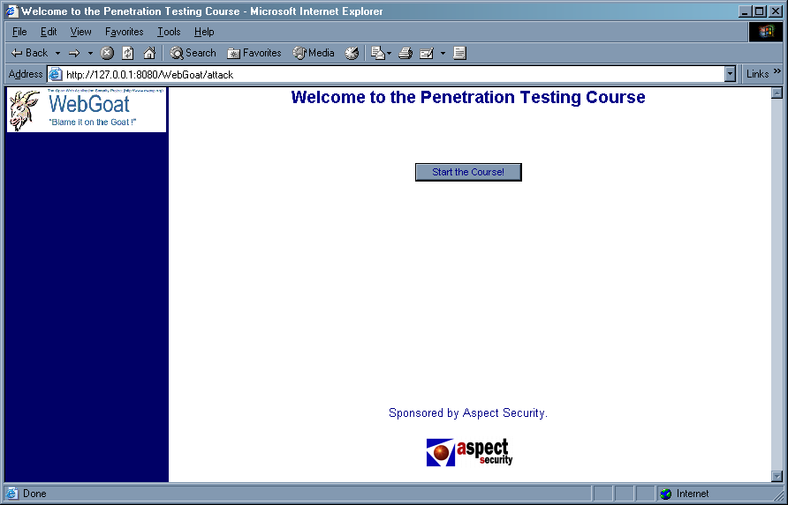

Lesson Plans
For each lesson within WebGoat, an overview and objectives are provided, and are accessed through the Show Lesson Plan button.
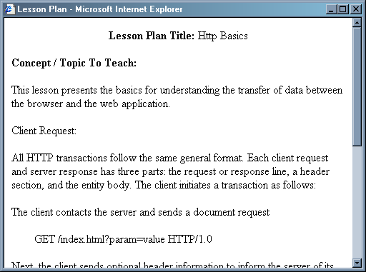
These lesson plans describe the operation of each aspect of the target application, the areas of interest relating to the security assessment and provide some indication of the type of attack that should be attempted.

Basic operation
At each stage of an application security assessment, it is important to understand the operation of the target.
This typically involves:
- Examining client side content, such as HTML and script,
- Analysing communications between the client and server,
- Reviewing cookies and other local data.
Under normal circumstances, HTML and other client-side data could be viewed using the browsers own features:
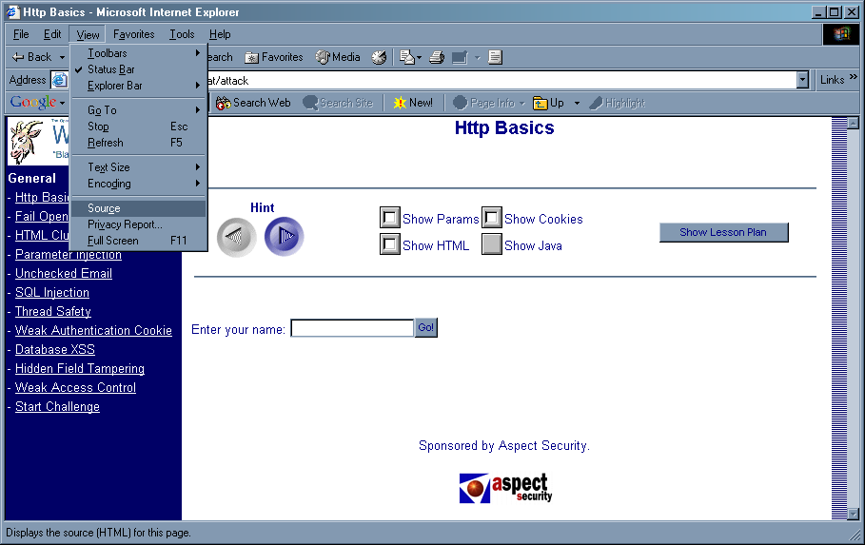
WebGoat provides a wrapper around the test application. This source would therefore also include the side and top bars, and other information which is not relevant to the lessons.
For this reason, the Show HTML tag has been provided. This shows only the content relating to the target application.
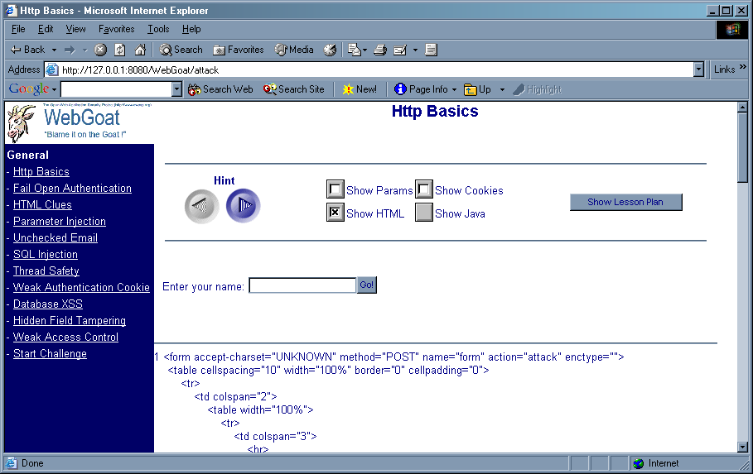
Similarly, form parameters and cookies can be displayed:
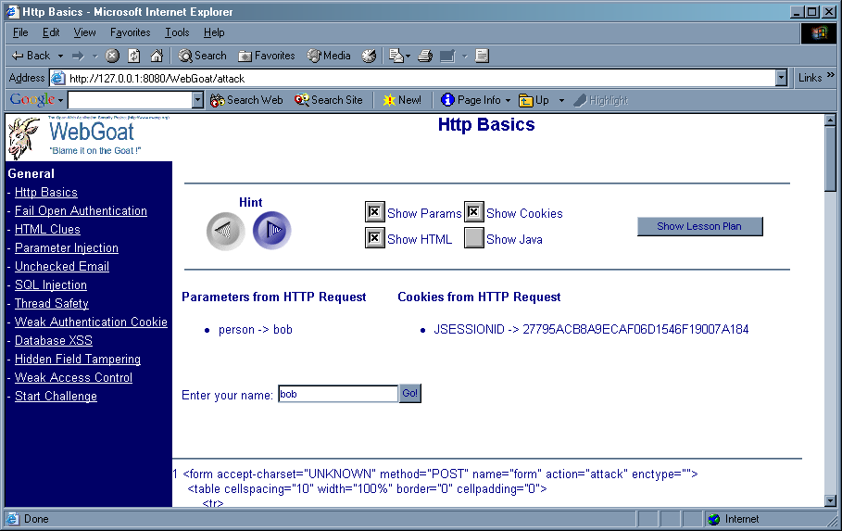
Furthermore, the luxury of being able to examine the server-side source has been provided in WebGoat, through the Show Java option.

Proxy Utilisation
The features within WebGoat for revealing the workings of the application also need to be supplemented with the assessor’s application assessment proxy of choice.
This enables further analysis and modification of the client-server interaction, and data in transit.
Use and configuration will be unique to each tool, but the basic concepts are as follows:
- The application assessment proxy must sit between the client browser and the remote server
- It should allow the display and modification of all HTTP data in transit
Typically, the tool will either plug directly into the browser, or listen on another local port. In the former case, a special URL may need to be entered in the browser; in the latter the browser will probably need to be configured to use the proxy as it would any other, e.g.
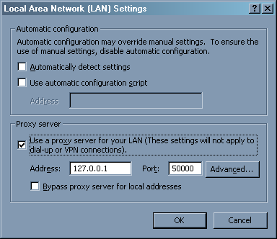
Now, when receiving or sending data from the client browser, we can intercept, analyse and modify it to test for security flaws in the target.
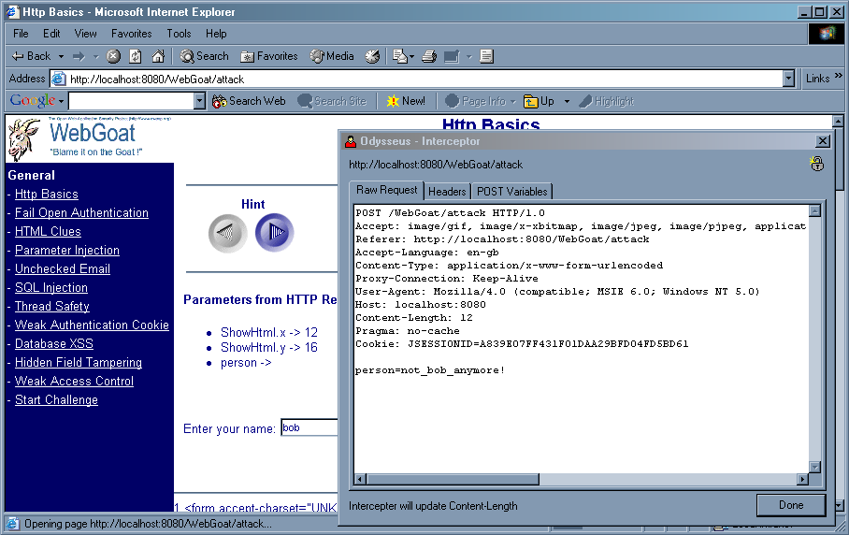
In using proxies of this kind, a number of capabilities become available to the assessor, including:
- All GET/POST parameters are available for modification, regardless of their hidden status,
- Cookies, both persistent and non-persistent may be modified when entering or leaving the browser,
- All client-side data validation can be bypassed, as the parameters can be modified immediately before being sent to the server,
- Information regarding the caching of data (e.g. Pragma: no-cache) is exposed for analysis,
- Server: and other headers are revealed, which may be useful for enumeration of the remote web- and application- server technologies.

Ready to Go!
All that remains is to start the WebGoat lessons.
One last point – if the problem or solution don’t reveal themselves to you, there are hints available to guide you through the lessons. Don’t be too eager, though – application testing is 10% technique and 90% lateral thinking. You can blame it on the Goat, but you can’t rely on him!

Although by virtue of the fact WebGoat is Open-Source, this is debateable! The Show Java option has therefore been provided.

