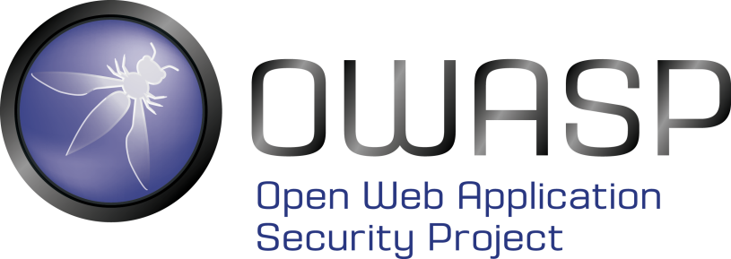

OWASP Boston Chapter Sponsorship Request

**Open Web Application Security Project (OWASP)** is an open-source application security project made up of corporations, educational organizations, and individuals from around the world. Providing free, vendor-neutral, practical, cost-effective application security guidelines and software, the organization is the defacto standards body for web application security. The Federal Trade Commission and the Payment Card Industry (PCI) Data Security Standard both refer to the OWASP Top Ten vulnerabilities in their security requirements documents. The organization has chapters around the world, and provides documents, software tools, videos, podcasts, wikis, blogs and software libraries that help in the development of secure applications.

The OWASP Foundation is a 501c3 Not-For-Profit entity.

The Boston OWASP chapter has been meeting for over 11 years. In that time we have:

* Held monthly meetings covering a wide range of application security technical and non-technical topics, now more than one a month in Boston, Cambridge and MetroWest locations in order to serve different geographic audiences
* Put on 5 local, **free** Boston Application Security Conferences (BASC), typically with 12 speakers, keynote and panel, CFT, resume and communication consulting and additional tools usage presentations.
* Sponsored the MIT MediaLab Internet of Things Security Hack-A-Thon
* Provided travel funds for Women In Computing to attend OWASP conferences
* Held a very low cost ($500) two day Web Application Penetration Testing class that was extremely well received by the 40 attendees, and had 16 people on the waiting list.
* Provided discount admission for numerous local security events (e.g. SOURCE Boston, Secure World)
* Assisted in a CyberMedrx security event

In addition, we plan to contribute time, knowledge and money to the following:

* Black Girls Code
* Student chapters at local universities
  + https://www.owasp.org/index.php/OWASP_Student_Chapters_Program
* Additional training sessions for the community
* BASC 2016
* Participation in Internet and Security of Things events
* Hosting Defend the Flag events
* OWASP Flagship, Lab and Incubator projects

However, to continue what we have been doing and embark on the additional efforts, we need sponsorship dollars. Any amount will help but we are asking for $500, $1000 or $2000 (or more) donations.

Sponsor Benefits

* Logo on both the chapter wiki and meetup sites.
* Logo on any additional chapter events such as BASC or training or Defend the Flag.
* Thanked in emails to both wiki (666 addresses) and Meetup (561 addresses) mailing lists, and to twitter followers (413).
* Acknowledged at chapter meetings.

While sponsorship does not guarantee a chapter meeting or conference presentation slot, we welcome technical presentation proposals from sponsors – we’re always looking for speakers.

We have the volunteers, commitment, time and knowledge; we just need your dollars for those resources to be put to use providing application security knowledge, experience, tools and money to a wide range of Boston area students, professionals, organizations and events.

You can go to <https://www.owasp.org/index.php/Boston> and click the ‘Donation’ button. Fill out the information in the forms, for Donation Type select ‘Chapter Supporter’, select the amount of your donation and enter ‘Boston’ for the chapter to support.

Thank You

Jim Weiler

[jim.weiler@owasp.org](mailto:jim.weiler@owasp.org)

OWAP Boston chapter founder and director

<https://www.owasp.org>

<https://www.owasp.org/index.php/Boston>

<http://www.meetup.com/owaspboston/>

