BI Odoo Dashboard Integration
by OdooTech

1. Required Cred (Login Details Username, Password and Client_id )

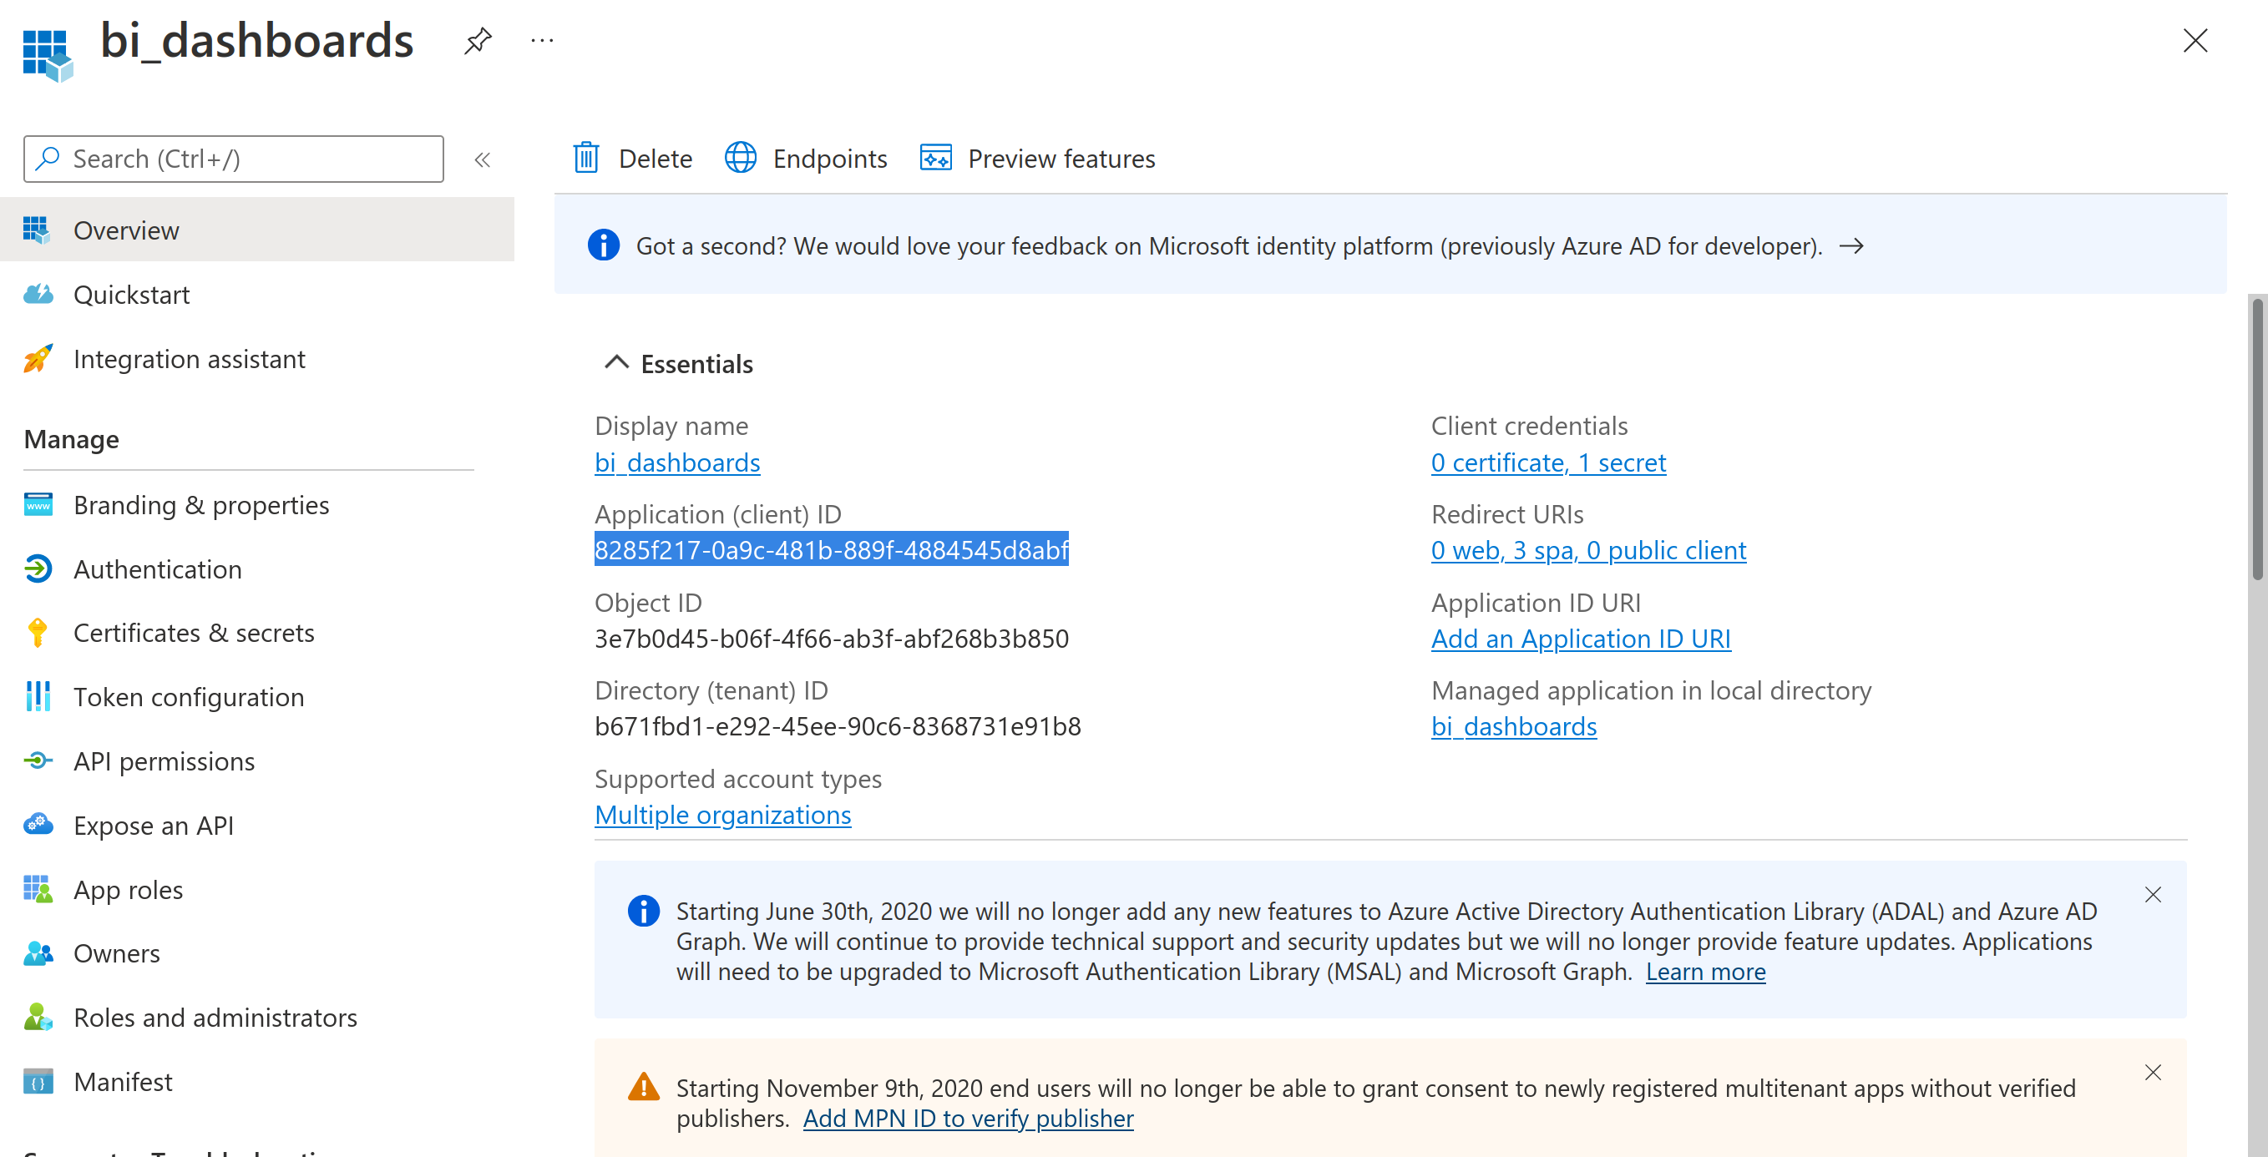

2. Ensure that you have register a app in azure app portal ( Power BI) with the above credentials full full API access ( If you don’t know about how to create register a application in azure just follow the given link below Everything is free on extra cost https://docs.microsoft.com/en-us/power-bi/developer/embedded/register-app?tabs=customers%2CAzure )
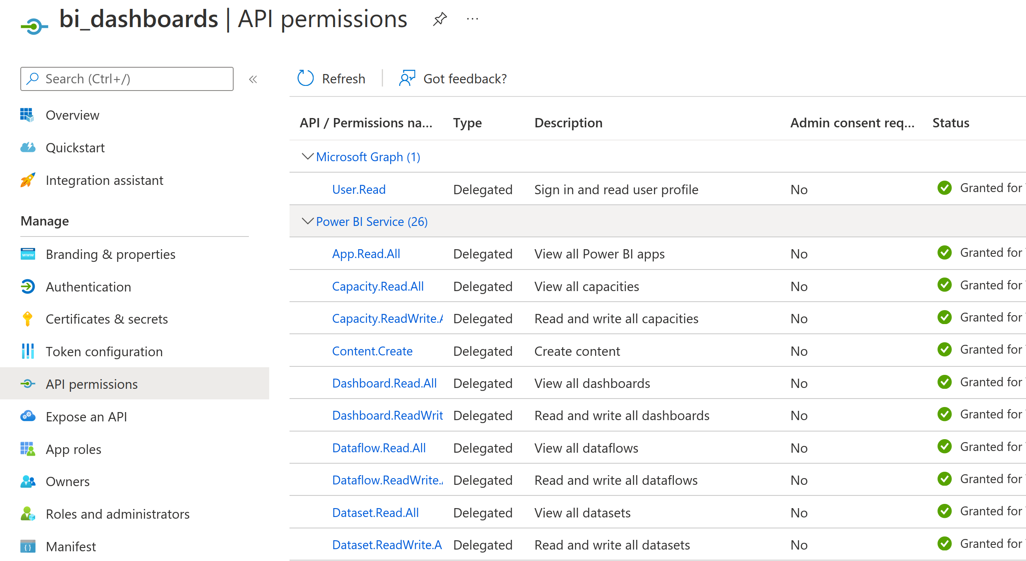

3. Install the Module ( Login as Admin in Odoo )

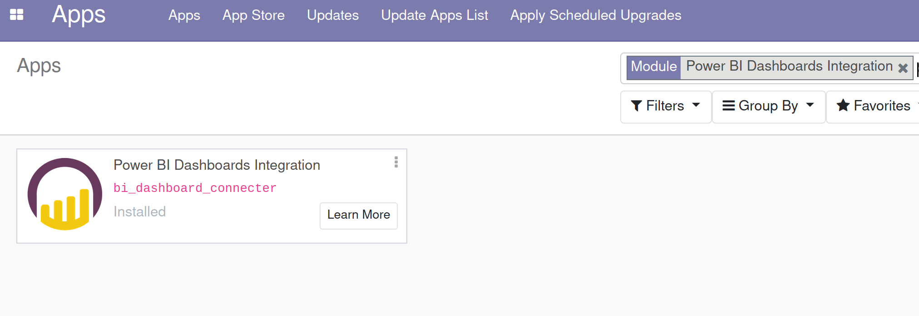

4. Open BI Dashboards from the Menu bar and go to settings in the app menu and click on create button

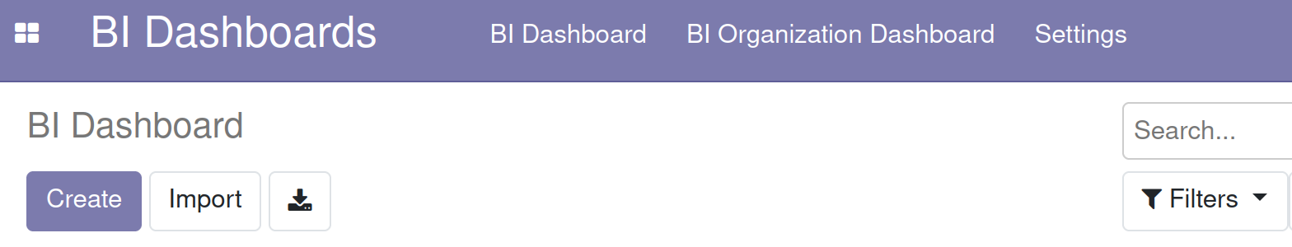

5. Fill the required fields with the correct information and click on save wait for 15 minutes to 3 hours to successfully activation ( One time activation )

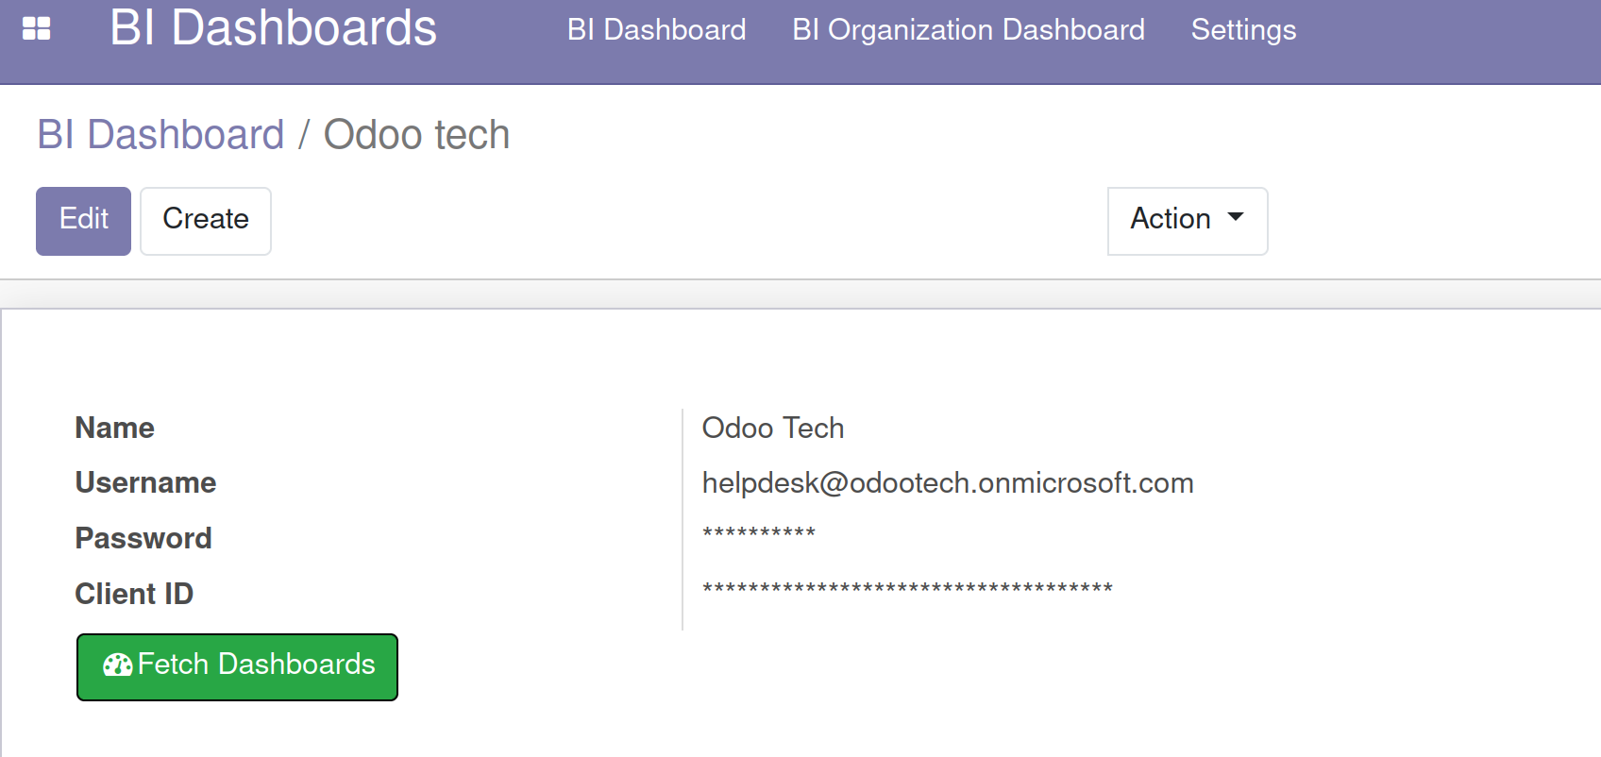

6. Click on Fetch Dashboard button to fetch all the power bi Dashboards

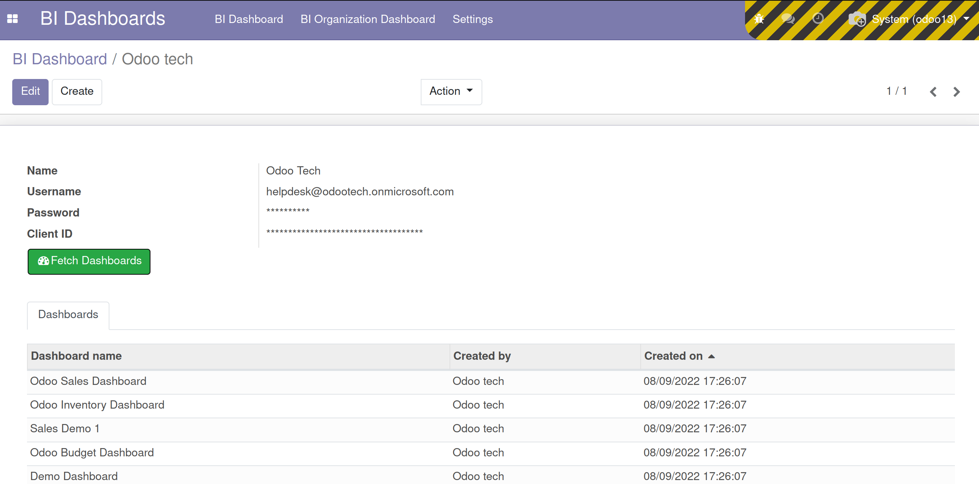
7. Now all your Odoo Employees see your Dashboard with out any Microsoft permission or and password ( This is handle by Microsoft internal security method )

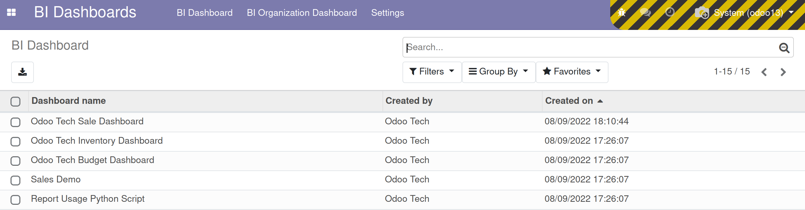

8. Open any Dashboard now you are able to see Power BI dashboard in Odoo ( You can see the dashboard inside Odoo and there is a button to see in full screen and delete the dashboard for their functionality ) You have all the power bi Features in Odoo itself

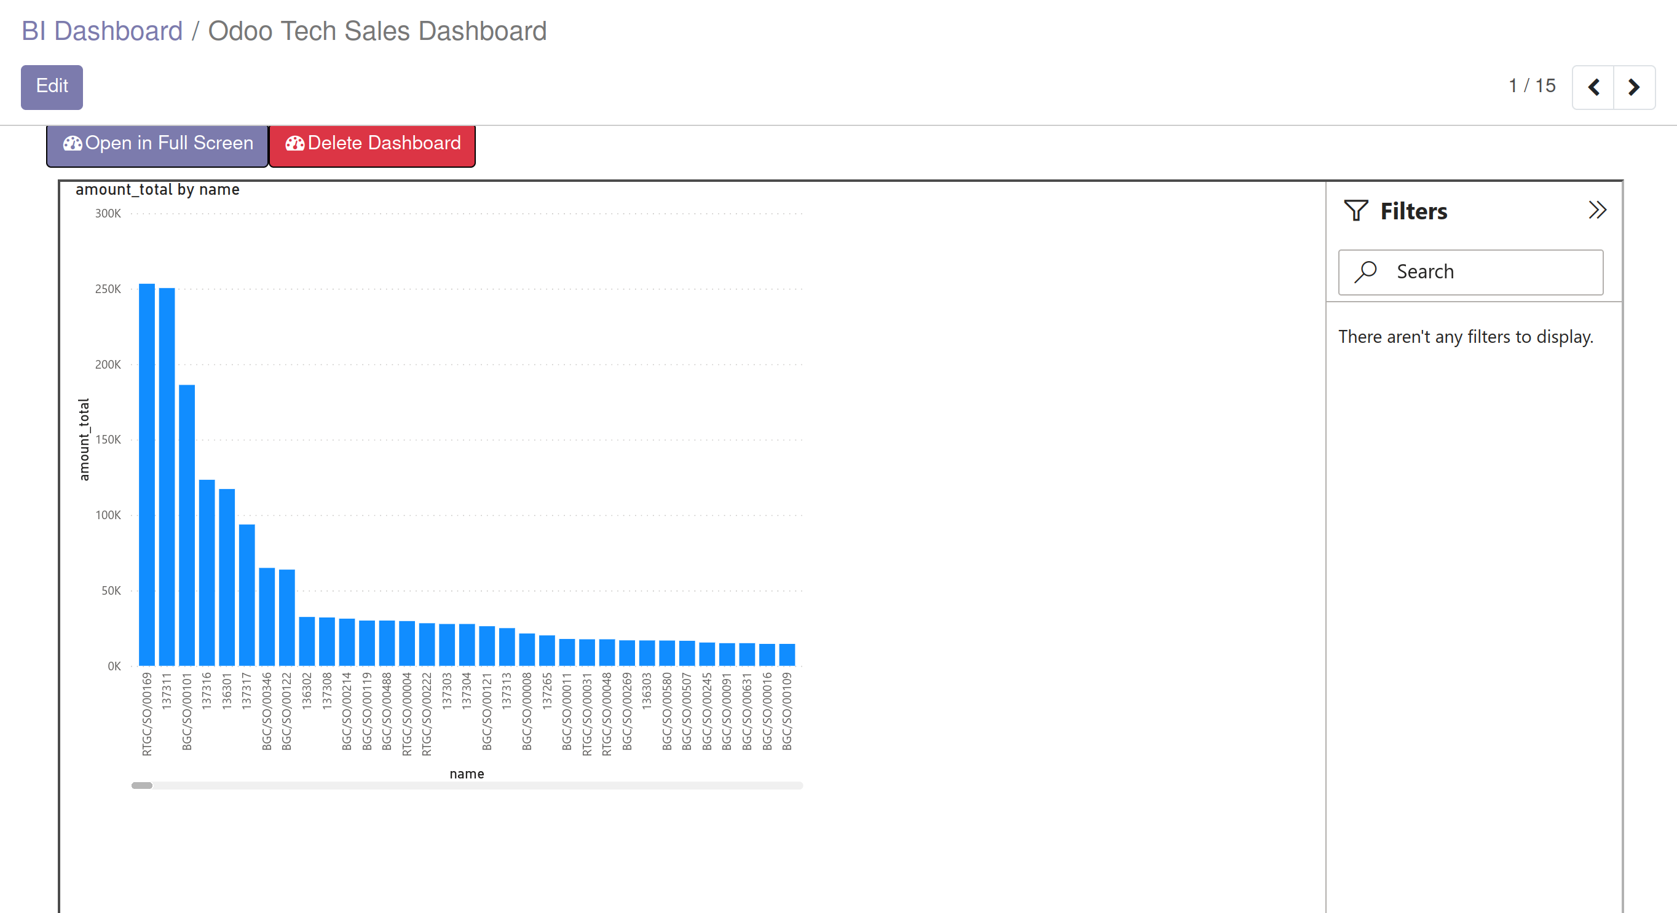
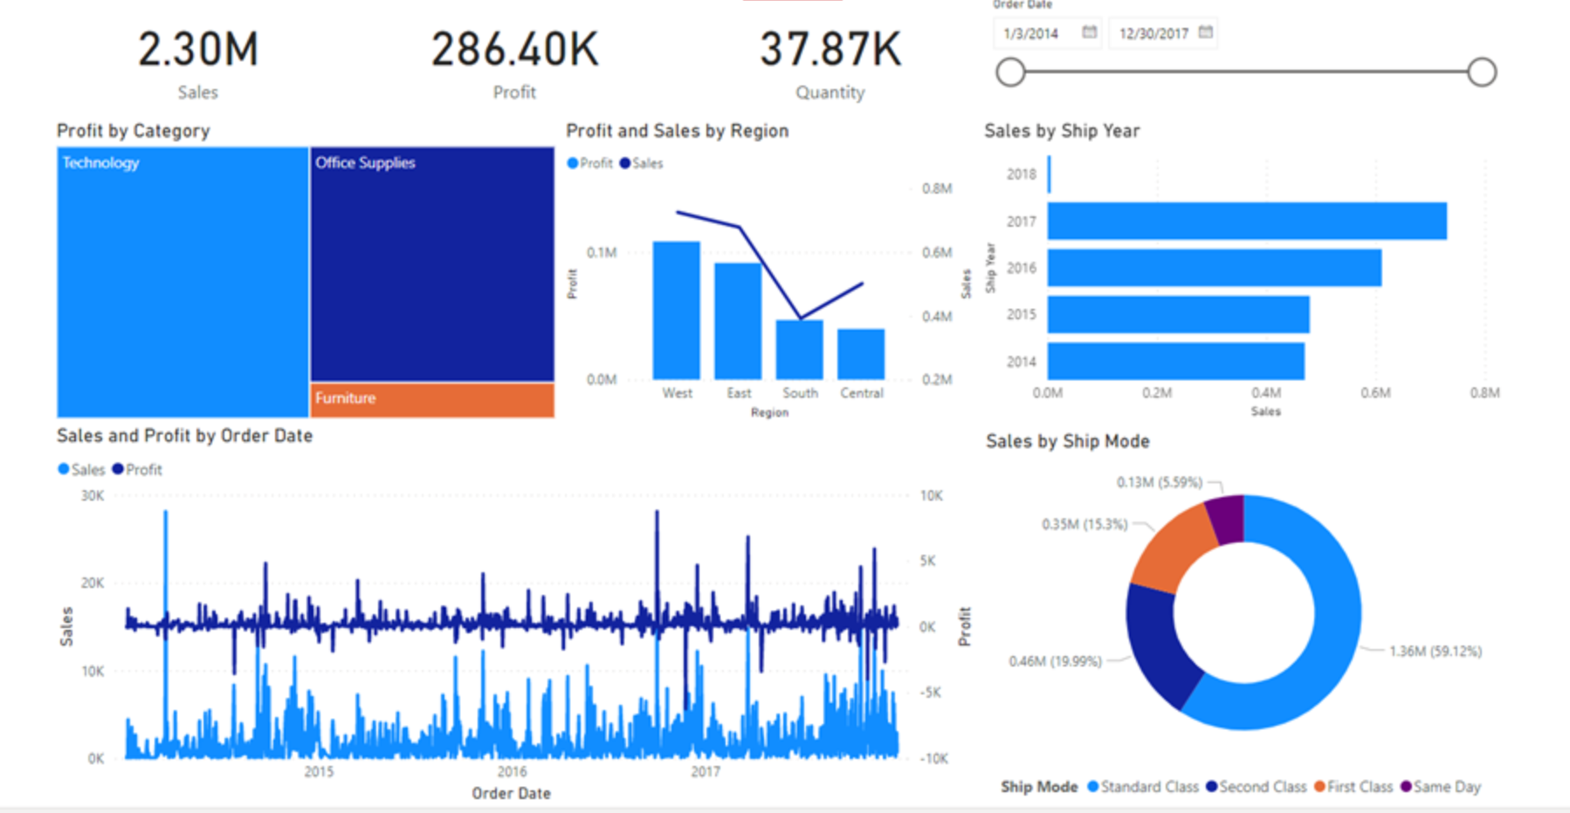

9. There is also a Organizational Dashboard Tab to create a organizational level dashboard which require Login with from every employee ( This require the additional permission for every user )

Thank You
OdooTech
www.odootech.in
(odootech.in@gmail.com)

