Based on Glaparex- https://drive.google.com/drive/folders/0B0eIHLJiYkqMZWJPSE10emdtak0

a)．Sample 1, Kappa_i=89.3 (1st short cut) Sample 2, Kappa_i= 109.36 at R1=0.85, R2=0.001 (2nd short cut). 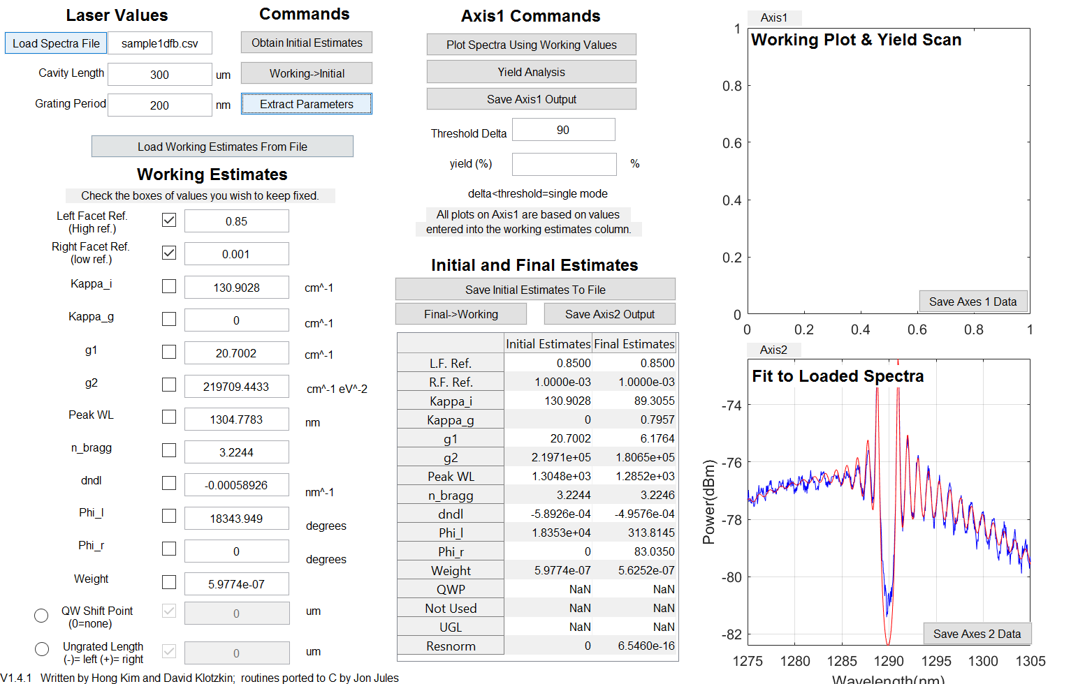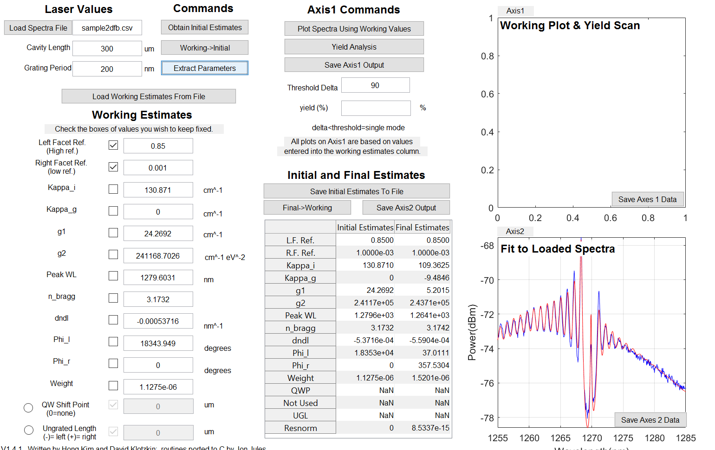

b) Sample 3, Resnorm=9.9353e-13 with Kappa_g=-0.2804

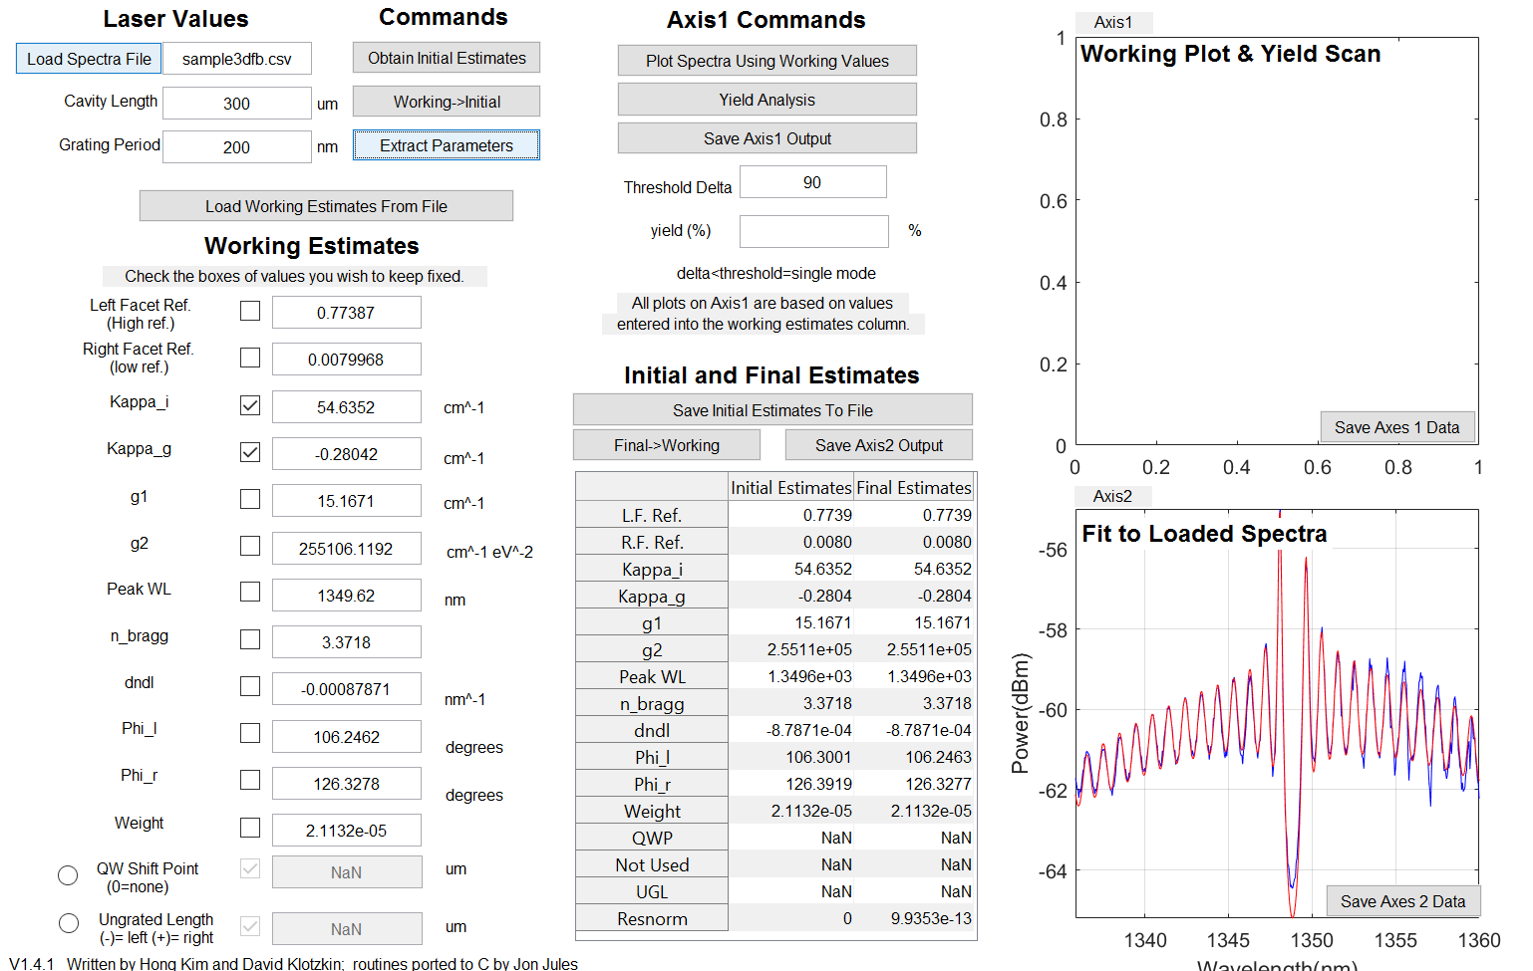

c) at R=0.001, yield=39%

at R=0.01, yield=27.1%

at R=0.1, yield=0%

the reflectivity at front facet should be closed to 1.

