Xin Wen- Distributed Feedback Laser modeling

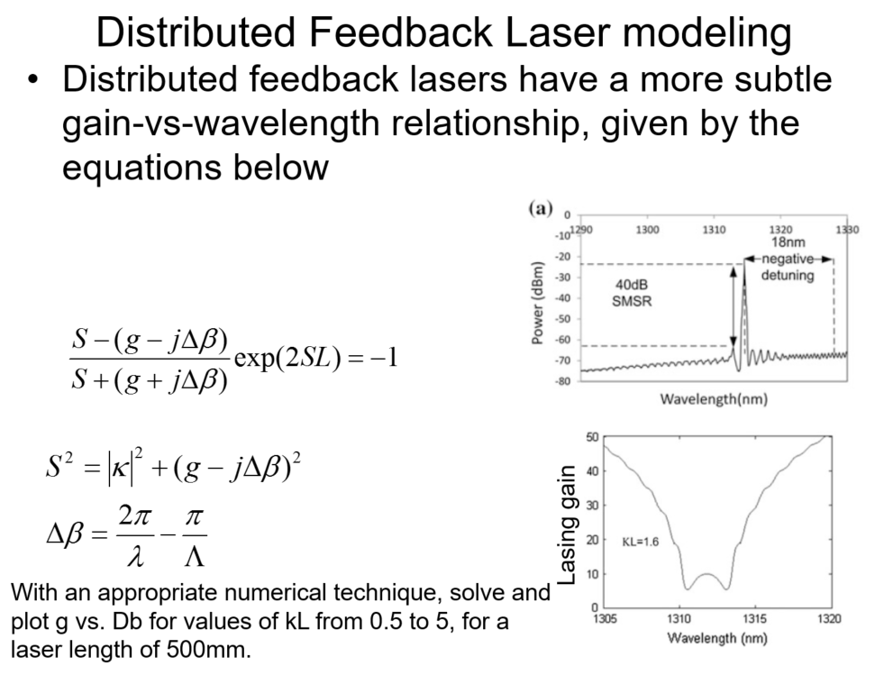

1. Set Bragg wavelength =1315nm, Cavity length=500μm, naverage=3, gain start with [4000, 10000]/m, decreases when increases. Pick =[0.5, 1.0, 2.0, 3.5, 5] to plot gain vs. . value is labeled on graph.
2. Set wavelength start from 1305nm, increase with step 0.01, end at 1325nm. Calculate the following parameters

(grating pitch)

1. Set gain g start with 10, increase with step 10, end at 4000. For **each g**, S can be calculated by S is complex propagation constant g is gain

.

Thus for a given g, S is a function of .

1. For each element in S(), calculate the equation

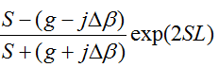

1. Based on the result in step 4, take =1 and gain= 6000/m for example. The points closed to 0 is the working wavelength for this gain.

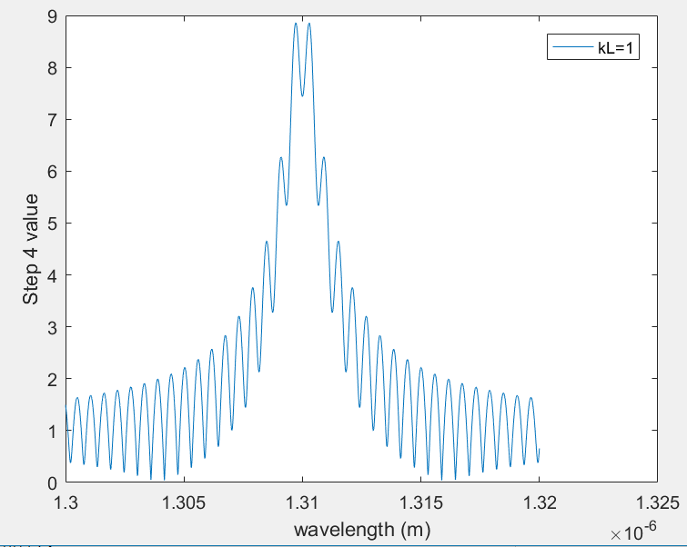

1. Plot gain vs.
2. Repeat 4-6 for different gain.
3. Repeat 2-7 for different

Note: The top graph for each has relative loose criteria (closed to 0 in step 5), and the bottom graph have relative strict criteria.

