Xin Wen

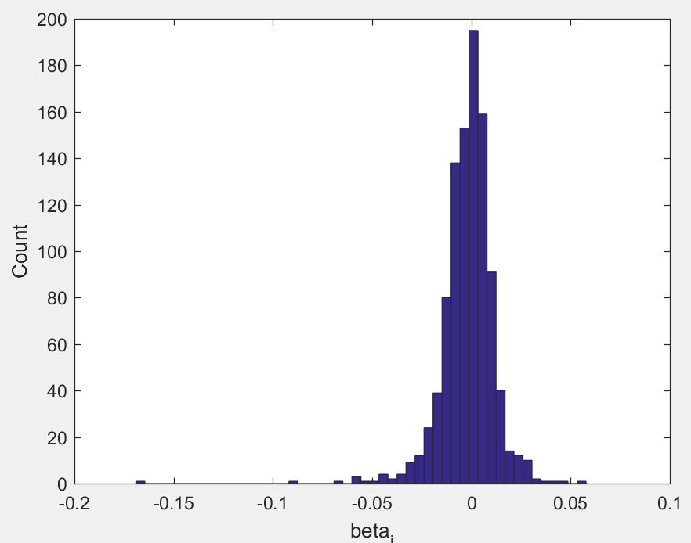

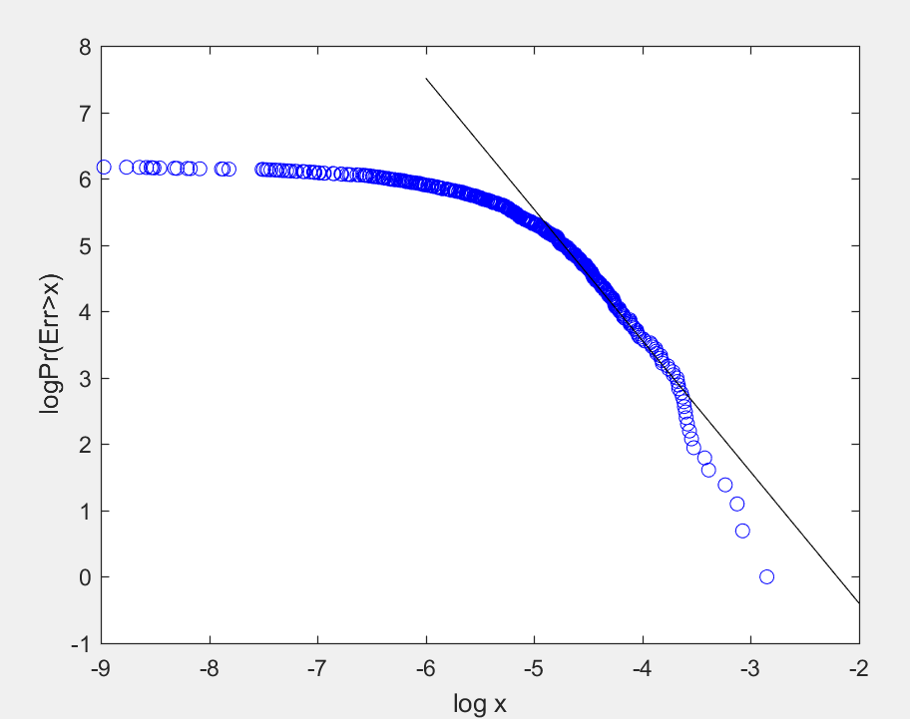

select point between -5.5 and -3.5, the fitted line has slope, which is $υ$ = -1.9783

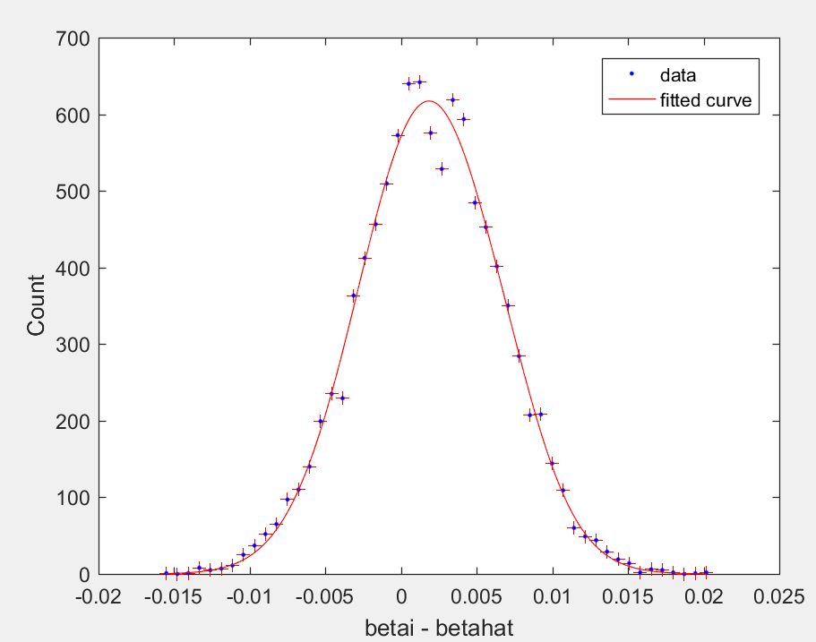

I choose image L1000724.jpg and random seed 1:1:10000 for testing. Bias = 0.001897, fitted gaussian mean = 0.001913, fitted gaussian variance = 4.15 * 10^-7

see code main_part1.m and main_part2.m