Xin Wen FLD

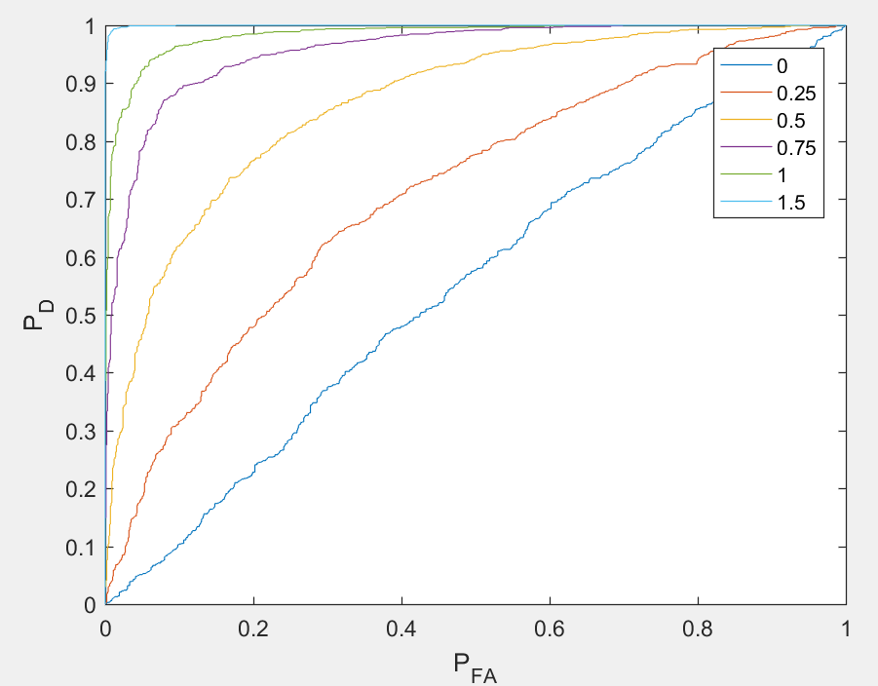

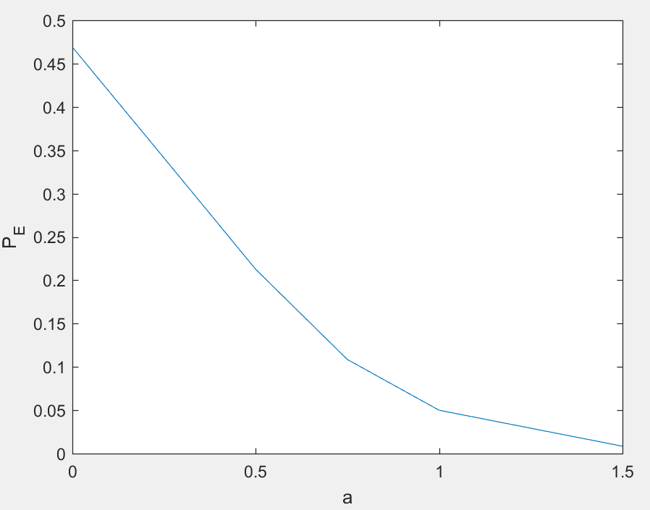

function [V,PE] = FLD(X, Y)

%X ... a matrix of cover features as columns

%Y ... a matrix stego features as columns

%v ... generalized eigenvector

%PE ... total minimal detection error under equal priors

[d, N] = size(X);

ux = mean(X, 2);

uy = mean(Y, 2);

size(repmat(ux, 1, N))

MX = X - ux;

MY = Y - uy;

SW = MX * MX' + MY*MY';

V = inv(SW) * (ux-uy);

Px = V' * X;

Py = V' * Y;

if mean(Px) > mean(Py)

Px = -Px;

Py = -Py;

end

P = [Px Py];

I = [zeros(N,1); ones(N,1)];

[~,order] = sort(P);

PFA = zeros(1,2*N+1);

PD = zeros(1,2*N+1);

PFA(1) = 1;

PD(1) = 1;

for i = 1:2*N

if (I(order(i))==0)

PFA(i+1) = PFA(i) - 1/N;

PD(i+1) = PD(i);

else

PFA(i+1) = PFA(i);

PD(i+1) = PD(i) - 1/N;

end

end

plot(PFA,PD);

axis([0, 1, 0, 1]);

xlabel('P_F_A');ylabel('P_D');

PE = min((PFA+1-PD)./2)

hold on;

end