Xin Wen

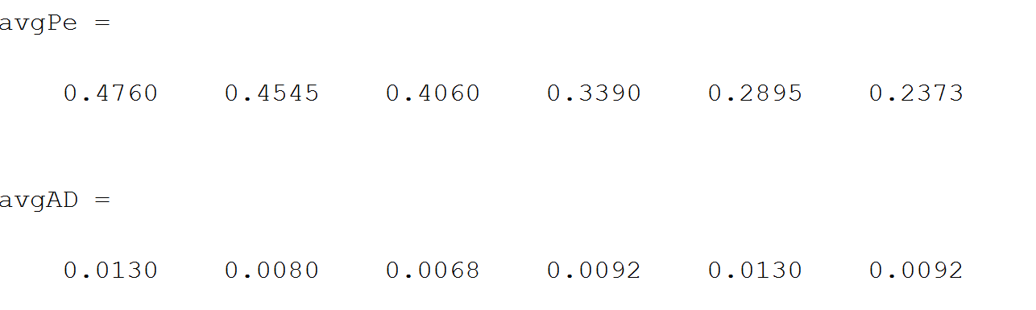

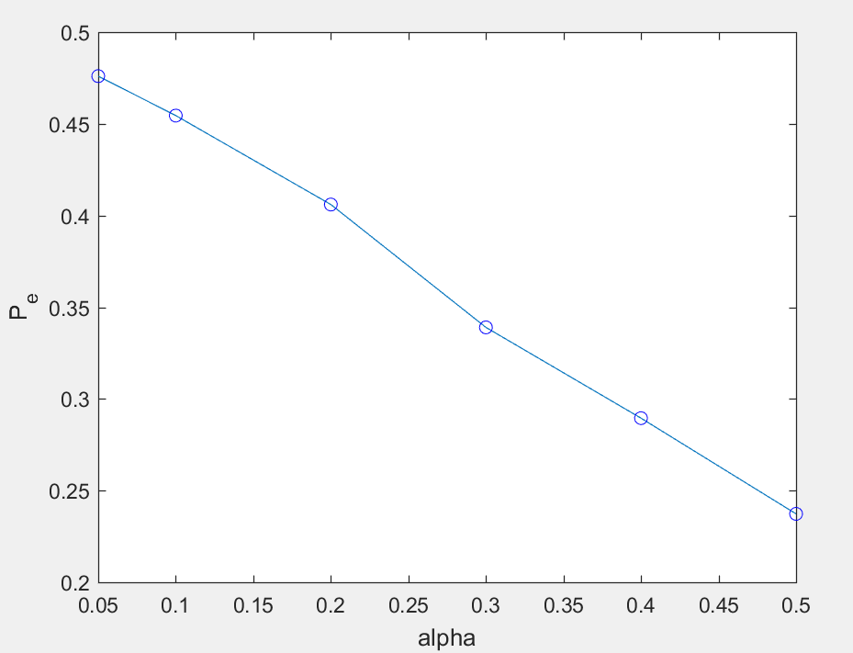

Cost function: similar to the cost function in R-D distortion assignment, but add the weight of 4 corner pixel with 2 neighboring average, weight of other pixels on boundary with 3 neighboring average.

Created Files:

calcost.m calculate cost of input image

genStegoImage.m generate stego image with given cost

genKBfeature.m generate KB feature and save to .mat file

calError.m calculate error rate

main.m put things together