Xin Wen

|  |  |  |  |  |  |  |  |  |  |
| --- | --- | --- | --- | --- | --- | --- | --- | --- | --- |
| w | 2 | 3 | 4 | 5 | 6 | 7 | 8 | 9 | 10 |
| h=5 | 0.0146 | 0.0078 | 0.0051 | 0.0037 | 0.0029 | 0.0023 | 0.0019 | 0.0016 | 0.0014 |
| h=8 | 0.0135 | 0.0071 | 0.0046 | 0.0033 | 0.0025 | 0.0020 | 0.0017 | 0.0014 | 0.0012 |
| h=10 | 0.013 | 0.0068 | 0.0044 | 0.0032 | 0.0024 | 0.0019 | 0.0016 | 0.0013 | 0.0012 |

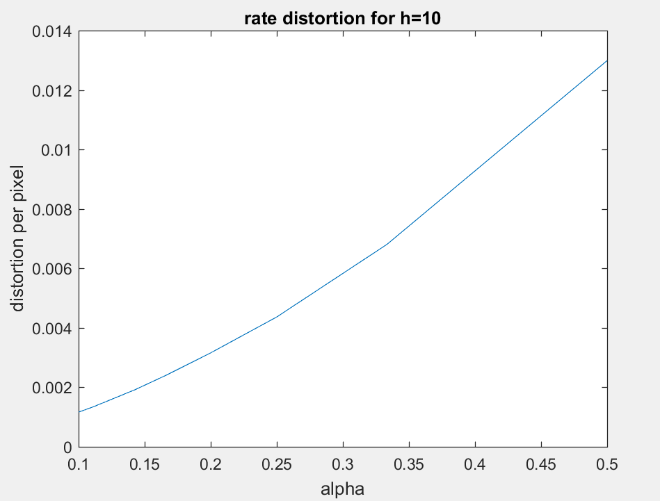

% hw5 Xin Wen

h = 10; % change h to 5, 8 or 10 for different output

Nruns = 10;

image = '130.bmp';

[R,D,lambda,rho] = DrawRDbound(image,'N');

overallCost = zeros(1, 9); % cost over different w, with same h

for w=2:10

costs_per_pixel = zeros(Nruns, 1);

Hmatrices = zeros(h, w, Nruns);

for k=1:Nruns

H_hat = round(rand(h,w));

H_hat(1,:) = 1;

H_hat(end,:) = 1;

rep = 100;

[code,alpha] = create_code_from_submatrix(H_hat, rep);

X = double(imread(image)); % Cover image

X = X(2:end-1,2:end-1);

x = mod(X(:), 2);

message = round(rand(1,floor(alpha*numel(x))));

[y cost] = STC_Embed(message, x, rho, code); % Embed message in x using code for costs in rho

costs_per_pixel(k) = cost/numel(x); % save costs per pixel

m = min(numel(message), numel(extracted_message));

end

[mincost, minindex] = min(costs_per_pixel);

bestHmatrix = Hmatrices(:, :, minindex); % You could retrieve the best Hmatrix

overallCost(w-1) = mincost

end

if h==10

w = 2:1:10;

alpha = 1./w;

plot(alpha, overallCost);

xlabel('alpha')

ylabel('distortion per pixel')

title('rate distortion for h=10')

end