import pandas as pd  
import numpy as np  
import os  
  
from openpyxl.chart.marker import Marker  
from scipy.interpolate import interp1d  
import statsmodels.api as sm

下读入五个显著相关的数据（科研投入、高新企业数量、出口货物、零售、就业情况），并对缺失数据进行线性插值和数据外推处理。

data_dir = os.path.join(os.getcwd(), 'data')  
  
gdp_data = pd.read_excel(os.path.join(data_dir,'GDP.xlsx'))  
factors = ['科研投入', '高科技企业数量', '出口货值', '零售', '就业情况']  
factors_data = [pd.read_excel(os.path.join(data_dir, f'selected', f'{factor}.xlsx')) for factor in factors]  
  
def interpolate(data, start, end):  
 x = data['年份']  
 y = data['大湾区汇总'].interpolate(method='linear')  
 # 进行数据外推，针对'科研投入'和'高科技企业数量'两个因素  
 f = interp1d(x, y, kind='linear', bounds_error=False, fill_value="extrapolate")  
 new_x = np.arange(start, end + 1)  
 new_y = f(new_x)  
 new_y = np.maximum(new_y, 0)  
 return pd.Series(new_y, index=new_x)  
  
all_factors = pd.DataFrame(index=range(1999,2024))  
  
cnt = 0  
for factor in factors_data:  
 interpolated_data = interpolate(factor, 1999, 2024)  
 # 防止有遗漏的NA值  
 interpolated_data = interpolated_data.interpolate(method='linear')  
 all_factors[factors[cnt]] = interpolated_data  
 cnt += 1  
print(all_factors)

科研投入 高科技企业数量 出口货值 零售 就业情况  
1999 0.00 0.0 2079.020000 2102.66000 1758.6600  
2000 0.00 0.0 2428.210700 3290.77000 2243.1900  
2001 0.00 0.0 2339.230000 3497.10000 2292.8900  
2002 0.00 0.0 2547.390000 3913.14000 2376.4200  
2003 0.00 0.0 2915.390000 4402.42000 2590.0300  
2004 0.00 0.0 3451.980000 5019.48000 2841.5300  
2005 0.00 0.0 3909.402337 8148.64000 3180.0100  
2006 0.00 0.0 4397.810000 8967.24000 3358.8400  
2007 0.00 0.0 4946.930000 10514.23000 3484.3724  
2008 149.46 0.0 5292.050000 12464.94000 3614.9962  
2009 359.21 0.0 4618.630000 13805.69000 3790.0489  
2010 568.96 0.0 5702.567179 16617.22000 4060.7400  
2011 778.71 0.0 6342.228130 19608.02000 4020.6155  
2012 988.46 0.0 6612.590000 21789.56000 4038.9700  
2013 1198.21 0.0 6986.815800 24243.11000 4431.9400  
2014 1407.96 1055.0 7315.999500 26865.68000 4621.2800  
2015 1617.71 10356.0 7299.624390 28778.54000 4760.5900  
2016 1827.46 19657.0 7131.132785 30703.19000 4936.7700  
2017 2037.21 28958.0 7592.618236 33459.44000 5109.0600  
2018 2246.96 38259.0 8160.190000 36416.62000 5296.7200  
2019 2460.96 45926.0 7891.019711 38321.08000 5261.9800  
2020 2653.79 48325.0 7814.201300 34928.82000 5319.7500  
2021 4007.42 55560.0 9886.539580 38683.14653 5354.2200  
2022 4007.42 55560.0 9241.036143 39036.20000 5161.4800  
2023 4007.42 55560.0 8373.665171 41966.67000 4968.7400

下构建多元线性回归模型

X = all_factors  
Y = gdp_data['大湾区汇总']  
Y.index = gdp_data['年']  
  
# 使用statsmodel库构建多元线性回归模型  
X = sm.add_constant(X)  
model = sm.OLS(Y, X)  
results = model.fit()  
  
print(results.summary())

OLS Regression Results   
==============================================================================  
Dep. Variable: 大湾区汇总 R-squared: 0.998  
Model: OLS Adj. R-squared: 0.998  
Method: Least Squares F-statistic: 2189.  
Date: Fri, 08 Nov 2024 Prob (F-statistic): 1.55e-25  
Time: 02:36:47 Log-Likelihood: -220.75  
No. Observations: 25 AIC: 453.5  
Df Residuals: 19 BIC: 460.8  
Df Model: 5   
Covariance Type: nonrobust   
==============================================================================  
 coef std err t P>|t| [0.025 0.975]  
------------------------------------------------------------------------------  
const 1.246e+04 3853.930 3.233 0.004 4394.563 2.05e+04  
科研投入 6.2164 2.068 3.006 0.007 1.888 10.545  
高科技企业数量 0.1391 0.069 2.008 0.059 -0.006 0.284  
出口货值 1.0911 1.186 0.920 0.369 -1.391 3.574  
零售 1.9093 0.226 8.456 0.000 1.437 2.382  
就业情况 0.9989 2.653 0.376 0.711 -4.555 6.552  
==============================================================================  
Omnibus: 4.957 Durbin-Watson: 1.501  
Prob(Omnibus): 0.084 Jarque-Bera (JB): 3.111  
Skew: 0.788 Prob(JB): 0.211  
Kurtosis: 3.709 Cond. No. 3.53e+05  
==============================================================================  
  
Notes:  
[1] Standard Errors assume that the covariance matrix of the errors is correctly specified.  
[2] The condition number is large, 3.53e+05. This might indicate that there are  
strong multicollinearity or other numerical problems.

最终得到 **大湾区的GDP多元线性回归模型方程**

**GDP** = **6.2164** × 科研投入 + **0.1391** × 高科技企业数量 + **1.0911** × 出口货值 + **1.9093** × 零售 + **0.9989** × 就业情况 + **12460**

其中： - 6.2164 是科研投入的系数。 - 0.1391 是高科技企业数量的系数。 - 1.0911 是出口货值的系数。 - 1.9093 是零售的系数。 - 0.9989 是就业情况的系数。 - 12460 是常数项。

import matplotlib  
import matplotlib.pyplot as plt  
  
matplotlib.rcParams['font.sans-serif'] = ['SimHei']  
plt.figure(figsize=(10, 6))  
for column in all_factors.columns:  
 plt.plot(all_factors.index, all_factors[column], marker='o', label=column)  
   
plt.legend()  
  
plt.title('粤港澳大湾区影响GDP的因素随时间变化图')  
plt.xlabel('年份')  
plt.ylabel('数值')  
  
plt.show()

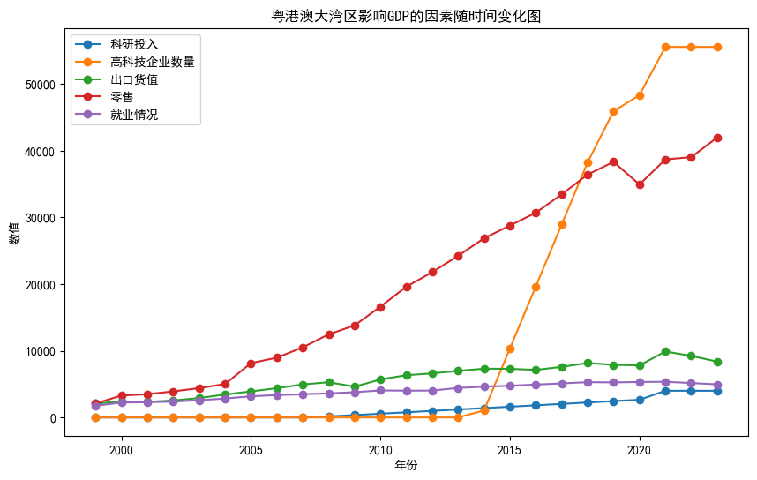

png

plt.figure(figsize=(10, 6))  
gdp_data.index = range(1999,2024)  
plt.plot(gdp_data.index, gdp_data['大湾区汇总'], marker='o', label='大湾区汇总')  
   
plt.legend()  
  
plt.title('粤港澳大湾区GDP随时间变化图')  
plt.xlabel('年份')  
plt.ylabel('GDP')  
plt.xticks(gdp_data.index, rotation=45)  
plt.yticks(range(0,160000,10000))  
plt.grid(True)  
  
plt.show()

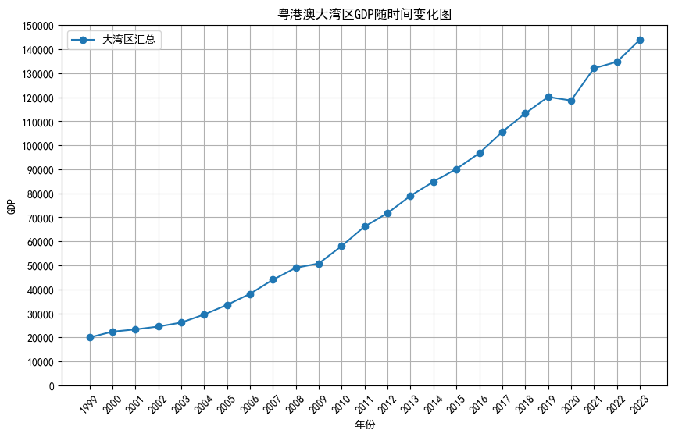

png