OXID eSales  
Documentation

Paymorrow Payments Module

User Manual

Copyright

Copyright © 2016 OXID eSales AG, Germany

Copying of this document or its contents, in particular, using texts or parts of text is subject to the explicit prior permission by OXID eSales AG.

The information provided in this document was prepared according to the current state of the art. OXID eSales, however, will assume no liability or warranty for the timeliness, correctness and completeness of the information provided. Since errors – despite all efforts – cannot be ruled out entirely, we always appreciate suggestions.

License

Licensing of the software product depends on the shop edition used.

The software for OXID eShop Community Edition is published under the GNU General Public License v3. You may distribute and/or modify this software according to the licensing terms published by the Free Software Foundation. Legal licensing terms regarding the distribution of software being subject to GNU GPL can be found under http://www.gnu.org/licenses/gpl.html.

The software for OXID eShop Professional Edition and Enterprise Edition is released under commercial license. OXID eSales AG has the sole rights to the software. Decompiling the source code, unauthorized copying as well as distribution to third parties is not permitted. Infringement will be reported to the authorities and prosecuted without exception.

Conventions

The following conventions are used:

proportional font with grey background

For user input, code and URLs

Grey italic

For filenames, file paths and other italic highlighting

Bold

For controls and navigation paths

Bold red

For warnings and important hints

Legal Notice

OXID eSales AG

Bertoldstrasse 48

79098 Freiburg

Germany

Fon: +49 (761) 36889 0

Fax: +49 (761) 36889 29

Executive board: Roland Fesenmayr (CEO)

Supervisory board: Michael Schlenk (chairman)

Headquarters: Freiburg

Country court Freiburg i. Brg.

Commercial register number: HRB 701648

Table of contents

Copyright 2

License 2

Conventions 3

Legal Notice 3

Table of contents 4

1 Module Description 5

2 System requirements 5

3 Installation 5

3.1 Backup Shop Files And Database 6

3.2 Copy Module Files 6

3.3 Multi-Shop & -Language 6

3.4 Special Shop System Version 6

3.5 Activate Module 6

3.6 Delete Temporary Files 6

4 Configuration 7

4.1 API-Configuration 7

4.2 Configure Payment Methods In Shop 7

4.3 Adjust Shipping Methods For Paymorrow In The Shop 8

5 Functional Description 8

5.1 Paymorrow Payments In The Checkout Process 8

5.2 Paymorrow Payments For Orders 11

5.3 OXID eShop Mobile Theme 11

# Module Description

The Paymorrow Payments module handles the payment methods invoice and direct debit with guarantee of Paymorrow GmbH and is being developed and deployed by OXID eSales. In this way shop operators are protected against payment defaults, as the payment request is verified and confirmed in advance.

Module title: Paymorrow Zahlungen

Version: 1.0.0

Category: OXID eFire Extension – Payment in the online shop

Manufacturer: OXID eSales AG

Internet: [www.oxid-esales.com](http://www.oxid-esales.com)

E-mail: [info@oxid-esales.com](mailto:info@oxid-esales.com)

For questions about Paymorrow products as well as support for module installation & setup, please contact Paymorrow.

* Product Consulting: [beratung@paymorrow.de](mailto:beratung@paymorrow.de)
* Technical Customer Service: [technik@paymorrow.de](mailto:technik@paymorrow.de)
* URL: <https://paymorrow.de>

The Paymorrow Payments module was designed by OXID eSales in cooperation with Paymorrow.

# System requirements

The system requirements given below apply to the Paymorrow Payments module.

* PHP >= 5.3
* cURL
* OpenSSL

# Installation

In this chapter, the installation of the Paymorrow Payments module for the OXID eShop versions 4.7.x/5.0.x – 4.10.x/5.3.x. is described. Follow this guide step by step.

In a new installed shop, Paymorrow Payments is already integrated. You can skip this section. The Paymorrow Payments module has to be simply activated. Therefor go to **Extensions** -> **Modules** in the admin panel of the shop. In the **Overview** tab of the module, click the **Activate** button.

The technical customer service of Paymorrow also offers you a free module integration and set-up service. Please use the following contact information for communication with Paymorrow:

E-mail: technik@paymorrow.de & phone: +49 721 / 480 84 30

For contract partners, OXID eSales can carry out the installation of the module. The OXID eSales support can be reached via e-mail at support@oxid-esales.com

## Backup Shop Files And Database

Before you begin with the installation of the Paymorrow Payments module we strongly encourage you to make backup of both shop files and database.

## Copy Module Files

Transfer the content of the folder copy_this and changed_full from the zip archive using a FTP software to the root level of the shop on your web server. Make sure that the files are transferred in binary mode.

The target directories of the module package are based on the standard version and installation of the OXID eSales shop system. If your directory structure differs, please contact us.

## Multi-Shop & -Language

If you have many sub-shops and more languages than English and German, please see comments in /modules/oxps/paymorrow/docs/install.sql to install all CMS snippets manually.

## Special Shop System Version

If your shop version is 4.7.6/5.0.6 or older, you need to adjust an admin template in order to extend the module setting (add a block named admin_module_config_form):

* Open the eShop template file located under ***application/views/admin/tpl/module_config.tpl*** with a text editor
* Add the following code after line 37 (before the cycle and foreach tags):

[{block name="admin_module_config_form"}]

* Also add the block closing code after line 78 (before </form> tag):

[{/block}]

* Also clear the cache by removing ***/tmp*** folder content (all files except ***.htaccess***).

## Activate Module

The module Paymorrow Payments should now be activated in the shop backend. Go to the shop backend to **Extensions** -> **Modules** and select the module. In the **Overview** tab, press the **Activate** button.

By activating the module the database commands from /modules/oxps/paymorrow/docs/install.sql are executed automatically.

## Delete Temporary Files

Clear the cache by removing /tmp folder content (all files except .htaccess).

# Configuration

In order to enable payment via Paymorrow Payments for customers in the OXID eShop, the related module needs to be configured.

## API-Configuration

Configuration of the Paymorrow Payments module in the admin panel:

**Extensions** -> **Modules** -> **Paymorrow Payments** -> **Settings [tab]** -> **API Configuration**

* Request your personal **Webservice User** and **Initialization Code** for the certificate registration via email to technik@paymorrow.de (live and/or test)
* Enter the Paymorrow **Webservice User** (live and/or test)
* Save the changes
* Then **„Live/Test Register Certificates“** buttons will appear
* Use the Live or Test button to open a window where you enter the **Initialization code** and generate the certificate. **The Initialization** **Code is supplied by Paymorrow and is a one-time code to generate a certificate**

## Configure Payment Methods In Shop

Mapping of the payment methods invoice and direct debit in the admin panel:

**Shop Settings** -> **Payment Methods** -> **\*any payment method available\*** -> **Paymorrow [tab]**

* Activate a payment method as Paymorrow and press **Save**
* Choose payment method type and configure **Paymorrow** tab
* If there are no errors in the form save it
* Make user group and country assignments (see **Main** and **Country** tab)

*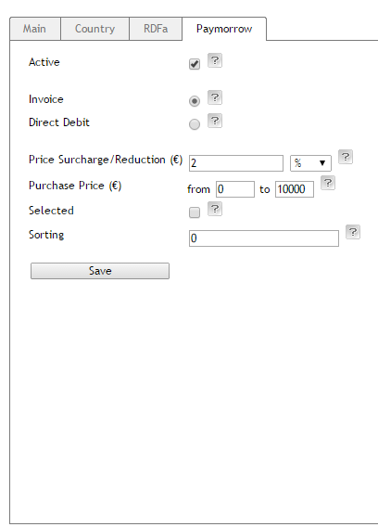Figure 1:* *Admin Panel, payment methods*

## Adjust Shipping Methods For Paymorrow In The Shop

Adjust all shipping methods, which are in use via **Shop Settings** -> **Shipping Methods** and assign them to the appropriate payment methods, countries, shipping cost rules and user groups.

# Functional Description

## Paymorrow Payments In The Checkout Process

Depending on the configuration of the Paymorrow Payments module, payment via invoice and direct debit is enabled during checkout step 3. At this time, the user is already logged in to the shop or shopping without registration. If the Paymorrow Payments module detects that any user data is missing, the user is required to enter the missing information.

*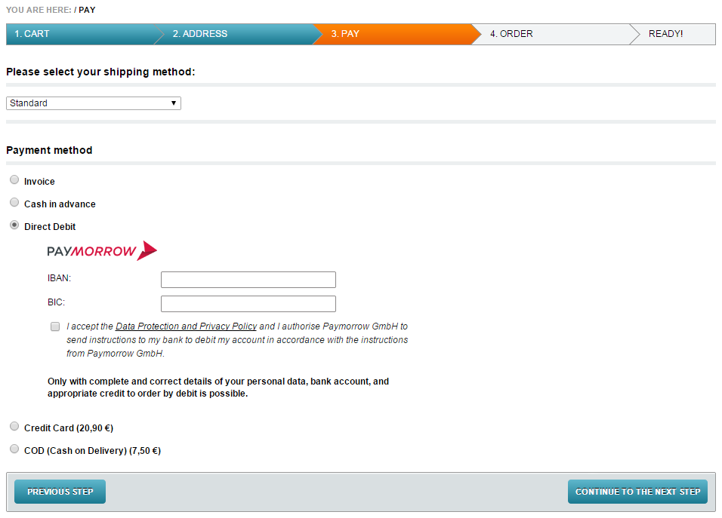Figure 2: Checkout, order step 3, direct debit*

*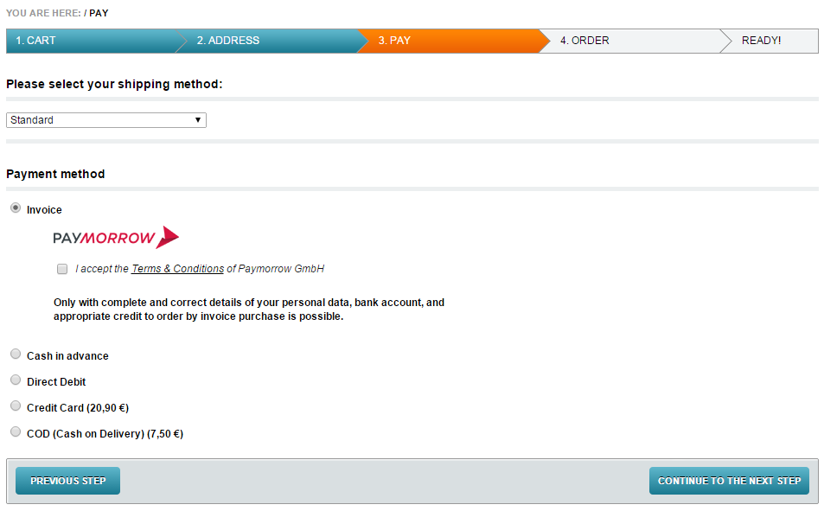Figure 3: Checkout, order step 3, invoice*

When the user continues to the next checkout step, the payment request is verified and confirmed in advance, e.g. by checking the credit rating of the customer.

*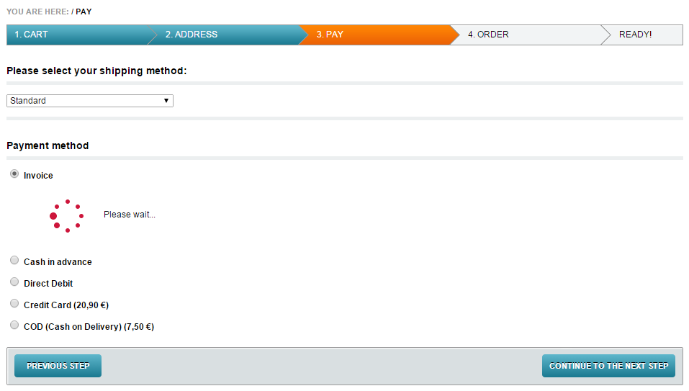Figure 4: Checkout, order step 3,* *payment request validation*

## Paymorrow Payments For Orders

If products have been paid via a payment method mapped with Paymorrow Payments, a history of orders can be found in the admin panel. Therefore go to **Administer Orders** -> **Orders**. You can also find an overview of orders on the **Paymorrow Merchant Portal** (<https://paymorrow.net/perthPortal/>).

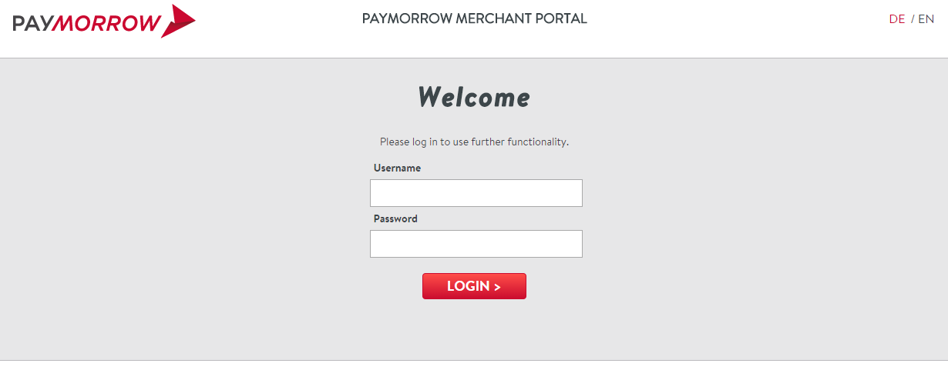Contact Paymorrow GmbH in case you didn’t yet receive username and password.

*Figure 5: Paymorrow Merchant Portal*

## OXID eShop Mobile Theme

Compatibility with the OXID eShop mobile theme is currently not provided.