OXID eShop  
eVAT module

Copyright

Copyright © 2014 OXID eSales AG, Germany

All rights reserved.

No part of this publication may be reproduced or transmitted in any form or for any purpose without the prior written permission of OXID eSales AG.

Decompilation of source code, piracy as well as transfer to a third party is not allowed.

Use of this content for any other purpose is expressly prohibited and may result in severe civil and criminal penalties. Violators will be prosecuted to the maximum extent possible.

The information contained within this document was created accordingly to the state of the art technology.

OXID eSales AG assumes no liability or warranty for the accuracy, the completeness or reliability of any content.

In spite of all efforts, the occurrence of mistakes cannot be eliminated completely.

Thus we appreciate any tips.

License

Licensing of the software product depends on the shop edition used.

The software for OXID eShop Community Edition is published under the GNU General Public License v3. You may distribute and/or modify this software according to the licensing terms published by the Free Software Foundation. Legal licensing terms regarding the distribution of software being subject to GNU GPL can be found under http://www.gnu.org/licenses/gpl.html.

The software for OXID eShop Professional Edition and Enterprise Edition is released under commercial license. OXID eSales AG has the sole rights to the software. Decompiling the source code, unauthorized copying as well as distribution to third parties is not permitted. Infringement will be reported to the authorities and prosecuted without exception.

Conventions

The following conventions are used:

proportional font with grey background

For user input, code and URLs

Grey italic

For filenames, file paths and other italic highlighting

Bold

For input fields and navigation paths

Bold red

For warnings and important hints

Contact

OXID eSales AG

Bertoldstrasse 48

79098 Freiburg

Germany

Fon: +49 (761) 36889 0

Fax: +49 (761) 36889 29

Represented by the Management Board: Roland Fesenmayr (CEO), Andrea Seeger

Supervisory Board: Michael Schlenk (Chairman)

Commercial Register Freiburg

No. HRB 701648

Table of contents

[Copyright 2](#_Toc402961514)

[License 2](#_Toc402961515)

[Conventions 2](#_Toc402961516)

[Contact 3](#_Toc402961517)

[Table of contents 4](#_Toc402961518)

[1 Introduction 5](#_Toc402961519)

[2 System requirement 5](#_Toc402961520)

[3 Installation 6](#_Toc402961521)

[3.1 Copying module files 6](#_Toc402961522)

[3.2 Preparing templates 6](#_Toc402961523)

[3.2.1 Add missing blocks 6](#_Toc402961524)

[4 Activation 8](#_Toc402961525)

[5 Configuration 8](#_Toc402961526)

[5.1 Country VAT Groups 9](#_Toc402961527)

[5.2 Products as TBE services 9](#_Toc402961528)

[5.3 User Location Evidences 9](#_Toc402961529)

[5.3.1 Logic behind 9](#_Toc402961530)

[5.3.2 Default evidences 9](#_Toc402961531)

[5.3.3 Integration with OXID eSales PayPal module 9](#_Toc402961532)

[5.4 Compatibility with invoicePDF module 10](#_Toc402961533)

[6 Functional description 10](#_Toc402961534)

[6.1 Frontend functionality 11](#_Toc402961535)

[6.1.1 TBE services in catalogue 11](#_Toc402961536)

[6.1.2 TBE services during checkout 13](#_Toc402961537)

[6.2 Backend (admin) functionality 17](#_Toc402961538)

[6.2.1 Country VAT groups 17](#_Toc402961539)

[6.2.2 Products as TBE services 19](#_Toc402961540)

[6.2.3 Manage TBE services via categories 20](#_Toc402961541)

[6.2.4 Location evidences in order 21](#_Toc402961542)

[6.2.5 How to configure customer location evidences 22](#_Toc402961543)

[6.2.6 VAT ID store date 22](#_Toc402961544)

[6.2.7 Invoice PDF module changes 23](#_Toc402961545)

[7 Extending 24](#_Toc402961546)

[7.1 How write and add additional evidence 24](#_Toc402961547)

[7.2 How to mark invalid items in basket 25](#_Toc402961548)

# Introduction

This module implements requirements that is to allow an OXID eShop to comply with the EU regulations as specified by the EU VAT directive 1042/2013 regarding VAT for telecommunications, broadcasting and electronic services. This regulation becomes active on the 1st of January 2015.

From the 1st of January a EU directive becomes active that states (in principle) that for **telecommunications, broadcasting & electronic services** (in the following **TBE services**), VAT has to be paid in the country where the customer belongs and no longer in the country of the supplier - irrespective of whether the end customer is a business (taxable person) or a non-taxable person (e.g a private individual).

The reason for this is the following:

"Until the end of 2014, business to final consumer (B2C) supplies by EU businesses are taxed in the country of the supplier. This means that for supplies made to final consumers, businesses established in Member States applying lower VAT rates have a competitive advantage over businesses established in other Member States."[[1]](#footnote-1)

However:

"The scope of the 2015 VAT changes only covers telecommunications, broadcasting and electronic services. Those changes are relevant only insofar as the customer is a final consumer."[[2]](#footnote-2)

Module title: OXID eShop eVAT

Version: 1.0.0

Manufacturer: OXID eSales AG

Internet: [www.oxid-esales.com](http://www.oxid-esales.com/)

E-mail: [info@oxid-esales.com](mailto:info@oxid-esales.com)

# System requirement

The system requirements given below apply to eVAT module.

* PHP 5.3 or higher
* OXID eShop 4.7/5.0, 4.8/5.1 or 4.9/5.2

# Installation

In this chapter, the installation of the eVAT module for the OXID eShop versions 4.7.\*/5.0.\*, 4.8.\*/5.1.\*, 4.9.\*/5.2.\* is described. Follow this guide step by step.

## Copying module files

Copy the contents of the /copy\_this folder into the root folder of your shop.

## Preparing templates

Additional files required for the use of the module in the shop can be found in the /***changed\_full*** folder. The subfolder /changed\_full/modules contains standard module files as well as block files used for the "Azure" theme.

When installing the module in a shop without customized templates and files, you can copy all files from this folder directly to the shop.

Generally, and in particular in the case of a customized shop, you need to compare old and new templates and files and adopt recent changes. The changes made are documented in the following folders:

* /templ\_docu\_admin - changes in /modules/oe/oevattbe/views/admin
* /templ\_docu\_blocks - changes in /modules/oe/oevattbe/views/blocks

The folders containing the template documentation are only available in the installation package if changes were made in the respective templates and files.

### Add missing blocks

eShop versions 4.7.\*/5.0.\*, 4.8.\*/5.1.\* and 4.9.\*/5.2.\* are missing some template blocks which are needed to work module properly, you’ll have to add these blocks to your templates.

Missing blocks in eShop 5.0.x and 5.1.x (Blocks names and files names are given bellow):  
*details\_productmain\_price\_value - page/details/inc/productmain.tpl,*

*widget\_product\_boxproduct\_price\_value - widget/product/boxproduct.tpl,*

*widget\_product\_bargainitem\_price\_value - widget/product/bargainitem.tpl,*

*widget\_product\_compareitem\_price\_value - widget/product/compareitem.tpl,*

*checkout\_basket\_next\_step\_bottom - page/checkout/basket.tpl*

*checkout\_order\_next\_step\_bottom - page/checkout/order.tpl*

*content\_main - layout/page.tpl*

Missing blocks in eShop 5.2.x (Blocks names and files names are given bellow):

*details\_productmain\_price\_value - page/details/inc/productmain.tpl,*

*widget\_product\_boxproduct\_price\_value - widget/product/boxproduct.tpl,*

*widget\_product\_bargainitem\_price\_value - widget/product/bargainitem.tpl,*

*widget\_product\_compareitem\_price\_value - widget/product/compareitem.tpl*

Places where these blocks should be added (line numbers might not match):

|  |
| --- |
| page/details/inc/productmain.tpl 253-276 details\_productmain\_price\_value:  252: [{oxhasrights ident="SHOWARTICLEPRICE"}]  253: [{block name="details\_productmain\_price\_value"}]  276: [{/block}]  278: [{/oxhasrights}]    widget/product/boxproduct.tpl 16-38 widget\_product\_boxproduct\_price\_value:  15: [{oxhasrights ident="SHOWARTICLEPRICE"}]  16: [{block name="widget\_product\_boxproduct\_price\_value"}]  38: [{/block}]  39: [{/oxhasrights}]  widget/product/bargainitem.tpl 21-49 widget\_product\_bargainitem\_price\_value:  15: [{oxhasrights ident="SHOWARTICLEPRICE"}]  16: [{if $\_product->getTPrice()}]  17: <span class="priceOld">  18: [{ oxmultilang ident="REDUCED\_FROM\_2" }] <del>[{oxprice price=$\_product->getTPrice() currency=$oView->getActCurrency()}]</del>  19: </span>  20: [{/if}]  21: [{block name="widget\_product\_bargainitem\_price\_value"}]  49: [{/block}]  50: {/oxhasrights}]  widget/product/compareitem.tpl 94-106 widget\_product\_compareitem\_price\_value:  93: [{oxhasrights ident="SHOWARTICLEPRICE"}]  94: [{block name="widget\_product\_compareitem\_price\_value"}]  106: [{/block}]  107: [{if $product->loadAmountPriceInfo()}]  108: [{oxscript include="js/widgets/oxamountpriceselect.js" priority=10 }]  109: [{include file="page/details/inc/priceinfo.tpl" oDetailsProduct=$product}]  110: [{/if}]  111: [{/oxhasrights}]  page/checkout/basket.tpl 80-109 checkout\_basket\_next\_step\_bottom:  80: [{block name="checkout\_basket\_next\_step\_bottom"}]  81: <div class="lineBox clear">  82: [{if $oView->showBackToShop()}]  108: </div>  109: [{/block}]  110: [{/if}]  111: [{if $oView->isWrapping() }]  112: [{include file="page/checkout/inc/wrapping.tpl"}]  113: [{/if}]  page/checkout/order.tpl 167-213 checkout\_order\_next\_step\_bottom:  163: [{block name="order\_basket"}]  164: [{include file="page/checkout/inc/basketcontents.tpl" editable=false}]  165: [{/block}]  167: [{block name="checkout\_order\_next\_step\_bottom"}]  168: [{if $oView->isLowOrderPrice()}]  210: </form>  211: [{/block}]  212: [{/if}]  213: [{/block}]  layout/page.tpl 21-26 content\_main:  20: <div id="content">  21: [{block name="content\_main"}]  22: [{include file="message/errors.tpl"}]  23: [{foreach from=$oxidBlock\_content item="\_block"}]  24: [{$\_block}]  25: [{/foreach}]  26: [{/block}]  27: </div> |

# Activation

The module has to be activated in the shop. In the **Overview** tab of the module, click the **Activate** button. Delete all files and folders except for .htaccess from the /tmpfolder of your shop.

# Configuration

After module activation you need to configure module:

* Add VAT rates for countries
* Mark product as TBE services, and add VAT rates for different countries for this product
* Configure location evidence collectors

## Country VAT Groups

VAT group with VAT rates will be already preconfigured for EU countries. During module activation general and reduced VAT rates for EU countries will be imported. You can find out more about VAT groups in ***6.2.1 Country VAT groups***.

Important: shop owner is responsible for validity of VAT rate groups setup:

* Countries which applies EU VAT directive must be marked to apply eVAT module VAT rates;
* Countries VAT rates must be configured.

## Products as TBE services

Products data is not configured out of the box. You need to configure all TBE products define appropriate VAT group per country. You can find out more information how to configure Products in ***6.2.2 Products as TBE services***

## User Location Evidences

### Logic behind

EU VAT directive 1042/2013 require that Shop would find out customer location and apply VAT according to his country. This directive tells that customer location must be found out by at least two evidences. Location provided by customer cannot be used as evidence. OXID eShop eVAT module provides one rule how to find out customer location country and mechanism how to add additional evidence finding algorithms.

### Default evidences

OXID eShop eVAT module use two algorithms to find out customer location: billing address and geo location (based on customer IP address). One of the evidence has highest value than others as those evidences might be contradicted. By default billing address is the default one. For example customer location is Austria if customer billing address is Austria; even geo location said that it is Ireland. If default evidence cannot determine user country, first active evidence with determined user country will be used. Default evidence can be specified in module configuration screen where evidence id should be entered.

You can find out more information about evidences and their configuration in ***6.2.4 How to configure customer location evidences*** chapter of this document and how to extend with other evidences in chapter ***7.1 How to write and add additional evidence****.*

### Integration with OXID eSales PayPal module

Taking in account that for anonymouse user we can not calculate TBE service final price, because it depends on users residence country. PayPal module‘s express checkout functionality is not compatible with TBE services.

## Compatibility with invoicePDF module

If InvoicePdf module is used in eShop some configuration must be done. Chain of classes which are overloaded can be configured wrongly, so there is need to check them. Go to: *Extensions->Modules->Installed Shop Modules*. List of overloaded classes will be displayed. Class – *oxorder* must be overloaded in this order (from top to bottom): *invoicepdfoxorder (myorder in shop 5.1 and 5.0), oevattbeoxorder*. Check image bellow:

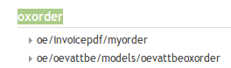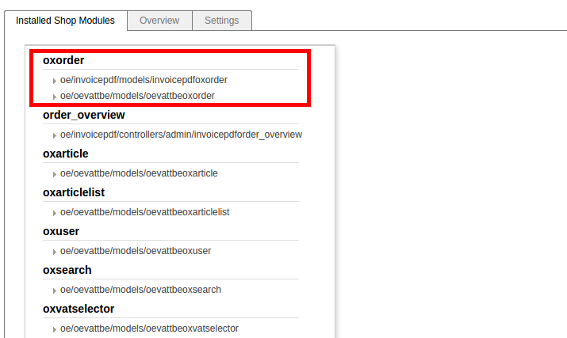

If classes order is not as described before they should be changed by dragging them to correct order and than saved by clicking **Save** button.

## Place of business

Place of business is used to determine if customer is from the same country as eShop.

If user is from the same location as place of business, default shop behaviour to calculate VAT is used. Also no messages or notification marks are shown for TBE services.

To configure it go to: Extensions -> Modules -> OXID eShop eVAT -> Settings and set “Place of Business” country code in ISO2 format.

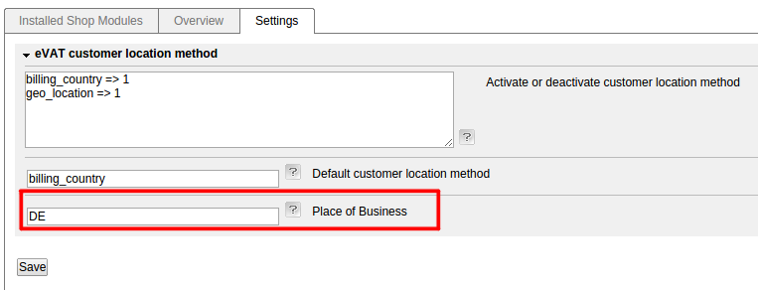

Note: If no code or incorrect code is entered eShop acts like no place of business is defined.

# Functional description

This module change how Shop calculates VAT for TBE products. Shop without module always use Shop VAT rate which should be configured by the Shop location country. With this module Shop separate products in to two groups: TBE and Not TBE services. Not TBE services are calculated with default Shop VAT rate (regular way). TBE products are calculated with user location country VAT rate.

Shop with module would apply VAT depending on Shop location and customer location.

EU located Shop supplying for customer:

|  |  |
| --- | --- |
| 1. Business in another EU country | No VAT charged.  Customer must account for the tax (reverse-charge mechanism). |
| 2. Consumer in another EU country | Must charge VAT in the EU country where the customer belongs (not where the business is based). |
| 3. Business or consumer outside the EU | No EU VAT charged.  But if the service is **effectively used & enjoyed** in an EU country, that country  can decide to levy VAT. |

NON-EU located Shop supplying for customer:

|  |  |
| --- | --- |
| 1. Business in the EU | No VAT charged.  Customer must account for the tax (reverse-charge mechanism). |
| 2. Consumer in the EU (telecoms, broadcasting or electronic services) | Must charge VAT in the EU country where the customer belongs. |
| 3. Business or consumer outside the EU | No EU VAT charged. |

## Frontend functionality

### TBE services in catalogue

Shop can have various products: TBE service and not. So in all Category lists, details pages, start page and other places (except checkout) TBE services are marked with two stars “\*\*”.

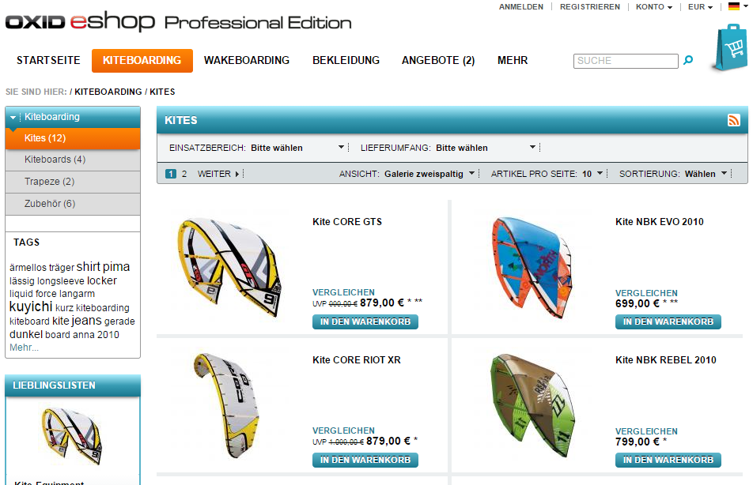

Figure 1 TBE services in category page

There is the link at the bottom of the page. This link leads to the page that explains rules how VAT is calculated.

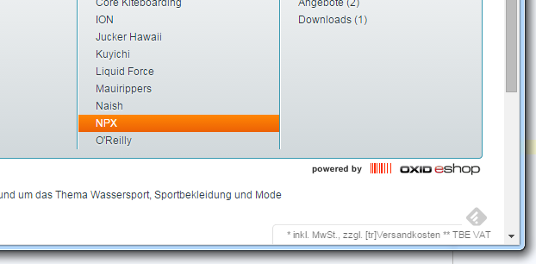

Figure 2 Information block

To define content of this page go to admin: *Customer info->CMS Pages*. Select “CMS page” with identification - **oxdeliveryinfo**. Change content of this page.

### TBE services during checkout

In First checkout step – basket overview products which are TBE services VAT rate is shown with “stars”. At the bottom of basket explanation message is shown. This message explains, that this VAT rate will be changed after user will log in.

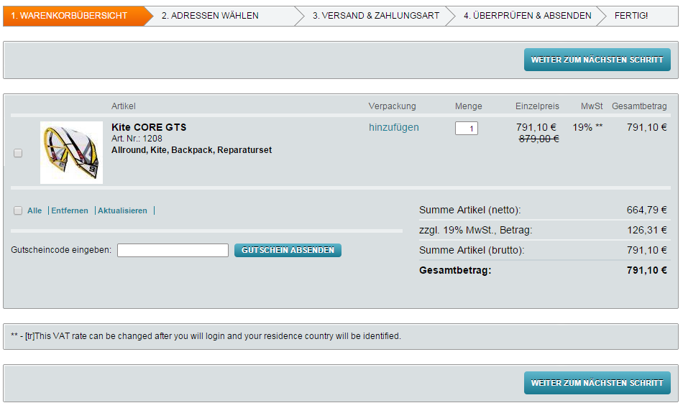

The VAT rate is calculated according to collected evidences and explanation message shows which country is used for calculation when user is logged in.

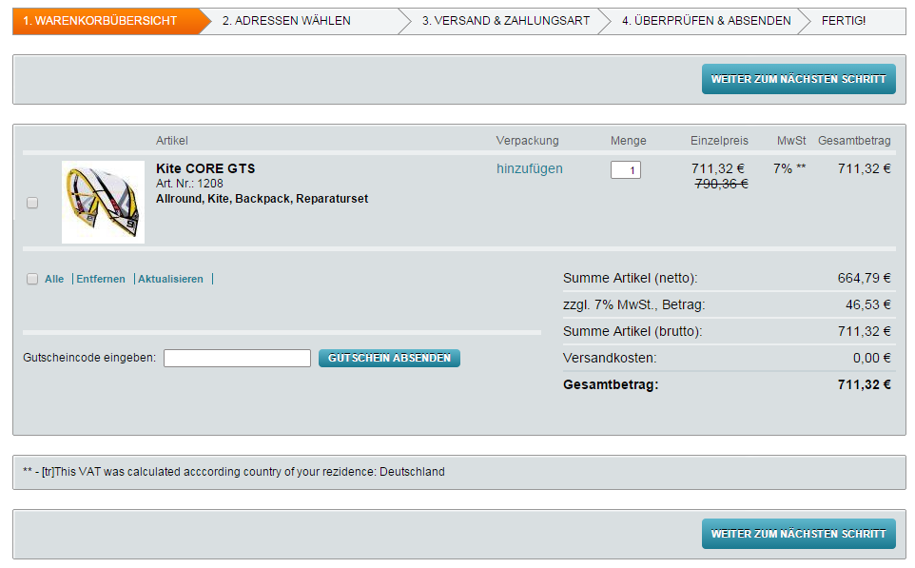

User is informed that country is changed and VAT will be recalculated when user residence country changes.

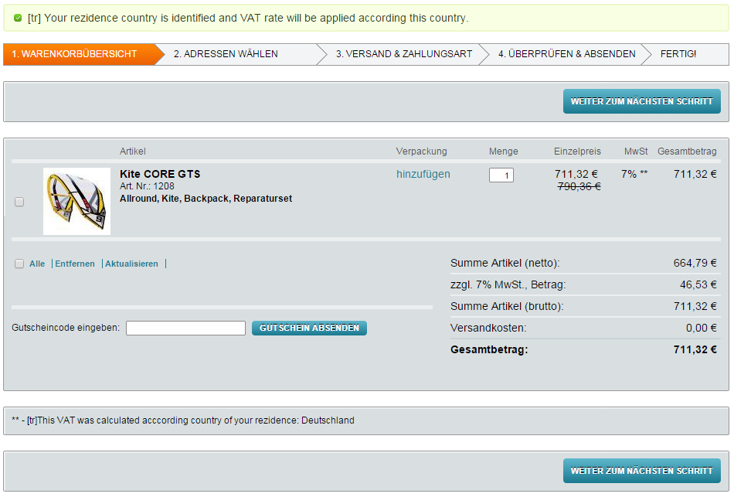

There can be situation when shop is not configured for some EU countries. So after user login with this billing country error will be shown. And of course you can proceed with order if there such situation.

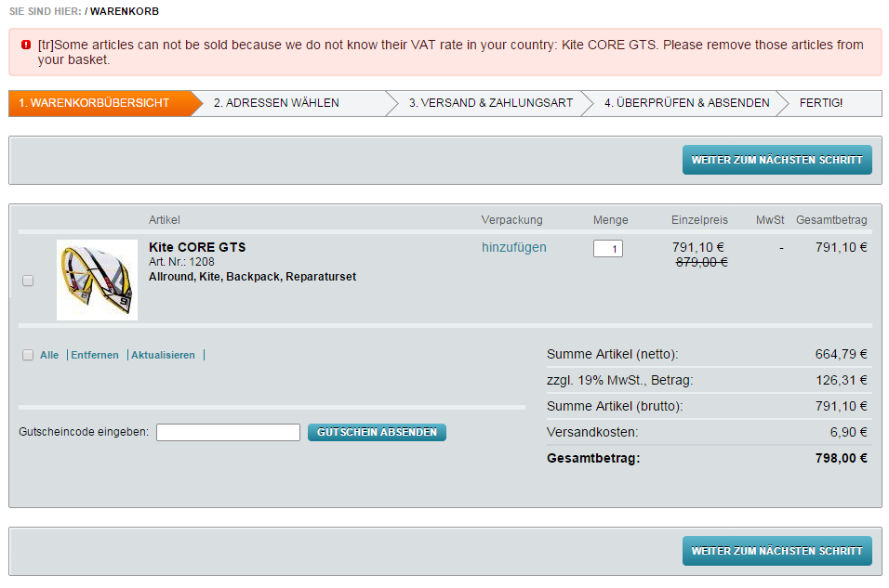

## Backend (admin) functionality

In backend you can configure:

* Country VAT groups
* Products as TBE services
* Location evidences

Also:

* Added information about stored VAT ID date
* In order added information about collected location evidences

### Country VAT groups

In order to use configured country VAT groups, country should be marked as “Apply TBE VAT rates”. *Master setting -> Countries -> Main*.

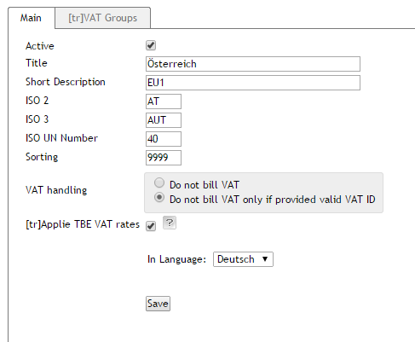

To configure (create, update) VAT groups go to: *Master setting -> Countries -> VAT Groups*

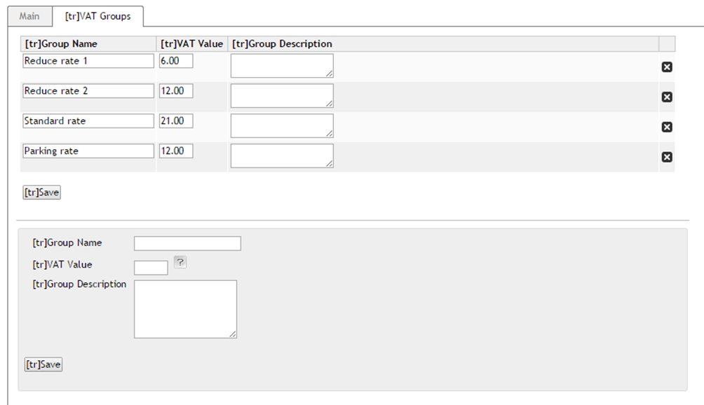

At the bottom of tab there is new VAT group creation form. Mandatory fields are “VAT rate name” and “VAT rate”. In list above form you can edit information after that just push button save. If there is need to delete group just click on [X] in the right column.

Note: Countries are for all subshops so editing country VAT groups will affect all shops.

### Products as TBE services

To configure Product as TBE services go to: *Administer products->Products choose products* and go to “eVAT config” tab.

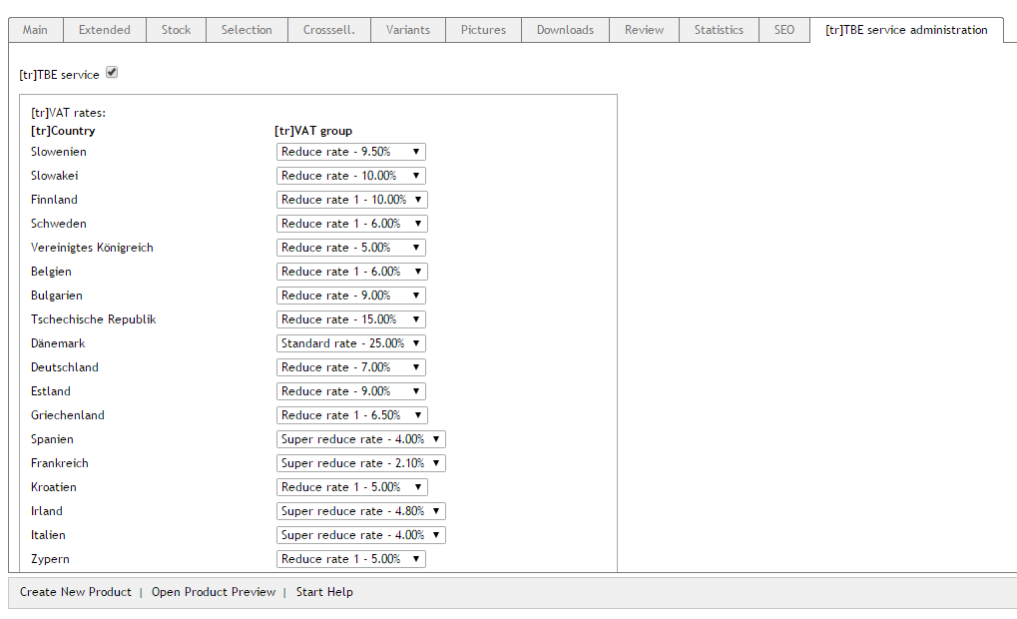

Mark product as “TBE service” with marking checkbox and select proper VAT rate group for each country. Press Save – to save data.

Note: Product can only be edited in main shop.

### Manage TBE services via categories

Module provides possibility to configure products using categories. To do this go to: *Administer products->Categories->eVAT config*. Page with possible options will be displayed:

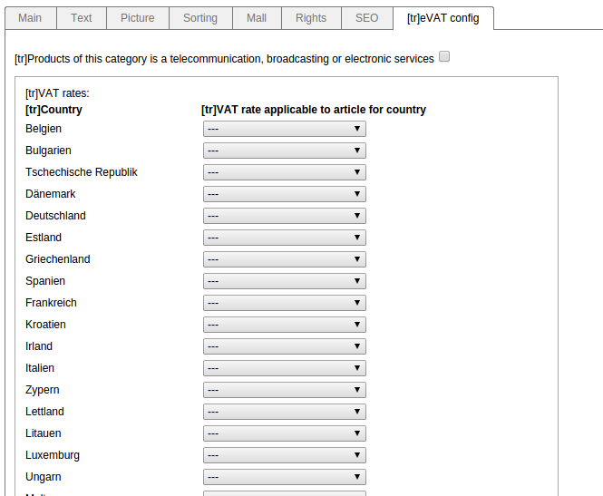

All products which are in selected category will be updated according selected options when button **Save** will be clicked.

Important: All products, which are in selected category, TBE configuration information will be overwritten with new information. This means that if product had configured TBE information individually, it still will be overwritten with category TBE configuration.

### Location evidences in order

Module have possibility to collect and display evidences of customer location. It's displayed only when order have at least one TBE product in order. This information can be found in *Administer Orders->Orders->Select any order which has TBE products->Main*

At the bottom table will be displayed information like in image displayed bellow:

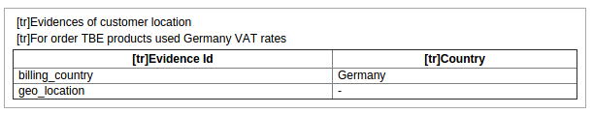

From the image can be seen that for this order TBE services Germany VAT rates were used.

There are also displayed evidences which were used to check the country. Evidence billing\_country shows Germany, and evidence geo\_location doesn't show any country because it did not give any results.

### How to configure customer location evidences

In module configuration screen registered evidences can be activated or deactivated. It is also possible to specify which evidence should be used as default:

Evidences can be activated or deactivated by changing evidence value to 1 (active) or 0 (inactive). 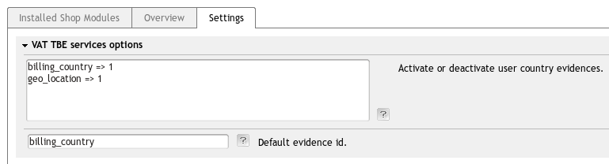

For example to deactivate billing\_country evidence, its value should be changed to 0:

billing\_country => 0

geo\_location => 1

Only active evidences will be used in user country calculations and stored in order information.

To change default evidence, enter evidence id to the input field (change billing\_country to geo\_location in this case).

In case default evidence can not be found or no default evidence is specified, first evidence with non empty country will be used.

### VAT ID store date

Module has feature to store first date when VAT IN (VAT Identification number) of customer was provided. For new registered users if VAT IN was valid, it is stored during user registration. If user provides VAT IN later, it will be stored. User can provide it during checkout or changed in account settings. To see the date when VAT IN was provided go to: *Admin->Users select user*:

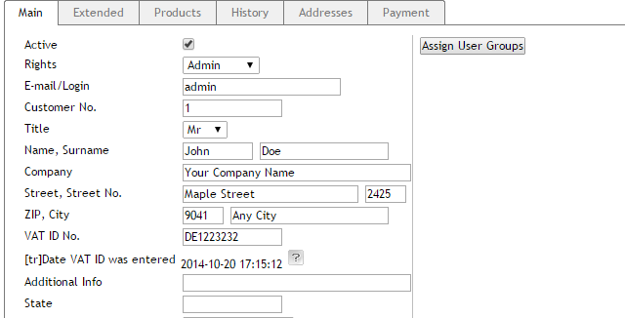

### Invoice PDF module changes

eVAT module adds some changes to invoice PDF file. If an order has TBE services there is shown mark - **\*** near VAT rate in the invoice. And also there is an explanation what does it means. Country which VAT rate was applied also shown. See an image bellow:

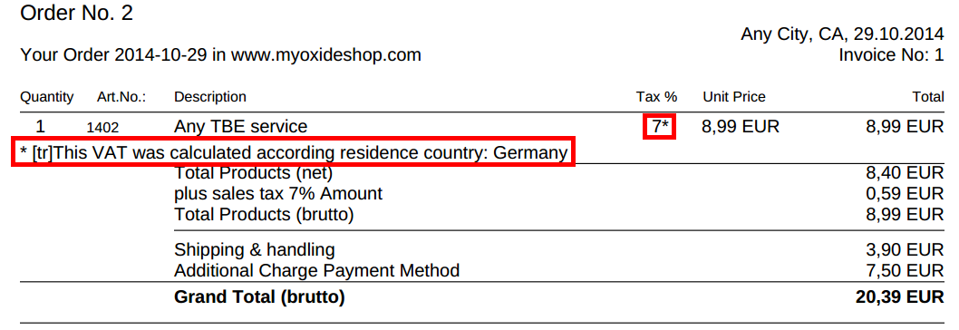

# Extending

In this section we will describe how to extend current module by adding additional evidence collectors.

## How write and add additional evidence

To add additional customer location evidences you need to write location evidence class and register it.

* Evidence class must extend **oeVATTBEEvidence** class to have required interface.
* This class should be registered with **oeVATTBEEvidenceRegister::registerEvidence()**.
* This class should be unregistered with **oeVATTBEEvidenceRegister::unregisterEvidence()** when it is no longer available.

This can be done by [creating a module](http://wiki.oxidforge.org/Tutorials" \l "Modules_and_Extensions) containing new evidence classes and registering them in module's onActivate() and onDeactivate() events:

|  |
| --- |
| public static function onActivate()  {  if (class\_exists('oeVATTBEEvidenceRegister')) {  $oConfig = oxRegistry::getConfig();  /\*\* @var oeVATTBEEvidenceRegister $oEvidenceRegister \*/  $oEvidenceRegister = oxNew('oeVATTBEEvidenceRegister', $oConfig);  $oEvidenceRegister->registerEvidence('oeVATTBEExtendedEvidence1');  $oEvidenceRegister->registerEvidence('oeVATTBEExtendedEvidence2');  }  }  public static function onDeactivate()  {  if (class\_exists('oeVATTBEEvidenceRegister')) {  $oConfig = oxRegistry::getConfig();  /\*\* @var oeVATTBEEvidenceRegister $oEvidenceRegister \*/  $oEvidenceRegister = oxNew('oeVATTBEEvidenceRegister', $oConfig);  $oEvidenceRegister->unregisterEvidence('oeVATTBEExtendedEvidence1');  $oEvidenceRegister->unregisterEvidence('oeVATTBEExtendedEvidence2');  }  } |

If module will not unregister added evidences on deactivation, those evidences will be removed on next user country calculation.

New evidence classes must be registered in module's metadata.

Module with additional evidences must be activated only when eVAT module is active, otherwise oeVATTBEEvidenceRegister will not be found.

Example module can be found in path/to/module/documentation/countryEvidenceExampleModule/.

Currently **oeVATTBEGeoLocationEvidence** evidence class is only a dummy class and should be implemented. This can also be done by extending this class with module and implementing oeVATTBEGeoLocationEvidence::getCountryId() method.

## How to mark invalid items in basket

In some cases product cannot be sold because its VAT cannot be calculated. For example, it might be because product is marked as TBE, but no VAT group assigned for buyer country. In this case default module behaviour is to show notice and announce which products cannot be sold. However buyer needs to find those products in basket list and remove them manually.

CSS class can be added to mark invalid basket item differently. Change template “***tpl/page/checkout/inc/basketcontents.tpl***” to add additional CSS class. Information if basket item is invalid can be received from controller method ***isOeVATTBETBEArticleValid***.

|  |
| --- |
| [{foreach key=basketindex from=$oxcmp\_basket->getContents() item=basketitem name=basketContents}]  [{block name="checkout\_basketcontents\_basketitem"}]  ....  <tr class="basketItem  [{if !$oView->isOeVATTBETBEArticleValid()}] ***oeVATTBEBasketItemInvalid***[{/if}]"  id="cartItem\_[{$smarty.foreach.basketContents.iteration}]"> |

Add CSS class to module CSS file “***oe/oevattbe/out/src/css/vattbe.css***” or to your Shop theme.

|  |
| --- |
| ....  .oeVATTBEBasketItemInvalid {  background-color: #e70404;  } |

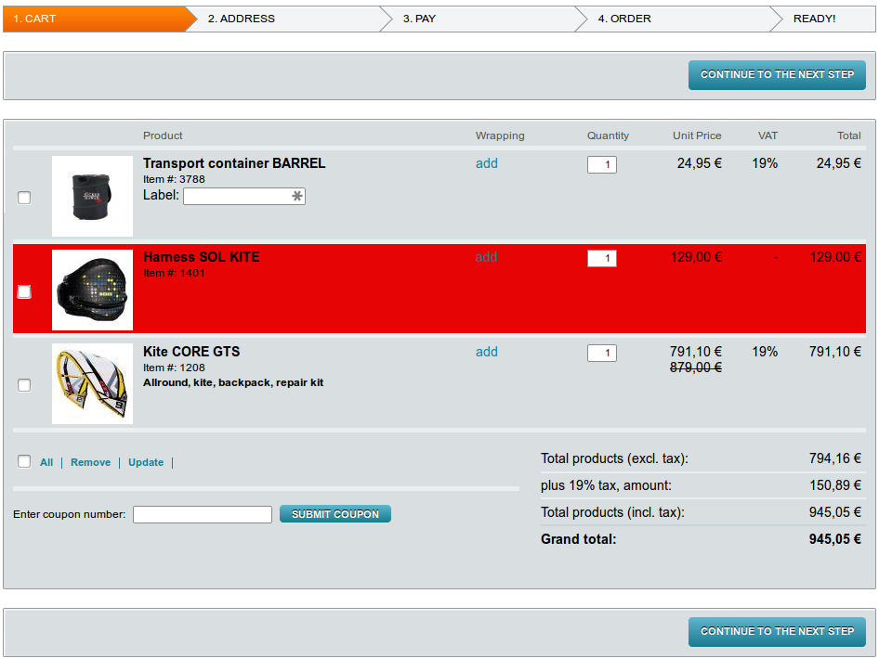

# Known issues

In this section we describe several know issues about order management. These issues exist in Shop admin order administration.

## Products with zero VAT

Current implementation does not show 0 VAT entries. Shop would only show 19% VAT and does not show 0% even if there are two products in order – one with 19% vat and one with 0%. However totals are calculated correctly.

## Up to two VAT

Order can store only up to two different VAT rates. This might be an issue if some country would apply more than two different VAT rates. For example order vas made with three different VAT rates: 15% 19% and 21% basket would display correct information, but order summary in admin would only display two of those different VAT 15% and 19%. 21% VAT rate would not be visible in order information. However totals are calculated correctly.

## Order recalculation

Order recalculation is done by default Shop VAT rate. For example Shop default VAT rate is 19%. An electronic product was bought by user with 10% VAT rate. Order in administration would be with correct VAT rate – 10%. However this would change to 19% VAT rate if order would be recalculated for example by increasing the amount of articles.

1. http://ec.europa.eu/taxation\_customs/resources/documents/taxation/vat/how\_vat\_works/telecom/explanatory\_notes\_2015\_en.pdf [↑](#footnote-ref-1)
2. http://ec.europa.eu/taxation\_customs/resources/documents/taxation/vat/how\_vat\_works/telecom/explanatory\_notes\_2015\_en.pdf [↑](#footnote-ref-2)