OXID eSales  
eVAT module

Copyright

Copyright © 2014 OXID eSales AG, Germany

All rights reserved.

No part of this publication may be reproduced or transmitted in any form or for any purpose without the prior written permission of OXID eSales AG.

Decompilation of source code, piracy as well as transfer to a third party is not allowed.

Use of this content for any other purpose is expressly prohibited and may result in severe civil and criminal penalties. Violators will be prosecuted to the maximum extent possible.

The information contained within this document was created accordingly to the state of the art technology.

OXID eSales AG assumes no liability or warranty for the accuracy, the completeness or reliability of any content.

In spite of all efforts, the occurrence of mistakes cannot be eliminated completely.

Thus we appreciate any tips.

License

Licensing of the software product depends on the shop edition used.

The software for OXID eShop Community Edition is published under the GNU General Public License v3. You may distribute and/or modify this software according to the licensing terms published by the Free Software Foundation. Legal licensing terms regarding the distribution of software being subject to GNU GPL can be found under http://www.gnu.org/licenses/gpl.html.

The software for OXID eShop Professional Edition and Enterprise Edition is released under commercial license. OXID eSales AG has the sole rights to the software. Decompiling the source code, unauthorized copying as well as distribution to third parties is not permitted. Infringement will be reported to the authorities and prosecuted without exception.

Conventions

The following conventions are used:

proportional font with grey background

For user input, code and URLs

Grey italic

For filenames, file paths and other italic highlighting

Bold

For input fields and navigation paths

Bold red

For warnings and important hints

Contact

OXID eSales AG

Bertoldstrasse 48

79098 Freiburg

Germany

Fon: +49 (761) 36889 0

Fax: +49 (761) 36889 29

Represented by the Management Board: Roland Fesenmayr (CEO), Andrea Seeger

Supervisory Board: Michael Schlenk (Chairman)

Commercial Register Freiburg

No. HRB 701648

Table of contents

Copyright 2

License 2

Conventions 2

Contact 3

Table of contents 4

1 Introduction 6

2 System requirement 6

3 Installation 7

3.1 Copying module files 7

3.2 Preparing templates 7

4 Activation 7

5 Configuration 7

5.1 Country VAT Groups 8

5.2 Articles as TBE services 8

5.3 User Location Evidences 8

5.3.1 Logic behind 8

5.3.2 Default evidences 8

6 Functional description 8

6.1 Frontend functionality 9

6.1.1 TBE services in catalogue 9

6.1.2 TBE services during checkout 11

6.2 Backend (admin) functionality 15

6.2.1 Country VAT groups 15

6.2.2 Articles as TBE services 17

6.2.3 Location evidences in order 18

6.2.4 How to configure customer location evidences 19

6.2.5 VAT ID store date 19

7 Extending 20

7.1 How write and add additional evidence 20

Revision History

|  |  |  |  |
| --- | --- | --- | --- |
| Revision | Date | Author | Description |
|  |  |  |  |
|  |  |  |  |
|  |  |  |  |

Related Documents

|  |  |  |
| --- | --- | --- |
| Reference | ID | Name |
|  |  |  |
|  |  |  |
|  |  |  |

# Introduction

This module implements requirements that is to allow an OXID eShop to comply with the EU regulations as specified by the EU VAT directive 1042/2013 regarding VAT for telecommunications, broadcasting and electronic services. This regulation becomes active on the 1st of January 2015.

From the 1st of January a EU directive becomes active that states (in principle) that for **telecommunications, broadcasting & electronic services** (in the following **TBE services**), VAT has to be payed in the country where the customer belongs and no longer in the country of the supplier - irrespective of whether the end customer is a business (taxable person) or a non-taxable person (e.g a private individual).

The reason for this is the following:

"Until the end of 2014, business to final consumer (B2C) supplies by EU businesses are taxed in the country of the supplier. This means that for supplies made to final consumers, businesses established in Member States applying lower VAT rates have a competitive advantage over businesses established in other Member States. The new rules of ? will provide ... a level playing field..."1

However:

"The scope of the 2015 VAT changes ? only covers telecommunications, broadcasting and electronic services. Those changes are relevant only insofar as the customer is a final consumer."2

<http://ec.europa.eu/taxation_customs/resources/documents/taxation/vat/how_vat_works/telecom/explanatory_notes_2015_en.pdf>

<http://ec.europa.eu/taxation_customs/resources/documents/taxation/vat/how_vat_works/telecom/explanatory_notes_2015_en.pdf>

Module title: e-VAT

Version: 1.0

Category: OXID eFire Extension

Manufacturer: OXID eSales AG

Internet: [www.oxid-esales.com](http://www.oxid-esales.com/)

E-mail: [info@oxid-esales.com](mailto:info@oxid-esales.com)

# System requirement

The system requirements given below apply to eVAT module.

* PHP 5.3 or higher
* OXID eShop 5.2

# Installation

In this chapter, the installation of the e-VAT module for the OXID eShop versions 4.9.0/5.2.0 is described. Follow this guide step by step.

## Copying module files

Copy the contents of the /copy_this folder into the root folder of your shop.

## Preparing templates

Additional files required for the use of the module in the shop can be found in the /***changed_full*** folder. The subfolder /changed_full/modules contains standard module files as well as block files used for the "Azure" theme.

When installing the module in a shop without customized templates and files, you can copy all files from this folder directly to the shop.

Generally, and in particular in the case of a customized shop, you need to compare old and new templates and files and adopt recent changes. The changes made are documented in the following folders:

* /templ_docu_admin - changes in /modules/oe/oepaypal/views/admin
* /templ_docu_blocks - changes in /modules/oe/oepaypal/views/blocks

The folders containing the template documentation are only available in the installation package if changes were made in the respective templates and files.

# Activation

The module has to be activated in the shop. In the **Overview** tab of the module, click the **Activate** button. Delete all files and folders except for .htaccess from the /tmpfolder of your shop.

# Configuration

After module activation you need to configure module:

* Add VAT rates for countries
* Mark article as TBE services, and add VAT rates for different countries for this product
* Configure location evidence collectors

## Country VAT Groups

VAT group with VAT rates will be already preconfigured for EU countries. During module activation general and reduced VAT rates for EU countries will be imported. You can find out more about VAT groups in 6.2.1 Country VAT groups.

## Articles as TBE services

Articles data is not configured out of the box. You need to configure all TBE articles define appropriate VAT group per country. You can find out more information how to configure Articles in 6.2.2 Articles as TBE services

## User Location Evidences

### Logic behind

EU VAT directive 1042/2013 require that Shop would find out customer location and apply VAT according to his country. This directive tells that customer location must be found out by at least two evidences. Location provided by customer cannot be used as evidence. OXID eSales eVAT module provides few rules how to find out customer location country and mechanism how to add additional evidence finding algorithms.

### Default evidences

OXID eSales eVAT module use two algorithms to find out customer location: billing address and geo location (based on customer IP address). One of the evidence has highest value than others as those evidences might be contradicted. By default billing address is the default one. For example customer location is Austria if customer billing address is Austria; even geo location said that it is Ireland. If default evidence cannot determine user country, first active evidence with user country will be used. Default evidence can be specified in module configuration screen where evidence id should be entered.

You can find out more information about evidences and their configuration in 6.2.4 How to configure customer location evidences chapter of this document and how to extend with other evidences in chapter 7.1 How to write and add additional evidence.

### Integration with OXID eSales PayPal module

Taking in account that for anonymouse user we can not calculate TBE service final price, because it depends on users residence country, PayPal module‘s express checkout functionality is not compatible with TBE services.

## Compatibility with invoicePDF module

If InvoicePdf module is used in eShop some configuration must be done. Chain of classes which are overloaded can be configured wrongly, so there is need to check them. Go to: *Extensions->Modules->Installed Shop Modules*. List of overloaded classes will be displayed. Class – *oxorder* must be overloaded in this order(from bottom to top): *oevattbeoxorder*, *invoicepdfoxorder*. Check image bellow:

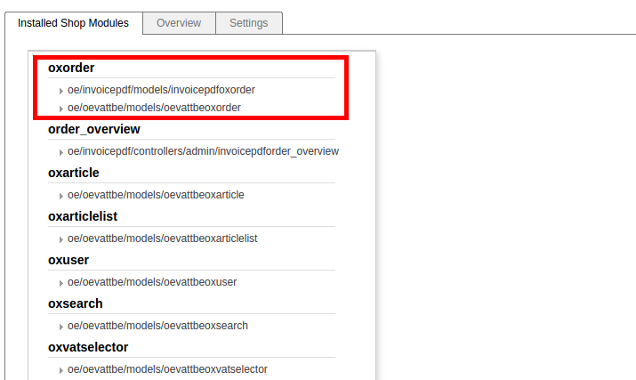

If classes order is not as described before they should be changed by dragging them to correct order and than saved by clicking **Save** button.

# Functional description

This module change how Shop calculates VAT for TBE products. Shop without module always use Shop VAT rate which should be configured by the Shop location country. With this module Shop separate articles in to two groups: TBE and Not TBE services. Not TBE services are calculated with default Shop VAT rate (regular way). TBE articles are calculated with user location country VAT rate.

Shop with module would apply VAT depending on Shop location and customer location.

**EU located Shop supplying for customer:**

|  |  |
| --- | --- |
| **1. Business in another EU country** | No VAT charged.  Customer must account for the tax (reverse-charge mechanism). |
| **2. Consumer in another EU country** | Must charge VAT in the EU country where the customer belongs (not where the business is based). |
| **3. Business** or **consumer outside the EU** | No EU VAT charged.  But if the service is **effectively used & enjoyed** in an EU country, that country  can decide to levy VAT. |

**NON-EU located Shop supplying for customer:**

|  |  |
| --- | --- |
| **1. Business in the EU** | No VAT charged.  Customer must account for the tax (reverse-charge mechanism). |
| **2. Consumer in the EU** (telecoms, broadcasting or electronic services) | Must charge VAT in the EU country where the customer belongs. |
| **3. Business or consumer outside the EU** | No EU VAT charged. |

## Frontend functionality

### TBE services in catalogue

Shop can have various products: TBE service and not. So in all Category lists, details pages, start page and other places (except checkout) TBE services are marked with two stars “**”.

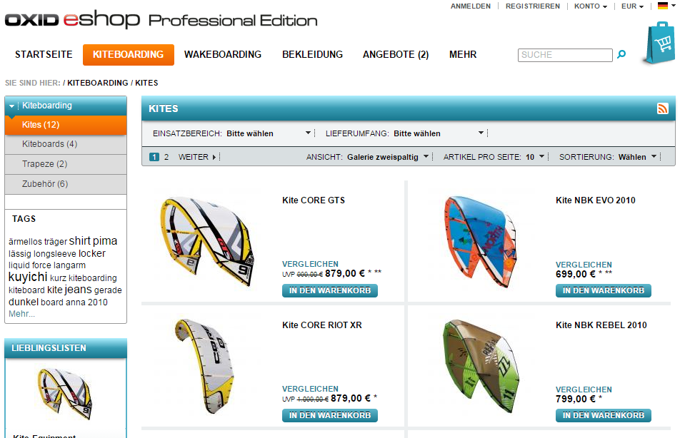

Figure 1 TBE services in category page

At the bottom of the page there link in to page that explains rules how VAT is calculated.

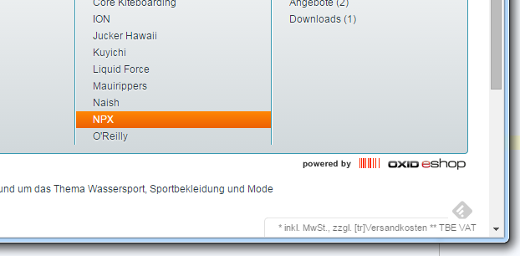

Figure 2 Information block

To define content of this page go to admin: *Customer info->CMS Pages*. Select “CMS page” with identification - **oxdeliveryinfo**. Change content of this page.

### TBE services during checkout

In First checkout step – basket overview articles which are TBE services vat rate is shown with “stars”. At the bottom of basket explanation message is shown. This message explains, that this VAT rate will be changed after user will log in.

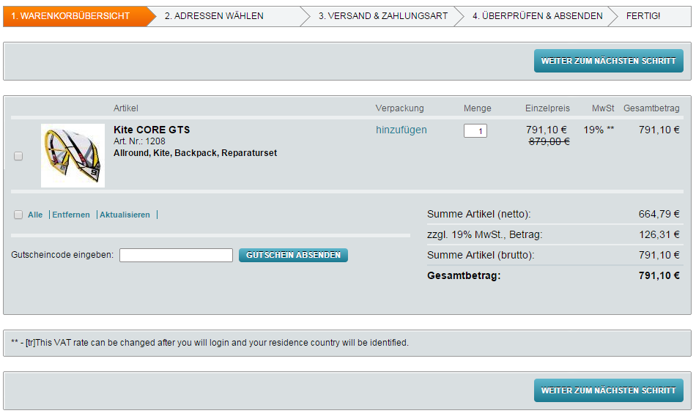

If user is logged in the VAT rate is calculated according to collected evidences and explanation message shows which country is used for calculation.

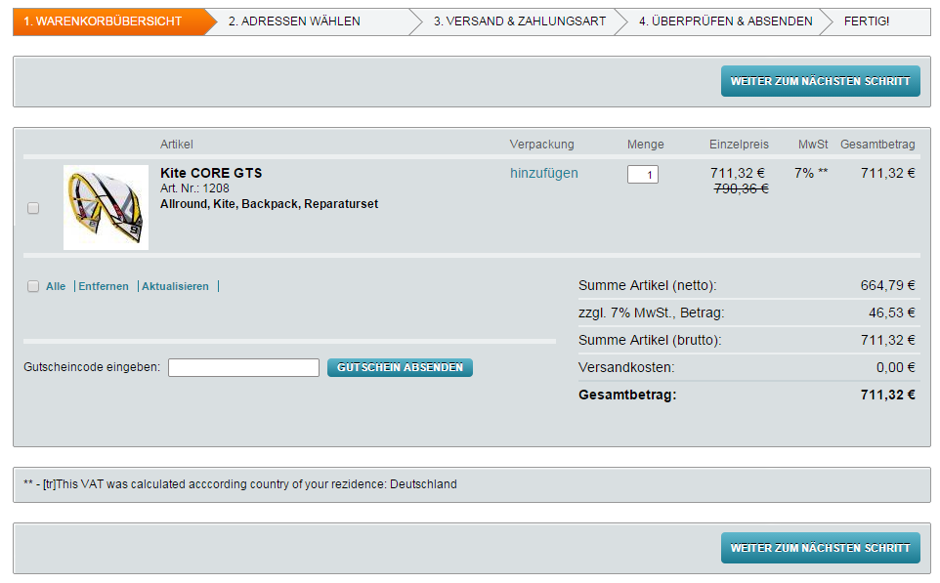

During the first login or if logged in user changes billing address user is informed that country is changed and VAT will be recalculated.

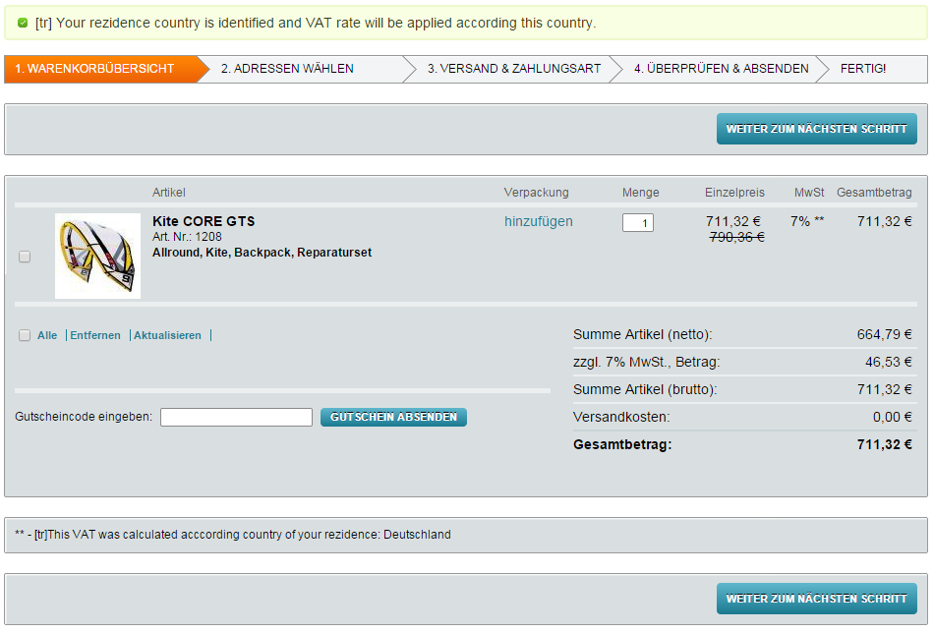

There can be situation when shop is not configured for some EU countries. So after user login with this billing country error will be shown. And of course you can proceed with order if there such situation.

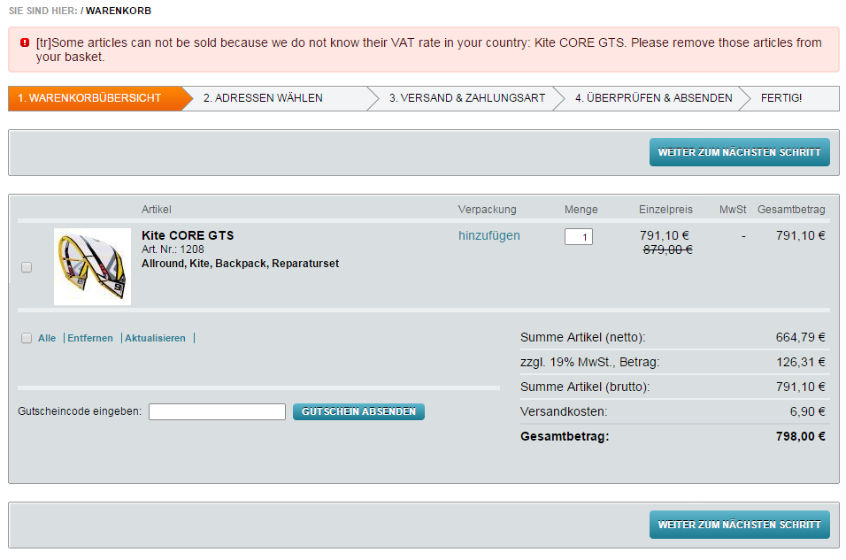

## Backend (admin) functionality

In backend you can configure:

* Country VAT groups
* Articles as TBE services
* Location evidences

Also:

* Added information about stored VAT ID date
* In order added information about collected location evidences

### Country VAT groups

In order to use configured country VAT groups, country should be marked as “Apply TBE VAT rates”. Master setting -> Countries -> Main.

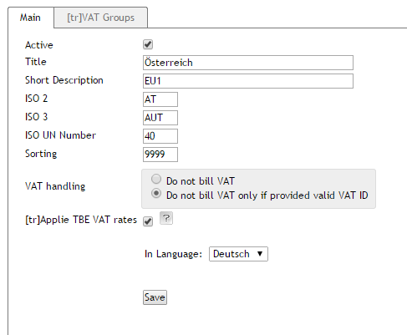

To configure (create, update) VAT groups go to: Master setting -> Countries -> VAT Groups

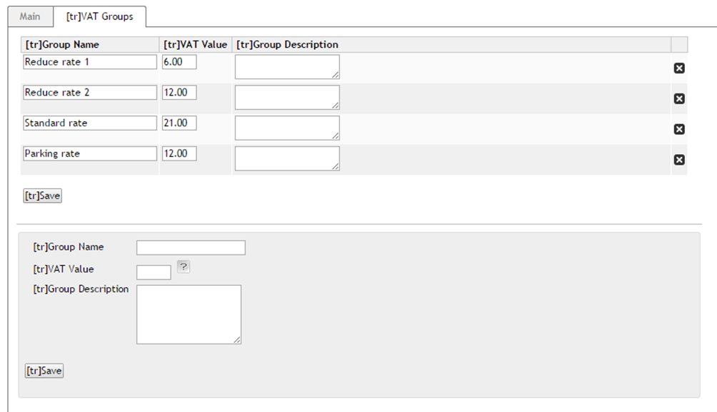

At the bottom is new VAT group creation form. Mandatory fields are “Group name” and “VAT rate”. In list above form you can edit information after that just push button save. If there is need to delete group just click on [X] on the write column.

### Articles as TBE services

To configure Article as TBE services go to: administer products->products choose products and go to “TBE administration” tab.

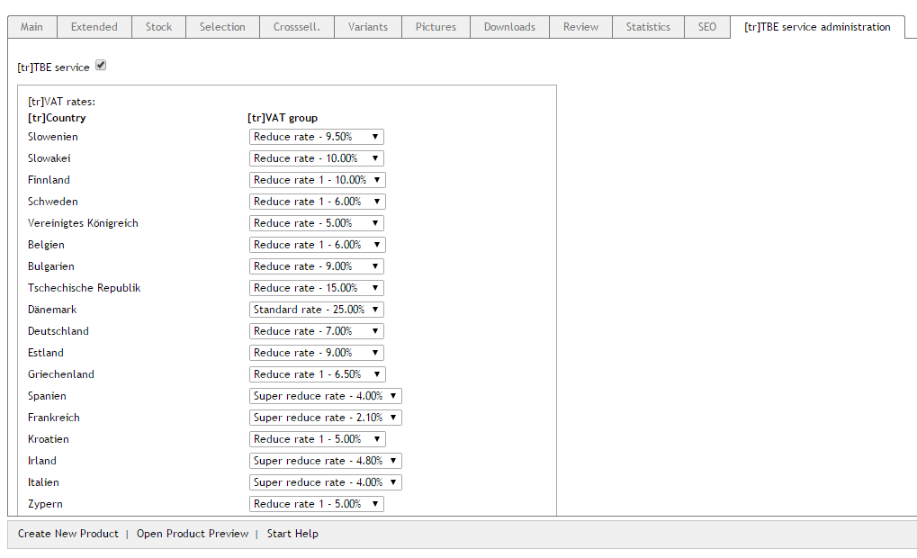

Mark article as “TBE service” with marking checkbox and select proper VAT rate group for each country. Press Save – to save data.

### Location evidences in order

Module have possibility to collect and display evidences of customer location. It's displayed only when order have at least one TBE article in order. This information can be found in *Administer Orders->Orders->Select any order which has TBE products->Main*

At the bottom table will be displayed information like in image displayed bellow:

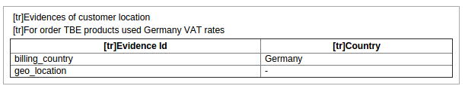

From the image can be seen that for this order TBE services Germany VAT rates were used.

There are also displayed evidences which were used to check the country. Evidence billing_country shows Germany, and evidence geo_location doesn't show any country because it did not give any results.

### How to configure customer location evidences

In module configuration screen registered evidences can be activated or deactivated. It is also possible to specify which evidence should be used as default:

Evidences can be activated or deactivated by changing evidence value to 1 (active) or 0 (inactive). 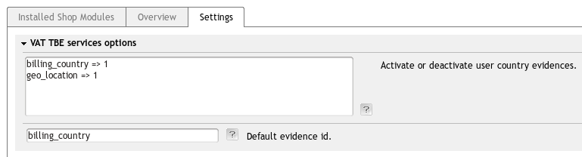

For example to deactivate billing_country evidence, its value should be changed to 0:

billing_country => **0**

geo_location => 1

Only active evidences will be used in user country calculations and stored in order information.

To change default evidence, enter evidence id to the input field (change billing_country to geo_location in this case).

In case default evidence can not be found or no default evidence is specified, first evidence with non empty country will be used.

### VAT ID store date

Module adds feature to store first date when VAT IN of customer was provided. For new registered users if VAT IN vas valid it is stored during user registration. If user provides VAT IN later it will be stored when it will be provided: during checkout or changed in account pages. To see the date when VAT IN was provided do to admin->users select user:

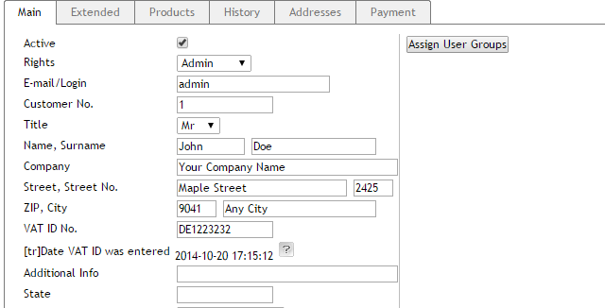

### Invoice PDF module changes

eVAT module adds some changes to invoice PDF file. If an order has TBE services there is shown mark - **\*** near VAT rate in the invoice. And also there is an explanation what does it means. Country which VAT rate was applied also shown. See an image bellow:

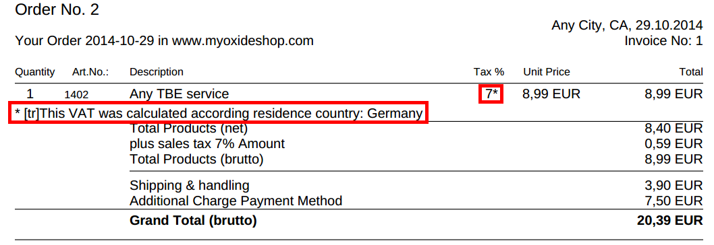

# Extending

In this section we will describe how to extend current module by adding additional evidence collectors.

## How write and add additional evidence

To add additional customer location evidences you need to write location evidence class and register it.

* Evidence class must extend **oeVATTBEEvidence** class to have required interface.
* This class should be registered with **oeVATTBEEvidenceRegister::registerEvidence()**.
* This class should be unregistered with **oeVATTBEEvidenceRegister::unregisterEvidence()** when it is no longer available.

This can be done by [creating a module](http://wiki.oxidforge.org/Tutorials#Modules_and_Extensions) containing new evidence classes and registering them in module's onActivate() and onDeactivate() events:

|  |
| --- |
| public static function onActivate()  {  if (class_exists('oeVATTBEEvidenceRegister')) {  $oConfig = oxRegistry::getConfig();  /** @var oeVATTBEEvidenceRegister $oEvidenceRegister */  $oEvidenceRegister = oxNew('oeVATTBEEvidenceRegister', $oConfig);  $oEvidenceRegister->registerEvidence('oeVATTBEExtendedEvidence1');  $oEvidenceRegister->registerEvidence('oeVATTBEExtendedEvidence2');  }  }  public static function onDeactivate()  {  if (class_exists('oeVATTBEEvidenceRegister')) {  $oConfig = oxRegistry::getConfig();  /** @var oeVATTBEEvidenceRegister $oEvidenceRegister */  $oEvidenceRegister = oxNew('oeVATTBEEvidenceRegister', $oConfig);  $oEvidenceRegister->unregisterEvidence('oeVATTBEExtendedEvidence1');  $oEvidenceRegister->unregisterEvidence('oeVATTBEExtendedEvidence2');  }  } |

If module will not unregister added evidences on deactivation, those evidences will be removed on next user country calculation.

New evidence classes must be registered in module's metadata.

Module with additional evidences must be activated only when “VAT TBE Services” module is active, otherwise oeVATTBEEvidenceRegister will not be found.

Currently **oeVATTBEGeoLocationEvidence** evidence class is only a dummy class and should be implemented. This can also be done by extending this class with module and implementing oeVATTBEGeoLocationEvidence::getCountryId() method.