准备两台虚拟机下载mysql5.7.21通用二进制版
wget https://dev.mysql.com/get/Downloads/MySQL-5.7/mysql-5.7.21-linux-glibc2.12-x86_64.tar.gz
创建mysql用户组和mysql用户
useradd mysql
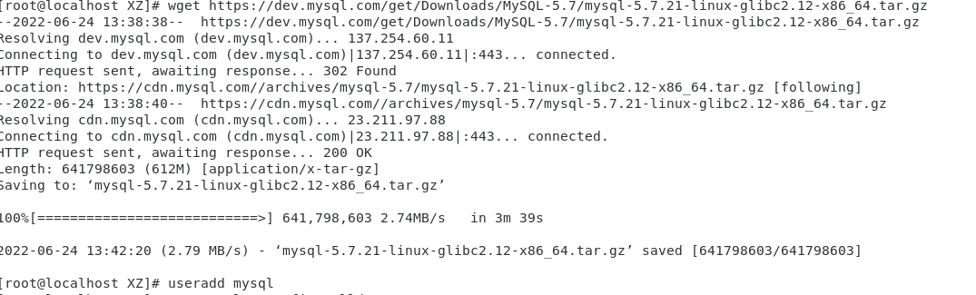
解压安装包，并将解压好的文件夹重命名为mysql
tar -zxvf mysql-5.7.21-linux-glibc2.12-x86_64.tar.gz
mv mysql-5.7.21-linux-glibc2.12-x86_64 mysql
移动到/usr/local目录下
mv mysql /usr/local
创建/etc/my.cnf配置文件
主库
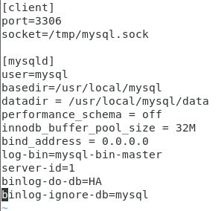
从库
[client]
port=3306
socket=/tmp/mysql.sock

[mysqld]
user=mysql
basedir=/usr/local/mysql
server_id=2
datadir = /usr/local/mysql/data
performance_schema = off
innodb_buffer_pool_size = 32M
bind_address = 0.0.0.0

初始化mysql、复制mysql临时密码
cd /usr/local/mysql/bin
./mysqld --initialize --user=root --basedir=/usr/local/mysql/ --datadir=/usr/local/mysql/data
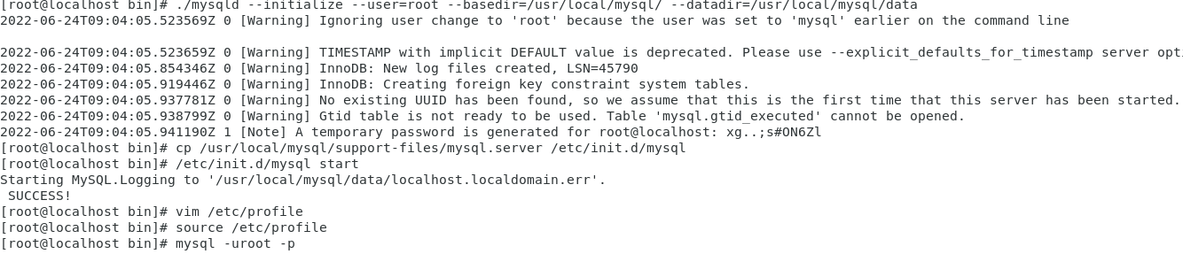
cp /usr/local/mysql/support-files/mysql.server /etc/init.d/mysql运行
将mysql启动文件写入到环境变量中,在最底下加上2行配置
vim /etc/profile
PATH=$PATH:/usr/local/mysql/bin
export PATH

刷新环境变量，使最新的环境变量运行
source /etc/profile
开启/etc/init.d/mysql start
启动mysql -uroot -p
输入mysql临时密码
重置密码
set password for root@'localhost'=password('123456');
刷新
flush privileges;
主从库授权
grant replication slave on *.* to 'test'@'192.168.178.129' identified by '123456';
#授权后需要刷新后，才能生效；
flush privileges;
#查看主库授权状态
show master status;
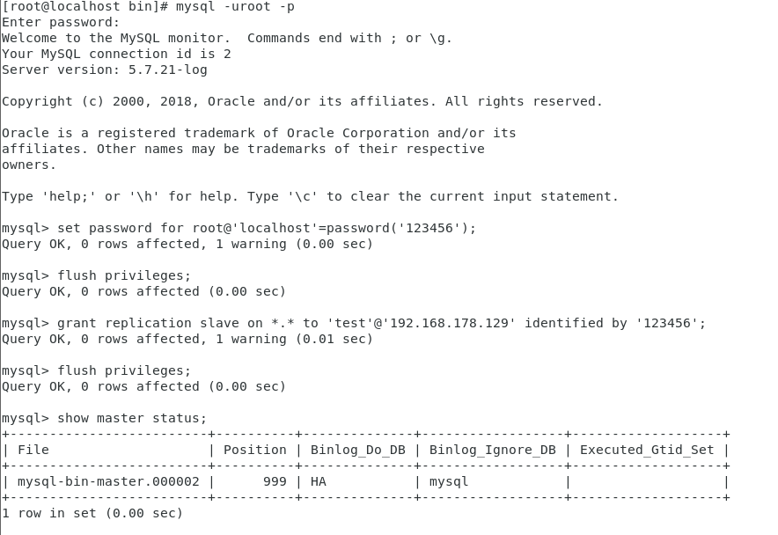
从库授权
change master to master_host='192.168.178.110',master_user='test',master_passw
刷新
flush privileges;
start slave;
#查看拷贝状态
show slave status;
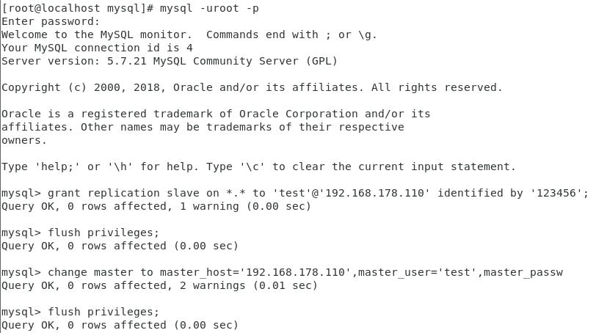
当查看从库的slave状态，下面两个状态都是yes时，代表主从库配置成功了。
Slave_IO_Running: Yes
Slave_SQL_Running: Yes
Slave_IO_Running ：一个负责与主机的io通信
Slave_SQL_Running：负责自己的slave mysql进程
两个为YES 就成功了！
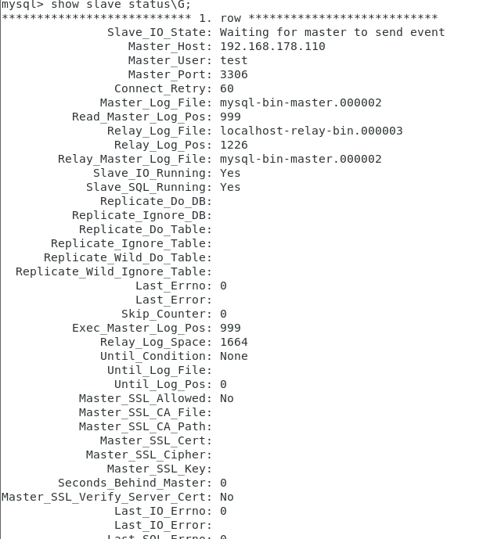
创建需要同步的数据库:HA

