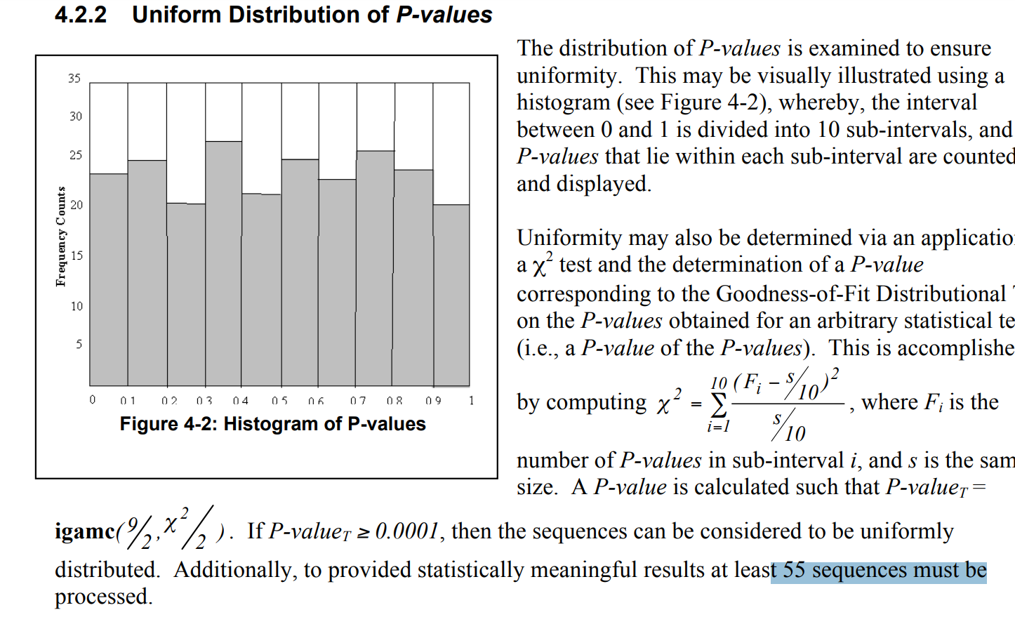

4-3 : 失敗原因跟變數設定

Number of sequence should be larger than $\frac{1}{α}$

p-value 要達魚的數字

2-1:

1. Sequence length (n) > 100 bits

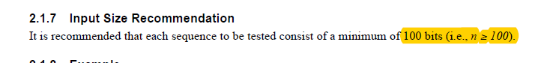

2-2

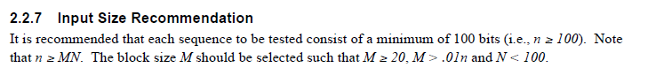

2-3

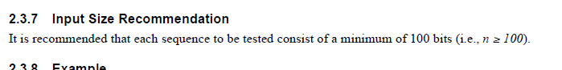

2-4:

1. 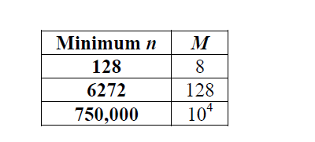

2-5

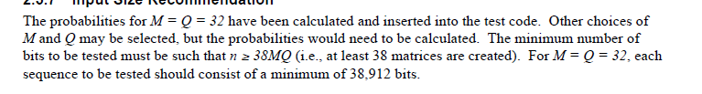

2-6



2-7

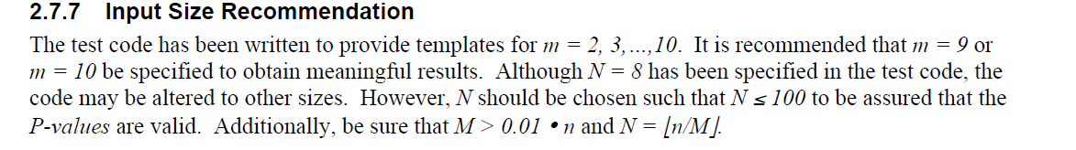

2-8

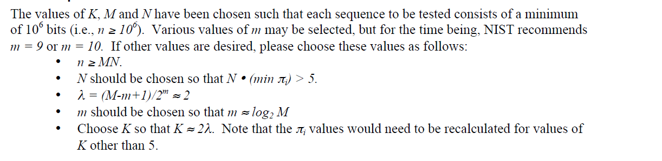

2-9

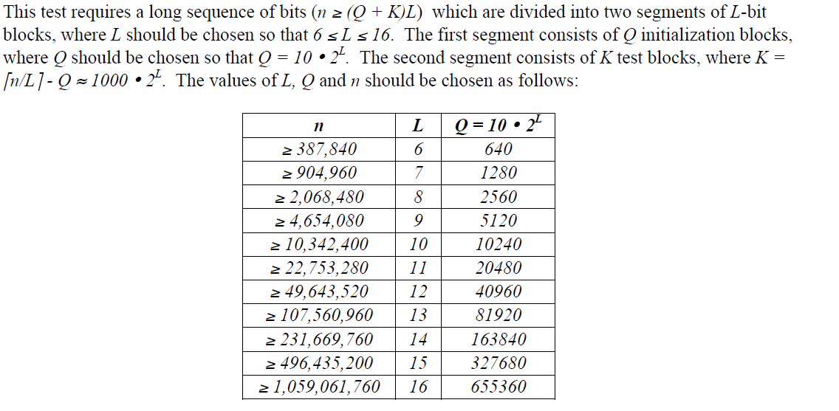

2-10

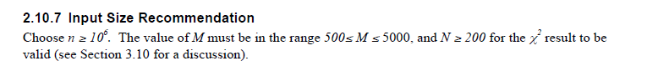

2-11

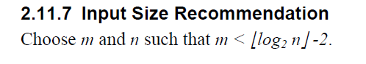

2-12

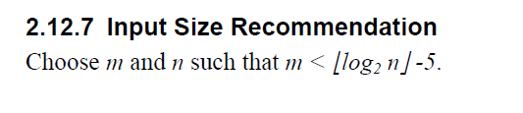

2-13

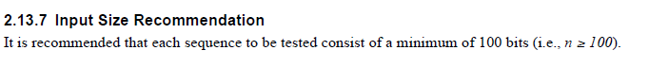

2-14



2-15



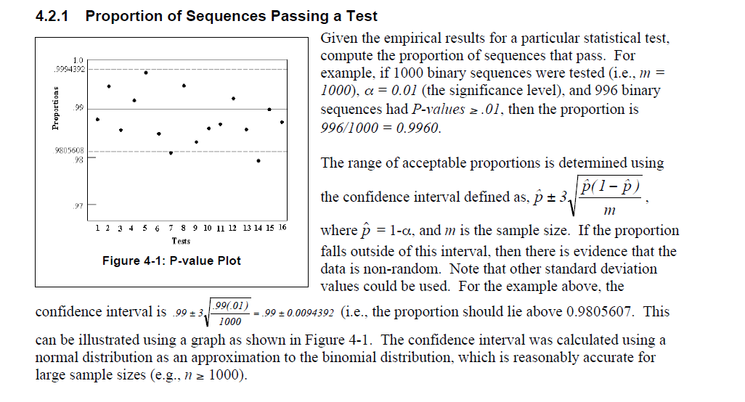

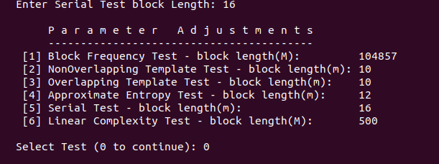

Frequency Test within a Block

Result 3

