**metin içeren bir resim

Açıklama otomatik olarak oluşturuldu**1) **TASK 3**

**tablo içeren bir resim

Açıklama otomatik olarak oluşturuldu**

WITH A1 AS ( SELECT RANK() OVER (PARTITION BY DEPARTMENT_ID

ORDER BY SALARY DESC ) RANK,

DEPARTMENT_ID,

SALARY

FROM HR.EMPLOYEES)

SELECT D.DEPARTMENT_NAME, A1.SALARY,RANK

FROM A1

JOIN HR. DEPARTMENTS D

ON D.DEPARTMENT_ID = A1.DEPARTMENT_ID AND RANK = 1

metin içeren bir resim

Açıklama otomatik olarak oluşturuldu2)

tablo içeren bir resim

Açıklama otomatik olarak oluşturuldu

WITH B1 AS ( SELECT X.LOCATION_ID, D.DEPARTMENT_ID

FROM HR.LOCATIONS X

JOIN HR.DEPARTMENTS D

ON X.LOCATION_ID = D.LOCATION_ID)

SELECT B1.LOCATION_ID, COUNT(E.EMPLOYEE_ID)

FROM B1

JOIN HR.EMPLOYEES E

ON B1.DEPARTMENT_ID = E.DEPARTMENT_ID

GROUP BY B1.LOCATION_ID

metin içeren bir resim

Açıklama otomatik olarak oluşturuldu3)

tablo içeren bir resim

Açıklama otomatik olarak oluşturuldu

WITH Z1 AS ( SELECT D.DEPARTMENT_ID, E.EMPLOYEE_ID

FROM HR.DEPARTMENTS D

FULL OUTER JOIN HR.EMPLOYEES E

ON D.DEPARTMENT_ID = E.DEPARTMENT_ID

WHERE E.EMPLOYEE_ID IS NULL)

SELECT D2.DEPARTMENT_ID, D2.DEPARTMENT_NAME, SUBSTR(D2.DEPARTMENT_NAME,5,1), Z1.EMPLOYEE_ID

FROM Z1

JOIN HR.DEPARTMENTS D2

ON Z1.DEPARTMENT_ID = D2.DEPARTMENT_ID

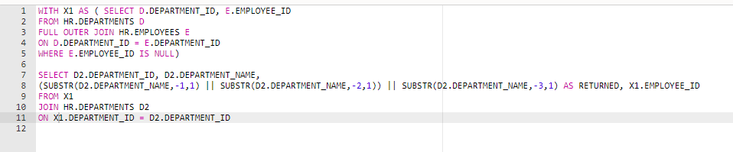4)

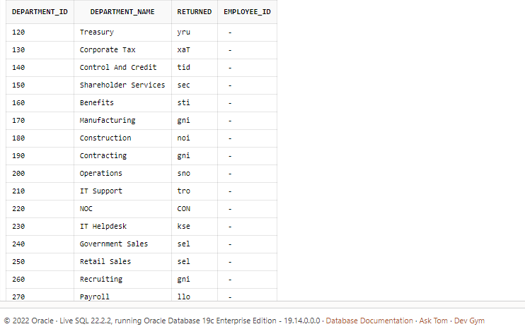

WITH X1 AS ( SELECT D.DEPARTMENT_ID, E.EMPLOYEE_ID

FROM HR.DEPARTMENTS D

FULL OUTER JOIN HR.EMPLOYEES E

ON D.DEPARTMENT_ID = E.DEPARTMENT_ID

WHERE E.EMPLOYEE_ID IS NULL)

SELECT D2.DEPARTMENT_ID, D2.DEPARTMENT_NAME,

(SUBSTR(D2.DEPARTMENT_NAME,-1,1) || SUBSTR(D2.DEPARTMENT_NAME,-2,1)) || SUBSTR(D2.DEPARTMENT_NAME,-3,1) AS RETURNED, X1.EMPLOYEE_ID

FROM X1

JOIN HR.DEPARTMENTS D2

ON X1.DEPARTMENT_ID = D2.DEPARTMENT_ID

NOT: 5.sorunun çözümünde hata aldığım için tamamlayamadım.