Revision History
Date | Version | Description | Author
<19/10/2015> | <0.1 > | <Writing the whole SRS> | <Alhussam Alwani>,  <Aras Selvi>

TABLE OF CONTENTS
Revision History 1
1 INTRODUCTION 3
1.1 Document overview 3
1.2 Abbreviations 3
1.3 References 3
1.4 Conventions 3
2 REQUIREMENTS 6
2.1 User Requirements Specification 6
2.2 System Architecture 7
2.3 Use Cases and Usage Scenarios 7
2.4 System Requirements Specification 8

INTRODUCTION

Document overview

This document presents the software requirements specifications of LDBMS software development project.

It describes:
- Requirements of functionalities, use cases, scenarios with the environment
- The compliance of requirements to customer needs
- The relative importance and precedence of requirements
- The services of the basic functions

System overview
The system is needed for a school’s online library management. It will provide the basic functions like login, signup, add/delete, display, borrow etc. It will have a simple user interface.

Abbreviations
LDBMS – Library Database Management System
SRS – Software Requirements Specifications
UML – Unified Modelling Language

References

# | Document Identifier | Document Title
1 | Software Development Plan | SDP

Conventions
Requirements listed in this document are constructed according to the following structure:

LogIn
The function that allows user log in
LogIn-010

SignUp
The function that allows user sign up
SignUp-020

Display
The function that allows user display books
Display-030

Borrow
The function that allows user request borrow
Borrow-040

Add/Delete
The function that allows admin add or delete book
Add/Delete-050

Search
The function that allows user/admin to search book
Search-060

Availability
The function that provides the availability status in display
Availability-070

Ethical
This nonfunctional requirement is about giving importance to ethics
Ethical-080

Security
This nonfunctional requirement is about providing security
Security-090

LogIn
The system requirement of LogIn function
0.10.1

SignUp
The system requirement of SignUp function
0.20.1

REQUIREMENTS

User Requirements Specification
SRS-LogIn-010 SAMPLE
LBDMS shall provide a login page to the user. The user can login by using his/her ID. If the user is an admin he/she has to use his/her password too.

V1.0

SRS-SignUp-020 SAMPLE
In the login page, there will be a signup function that will help the user create an account with his/her student ID/password.

V1.0

SRS-Display-030 SAMPLE
LDBMS software shall display all the available books in school’s library to the users using Display algorithm.

V1.0

SRS-Borrow-040 SAMPLE
Borrow algorithm should allow students to borrow books and provide admins with their borrowing status.

V1.0

SRS-Add/Delete-050 SAMPLE
The add/delete option should provide the admin with the option of adding or deleting a book to the library database.

V1.0

SRS-Search-060 SAMPLE
The search function should allow the users to find a book using its name or author or IBAN.

V1.0

SRS-Availability-070 SAMPLE
The LDBMS software shall be available to the admins during the working hours (Monday – Friday 08:00 – 17:30), and 24/7 to the students.

V1.0

SRS-Ethical-080 SAMPLE
The books in the Library will be cited clearly. The copyrights will be presented completely.

V1.0

System Architecture
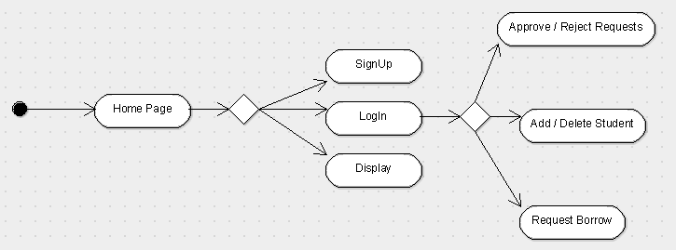

Use Cases and Usage Scenarios
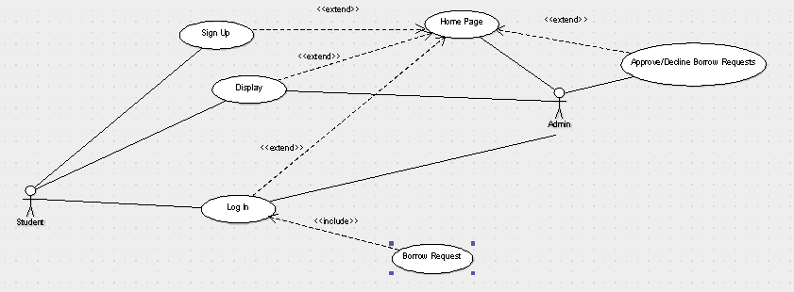

System Requirements Specification
SRS-Security-090 SAMPLE
If the user doesn’t have an account he/she shall not be able to borrow a book.

V1.0

SRS-LogIn-010.1 SAMPLE
If a user uses the function LogIn( ) the system will record that action in the login history. Also the system records the time the user stayed in the system.

V1.0

SRS-SignUp-020.1 SAMPLE
If a new user signs up, the new object will be created.

V1.0

