Revision History
Date | Version | Description | Author
<06/Oct/2015> | <0.1> | <Finished the Identification section> | <Beda Philbert>
<06/Oct/2015> | <0.1> | <Started working and almost finished both: Software Development Activities and Responsibilities Labeled (2, 3)> | <Aras Selvi>
<06/Oct/2015> | <0.1> | <Finished Risk Assessment part numbered as 4, (4.1) belongs to Ammar and (4.2) to Daniyal> | <Ammar Khan>, <Daniyal Anwar>
<07/Oct/2015> | <0.1> | <Completed the 2. And 3. Sections (SDA, Responsibilities) and combined the whole work to a single SDP file> | <Alhussam Alwani>

TABLE OF CONTENTS

Revision History 1
1 Identification 3
1.1 Document overview 3
1.2 Abbreviations 3
1.2.1 Abbreviations 3
1.3 References 3
1.3.1 Project References 3
2 Software Development Activities 3
2.1 Software development process 3
2.1.1 Overview of process phases 3
2.1.2 Technical documentation 3
2.1.3 Deliverables: 3
2.2 Software development tools 4
2.2.1 Workstation 4
2.2.2 Requirements management and documentation 4
2.2.3 Software Design 4
2.2.4 Coding and automated tests 4
2.2.5 Configuration management 4
2.3 Software development rules and standards 4
3 Responsibilities 4
3.1 Activities and responsibilities 4
4 Risk Assessment 5
4.1 Risk Analysis 5
4.2 Risk Planning 5

Identification

Document overview
This document contains the software development plan of software LDBMS.

Abbreviations

Abbreviations
LBDMS: Library Database Management System.
SDP: Software Development Plan.
SDA: Software Development Activities.
UML: Unified Modeling Language.
EXE: File Extension.
SRS: Software Requirements Document.
STP: Software Test Plan.
SDD: Software Design Document.
STR: Software Test Report.

References

Project References

# | Document Identifier | Document Title
[R1] | LDBMS 0.1 | The initial stage of LDBMS.

Software Development Activities
The section lists and describes the software development activities of LDBMS software development project.

Software development process
Our process will inherit from the waterfall model
We have chosen this model because we don’t have any clients (If you have a client it is harder to use waterfall model). And %30-50 of time will be remaining for test by this model.
The phases are easy to understand and follow.

Overview of process phases
Will be using the waterfall model phase.
Will follow:
- Conception
- Initiation
- Analysis
- Design
- Construction
- Testing
- Production/implementation
- Maintenance

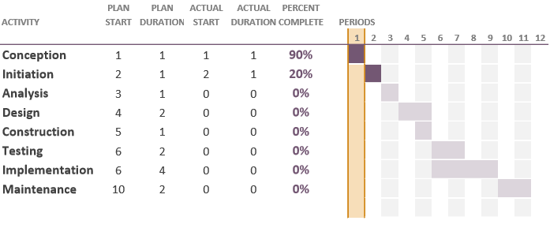

Technical documentation
The following documentation is going to be provided during the processes of the design:
- Software Requirements Document (SRS)
- Software Test Plan (STP)
- Software Design Document (SDD)
- Software Test Report (STR)
- Demo Of the Program

Deliverables:
The following items are delivered at the end of the process:
- The code of the program
- The output of our program (Sample outputs)
- The .EXE file to test and use
- User Documentation: User guide, Administration procedure.

Software development tools

Workstation
Each author is using his/her own Laptop, all connected to GitHub accounts and developing using the master server of GitHub.

Requirements management and documentation
- Will use Microsoft Word to share requirements. Responsibility distribution and other jobs will be done by using Word.
- Will provide diagrams and graphs from Microsoft Excel. (For example UML Diagrams)

Software Design
Tools used to design the software:
- ArgoUML (to link classes together).

Coding and automated tests
Will only use Visual Studio for programming C++. Both implementations and tests will be implemented inside Visual Studio using Visual Studio 2013 built-in libraries.

Configuration management
Tools used for Configuration Management and Bug Tracking:
- GitHub: Repository located in OZUCS320 Organization under the name CS320Project.
- Bugzilla: Used to track and keep record of the status of current bugs/issues.

Software development rules and standards
We will have an UML class diagram. It will be provided for the ones who will implement certain functions. Everyone will go by this diagram.

Responsibilities

Activities and responsibilities

Activity | Responsibility | Comment
Project management | Aras, Hussam | Will communicate with the team and edit the works. Also arrange meetings is a responsibility for them.
Configuration tools management | Ammar, Daniyal | Will manage and uniformly organize information to assure error-free development
Setting up the Development tools | Beda | Will lead the usage of the tools that will be used (Visual Studio, UML diagram).
Software specifications | Ammar, Daniyal | Will set a certain specifications for the software and inform the team about it
Database design | Hussam | Will lead the database inside Visual Studio (ofstream library is going to be used)
Follow-up the time and processes | Aras, Beda | Will follow the waterfall processes, inform people and arrange the time for each job.

Risk Assessment

Risk Analysis
Risk Type | Possible Risks
Technology | The technology stack being used may not fulfill the requirements.
People | Assigned group members may not be able to complete their tasks.
Performance | The performance of program can be slow.
Tools | Software tools may not work together in an integrated way.
Time Estimation | Time required to develop the program may take longer.
More Features | Some extra functionalities maybe required to complete the task.

Risk Planning
Risk | Possible Risks | Probability | Effect | Action against risks
Technology | The technology stack being used may not fulfill the requirements. | moderate | Serious | We will chose the best option
People | Assigned group members may not be able to complete their tasks. | low | Tolerable | The task will be handled by some other member
Performance | The performance of program can be slow | moderate | Serious | We will tweak the program to make it fast
Tools | Software tools may not work together in an integrated way. | moderate | Serious | Look at the other available tools
Time Estimation | Time required to develop the program may take longer. | high | Serious | Divide the work in small bits and pieces make small tasks in specific time to cover it in time.
More Features | Some extra functionalities maybe required to complete the task | moderate | Tolerable | Will be updated as required

