A Disaggregate Visitor Model for Oahu
Caliper Corporation
September 2025

Introduction and model structure
Visitor travel is a major source of transportation demand on Oahu, and the factors that impact visitors are distinct from residents. Caliper Corporation developed a fully disaggregate activity-based model for visitors to capture these unique behaviors.
This document summarizes the approach, methodological details and model estimation results for a new, disaggregate treatment of visitor travel in Oahu. The data for this enhancement come from the airport visitor survey conducted in 2024 and covers international visitors as well as those arriving in Oahu from other US states. Inter-island visitor travel was not included, per discussions with MPO staff.
The visitor model includes the following steps:
- A synthesis of visitor groups
- A model of lodging location choice
- A model predicting the presence of kid(s) in each group
- A model predicting the use of a rental car
- Models capturing tour frequency, destinations, time of day and modes by activity purpose
- Intermediate stops models, including mode switches
The tour and trip outputs are finally assimilated into origin-destination (OD) matrices by mode and time of day for assignment. The figure below shows the positioning of the visitor model within the overall model stream:
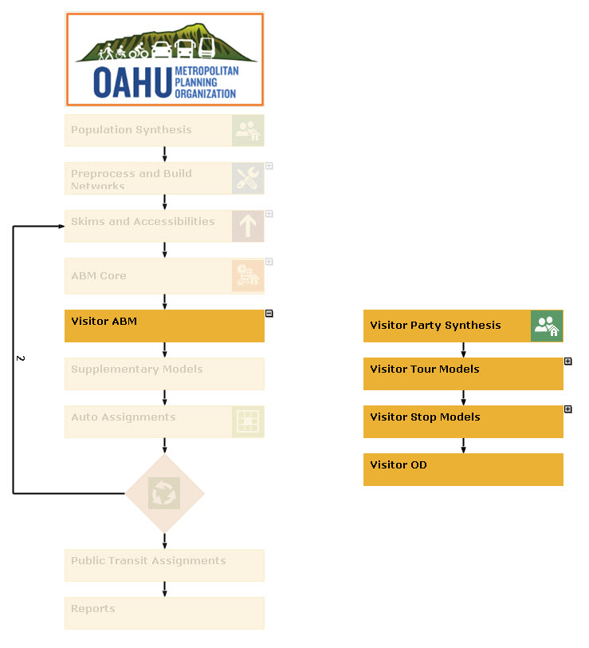
Visitor Party Synthesis includes the population synthesis and models predicting the presence of kids, the availability of a rental car and the choice of lodging zone.

Visitor population synthesis
The Oahu visitor population is synthesized as a list of visitor groups with one or more people in each group. However, unlike typical synthesis, the individual persons in each group are not enumerated because this information is not available in the survey.
After analyzing the visitor survey data, the synthetic population was stratified along the dimensions of country of origin, primary visit purpose, and party size. The weighted totals from the survey constituted the input marginals to the synthesis procedure. These totals are summarized in the table below:
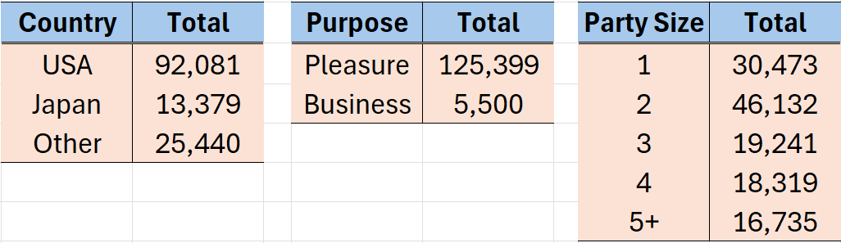
The survey records also served as the seed table for sampling visitor groups into the synthetic population. The output groups match the observed survey data to a high degree of accuracy and generated YYYY groups.

Visitor demand model components

Presence of kids
The presence of kids can have a significant impact on the decisions made by visiting parties. A model predicting the presence of kid(s) was estimated, and the specification is as below:
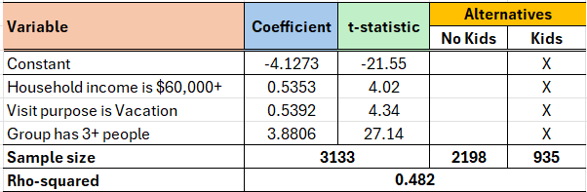
Groups from higher-income households, those visiting on vacation, and groups with 3 or more people tend to have kids.

Lodging location choice
The destination choice models for visitors adopt a nested Logit approach wherein zones are collected into clusters. The choice follows a hierarchical decision process so that each group selects a cluster and subsequently picks a zone from within that cluster. The clusters for lodging choice were developed to reflect the main type of lodging available in each zone: major resorts, minor resorts (including hotels and motels) and AirBnB/private. The allocation of zones to clusters and the frequency of choices in the survey are summarized in the table below:
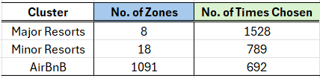
The estimated model specification is as below:
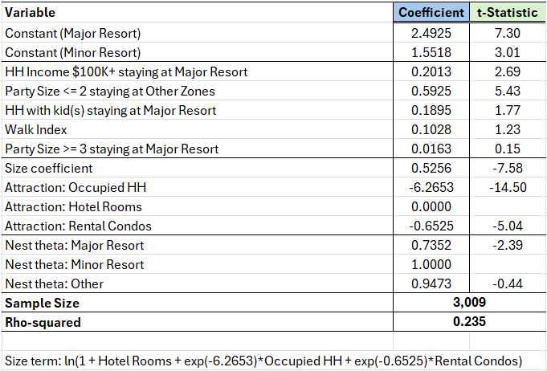
The choice of lodging zone is sensitive to group demographics and the walk index of the candidate zone. The size term, which fine-tunes destination choices toward attractions, is sensitive to the number of occupied households, hotel rooms and rented condos in each zone.

Rental car choice
Mode choice for visitors on the island are highly correlated with a group’s decision to rent a vehicle. The model estimated to capture this effect is shown below:
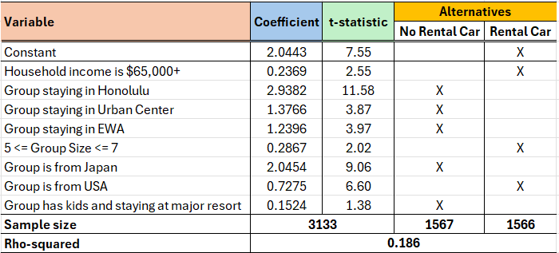
Higher-income households, larger groups and those from the US tend to rent a car. Those staying in dense neighborhoods such as those in Honolulu, and groups with kids staying at a major resort tend to not rent a vehicle.

Activity frequencies by purpose
Visitor activities in the Oahu model are classified into Work, Recreation, Shopping and Other purposes. The models for predicting the frequencies of each type of tour are presented in this section.

Work tour frequency
The work tour frequency model specification is as below. It was estimated on the survey records corresponding to respondents who indicated that their visit purpose was business. At most one work tour is allowed in the model.
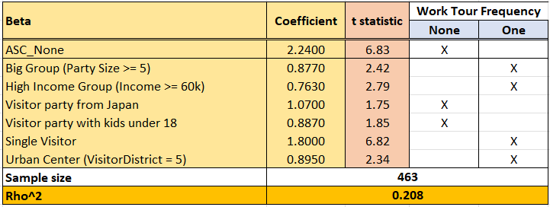

Recreation tour frequency
At most two recreation tours are allowed in the model.
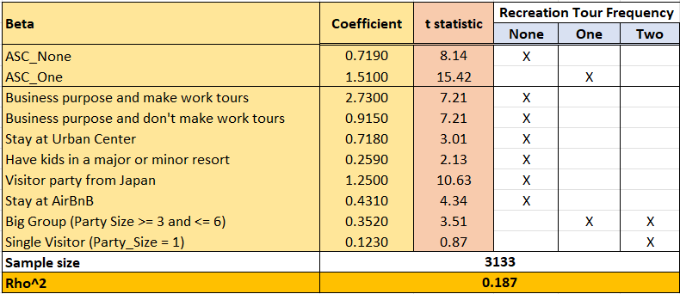

Shopping tour frequency
At most two shopping tours are allowed in the model.
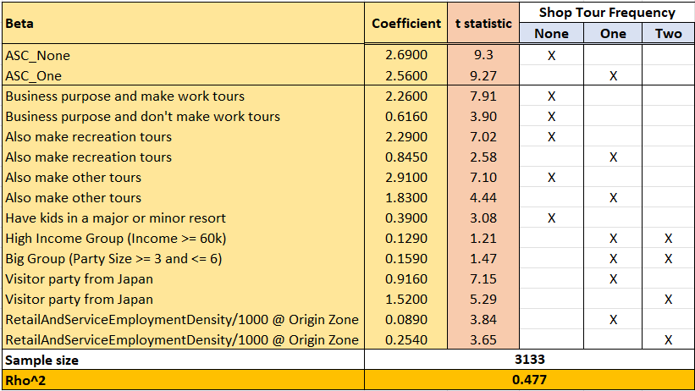

Other tour frequency
At most two tours are allowed in the model for all other purposes combined.
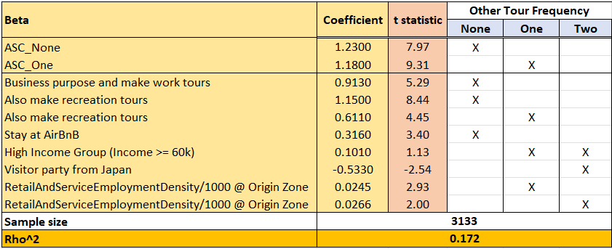

Activity destination choice
The locations of visitor activity destinations in Oahu are predicted using nested specifications (following the approach outlined for lodging zone choice). The clusters for the Work, Shop and Other purposes follows a geographically contiguous partitioning of zones as indicated in the figure below:
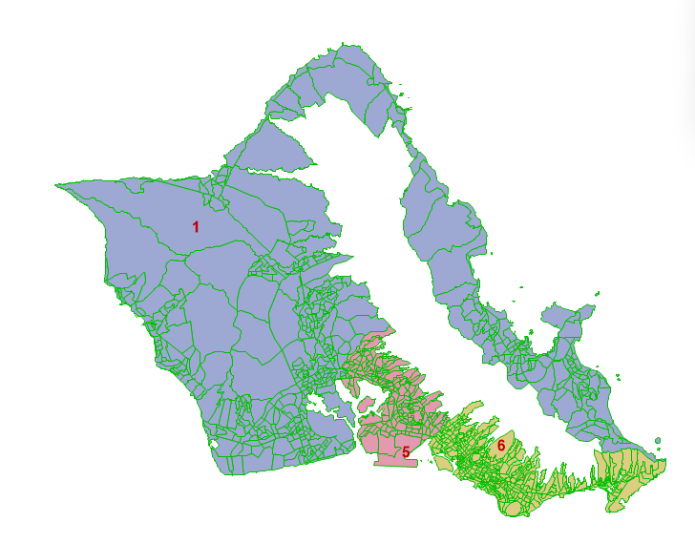
The three clusters correspond to Waikiki (in yellow), the central urban area (in pink) and all other zones (in blue). Tour destinations reported in the survey were largely concentrated in the two urban clusters. Attempts to further divide the blue cluster resulted in sample size issues and weak cluster coefficients.

Work activity destination choice
The sample size for this segment was relatively small, at 180 records. The estimated utility specification is shown below:
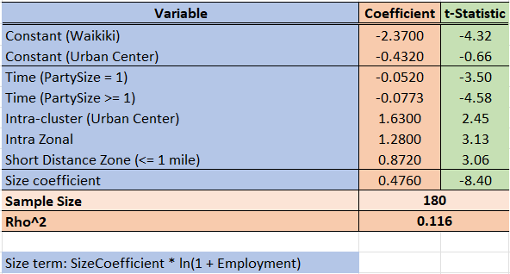
The coefficient of travel time is more onerous for work tours associated with larger group sizes, likely from a need to remain close to non-work activities by other members of the group. Intra-cluster and intra-zonal effects are strong and positive. Destinations within a mile of the lodging zone see a bump in preference.
The size term, influencing attraction effects, is driven by the total employment in each zone.
The model’s nest coefficients are summarized in the table below:
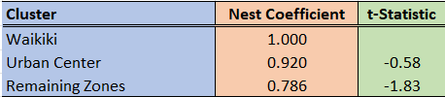

Shopping activity destination choice
The estimated utility specification is shown below:
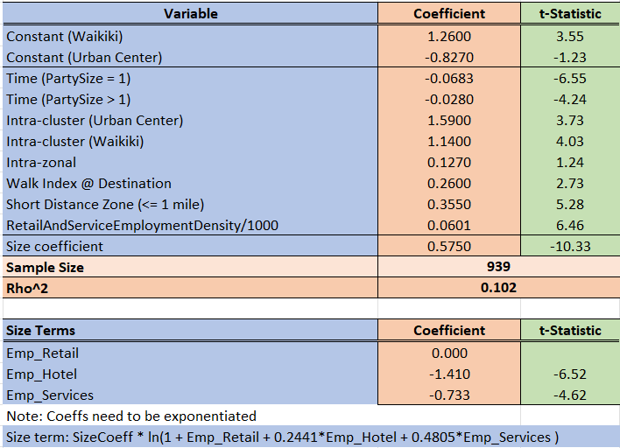
Those traveling alone exhibit a more onerous time effect for shopping. This may be explained by larger groups being more amenable to group shopping activities. A higher walk index is found to be more attractive. Intra-cluster effects are positive and strong.
The size term, influencing attraction effects, is driven by the zonal employment totals in the retail, hotel and services sectors.
The model’s nest coefficients are summarized in the table below:
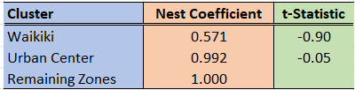
The nest coefficients are not statistically strong, indicating a non-nested behavioral response.

Other activity destination choice
The estimated utility specification is shown below:
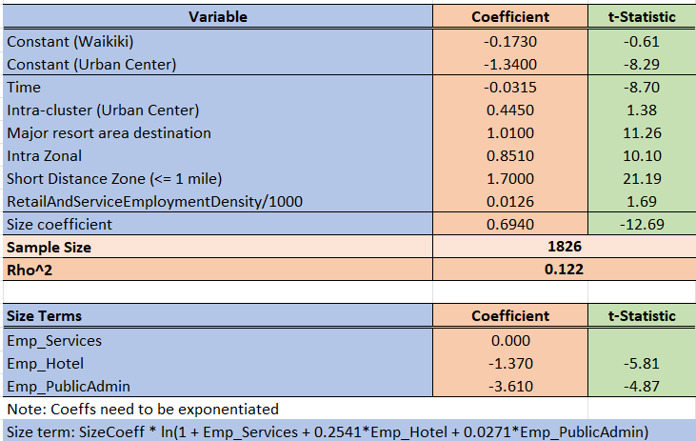
Time, short distances, intra-zonal and intra-cluster effects dominate the location choice. There is a strong preference for locations around major resorts. Higher retail and service employment densities show increased attraction.
The size term, influencing attraction effects, is driven by the zonal employment totals in the services, hotel and public administration sectors.
The model’s nest coefficients are summarized in the table below:
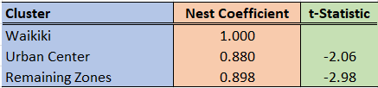

Recreation activity destination choice
Given the spread of recreational activity centers/attractions around the island, the clusters for this purpose are not constructed contiguously. Six clusters were identified based on the recreation locations (zones) reported in the survey. Modifications to the clustering were made based on feedback from MPO staff:
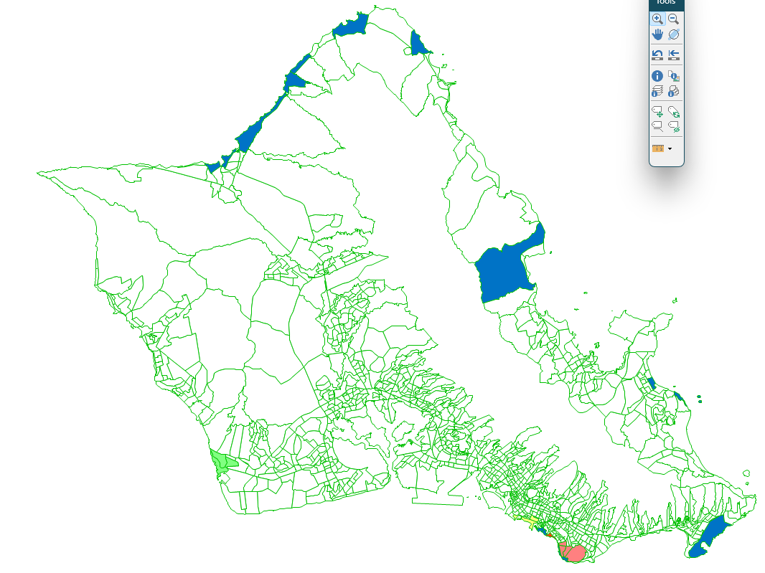
A zoomed-in view of the Waikiki area is shown below:
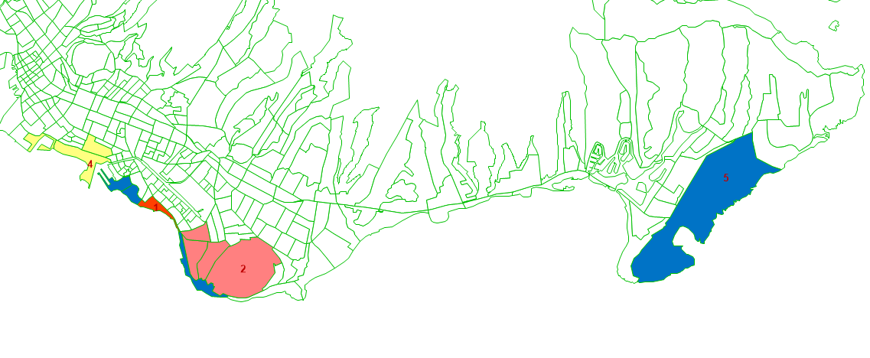
The six clusters correspond to Waikiki beach, Diamond Head area, Ko Olani, Ala Moana, and other beaches.
The estimated utility specification is shown below:
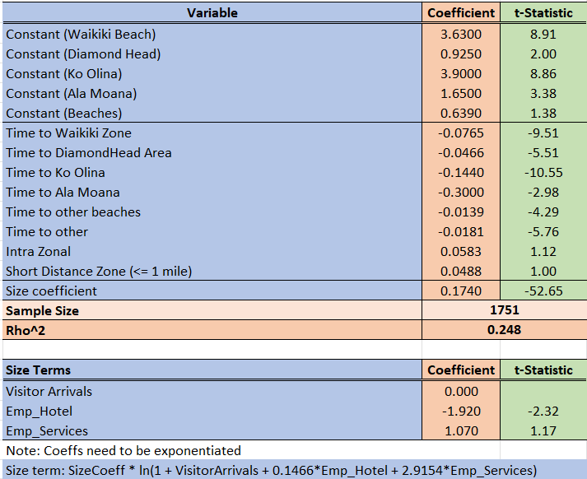
Time effects depend on the cluster, with Ko Olina and Ala Moana being the most sensitive. Less onerous time coefficients for the other clusters indicate a willingness to travel further to access those attractions.
The size term, influencing attraction effects, is driven by the zonal employment totals in the services and hotel sectors.
The model’s nest coefficients are summarized in the table below:
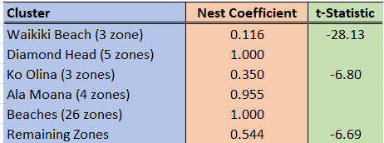

Tour mode choice
The tour mode choice model predicts the main mode for each tour. They are all multinomial Logit (MNL) specifications with the following alternatives:
- Single-occupancy vehicle (SOV)
- Carpool with 2 and 3+ occupants (HOV2 and HOV3)
- Transportation Network Companies (TNC)
- Transit
- Walk
- Other
As expected with visitors, the walk mode dominates.

Work tour mode choice
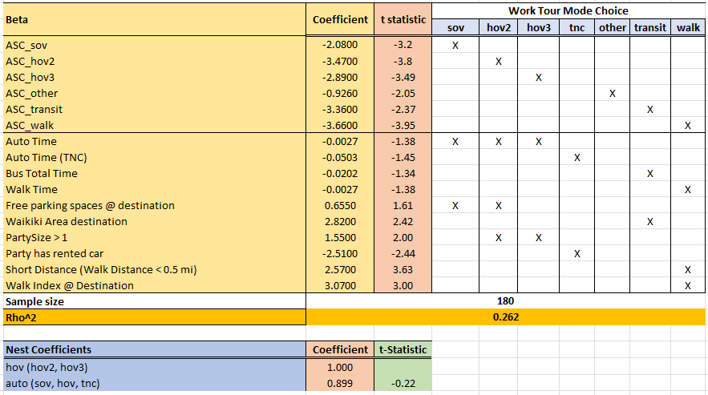
Drive time is not very onerous for work tours, likely due to people staying close to their work locations. Zones with free parking attract more drive trips. The Waikiki area attracts a lot of transit trips, while the availability of a rental car reduces the use of TNC. High walk index and short distances are strongly associated with walk trips.
While a nested specification was tried, the nest coefficients are insignificant, indicating an MNL model.

Shop tour mode choice
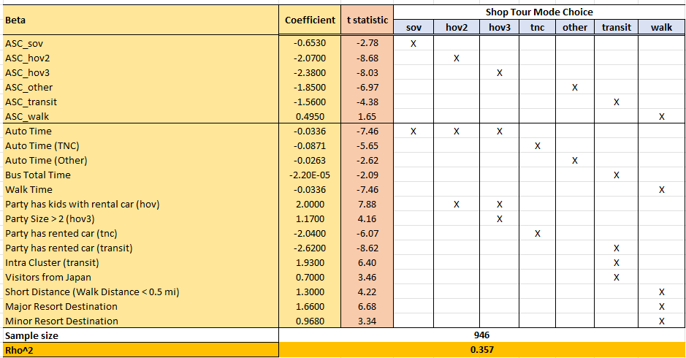
The coefficient of auto time is significant, while that of transit is not. This is logical, given the potentially low level of urgency associated with this activity purpose. Larger group sizes and those with kids+rental car have a propensity for HOV travel. Short distances and destinations in zones with major or minor resorts tend to favor walking. Transit use is strong with intra-cluster trips. The presence of a rental car significantly reduces the use of transit.

Other tour mode choice
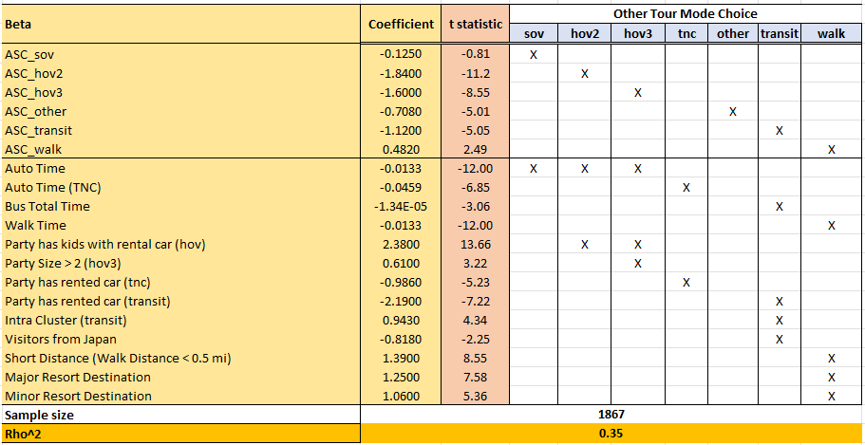
The coefficient of auto time is significant, while that of transit is not. This is logical, given the potentially low level of urgency associated with this activity purpose. Larger group sizes and those with kids+rental car have a propensity for HOV travel. Short distances and destinations in zones with major or minor resorts tend to favor walking. Transit use is strong with intra-cluster trips. The presence of a rental car significantly reduces the use of transit.

Recreation tour mode choice
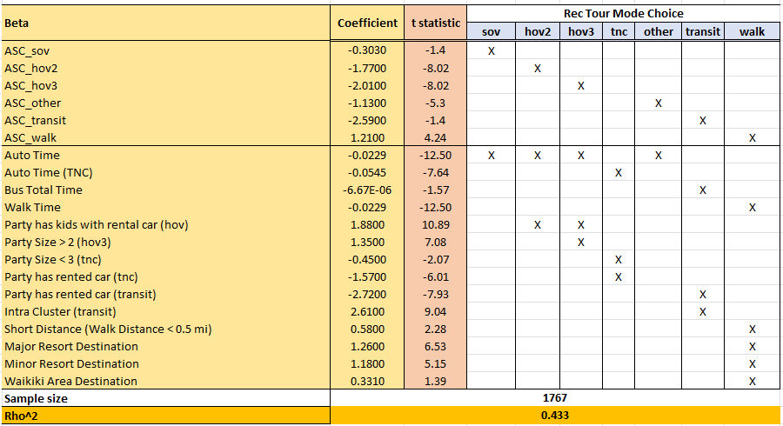
The coefficient of auto time is significant, while that of transit is not. This is logical, given the potentially low level of urgency associated with this activity purpose. Larger group sizes and those with kids+rental car have a propensity for HOV travel. Short distances and destinations in Waikiki or in zones with major or minor resorts tend to favor walking. Transit use is strong with intra-cluster trips. The presence of a rental car significantly reduces the use of transit.

Time-of-day choice
Visitor activity time-of-day decisions use the same time period definitions as the resident models: EA (early morning), AM, MD (mid-day), PM, EV (evening) and NT (night). The visitor activity time of day choice models simultaneously predict an activity’s start and end time periods. An activity that starts in the AM and ends in the PM, for example, is associated with the time-of-day option AM-PM. While there are 21 feasible combinations of the six time periods, only those appearing regularly in the survey were included for model estimation.
When applying the model, a specific start and end time period combination will be simulated from the probabilities computed by the model. Subsequently, specific start and end times (to the minute) are simulated using profiles derived from the survey. Trip departures are then reverse-engineered using the travel times from the appropriate period’s skim matrix.

Work time-of-day choice
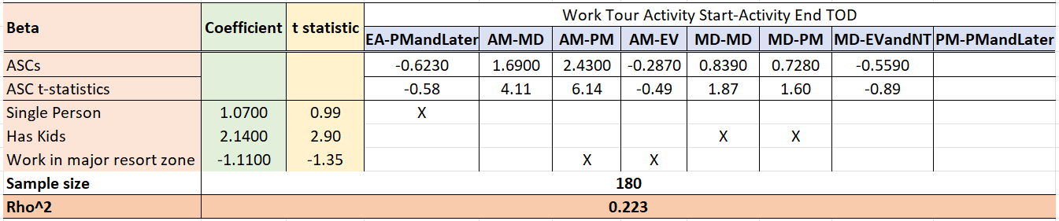
Work activities in the survey were concentrated on a small number of time-of-day alternatives. Work activities by people who arrived alone on the island tend to be longer. The presence of kids in the group shifts the preference to shorter work activities.

Shop time-of-day choice
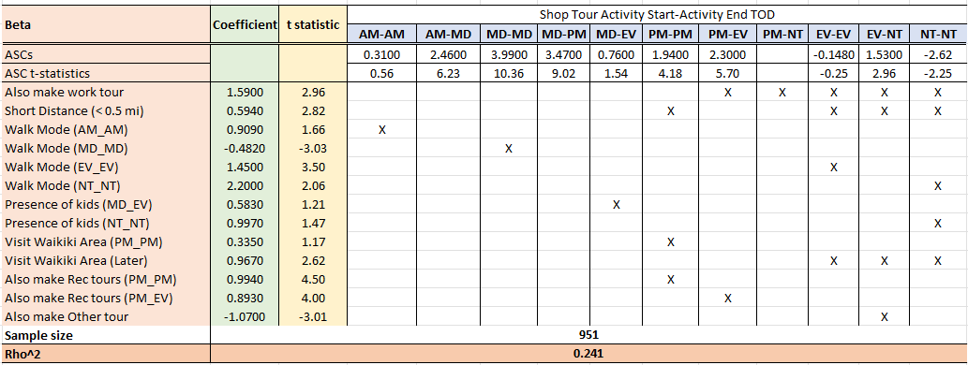
If the person is making a work tour in addition to this tour, then early and late starts are preferred. The presence of kids moves activities away from very early or very late time windows. If the group participates in two or more recreation activities, then other purpose activities start later in the day. Waikiki is more attractive in the later part of the day. Short-distance and walk tours prefer certain within-period activities (i.e. those that start and end within the same time period).

Other time-of-day choice
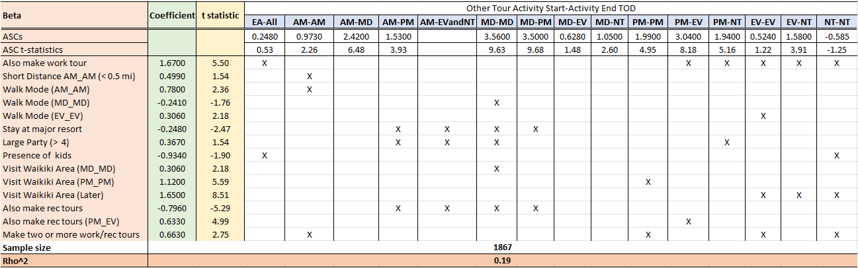
If the person is making a work tour in addition to this tour, then early and late starts are preferred. The presence of kids moves activities away from very early or very late time windows. If the group participates in two or more recreation activities, then other purpose activities start later in the day. Waikiki is more attractive in the later part of the day. Short-distance and walk tours prefer certain within-period activities (i.e. those that start and end within the same time period).

Recreation time-of-day choice
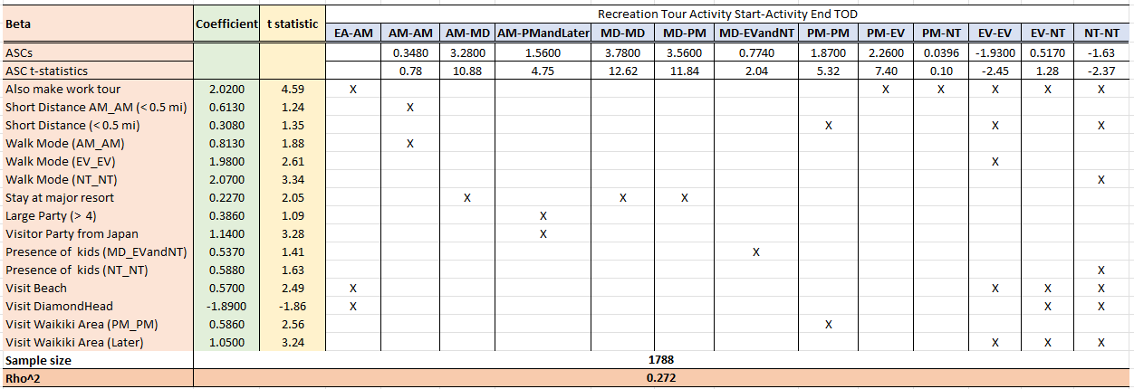
Very early or late activity durations are preferred if the person is doing work tours. Short-distance tours and walk mode tours tend to start and end in the same period. Tours tend to finish before the evening for those staying at a major resort. Large party size and Japanese visitors engage in longer recreation activities. Early or later start times are generally preferred for beach activities, though the opposite is true for visitors to the Diamond Head area. Waikiki is preferably visited in the PM period or later. The presence of kids pushes choices toward later hours.

Intermediate stop decisions

Stop frequency
Up to 3 stops are allowed along any visitor tour. These stops are further classified into those on the forward journey to the main destination, and those on the return journey. Each alternative is described by these two numbers. For example, 0-3 indicates no forward stops and three return stops. Only the combinations seen with regularity in the survey are included in the model.
The estimated model specification is shown below:
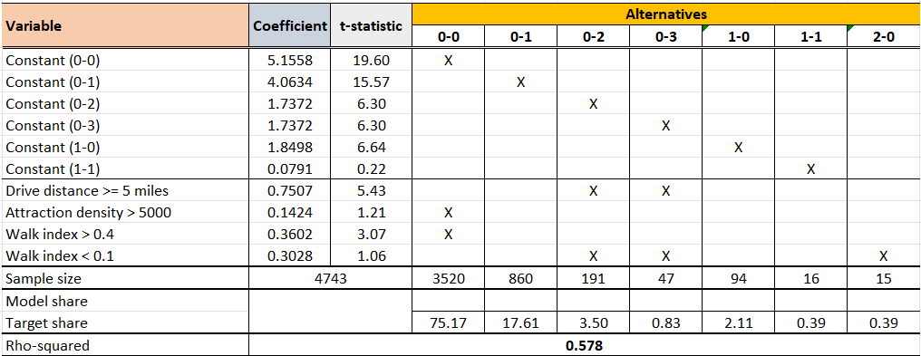
When the main destination is far from the lodging, there is a high chance of not stopping until the party reaches this destination and stopping multiple times on the way back. Destinations with high attraction density nudge toward no stops, as there are ample local opportunities. Destinations with high walk index dissuade stops while less walkable destinations encourage stops on the way back to the lodging.

Stop activity purpose
Intermediate stop activities can be for one of three purposes: Recreation, Shopping and Other.
The estimated model specification is shown below:
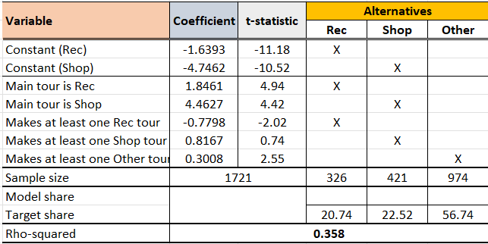
The stop activity’s purpose is strongly and positively correlated with the main activity purpose on the tour as well as the number of tours of each purpose made in the day.

Stop duration – for work
The intermediate stop work activity duration ranges from short (0-30 minutes) to long (180-250 minutes).
The estimated model specification is shown below:
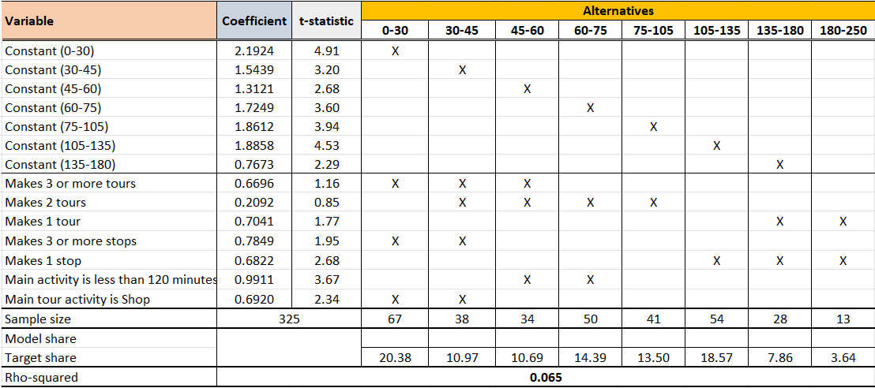
Work stop durations are highly restricted by the number of tours made in the day. The presence of three or more stops along the tour tends to predict shorter stop durations. If the main activity on the tour is shopping, the work stop tends to be short. A relatively short main activity opens the possibility of moderately long work stops.

Stop duration – for shopping
The intermediate stop shopping activity duration ranges from short (0-15 minutes) to long (135-200 minutes).
The estimated model specification is shown below:
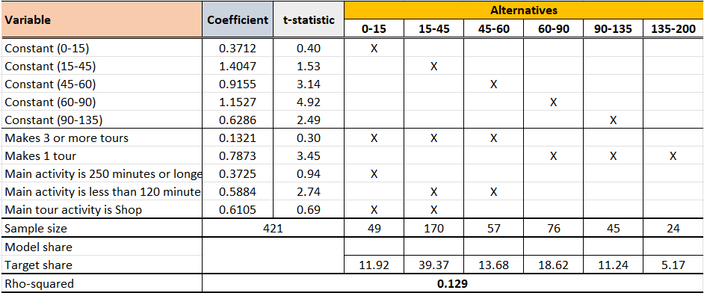
Shopping stop durations are restricted by the number of tours made in the day. If the main activity on the tour already involves shopping, then additional stops for shopping are very short. The main activity duration further constrains the time available for stops.

Stop duration – for other purposes
The intermediate stop other activity duration ranges from short (0-15 minutes) to long (150-200 minutes).
The estimated model specification is shown below:
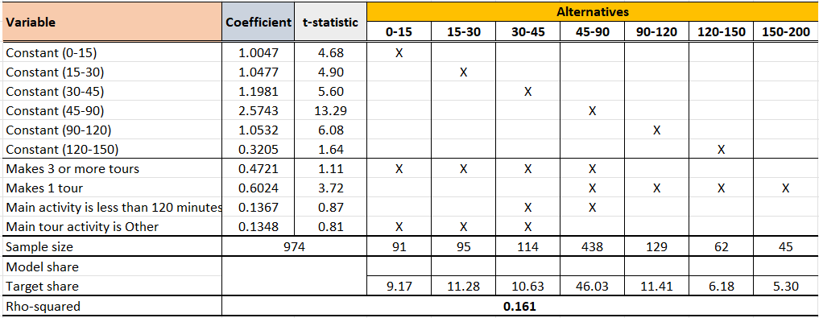
Other purpose stop durations are restricted by the number of tours made in the day. If the main tour already involves an “other” purpose activity, then additional stops for “other” activities are very short. The main activity duration further constrains the time available for stops.

Post-processing

