Figuring out the orientation
The Gundogs system expects the accelerometer to be in a certain position. If we are not in that orientation, we need to tell the system.

Relevant information from the paper and notes
This analysis system assumes the North-East-Down (NED) system where the X axis will be the surge (forward and back, North and South), Y will be the sway (side to side, East and West), and Z will be heave (up and down).
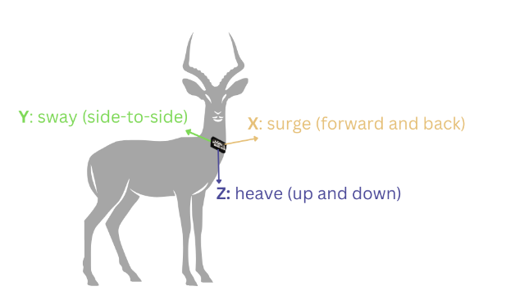
We then need to orient this accelerometer inside of the broader world. We do this by describing the compass direction of each axis. To conceptualise this, think of your hand as a practice accelerometer. Make a gum pointer finger with the middle finger extended as well such that the 3 digits will be at right angles from each other. The index finger represents the X axis, the middle finger is the Y axis, and the thumb is the X axis.
We then have to describe the direction of the 3 axes (fingers) according to these compass directions in the order of X, Y, Z.
The default orientation of the Gundog system is North-East-Down (NED) where the axes readings would be X = 0, Y = 0, and Z = -1. Before we could use data from our hand accelerometer, we would have to flip it upside down. Some devices may have a different local coordinate frame. Providing the original coordinate system allows the Gundogs system to convert your local system to the global system.

Figuring out the orientation
The orientations of the axes as written on our board are as follows.
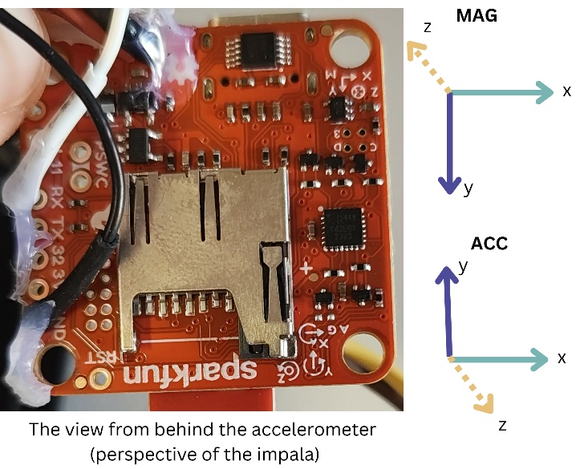
X acc | Side to side | Sway | East
Y acc | Up and down | Heave | Up
Z acc | Forward and back | Surge | South
X mag | Side to side |  | East
Y mag | Up and down |  | Down
Z mag | Forward and back |  | North

I then tried to verify this by looking at the accelerometer data when the animal was standing up (ground-truthed with video). Red is X, Blue is Y, Green is Z. When the animal is standing up, the X axis has close to 0 gravity. The gravity is shared over the Y and Z, with the most on the Z. This indicates that the collar is tipped forwards.
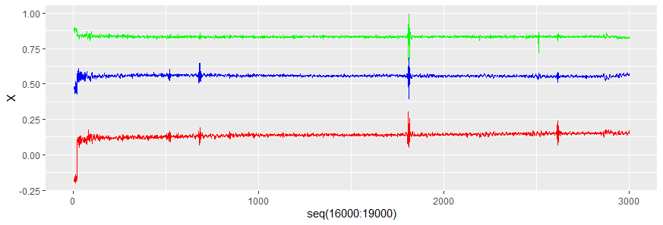
X | -0.160
Y | 0.633
Z | 0.729

Therefore, I propose the orientation is: acc EUS, mag EDN, gravity down, and a pitch forward of about 48 degrees.
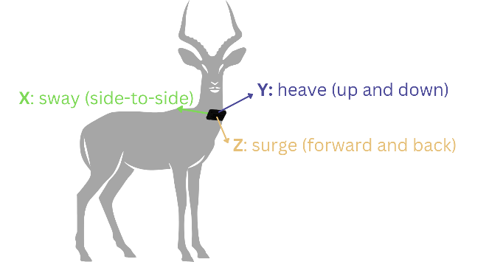

Trialing the orientation
To determine whether this was correct, I attempted dead reckoning on 1 day of Collar 8 impala data.

This appears to be completely wrong. Going to keep trialing and erroring though.

