Determining the DR Variables
Sorry this document is quite long. I wasn’t sure what information would be most helpful as I was working through so included each stage of my thinking. Conclusions highlighted blue for the TL;DR.

Figuring out the orientation
The orientation of the board, when the board was vertical as if on the impala’s neck during extreme vigilance, had X as sway (side to side), Y as heave (up and down), and z as surge (back and forth) (Fig 1).
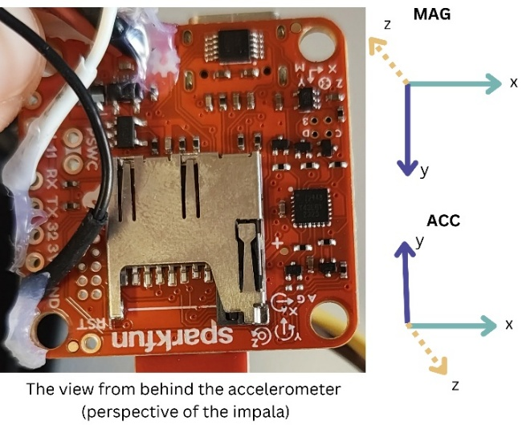
Fig 1. Orientation of the accelerometer and magnetometer. View from impala’s POV.
However, the natural orientation of the impala’s neck during locomotion/standing meant that the most common orientation of the board was rotated forwards. We tried to determine what the orientation should be during locomotion based on the actual data.
From Gunner correspondence with Jojo we know: “heave axis in acc will be the one closest to +/-1 g most of the time, and mag will the one changing the least... For the acc, you would expect greater variation in surge dimension because they stick their head to ground to forage and then stick their head back up when travelling and vigilance.”
Therefore, I extracted periods of time aligned with known videos to see the orientation when head up and head down (Fig 2). From these graphs I can guess that the heave axis is the Z axis, Surge is the Y, and therefore the sway is the X.

Fig 2. Acceleration patterns during known behaviours (from time-matched videos).
Therefore, from these, I summarised that these would be the axes:
 | Board | Graphs
X acc | Sway | Sway
Y acc | Heave | Surge
Z acc | Surge | Heave

We know from the board (Fig 1) that the magnetometer is orthogonal to the accelerometer, so the X will be the same, but the Y and Z will be opposites. As we do not know the orientation of the impala at release, this will have to be determined via a “guess and check” unique for each individual? (Trialled in Gundog.Tracks section)

Gundog.Compass
Firstly, I wanted to determine the pitch. In previous trials by Luke, the pitch.offset was used to account for the angle of the device but he knew the pitch. In my case, I don’t know the pitch of our device. Therefore, I extracted known walking events (see Fig 2 above) and used the mean of each axis to estimate the pitch trigonometrically as per equation below.
pitch <- atan2(-ax, sqrt(ay^2 + az^2)) # using the Surge and Heave axes
pitch_deg <- pitch * 180 / pi
This gave me a pitch of 15 degrees.
The calibration data collected in the field by our researchers (Fig 3) looks quite different to the calibration data collected in the other trials (e.g., by Luke when walking around the rugby field (Fig 4) and penguin tracks from Gunner et al., 2021 (Fig 4)).
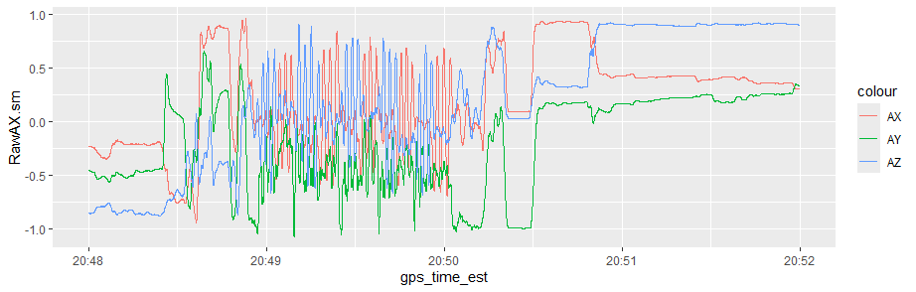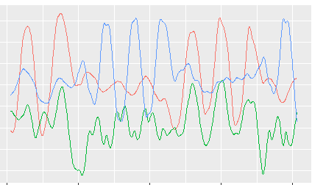
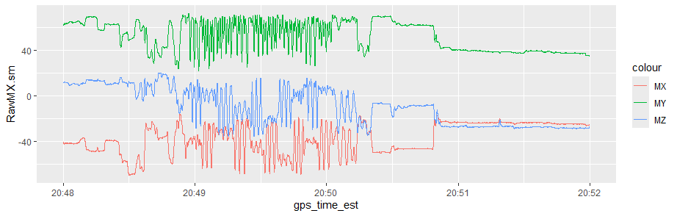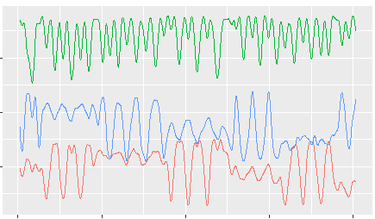
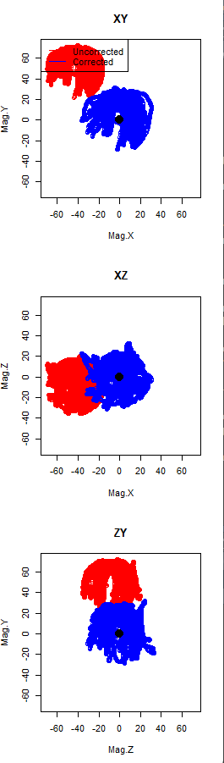
Fig 3. Calibration data accelerometer (top) and magnetometer (middle) readings collected during the impala fieldwork. Full calibration period (left) and zoom in (right). Gundog.Compass output at bottom (using method 2).
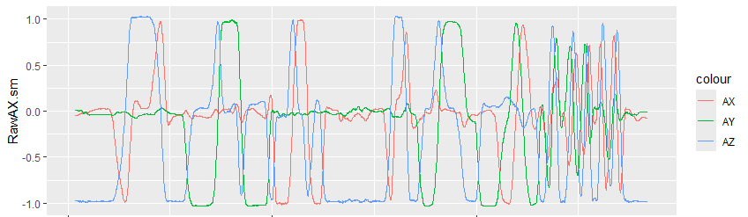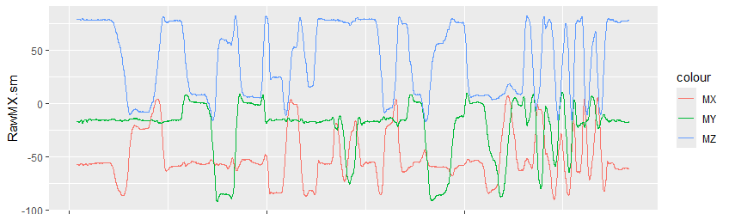
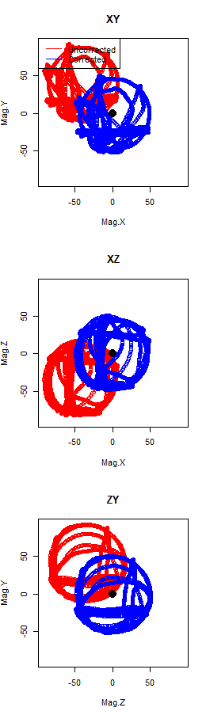
Fig 3. Calibration data accelerometer (left) and magnetometer (right) readings collected during the test trials around a rugby field by Luke. Gundog.Compass output at bottom.
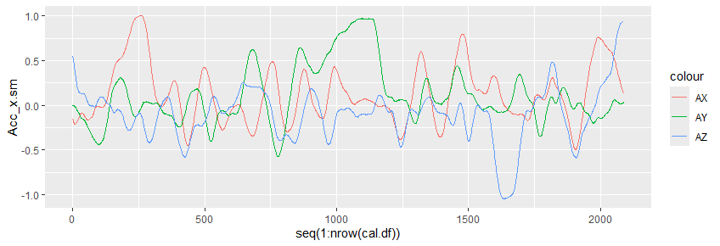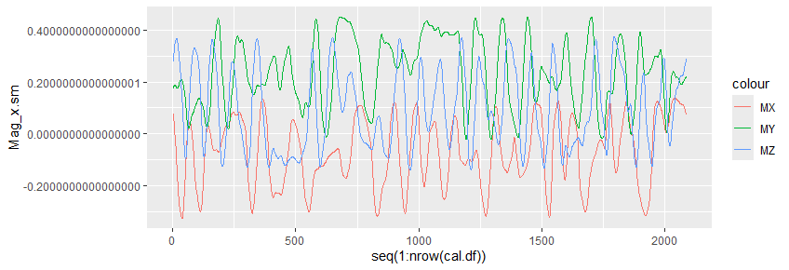
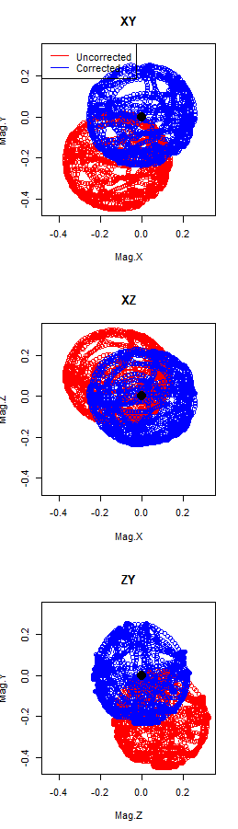
Fig 4. Calibration data accelerometer (left) and magnetometer (right) readings collected during the penguin worked example provided in Gunner et al., 2021. Gundog.Compass output at bottom.
From this, I concluded that something had gone wrong during our calibration and we had, for whatever reason, not fully calibrated the device and failed to go all the way around the compass’ directions. To correct/control for this, I think we have to select a different compass “method”?

Summarised notes from the supplementary materials of Gunner et al., 2021:
- method = 1 may prove effective when data is less affected by noise – e.g., nearly spherical.
- For rotated ellipsoids use method = 3 and for near spherical data and/or influenced by heavy noise, use method = 2.
- For, non-rotated ellipsoids use method = 4
- When x and y channel radii the same, use method = 5
- When x and z are the same, use method = 6
- When y and z are the same, use method = 7
- For spherical data use method = 1, 2 or 8.
I must admit my understanding is quite limited here, but I don’t think we have spherical data. Since we are influenced by heavy noise (maybe?) I could try method 2 or perhaps our X and Z are the closest to being the same (although incomplete). In which case, method 6 would be best?
I trialled both downstream in the Gundog.Tracks and preferred the output of method 2.
I didn’t know what to select for the algorithm so just chose “standard”. Trialling both didn’t seem to make a difference.

Gundog.Tracks
To determine the orientation (since the release direction of the impala was unknown), I did a guess and check with various options, iteratively running Gundog.Compass and Gundog.Tracks. For the worked example impala, the orientation I liked best can be seen in Fig 5, below with the orientations of Acc: NWU, Mag: NED, and Gravity direction: down.
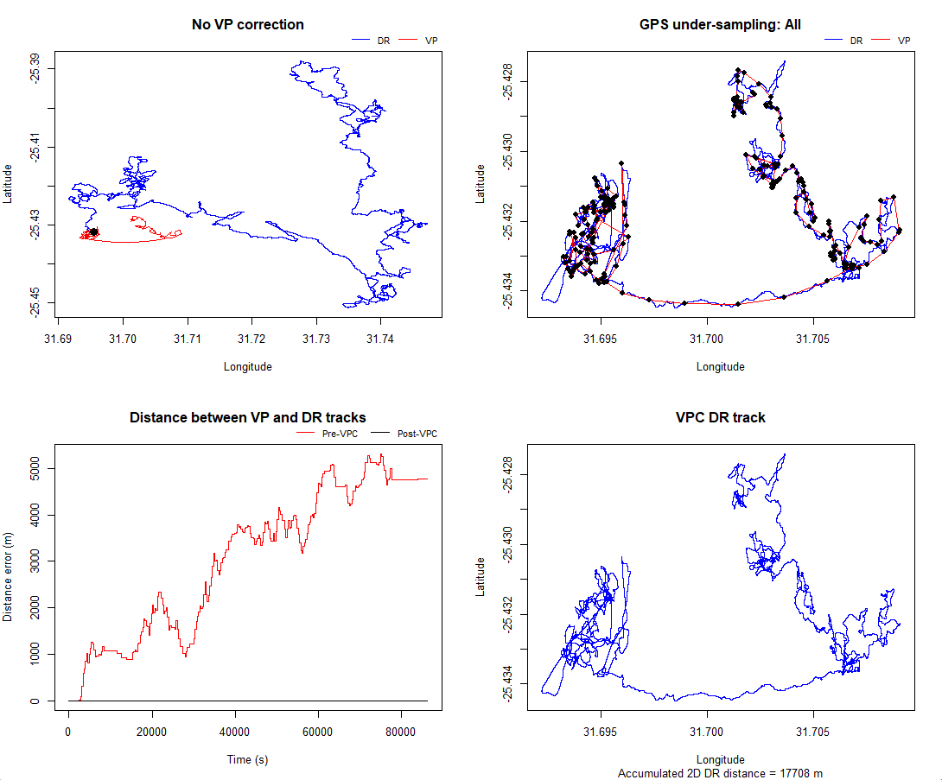
Fig 5. Best attempt so far at dead reckoning the worked example impala data.

Where to from here?
- Continue to play with the variables…
- I will ~soonish have developed a machine learning behavioural classification model for impala behaviour. We can use the output of this to differentiate different types of locomotion. By differentiating the head-down walking/grazing locomotion from the head-up locomotion, we can apply different pitches and orientations for these sections. (As Gunner et al., 2021 discussed for the penguins swimming vs walking).

