Worklog
The impala data was collected by Chris Clemente, Jasmin Annett, Robin Maag, Chris Bird, and Taylor Dick across 3 field deployments in South Africa: 2024, April 2025, and July 2025. The idea behind the project was to put our custom-designed collars (including an Artemis board which logged GPS and accelerometer data, as well as a stand-alone Axivity) on impalas, record their behaviours with a drone, and then reconstruct their exact behaviours and paths from the acceleration data. The following document now outlines the analysis of this data by me (Oakleigh Wilson).
I like to take notes as I work. These are things I observed and decisions I made. It is for my own sake of thinking-out-loud more than anything.

18/03
- Some history to this project is that I started it when guiding an undergraduate student through preliminary energy landscape analysis. During this time, we realized that the “perfectly time sychnonised” boards were, in fact, not time synchronised. ChrisC and I spent several weeks trying to align the board with the associated behavioural videos. That work is detailed in this googledoc: here. The long-story short of it was essentially that:
  - Extracting the data from the boards wasn’t straightforward. Once it’s done, it’s easy, but figuring it out for the first time took a lot of trial and error.
  - The time synchronisation video had been filmed with a camera never used for data collection (thus rendering it useless for time synchronisation)
  - The cameras that were used for data collection all had different ways of encoding the times 3 cameras filming the same event reported different times. Which time zones were these in (UTC, Australia/Brisbane, Africa/Johannesburg, daylight savings or no)? Do the time stamps refer to the start or the end of the video?
  - At the time, I was only able to achieve alignment for the drone videos as their timestamp was recorded in the filename.
  - Amelia Nelson (research assistant) painstakingly annotated every possible second of recorded drone footage. However, even after all her work, due to multiple device failures, this nevertheless resulted in only 2 individuals worth of data… which is insufficient for behavioural analysis.
  - Therefore, many months later, I’m back at it.
- First step is for me to get my head around the data that we have. Have filled in the metadata sheet in the excel sheet in the Notes folder.
- What this tells me is that my next most valuable endeavour is to figure out the alignment from Robin’s camera. Going to have a crack at that this arvo.
  - Note that a lot of the code I wrote for the kangaroo data was for accounting the errors in the boards. As far as I can see, these same errors don’t occur in the impala data. However, I left the debug in for the impalas just in case.

19/03
- I hate myself. Why did I change so many things all at once???
  - Below is collar 8 video 2 as annotated by Amelia with the old system (looked correct to the video). Now I have to be able to replicate that with my new system.
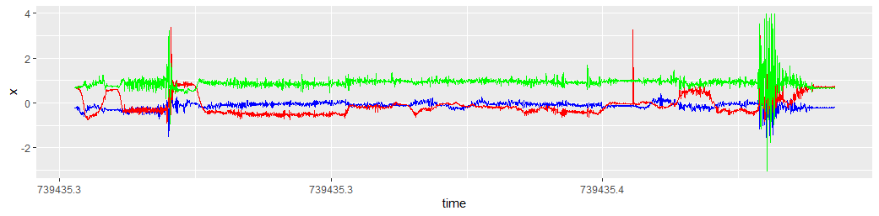
  - Which I was unable to do… Which means that, somewhere my new system is breaking. Which is actually a good sign… because the error is in my new code, not in the data (flow on implications for why the kangaroo stuff isn’t working).
- I need to debug this systematically, working backwards.
  - I reverted all my changes to the plotting method and got the same result. Therefore, either the video times are incorrect or the gps times are incorrect.
  - I rechecked the video times and no joy. Therefore, I think the gps times are wrong. Going to revert all the work I did yesterday back to the original versions.
    - Note that the kangaroo data had a lot of error not encountered in the impala data (e.g., multiple board resets, skipped reads, incorrect GPS writes, etc). The fact that using the “cleaning code” I wrote for the kangies on the impala caused the impala to break indicates that there is something wrong with the cleaning code…
- Okay, I’m actually going to revert everything. Back to the very beginning and check differences along every step of the way. I created a branch from 5 months ago and will check every step along the way:
  - GPS stitch: The old version misses the first GPS point for some reason? Moved to the new version.
  - Accel stitch: Exactly the same
  - Old method doesn’t account for the internal clock restarting on the accelerometer but when I more closely investigated, it does restart. There are duplicated values in the timestamps. there is also a restart in the GPS
  - Found a section in the interpolated times where the clock started going backwards presumably because the GPS glitched and went backwards.
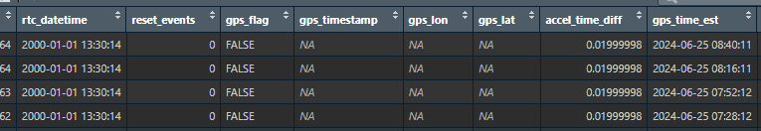
    - Reordered the dataset by the reset events and then removed the misreads where there was an uneven increment between the internal and external times on the gps_board

30/03
- Have been very busy teaching and submitting other papers. Am now back to working on this and feel like I’m going to suffocate from the stress of it.
  - Something I’m being wary of is the conversion between timestamps.
  - Below confirmed that the gps timestamps stay the same after writing and reading but also converted everything to numeric to be safe.
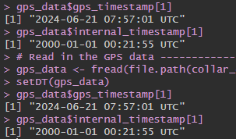
- First thing is to prevent the GPS from going backwards… Began by accounting for the reset events so the times aren’t matched across resets.
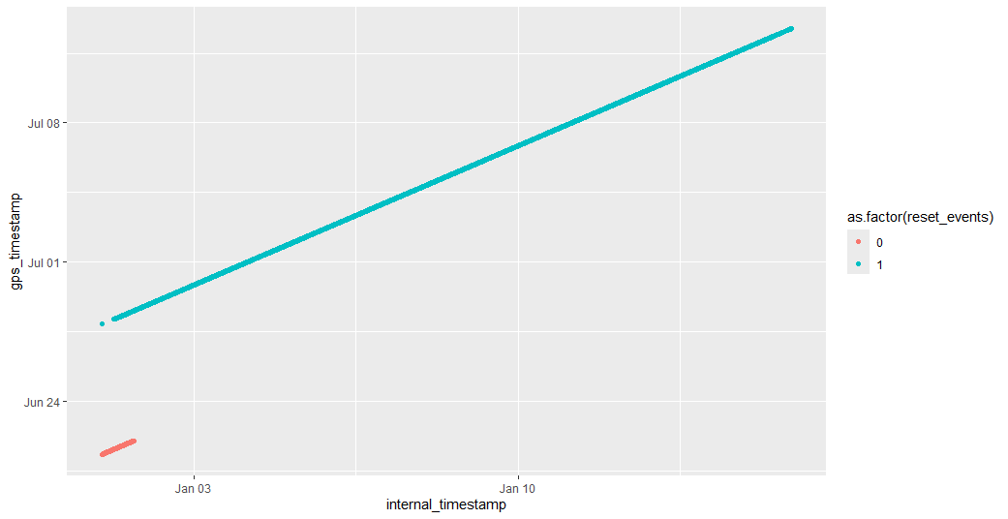
- This immediately showed where the interpolation error came from because all the error arose before the sampling even began (began on 28th, errors were back-interpolations to the 25th)
- But somehow they are then getting back mixed together after I combine the accel and gps?
  - I didn’t want to have to do this, but I might have to delete any data from the short reset events because they got blended… Left is before deletion, right is after.
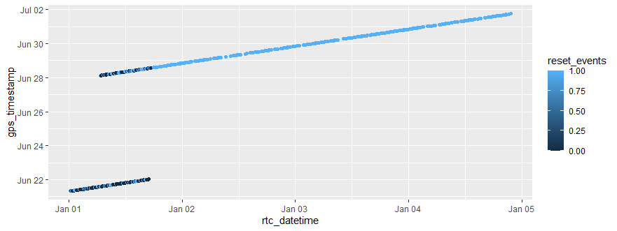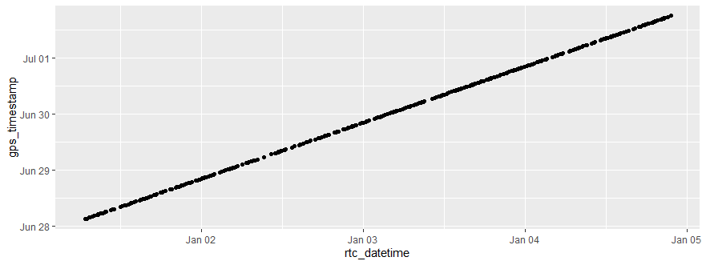
- This should now mean the data is accurately aligned for interpolation… As far as I can tell, it appears to be…
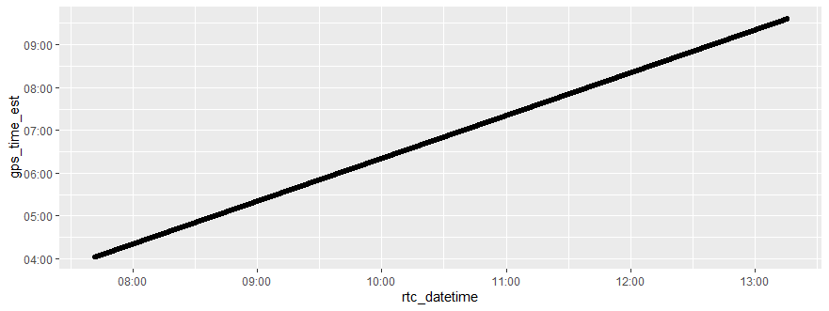
- LADS we did it!!! I got it aligned!
