Worklog as I move through the analysis
I like to take notes as I work. These are things I observed and decisions I made.

Reading the files together

10/03
- Found that the devices had turned on and off as much as 26 times during the deployment. It seems that most of these are maybe the death-throws of the battery. In the big Cahuna data, there was 11 straight days and then 23 times of being turned on for a few seconds. Decided to delete any events that were less than 1 hour (because we couldn't get any meaningful data out of them anyway, really). that solution worked.
- Not all GPS points are making it into the dataset (dropped about 20 points). Confirmed that all the GPS points fall inside the accelerometer range. Exploring the gps_data directly but found that sometimes the internal clock had tweaked and shown only a few seconds elapsed when the gps_timestamp showed that really a lot of time elapsed. See example image below.
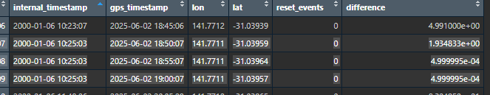
  - This could easily have happened if there was corruption in the artemis writing to file (there’s a lot of corruption). Let’s go check the relevant file…
    - Attached below and doesn’t appear to have any reason why my code wouldn’t have read it approporiately. Have highlighted the problem reads in yellow and their corresponding blue true reads. (Before and after this is fine btw.)
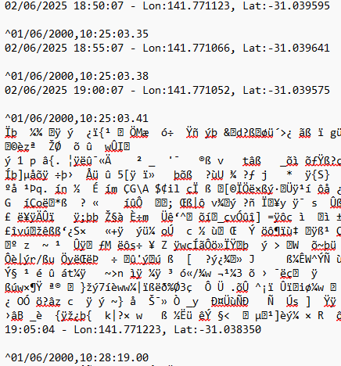
  - After a bit of thinking, the solution I can think of is to change the internal timestamp so it’s a relative change between the gps_timestamps. Because I don’t want to affect the other timestamps, I will just re-interpolate when the reads occur on the same internal_timestamp… this corrects as below:
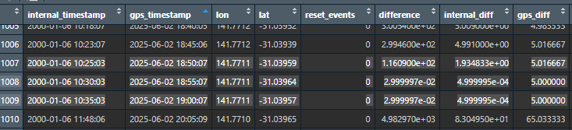
    - It’s not perfect (note the only 2-minute increase between the previous point and the first of the highlighted). However, it is better. ##NOTE: Come back and improve this logic later…
- Went to pull the videos and they’re way off. Need careful thinking through to find the misalignment.

