|  |  |  |
| --- | --- | --- |
| **Contents** | | |
| **Introduction** | **............................................................** | **3** |
| Welcome | ............................................................ | 3 |
| License Agreement | ............................................................ | 3 |
| Copyright and Trademarks | ............................................................ | 3 |
| **Application Window** | **............................................................** | **4** |
| Control Functions | ............................................................ | 4 |
| Connect Button | ............................................................ | 4 |
| Disconnect Button | ............................................................ | 4 |
| Properties Button | ............................................................ | 4 |
| Auxiliary 1 & 2 Button | ............................................................ | 4 |
| Enable Logging Checkbox | ............................................................ | 5 |
| Clear Data Button | ............................................................ | 5 |
| Save Log File Button | ............................................................ | 5 |
| Port Selection Field | ............................................................ | 5 |
| Baud Rate Selection Field | ............................................................ | 5 |
| Temperature Label | ............................................................ | 5 |
| Set Point Temperature Label | ............................................................ | 5 |
| Stage Remaining Time Label | ............................................................ | 5 |
| Stage Label | ............................................................ | 5 |
| Elapsed Time Label | ............................................................ | 5 |
| Heater label | ............................................................ | 6 |
| Auxiliary 1 Label | ............................................................ | 6 |
| Auxiliary 2 Label | ............................................................ | 6 |
| Log Data Grid | ............................................................ | 6 |
| Log Data Chart | ............................................................ | 6 |
| Menu Options | **............................................................** | **7** |
| File Menu | **............................................................** | 7 |
| View | ............................................................ | 7 |
| Profile | ............................................................ | 7 |
| **Contents** | | |
| Log File | ............................................................ | 8 |
| Chart File | ............................................................ | 9 |
| Chart Image | ............................................................ | 10 |
| Save | **............................................................** | **11** |
| Log File | ............................................................ | 11 |
| Chart File | ............................................................ | 12 |
| Chart Image | ............................................................ | 13 |
| Page Setup | ............................................................ | 14 |
| Print Preview | ............................................................ | 15 |
| Print | ............................................................ | 16 |
| Run Menu | **............................................................** | **17** |
| Calibrate Oven | ............................................................ | 17 |
| Start Reflow | ............................................................ | 18 |
| Start Bake | ............................................................ | 19 |
| Reset Controller | ............................................................ | 20 |
| Configure Menu | **............................................................** | **21** |
| Application Settings | ............................................................ | 21 |
| Configure RTC | ............................................................ | 22 |
| Create/Edit Profile | ............................................................ | 23 |
| Upload Profile | ............................................................ | 24 |
| Update Firmware | ............................................................ | 25 |
| Open Programmer | ............................................................ | 26 |
| Open Editor | ............................................................ | 27 |
| Help Menu | **............................................................** | **28** |
| About | ............................................................ | 28 |

**Introduction**

**Welcome**

The Reflow Controller application is an optional interface for the reflow controller hardware. The software is designed to allow computer control of the reflow controller and log reflow sessions for later viewing and editing.

**License Agreement**

This agreement shall govern the use of this software by the user of the Software Package. The user is granted the right to use, modify, and redistribute this Software Package as he or she wishes. The developer of this software will not assume any responsibility for the misuse of this software or any damage that may result from use of this software.

**Copyright and Trademarks**

Hobbybotics reserves the right to modify this license agreement at any time.

**Application Window**

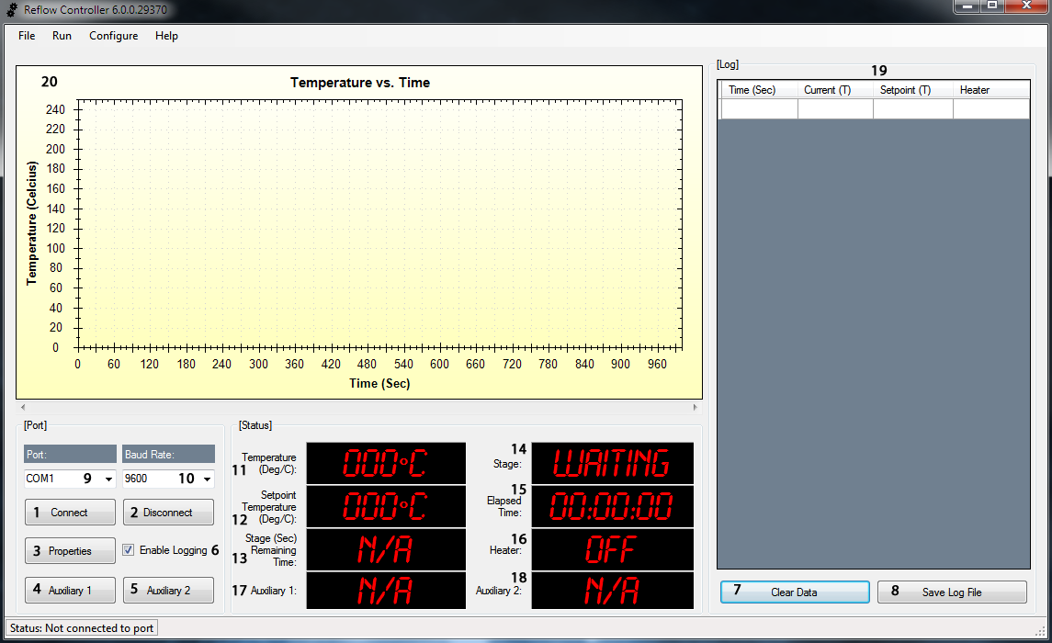

**Control Functions**

1. **Connect Button**

This button establishes a connection to the selected serial port at the selected baud rate if available ports are detected.

1. **Disconnect Button**

This button disconnects from the serial port.

1. **Properties Button**

This button opens the device manager applet so that the serial port properties may be viewed or edited.

1. **Auxiliary 1 Button**

This button will connect or disconnect the device attached to the auxiliary jack.

1. **Auxiliary 2 Button**

This button will connect or disconnect the device attached to the auxiliary jack.

1. **Enable Logging Checkbox**

This checkbox will enable or disable data logging.

1. **Clear Data Button**

This button will clear any data contained in the data grid.

1. **Save Log File Button**

This button will save a log file of data from the data grid to a file compatible with Microsoft Excel or any Excel compatible spreadsheet. The created file can also be opened with a text editor.

1. **Port Selection**

This field is loaded with all detected serial ports and allows a port to be selected for connection. The propertied button should be used to ensure the selected port matches the port the reflow controller is connected to.

1. **Baud Rate Selection**

This field is loaded with available baud rates. The default baud rate for the reflow controller is 9600 baud. The selected baud rate needs to match this setting to ensure proper communication.

1. **Temperature Label**

This label displays the current temperature measurement.

1. **Set Point Temperature Label**

This label displays the set point temperature value.

1. **Stage Remaining Time Label**

This label displays the remaining time for each stage (Preheat, Soak, Heating, Reflow, Cool Down and Bake).

1. **Stage Label**

This label displays the current stage (Preheat, Soak, Heating, Reflow, Cool Down and Bake).

1. **Elapsed Time Label**

This label displays the total time the process is taking.

1. **Heater Label**

This label displays the on/off state of the oven heater relay.

1. **Auxiliary 1 Label**

This label displays the on/off state of the auxiliary 1 device.

1. **Auxiliary 2 Label**

This label displays the on/off state of the auxiliary 2 device.

1. **Log Data Grid**

This data grid captures the time (seconds), current temperature (Celsius), set point temperature (Celsius) and heater on/off state of the reflow process. This data can be exported to an Excel compatible file.

1. **Log Data Chart**

This graphical chart plots the time (seconds) and current temperature (Celsius) of the reflow process as a line graph. This chart can be saved as an image, saved as a data file or printed.

**Menu Options**

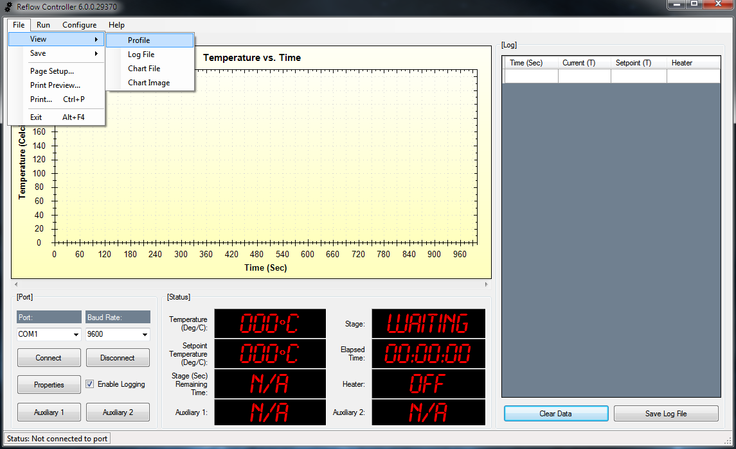

**File Menu**

* **View Profile**

This menu option opens a reflow profile for viewing and editing within the default text editor.

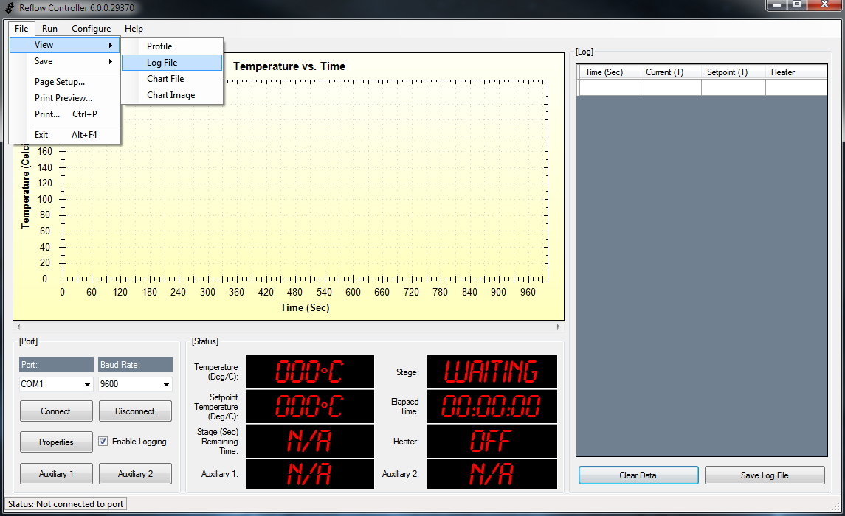

* **View Log File**

This menu option opens a log file for viewing and editing within Microsoft Excel. A compatible spreadsheet application or text editor can be used to view and edit a log file.

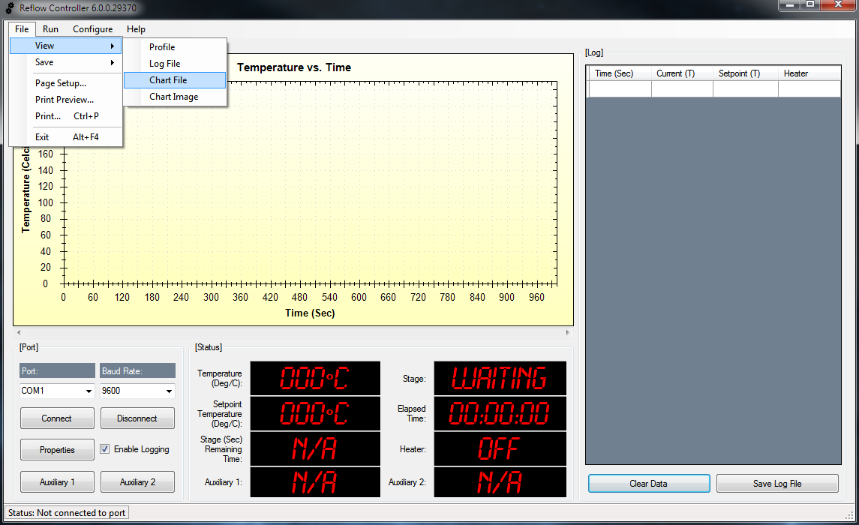

* **View Chart File**

This menu option opens a chart file for viewing within the reflow application.

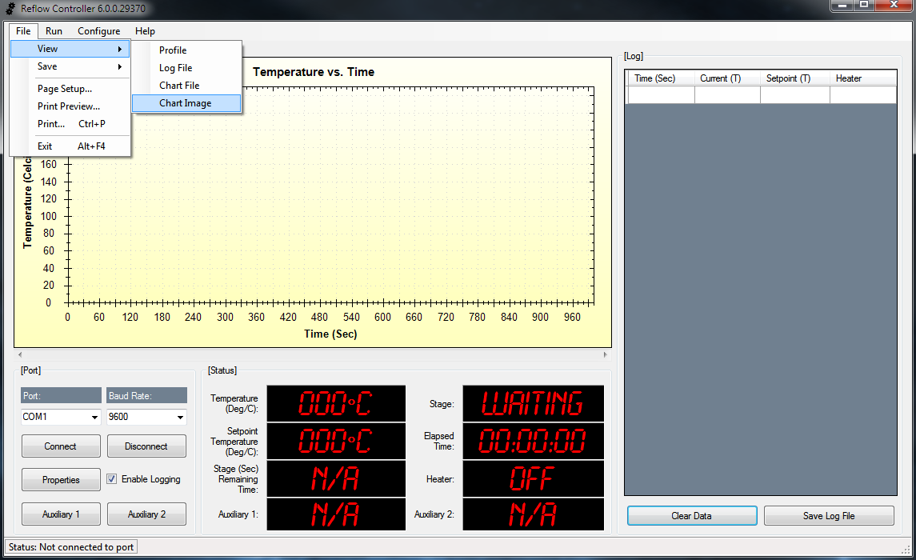

* **View Chart Image**

This menu option opens a chart image for viewing and editing with the default image application.

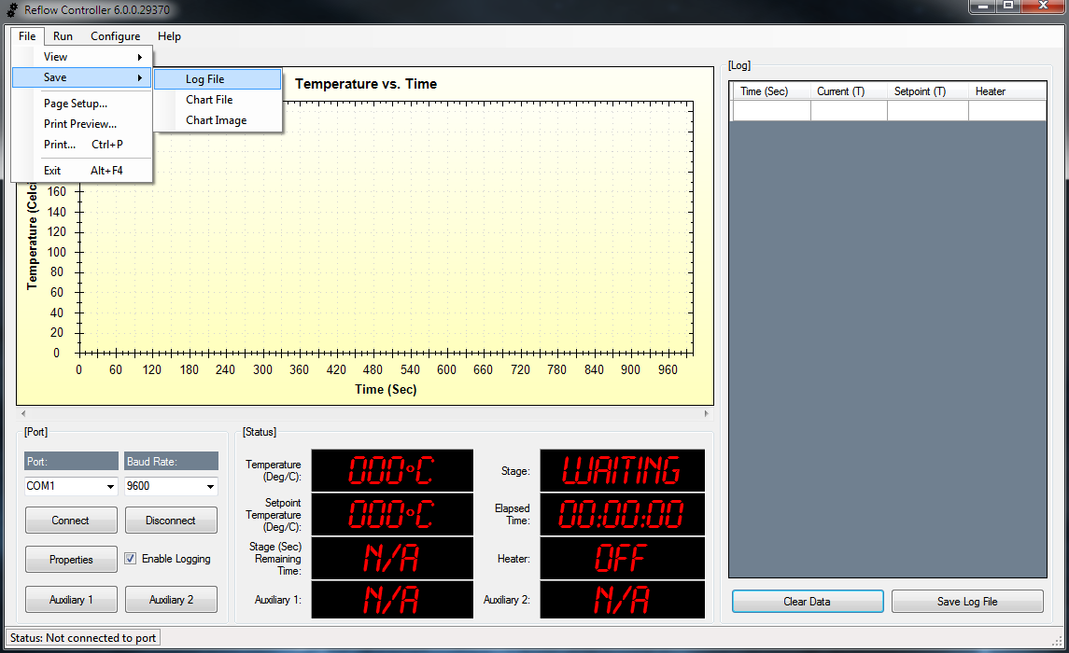

* **Save Log File**

This menu option saves a reflow session to a log file for viewing and editing in Microsoft Excel. A compatible spreadsheet application or text editor can be used to view and edit a log file.

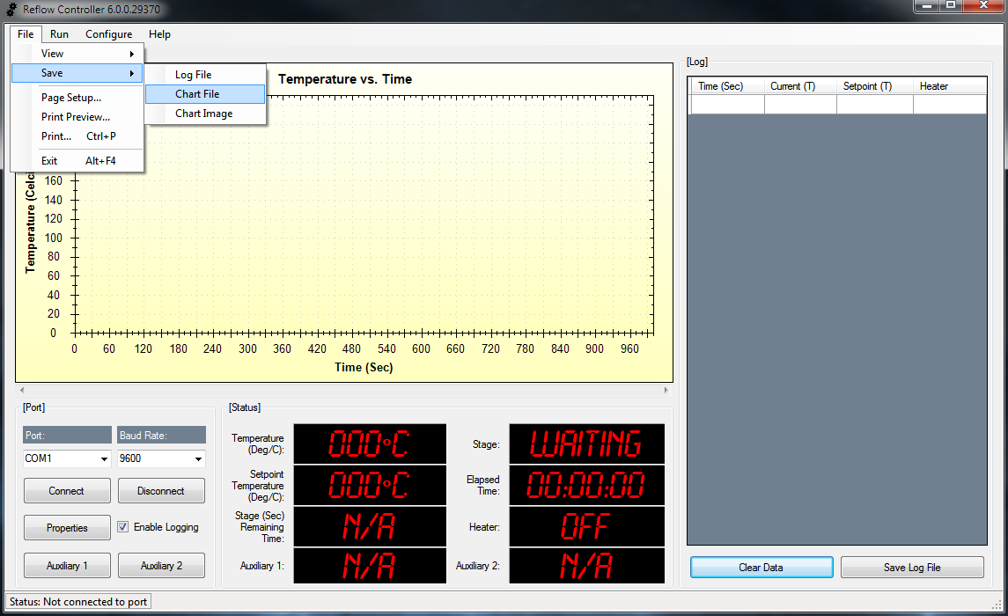

* **Save Chart File**

This menu option saves the graphical chart data to a chart file for viewing within the reflow application.

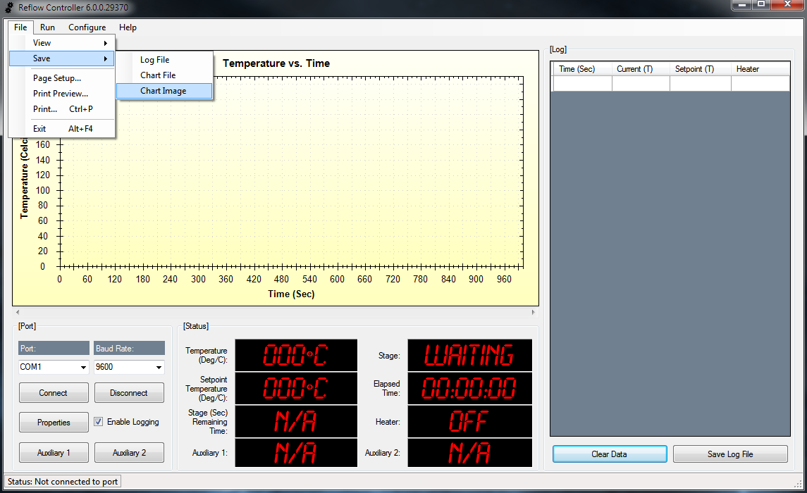

* **Save Chart Image**

This menu option saves a chart image to a file for viewing and editing with the default image application.

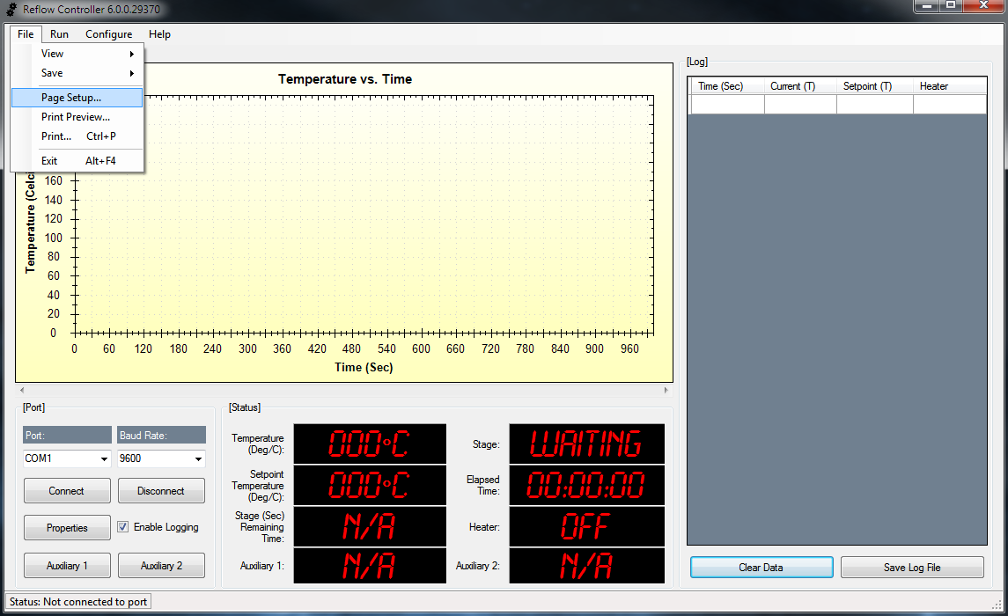

* **Page Setup**

This menu option allows page settings to be adjusted for printing.

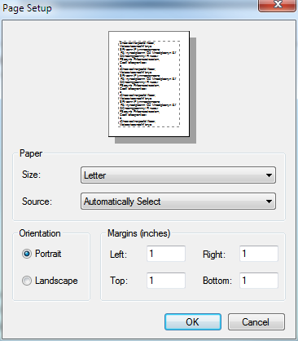

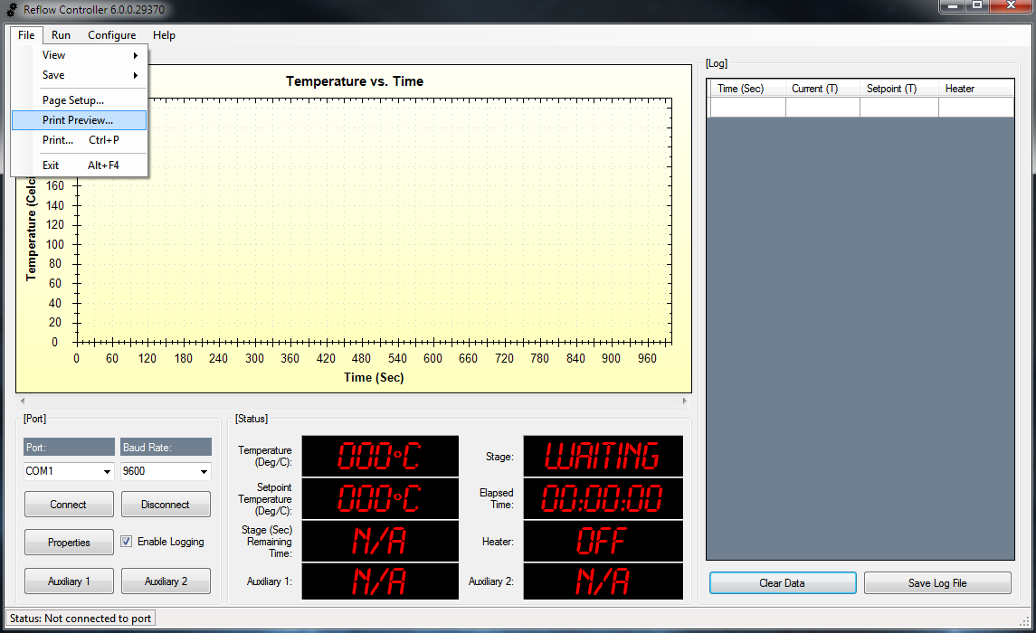

* **Print Preview**

This menu option shows a print preview of the chart image.

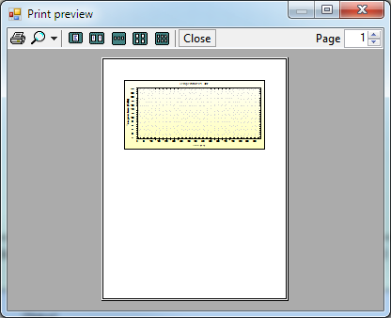

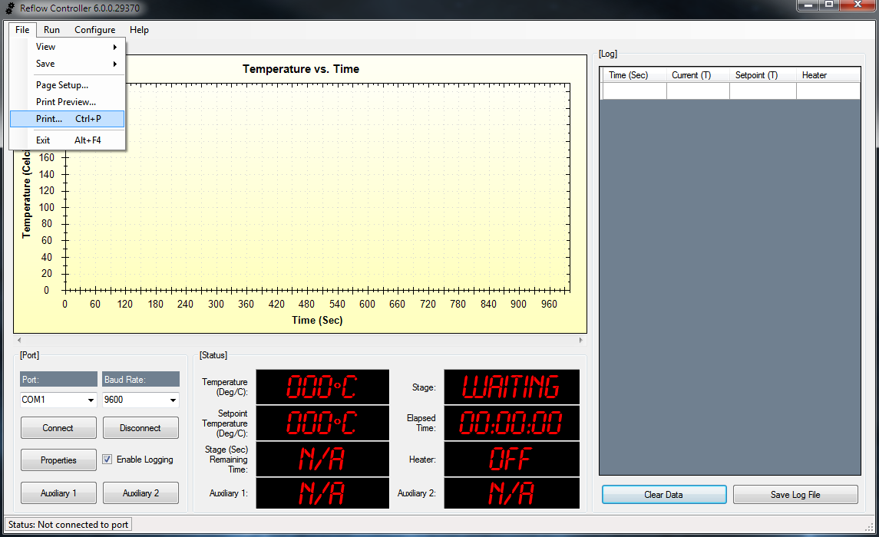

* **Print**

This menu option prints a chart image.

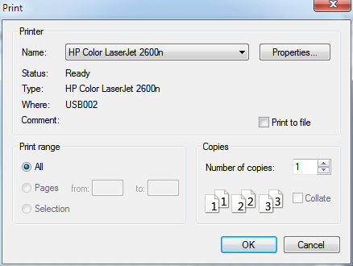

**Run Menu**

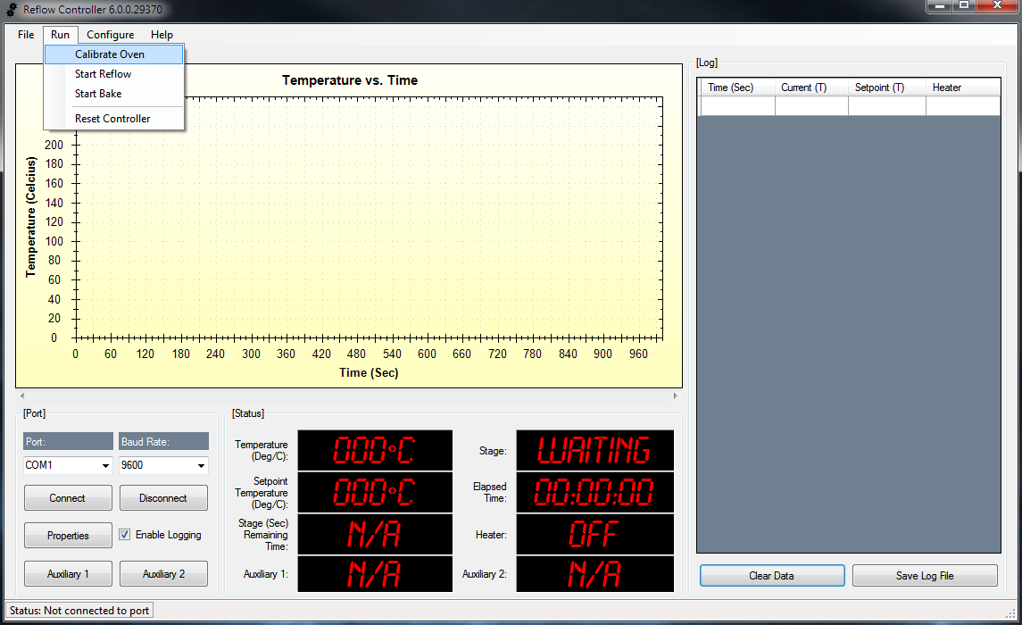

* **Calibrate Oven**

This menu option starts the calibration function of the reflow oven. The oven is heated up to 100 degrees Celsius and turned off. The reflow controller measures the amount of temperature drift above 100 degrees Celsius and stores that value as the oven overshoot value. The overshoot value is used during a reflow process to apply hysteresis.

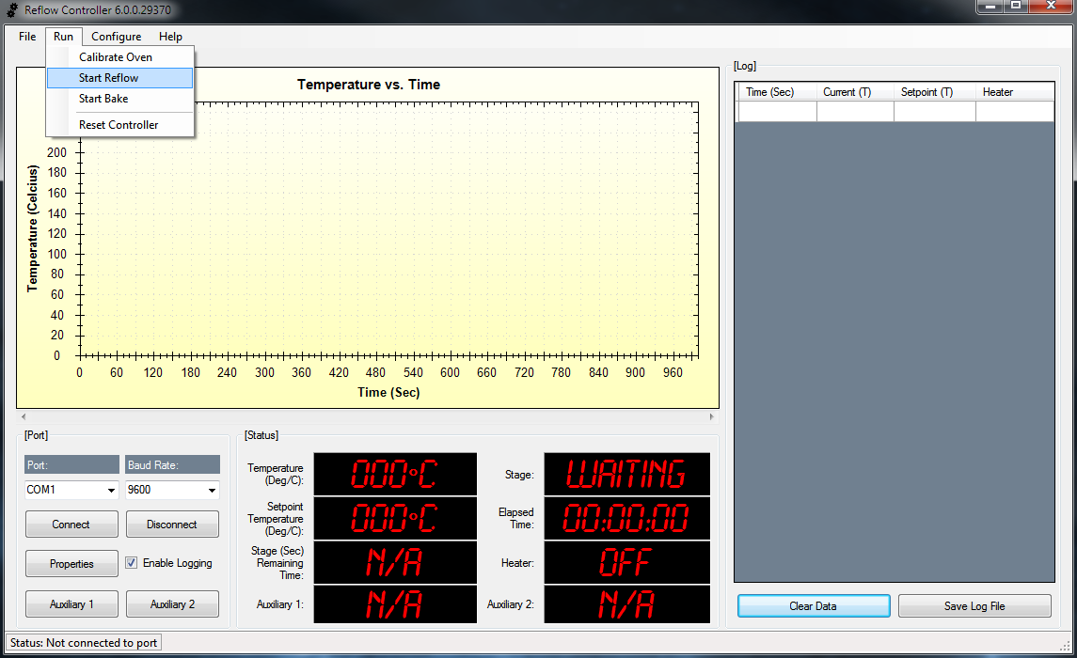

* **Start Reflow**

This menu option starts the reflow process. This process is used to solder components on a printed circuit board.

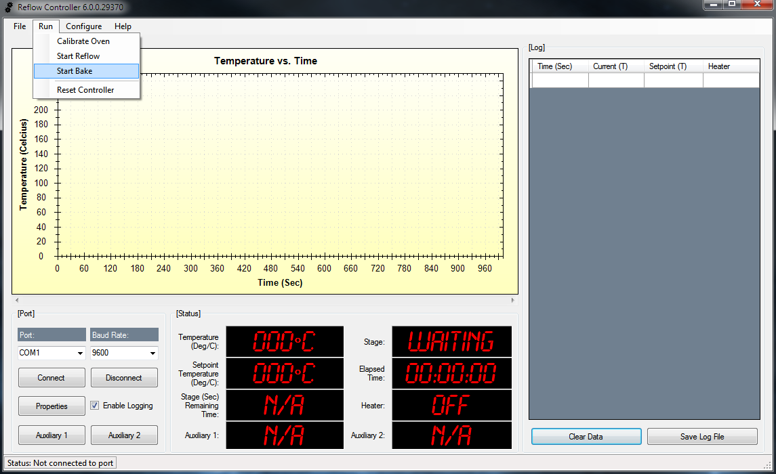

* **Start Bake**

This menu option starts the baking process. This process is used for removing moisture from components.

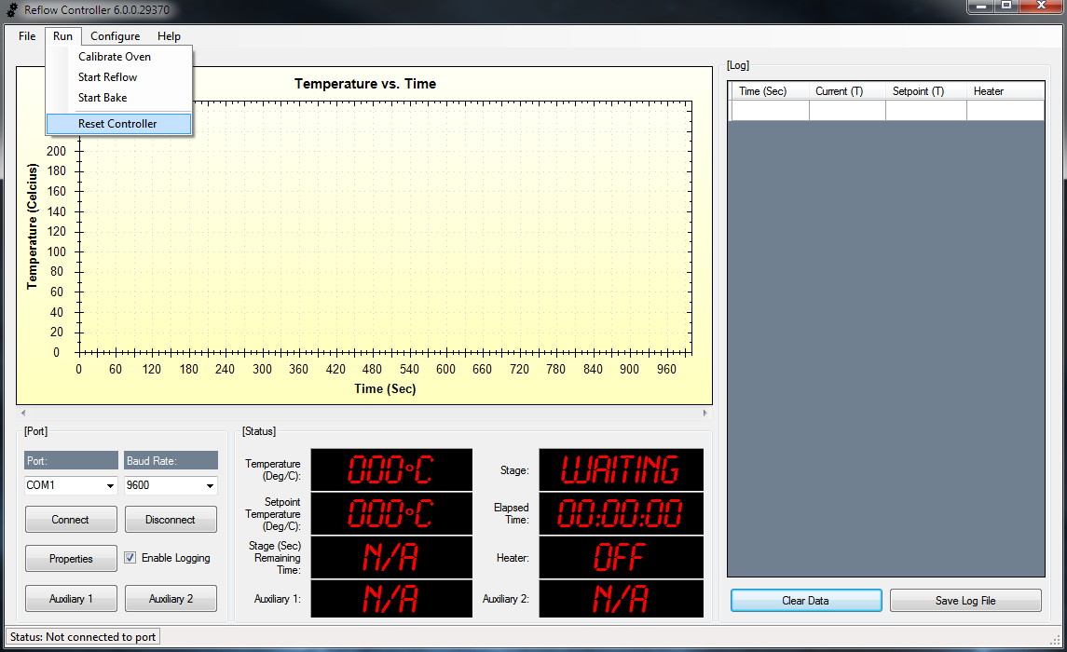

* **Reset Controller**

This menu option reboots the reflow controller.

**Configure Menu**

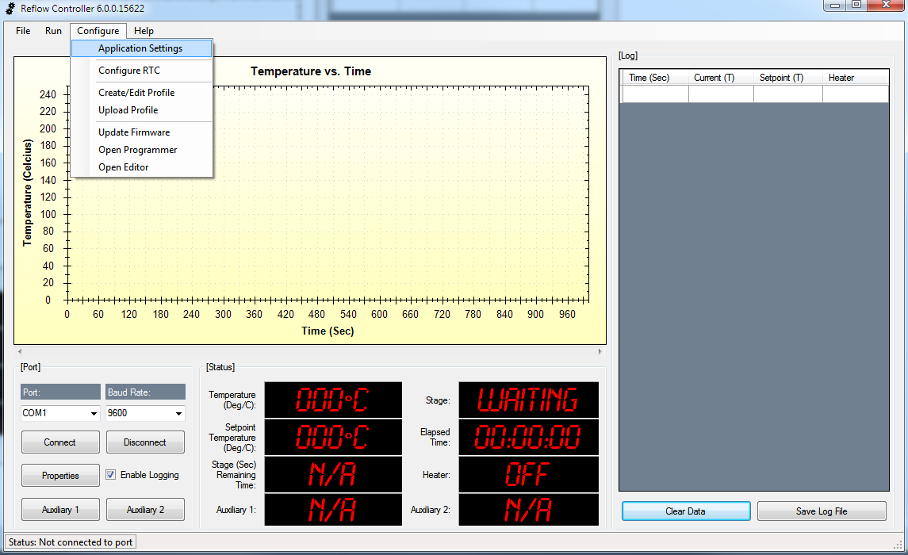

* **Application Settings**

This menu option opens a form where the default firmware loader, hardware programmer and program editor can be set.

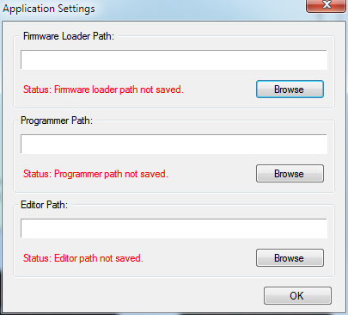

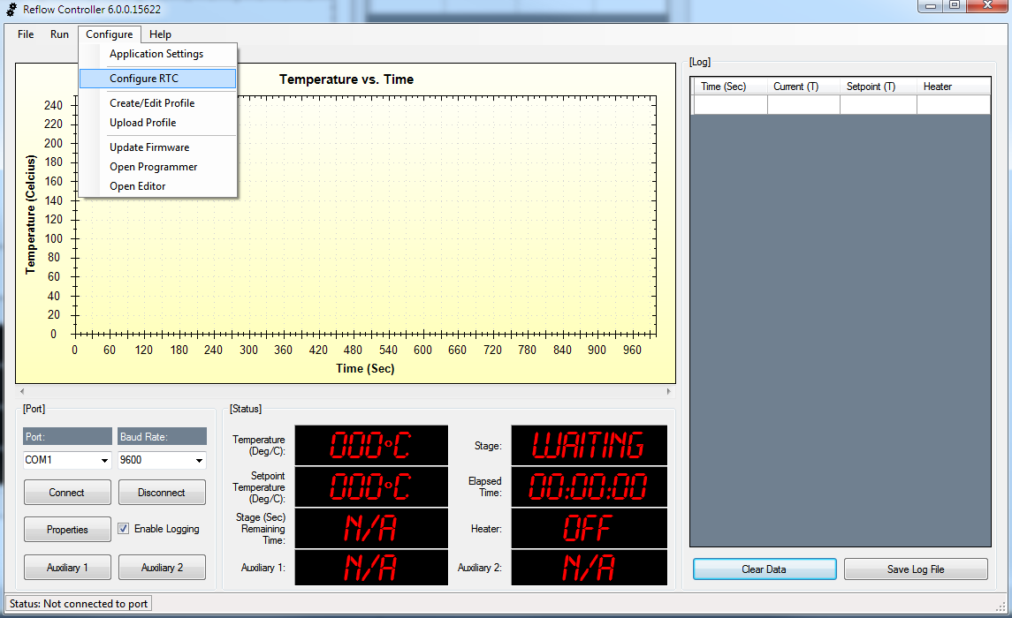

* **Configure RTC**

This menu option configures the optional real time clock (RTC) attached to the reflow controller. This option only needs to be selected for an initial configuration of the RTC.

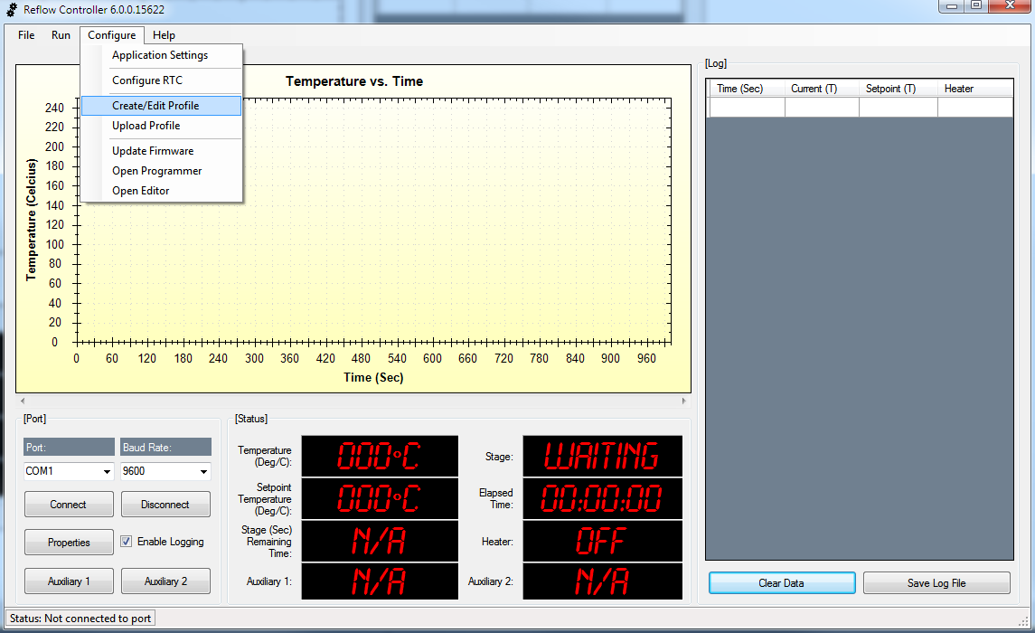

* **Create/Edit Profile**

This menu option opens a form where a reflow profile can be created or edited.

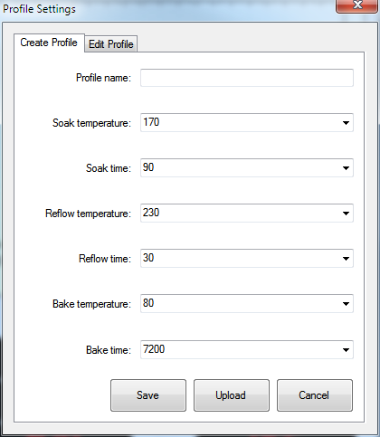 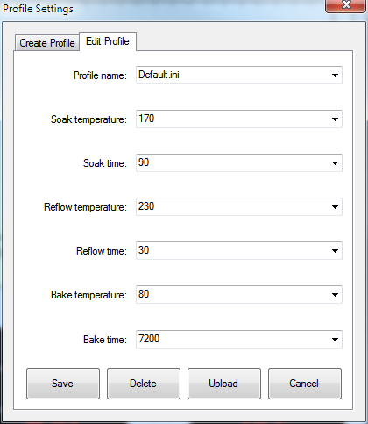

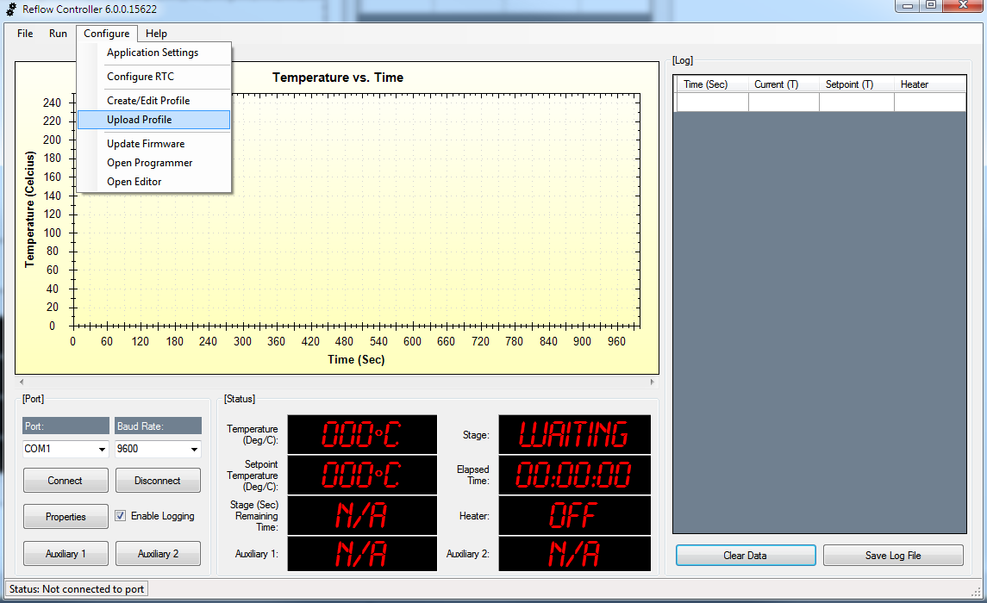

* **Upload Profile**

This menu option uploads a selected profile to the reflow controller.

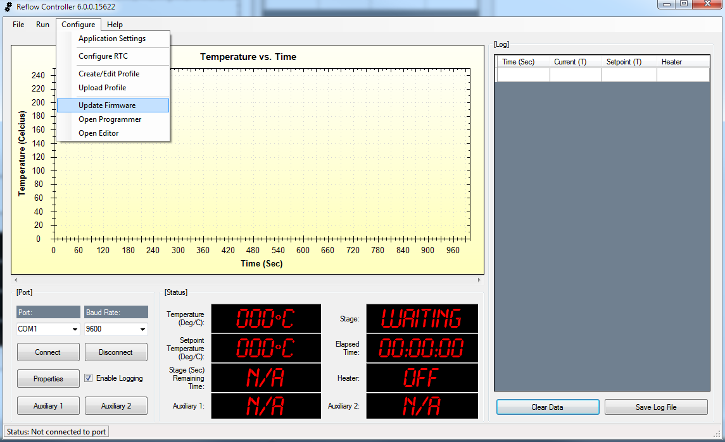

* **Update Firmware**

This menu option opens the default firmware loader. The firmware loader is used to re-flash the reflow controller over the serial port without needing a hardware programmer. The following error message will be displayed if no firmware loader application is found:

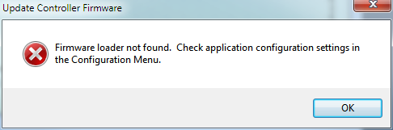

The firmware loader application is optional and not included with the reflow application.

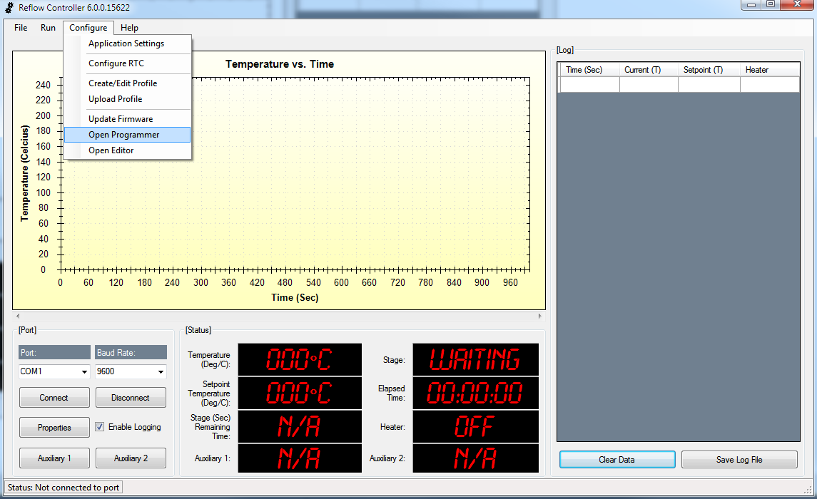

* **Open Programmer**

This menu option opens the default program loader. The program loader is used to load hex files onto the reflow controller without using a bootloader. The following error message will be displayed if no programmer application is found:

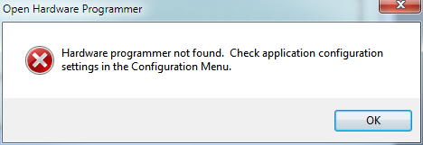

The programmer application is optional and not included with the reflow application.

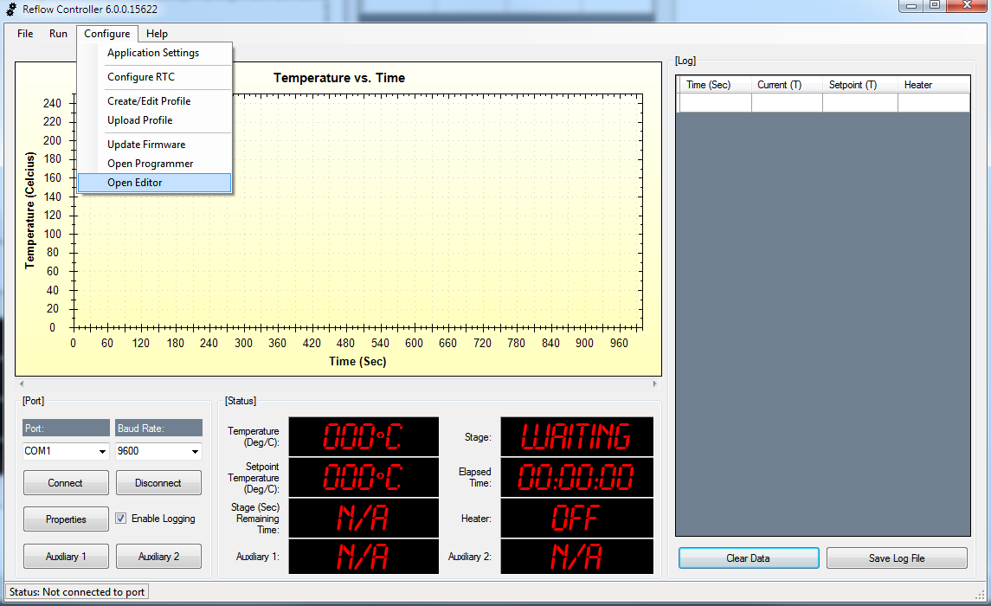

* **Open Editor**

This menu option opens the default program editor application. The program editor is used to edit code that will be compiled into a hex file and loaded onto the reflow controller using a programmer. The following error message will be displayed if no program editor application is found:

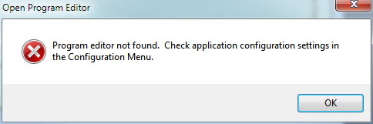

The program editor is optional and not included with the reflow application.

**Help Menu**

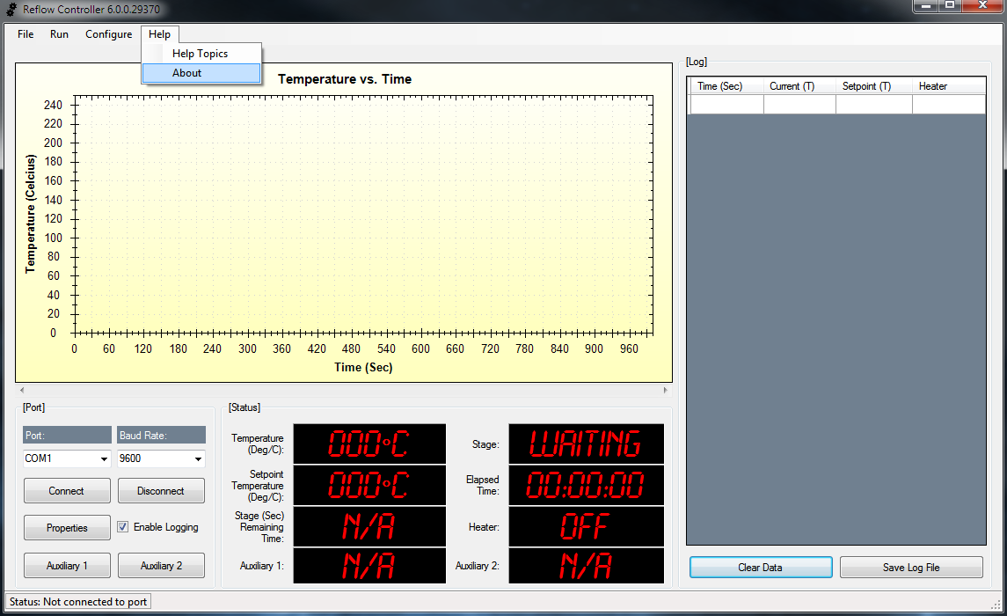

* **About**

This menu option opens a form that displays information about the current version of the reflow controller application.

