**Chapter-2**

**Literature Review**

The literature reviews related to home automation are discussed in this chapter. With advancement of Automation technology, life is getting simpler and easier in all aspects. The internet of thing, IOT, is in a huge way and people are rapidly inventing new gadgets that enhance society. This section describes the previous proposed home automation method.

2.1 Wireless Home Automation System using IoT

In this paper, the author mentioned that the internet of Things, IOT, is in a huge way and people are rapidly inventing new gadgets that enhance society.

Nowadays more and more everyday items things are becoming smart. Things have sensors and can communicate to other things and can provide control to more “things”. The internet of thing, IOT, is a system of interrelated computing devices, mechanical and digital machines, objects, animals, or people that are provided with unique identifiers (UIDs) and the ability to transfer data over a network without requiring human to human or human to computer interaction. IOT devices share the sensor data which collects by connecting to an IOT gateway or other edge device where data either sent to the cloud to be analyzed or analyzed locally. Sometimes, these devices communicate with other related devices and act on the information from one another. The devices do most of the work without human intervention, although everyone can interact with the device – for instance, to set them up, give them instructions or access the data. The internet of thing helps society and work smarter, as well as gain complete control over human lives. In addition to offering smart device to automate homes, IOT is essential to business.

In this paper, the system is done by using WIFI ESP8266 Module (NodeMCU), LM117-3.3V, Sugar Cube Relay, Resistor 10K,1K,4.7K, Capacitor 1000uF,10uF,104(0.1uF), PBT-2 connectors, ULN2003 Relay Driver and 12 Power Supply. NodeMCU is a low-cost module and can control four electrical devices and also can monitor temperature. ESP8266 WIFI Module is capable of either hosting application or offloading all WIFI networking functions from another application processor. The LM117-3.3V is a fixed low dropout voltage regulator with a dropout voltage of 1.2V at 800mA of load current. Sugar Cube Relay is a high-quality Single Pole-Double Throw (SPDT) and is used to switch high voltage (240AC) and/or high current devices(7A). A resistor is an electronic component used to resist the flow of current. A capacitor is an electronic component used to store electrical charge. ULN2003 Relay Driver is a relay driver IC and a Darlington array with high voltage and high current.

With advancement of Automation technology, life is getting simpler and easier in all aspects. In today’s world, Automatic systems are being preferred over manual system. With the rapid increase in the number of users of internet over the past decade had made internet a part and parcel of life.



Figure 2.1 Overall Block Diagram of Wireless Home Automation using IoT

2.1.1 Operation of the Proposed System

From the block diagram, LM117 is used for providing power supply to the ESP8266 WIFI module.WIFI module provides command ULN2003 relay drive to drive Relays. Relays operate to turn on/off LED and Fan.Temperature sensor is used to measure the amount of heat or even coldness that is generated by an object.

2.1.2 IOT based Home Automation Circuit Testing

1. Turn on the circuit.
2. Turn on WIFI on mobile Phone or Laptop
3. Enter 192.168.4.1 IP in browser.
4. Operate the Relay.

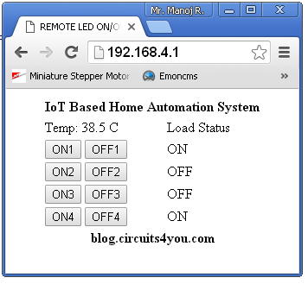

2.2 Voice Controlled Home Automation System using Bluetooth Module

In this system, home automation is done using bluetooth module and Arduino. The system uses a voice function to control home devices. This system is the part of the home automation series. The system is very easy to use in real life. People of any age can control it by speaking the commands. This Arduino based system has a larger range than IR and PC based ones.



Figure 2.3 Overall Block Diagram of Voice Controlled Home Automation Using Bluetooth Module

The components required for this proposed system are Arduino Uno, HC05 Bluetooth Module, 4-channel Relay Modules, LCD, AC bulbs with holder, AC wire with plug, Fan and External 5V supply. Arduino Uno is used due to its simplicity and it also provides the much digital pin to interface with LCD, Bluetooth Module, and Relay Module at the same time. HC05 is used to communicate with the mobile phone. 4-channel Relay Module is used to switch ON and OFF using 5V logical signal from Arduino. It can bear up to 250VAC and 10A. LCD is used to display system name, a list of commands which can be entered then it asks to give any command and show the status of the command which is entered. It is easy to interface with Arduino and very cheap in price. AC bulbs and Fan are used to represent appliances. It is easy to handle and very useful in prototyping any AC projects. External 5V DC supply is required to switch a relay ON and OFF.

2.2.1 Operation of the Proposed System

Human voice or voice command is sent to the Bluetooth Module through Android application which is then received by Arduino. At the same time, Arduino displays the status on LCD and write on the serial monitor. Each command has its unique operations which are defined in code. Android application converts voice into speech signal and sends this signal to Arduino through Bluetooth Module. Arduino performs the described tasks i.e. turn ON and OFF AC bulbs or Fan.

2.3 GSM Based Home Automation System using Cell Phone

The system is discussed by Rozita Teymourzadeh, CEng, Member IEEE/IET, Salah Addin Ahmed, Kok Wai Chan, and MOk Vee Hoong Faulty of Engineering, Technology & Built Environment UCSI University, Kuala Lumpur, Malaysia. This research work investigates the potential of ‘Full Home Control’, which is the aim of the Home Automation Systems in near future. The analysis and implementation of the home automation technology using Global System for Mobile Communication (GSM) modem to control home appliances such as light, conditional system, and security system via Short Message Service (SMS) text is presented in this paper. The proposed system work is focused on functionality of the GSM protocol, which allows the user to control the target system away from residential using the frequency bandwidths. The concept of serial communication and AT-commands has been applied towards development of the smart GSM-based home automation. Home owners will be able to receive feedback status of any home appliances under control whether switch ON or OFF remotely from mobile phones. PIC16F887 microcontroller with the integration of GSM provides the smart automated house system with the desired baud rate of 9600bps.

GSM is one of the most widely used cellular technologies in the world. With the increase in the number of GSM subscribers, research and development is heavily supported in further investigating the GSM implementation. Hence, this research work implements SMS based control for home appliances using the GSM architecture without accessing the local network.

The design and architecture consist of mobile phone and GSM modem. In the proposed system design, incoming SMS message is sent from the user phone to the GSM modem as a text message via cellular network. The GSM modem then sends the command in text mode to the PIC microcontroller using RS232 interface. The RS232 voltage levels are at +12V or -12V whereas both the microcontroller input and output operate at 0V to +5V. Since RS232 is not compatible with microcontroller, Max232 is utilized to enable the communication between both the GSM modem and PIC microcontroller by converting RS232 level signals to TTL level signal. Outgoing message from the system containing the home appliance status is delivered to the mobile phone through GSM modem.



Figure 2.4 Overall Block Diagram of the Proposed System

The 8bit PIC16F887 microcontroller generally consists of timers, Analog to Digital converter (ADCs)m and Universal Synchronous Asynchronous Receiver Transmitter (USART). In the proposed research work, the microcontroller receives instructions and decodes them to give device address and command, then sends corresponding signal to the driver of the power circuit. In addition, the microcontroller ensures dual independent operation action to turn ON the device or switch it OFF. A feedback status of any devices under control whether switch ON or OFF will be provided by the microcontroller.

The RS232 interface standard defines the electrical and mechanical details of the interface between Data Terminal Equipment (DTE) and Data Communications Equipment (DCE), which employ serial binary data interchange. The current version of the standard refers to DCE as Data Circuit terminating Equipment. Physically, interfacing between PIC16F887 and GSM modem was implemented using RS232 standard installed on Max232. Since the system design has not included a battery, an external power supply is connected to the system to drive sufficient amount of current through the circuit connections. Relays had been connected to the output of the loads for a stable electrical control because these relays can provide feeding for different voltage level loads. Hence, the output selection become easier at any voltage.

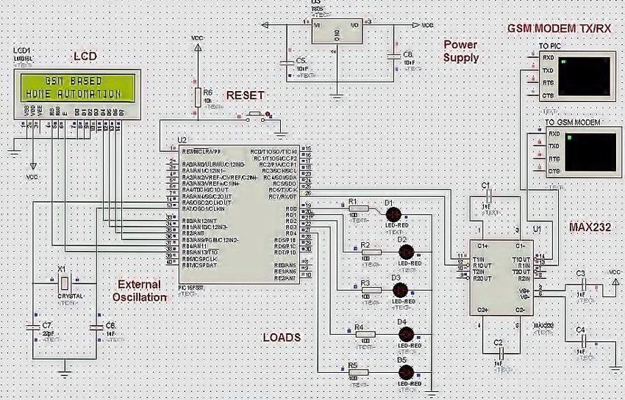

Figure 2.5 Simulation of the Proposed GSM Based Home Automation System

Figure 2.5 demonstrates the simulation of the proposed GSM based Home Automation System being implement in several stages. The PIC16F887 was simulated with the GSM Modem by connecting it to the physical ports on the PC. Max232 was placed to ensure proper transmission of data between the two terminals. Virtual terminal monitors the text sent from and to the PIC16F887 while checking the transmission process and testing the algorithm. The waveform of the transmitted and received messages is monitored from the oscilloscope. While simulating the GSM modem, the “COMPIM” clock physically tests the response of the GSM Modem by connecting it to a physical port on PC.

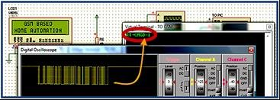Figure 2.6 AT+CMGD Command to Delete SMS Message

As shown in figure 2.6, waveform is generated in the digital oscilloscope when the command is transmitted from PIC16F887 to GSM modem. This command will execute the deletion of the first message from the SIM card memory. The program reaches to a sleep state waiting for the new incoming text messages and then compare the text message with the stored commands. If both the received text message and the store command match, then, it will execute the intended command, which is turning ON or OFF the output terminal.

The AT command was sent from PIC16F887 to the GSM Modem as the program starts up, then the response is received from the GSM modem after very short period of time that does not exceed 500 microseconds which is fast enough to detect the incoming message from the modem. PIC16F887 severs as a transmitter initially and then receives the response from Modem. The duration between the text sent and response received is less than 500 microseconds. After receiving the command to turn on the lights, the relay set will perform switching operation from normally open to close the circuit, allowing the current to start light, alarm and music.

2.3.1 Test and Result

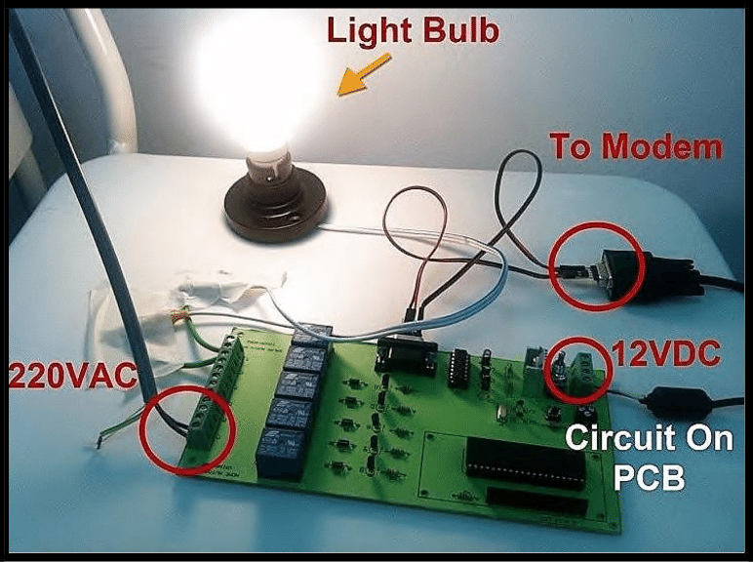Figure 2.7 Prototype of Proposed GSM Based Home Automation System

The prototype of the proposed GSM based home automation system is shown in figure 2.7. A 12V is supplied to the voltage regulator to power the circuit. Max232 is connected to the GSM Modem and the system activated and automated the house in desirable basis.

2.4 Summary

These systems above are home automation using the help of loads and sensors. Arduino takes the command from Bluetooth module and GSM Modem and performs the tasks as described. ESP826 WIFI module can act like microcontroller and also control the house as the desired situation.