CSC 381/780 Histogram (Java)
Oakga Lwin
C++ and Java hard copy: 9/05/2016 Tuesday in class

Algorithm Steps

*******************************
VI. Algorithm for Histogram
*******************************

step 0: - open input and output files

step 1: - read the image header from input file, the four numbers.
- dynamically allocate the histogram array
- initial the historgram array to 0

step 2: // process the input file from left to right and top to bottom

p(i,j) <- read from input
hitogram[p(i,j)]++

step 3: repeat step 2 until the file is empty

step 4: output histogram array to output file

step 5: close input file and output file

import java.io.File;
import java.io.IOException;
import java.io.FileNotFoundException;
import java.io.PrintWriter;
import java.util.Scanner;

public class main{
public static void main(String args[]) throws FileNotFoundException {
File inFile = new File(args[0]);
File outFile = new File(args[1]);
histogram processor = new histogram(inFile, outFile);
processor.computeHistogram();
}
}
class histogram {
int[] histogram;
int numRows;
int numCols;
int minVal;
int maxVal;
File inFile;
File outFile;
histogram(File inFile, File outFile){
try{
this.inFile = inFile;
this.outFile = outFile;
Scanner input = new Scanner(inFile);
numRows = input.nextInt();
numCols = input.nextInt();
minVal = input.nextInt();
maxVal = input.nextInt();
histogram = new int[maxVal+1];
input.close();
} catch (IOException e){
e.printStackTrace();
}
}
void computeHistogram(){
int pixel, maxPlus;
try{
PrintWriter output = new PrintWriter(outFile, "UTF-8");
Scanner input = new Scanner(inFile);
for(int i=0;i<4;i++){
input.nextInt();
}
while(input.hasNextInt()){
pixel = input.nextInt();
histogram[pixel]++;
}
output.write(numRows+" "+numCols+" "+minVal+" "+maxVal+"\n");
for(int i=0;i< maxVal;i++){
output.write("(" +i+"): "+ histogram[i]);
if(histogram[i]> 80) maxPlus = 80;
else maxPlus = histogram[i];
for(int j = 0; j< maxPlus; j++){
output.write("+");
};
output.write("\n");
}
output.write("\n");
input.close();
output.close();
} catch (IOException e){
e.printStackTrace();
}
}
}

*************************************
II. Algorithms for computeThreshold
*************************************

step 0: - open input file

step 1: - read the image header from input file, and store the four numbers.

step 2: - thr_value <- ask the user
- open the output file with the required name
- write the header (the four numbers) to the output file

step 3: // process the input file from left to right and top to bottom
// using i from 0 to numRows - 1 and j from 0 to numCols -
// make sure the output is a 2D array with header!!!

pixel_val <- read from input
if pixel_val < thr_value
output 0
else
output 1

step 4: repeat step 3 until input file is empty

step 5: close input and output files.

import java.io.File;
import java.io.IOException;
import java.io.FileNotFoundException;
import java.io.PrintWriter;
import java.util.Scanner;

class main{
public static void main(String args[]) throws FileNotFoundException {
File inFile = new File(args[0]);
File outFile = new File(args[1]);
Scanner in = new Scanner(System.in);
System.out.println("thresholdValue:");
int thresholdValue = in.nextInt();
in.close();
Thresholding processor = new Thresholding(inFile, outFile, thresholdValue);
processor.computeThreshold();
}
}
class Thresholding{
int[] histogram;
int numRows;
int numCols;
int minVal;
int maxVal;
int thresholdValue;
File inFile;
File outFile;
Thresholding(File inFile, File outFile, int thresholdValue){
try{
this.inFile = inFile;
this.outFile = outFile;
this.thresholdValue = thresholdValue;
Scanner input = new Scanner(inFile);
numRows = input.nextInt();
numCols = input.nextInt();
minVal = input.nextInt();
maxVal = input.nextInt();
histogram = new int[maxVal+1];
input.close();
} catch (IOException e){
e.printStackTrace();
}
}
void computeThreshold(){
int pixel = 0;
try{
PrintWriter output = new PrintWriter("thr_"+thresholdValue, "UTF-8");
Scanner input = new Scanner(inFile);
for(int i=0;i<4;i++){
input.nextInt();
}
output.write(numRows+" "+numCols+" "+minVal+" "+maxVal+"\n");
for(int i =0; i<numRows;i++){
for(int j=0;j<numCols;j++){
pixel=input.nextInt();
if(pixel < thresholdValue) output.write(0+" ");
else output.write(1+" ");
}
output.write("\n");
}
output.close();
input.close();
} catch (IOException e){
e.printStackTrace();
}
}
}

III. Algorithms for pretty print
*************************************

step 0: - open input file
- open the output file with the required name.

step 1: - read the image header from input file, the four numbers.

step 2: // process the input file from left to right and top to bottom
// using i from 0 to numRows - 1 and j from 0 to numCols -

pixel_val <- read from input
if pixel_val > 0
output pixel_val
else
output ' ' // blank

step 3: repeat step 2 until input file is empty

step 4: close input and output files.
import java.io.File;
import java.io.IOException;
import java.io.FileNotFoundException;
import java.io.PrintWriter;
import java.util.Scanner;

public class main{
public static void main(String args[]) throws FileNotFoundException {
File inFile = new File(args[0]);
File outFile = new File(args[1]);

Scanner in = new Scanner(System.in);
System.out.println("thresholdValue:");
int thresholdValue = in.nextInt();
in.close();
prettyPrint.print(inFile, outFile, thresholdValue);
}
}
class prettyPrint
{ static void print(File inFile,File outFile,int value){
int numRows,numCols,minVal,maxVal,thresholdValue,pixel;
try{
thresholdValue = value;
Scanner input = new Scanner(inFile);
PrintWriter output = new PrintWriter(outFile+"_PP.txt", "UTF-8");
numRows = input.nextInt();
numCols = input.nextInt();
minVal = input.nextInt();
maxVal = input.nextInt();
for(int i=0;i<numRows;i++){
for(int j=0;j<numCols;j++){
pixel = input.nextInt();
if(pixel < thresholdValue) output.write(" ");
else output.write(pixel+" ");
}
output.write("\n");
}
output.close();
input.close();
} catch (IOException e){
e.printStackTrace();
}
}
}

Output: threshold 48
histogram
46 46 1 63
(0): 0
(1): 277++++++++++++++++++++++++++++++++++++++++++++++++++++++++++++++++++++++++++++++++
(2): 278++++++++++++++++++++++++++++++++++++++++++++++++++++++++++++++++++++++++++++++++
(3): 264++++++++++++++++++++++++++++++++++++++++++++++++++++++++++++++++++++++++++++++++
(4): 319++++++++++++++++++++++++++++++++++++++++++++++++++++++++++++++++++++++++++++++++
(5): 277++++++++++++++++++++++++++++++++++++++++++++++++++++++++++++++++++++++++++++++++
(6): 7+++++++
(7): 6++++++
(8): 35+++++++++++++++++++++++++++++++++++
(9): 4++++
(10): 5+++++
(11): 7+++++++
(12): 8++++++++
(13): 6++++++
(14): 9+++++++++
(15): 3+++
(16): 3+++
(17): 0
(18): 12++++++++++++
(19): 1+
(20): 3+++
(21): 4++++
(22): 7+++++++
(23): 3+++
(24): 7+++++++
(25): 3+++
(26): 0
(27): 3+++
(28): 15+++++++++++++++
(29): 3+++
(30): 7+++++++
(31): 7+++++++
(32): 7+++++++
(33): 2++
(34): 10++++++++++
(35): 10++++++++++
(36): 0
(37): 0
(38): 17+++++++++++++++++
(39): 1+
(40): 6++++++
(41): 12++++++++++++
(42): 10++++++++++
(43): 20++++++++++++++++++++
(44): 15+++++++++++++++
(45): 6++++++
(46): 2++
(47): 2++
(48): 362++++++++++++++++++++++++++++++++++++++++++++++++++++++++++++++++++++++++++++++++
(49): 0
(50): 0
(51): 8++++++++
(52): 2++
(53): 1+
(54): 2++
(55): 11+++++++++++
(56): 0
(57): 0
(58): 10++++++++++
(59): 0
(60): 8++++++++
(61): 1+
(62): 2++

PrettyPrint

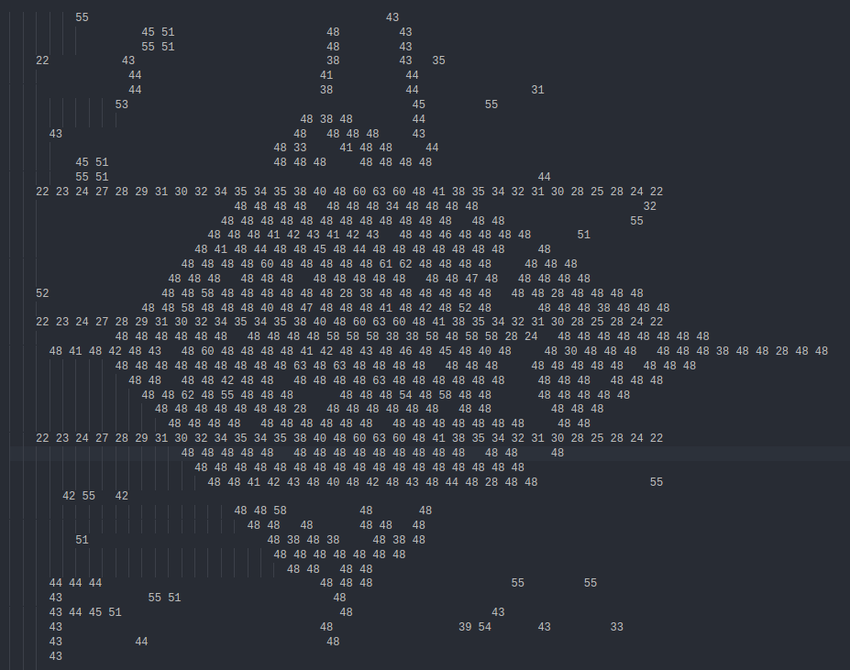

Thr_48


