**// For installing GUI of Fedora server**

sudo dnf install sddm

sudo dnf groupinstall "KDE Plasma Workspaces"

sudo systemctl enable sddm

sudo systemctl enable sddm

sudo systemctl start sddm

**//creating a sharing folder which is bridged between Linux and Windows**

sudo mkdir -p /srv/Database/Data/

sudo chmod -R 755 /srv/Database/Data/

sudo chown -R nonody:nobody /srv/Database/Data/

sudo chcon -t samba_share_t/srv/Database/Data/

**// firewall settings for making is accessable for Windows**

firewall-cmd --add-service=samba

firewall-cmd --add-service=samba --permanent

firewall-cmd --reload

getenforce

sudo setsebool -P samba_enable_home_dirs on

sudo hostname fedora

sude hostnamectl set-hostname Database

sudo  nano /etc/samba/smb.conf

sudo systemctl restart smb nmb

**//customizing smb**

sudo mv /etc/samba/smb.conf /etc/samba/smb.conf.bak

sudo nano /etc/samba/smb.conf

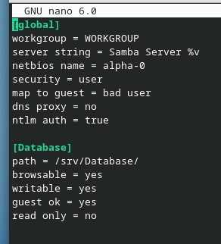

sudo systemctl restart smb nmb