Student: Oana Brudan

**Group: 30234**

Table of Contents

1. Requirements Analysis 3

1.1 Assignment Specification 3

1.2 Functional Requirements 3

1.3 Non-functional Requirements 3

2. Use-Case Model 4

3. UML Sequence Diagrams 5

4. Class Design 6

5. Bibliography 6

1. Requirements Analysis

# Assignment Specification

Use Swing/C# API to design and implement an application for the order managers of a furniture manufacturer. The application should have two types of users (a regular user represented by the order manager and an administrator user) which have to provide a username and a password in order to use the application.

The regular user can perform the following operations:

Add/update/view order information (customer, shipping address, identification number, delivery date, status.).

Create/update/delete/view product information (title, description, color, size, price, stock etc).

Add products to order and update order value and stock accordingly.

The administrator user can perform the following operations:

CRUD on employees’ information.

Generate reports for a particular period containing the activities performed by an employee.

# Functional Requirements

CRUD on orders information

CRUD on products information

Login as admin or regular user

CRUD on employees information

# Non-functional Requirements

Add products to order and update order value and stock accordingly

Generate reports for a particular period containing the activities performed by an employee.

2. Use-Case Model

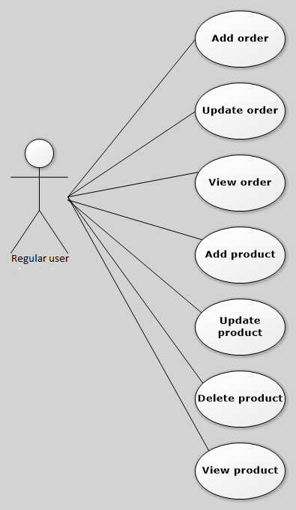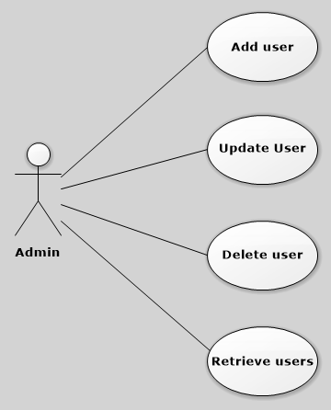

3. UML Sequence Diagrams

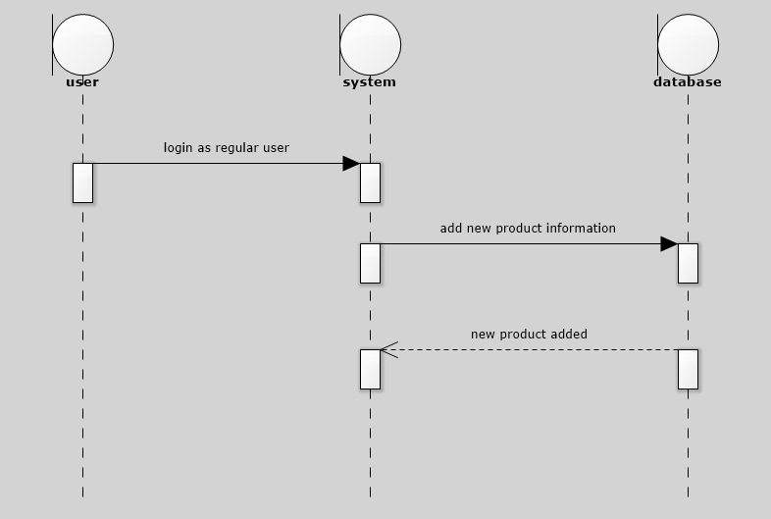

4. Class Design

**UML Class Diagram**

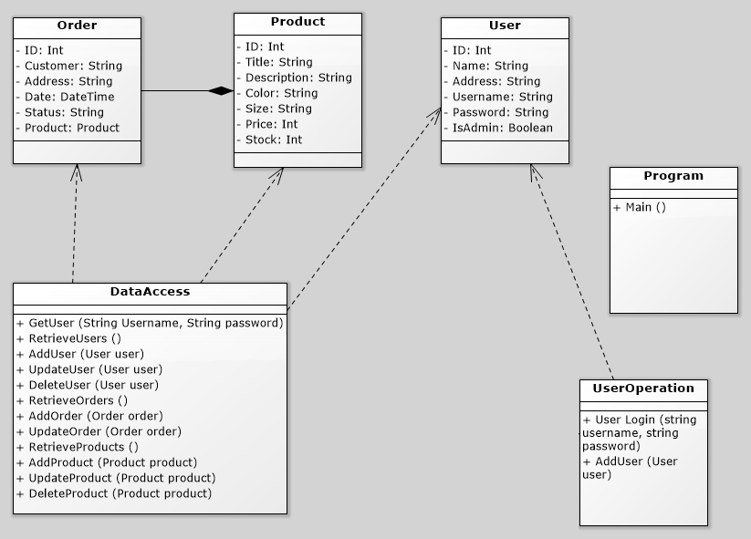

5. Bibliography

<https://msdn.microsoft.com/en-us/library/system.security.cryptography.md5(v=vs.110).aspx>

<https://msdn.microsoft.com/en-us/library/ms182532.aspx>

<https://msdn.microsoft.com/en-us/library/edakx9da.aspx>