Fingerprint Door Lock System

Jimborean Oana

Group 30432

This project consists of a door lock that opens when you touch the sensor and the fingerprint matches the correct one.

* Used Components:
* Ardiuno Uno

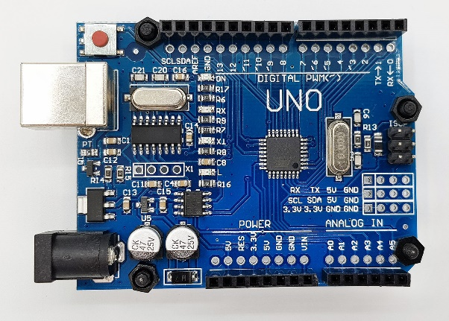

* 5V Relay

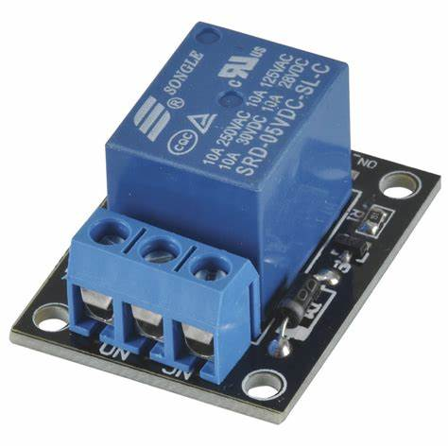

* Selonoid 12V Lock

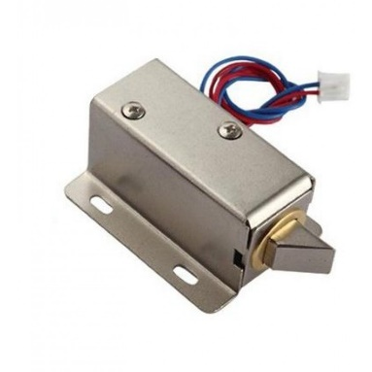

* Finger Print Sensor

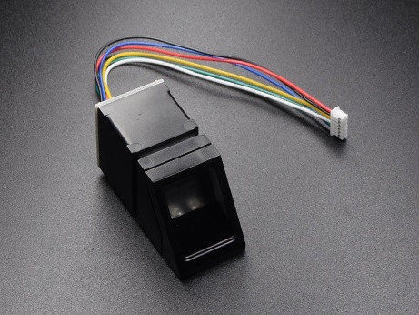

* Diagram:

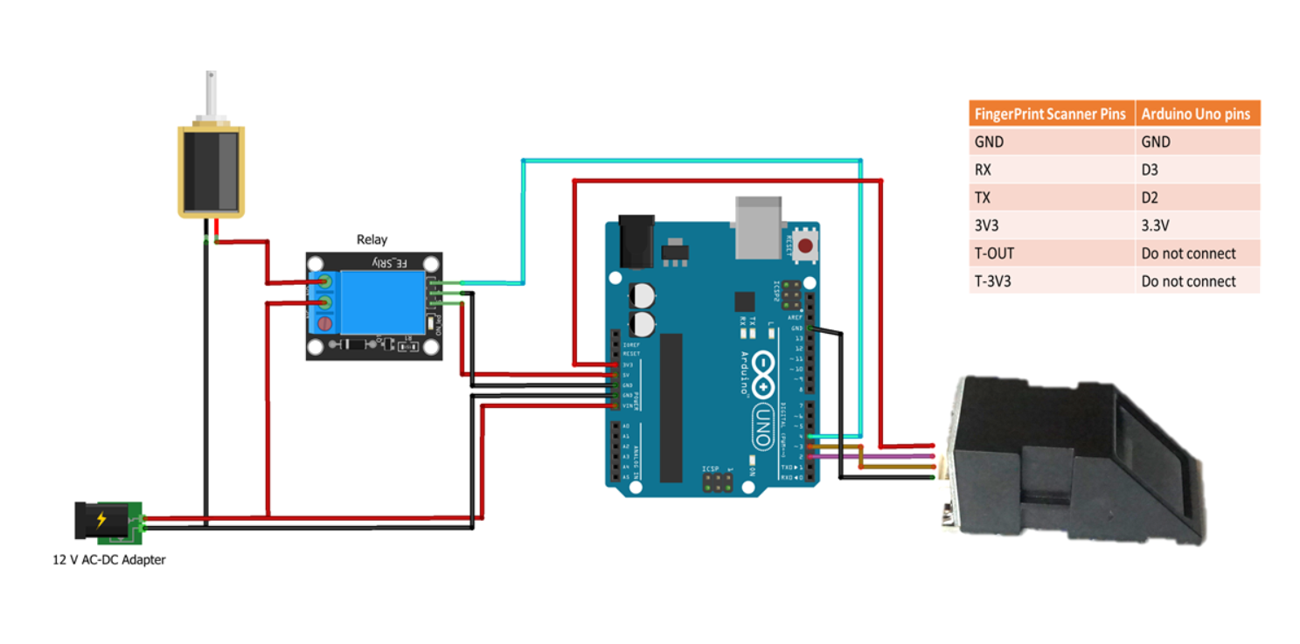

* Final Result:

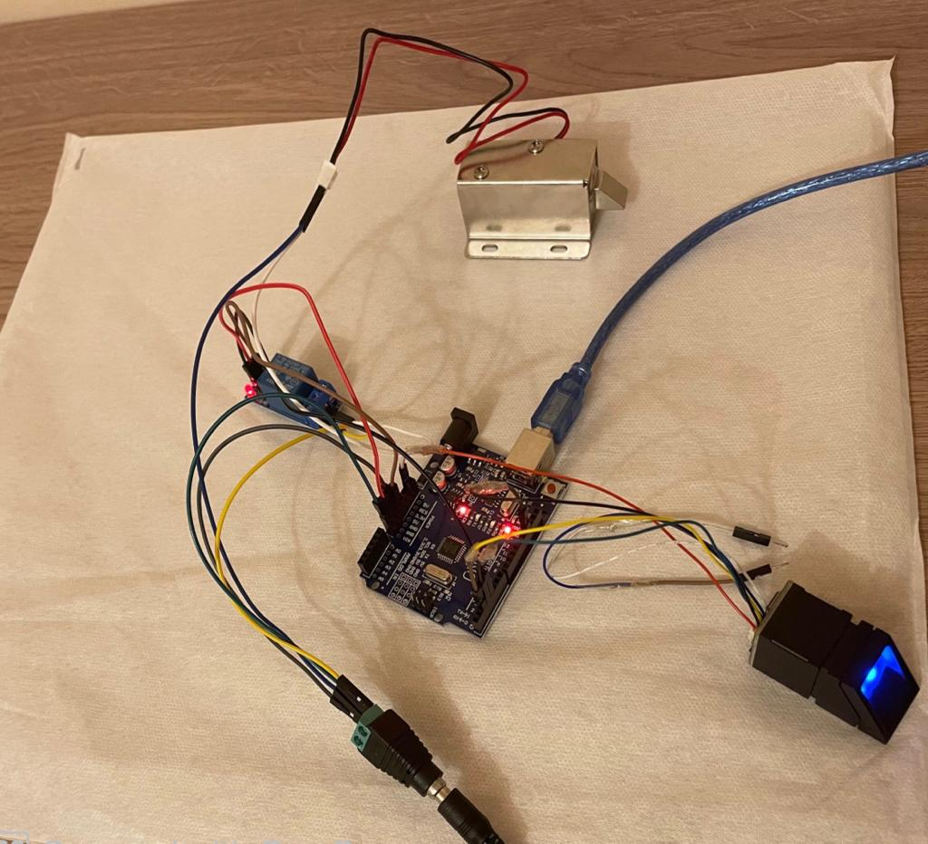

* How does this work?

The Arduino sketch for sensor administration begins with importing Adafruit Fingerprint Library. The software serial is instantiated for communication with the sensor.

The working principle of the fingerprint sensor mainly depends on the processing. The fingerprint processing mainly includes two elements namely enrollment and matching. In fingerprint enrolling, every user requires to place the finger twice.

So that the system will check the finger images to process as well as to generate a pattern of the finger and it will be stored. When matching, a user places the finger using an optical sensor then the system will produce a pattern of the finger & compares it with the finger library templates.

For 1:1 fingerprint matching, the system will evaluate the exits finger with a precise pattern which is selected within the module. Similarly, for 1: N matching, the scanning system will look for the complete finger records for the finger matching. In both situations, the scanning system will go back to the corresponding result, success otherwise crash.

The open-source Arduino software (IDE) makes is easy to write code and upload it to the board.

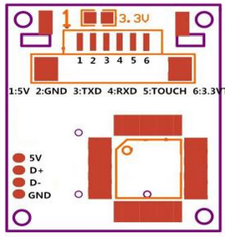

We connect the 5V pin and GND of the sensor to 5V out and any of the ground pins of Arduino UNO, respectively. Connect TxD and Rxd pins of the sensor to pin D2 and D3 of Arduino, respectively. The pins D2 and D3 are used as Rx and Tx of software serial on the Arduino board.

These devices are mainly used in safes where there is a high-powered DSP chip used in the rendering of image, feature-finding, searching and calculation by connecting it to any microcontroller with the help of TTL serial, & send data packets to get photos, notice prints, search and hash. The enrollment of new fingers can be stored directly within the flash memory of on board.

After making all the right connections between the board and the components, when there is a fingerprint match, the door lock will open. Otherwise, nothing happens.