DOCUMENTATION

ASSIGNMENT NUMBER 2
QUEUE MANAGEMENT SYSTEM

Jimborean Oana Elena
Group 30422

CONTENTS
- Objectives. . . . . . . . . . . . . . . . . . . . . . . . . . . . . . . . . . . . . . . . . . . . . . . .3
- Analysis. . . . . . . . . . . . . . . . . . . . . . . . . . . . . . . . . . . . . . . . . . . . . . . .. .3
- Design. . . . . . . . . . . . . . . . . . . . . . . . . . . . . . . . . . . . . . . . . . . . . . . . . . .4
- Implementation. . . . . . . . . . . . . . . . . . . . . . . . . . . . . . . . . . . . . . . . . . . .7
- Results. . . . . . . . . . . . . . . . . . . . . . . . . . . . . . . . . . . . . . . . . . . . . . . . . . .10
- Conclusions. . . . . . . . . . . . . . . . . . . . . . . . . . . . . . . . . . . . . . . . . . . . .. .13
- Bibliography. . . . . . . . . . . . . . . . . . . . . . . . . . . . . . . . . . . . . . . . . . . . . .13

- Objectives
- Main objective:
To design and implement a queues management application which assigns clients to queues such that
the waiting time is minimized.
- Sub-objectives:
- Creation of an object that can simulate the queue systems: Queues provide a place for a “client” to wait before receiving a “service”. In Java, the simulation of time-based systems, can be done using threads.
- Concurrency of queues: The application should be able to handle appropriately multiple such queue simulating objects(Multithreading).
- Generation of Client objects: Clients are characterized by three parameters, the id, the arrival time to the queue and the service time. These parameters need to be generated using the minimum and maximum values given in the input file specified in the arguments.
- Computation of the average waiting time: At the end of the simulation, the average waiting time needs to be computed i.e. the sum of the total time waited in queue by each processed client divided by the number of processed clients.
- Output generation: The log of the simulation at every time frame and the average waiting time need to be written to an output file given as an argument.
- Building a user interface through which the interaction between the system and the user is facilitated, contains all the functionalities desired and provides results that can be reused later: The UML diagrams of classes and packages for the project are presented; It highlights the data structures used, the algorithms used and the interfaces added.

- Problem analysis, modeling, scenarios, use cases
Queues are often used to model real-world apps. The main objective of a queue is to manage the location of a "customer" before they receive a "service". The management of queue-based systems aims to minimize the amount of waiting time for customers and streamlining processes by adding more servers (if possible) for distributing customers to all available servers.
This application should simulate customers waiting to receive a service (e.g. supermarket, bank, etc.) just like in the real world, they have to wait in queues, each queue processing clients simultaneously. The idea is to analyze how many clients can be served in a certain simulation interval, by entering parameters in an intuitive, user-friendly, application graphical interface.
Use Case: setup simulation
Primary Actor: user
Main Success Scenario:
1. The user inserts the values for the: number of clients, number of queues, simulation interval, minimum and maximum arrival time, and minimum and maximum service time
2. The user clicks on the validate input data button
3. The application validates the data and displays a message informing the user to start the simulation
Alternative Sequence:
- Invalid values for the setup parameters
- The user inserts invalid values for the application’s setup
parameters
- The application displays an error message and requests the
user to insert valid values
- The scenario returns to step 1

The user can read
- The average waiting time for every queue (in seconds)
- The “peak hour”, when the most clients were served
- The total number of clients served in the simulation
- The average service time length (in seconds)
- The number of clients and the average waiting time for a user given interval

Use case diagram:
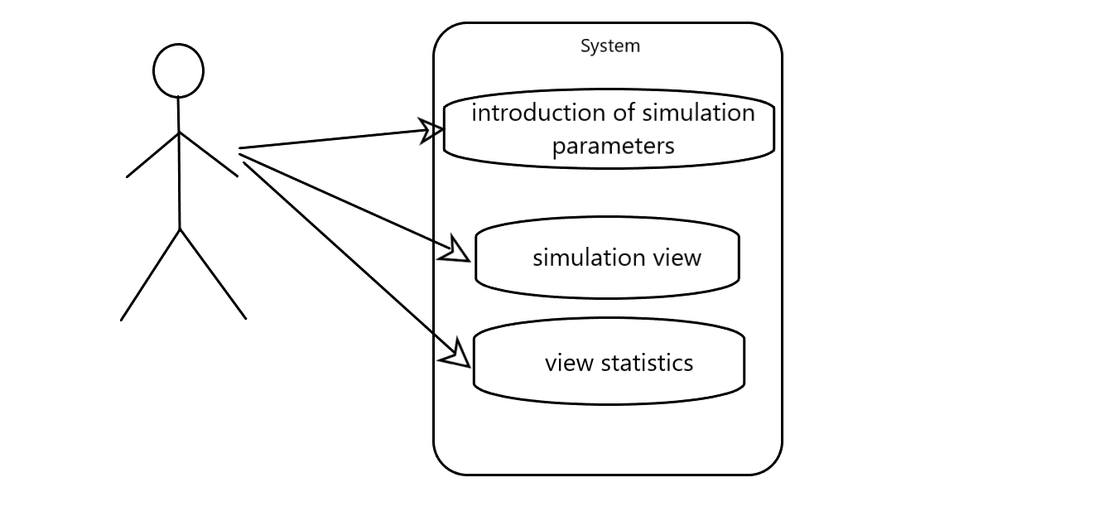

- Design
Here, we will expose the UML diagrams of classes, the hierarchical structure of the project and the data structures used. The application is structured in packages, the main ones being the View, Strategy and Model packages in which are implemented both the data structures in which we store information about clients, respectively queues, about their genesis and distribution in simulation and in which we have implemented the graphical interface.
UML diagram for packages:
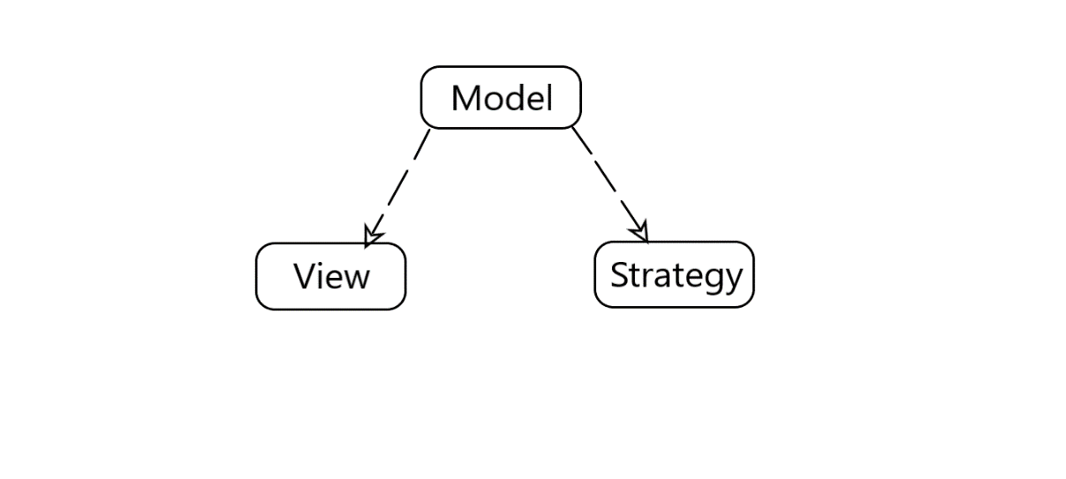
UML diagram for classes from the Model package:
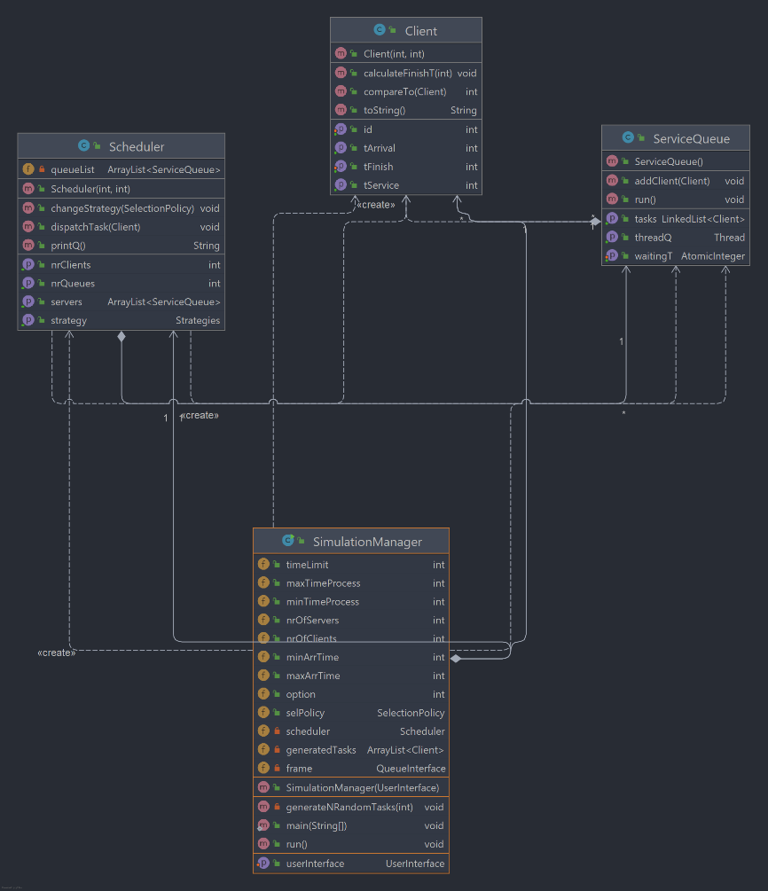

UML diagram for classes from the Strategy package:
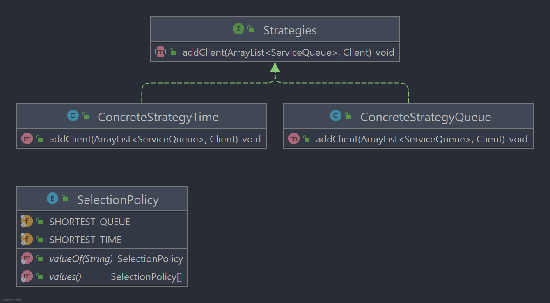

UML diagram for classes from the Strategy package:
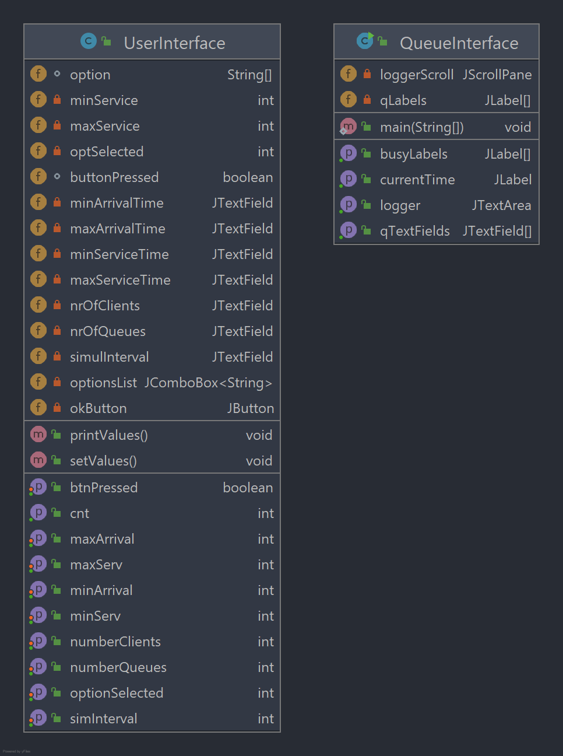

The User Interface:
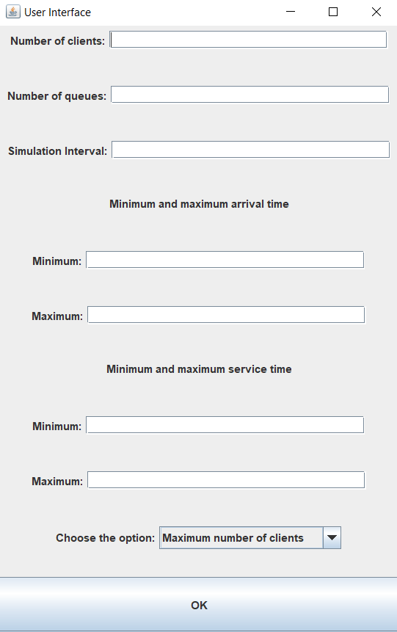
With the help of this graphical interface, we will be able to set the arrival time between customers, the processing time for a customer, the maximum number of customers that can be generated, the number of queues and the simulation interval. Also, you can choose to have the simulation run without taking into account the time interval between customer arrivals, this option is chosen through combobox:
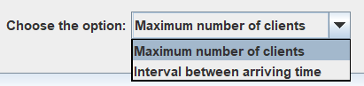

- Implementation
The application is divided into 3 packages: Model, View and Strategy.
The application comes with a graphical interface that has the role of facilitating the user's work with the system, and for this we implemented the View package that contains the classes UserInterface and QueueInterface. In UserInterface, the data will be entered for the start of the simulation. The QueueInterface will be the frame where you can view the simulation of queues and customers.
The UserInterface class contains JLabels and JTextFields for entering data, a ComboBox for selecting the option for simulation, and a button to start the simulation. For a button we added an ActionListener, and the class also has attributes for the values entered in the fields.
The buttonPressed attribute is set if the OK button has been pressed, within the setValue() method, which updates integer attributes for values added through mutating methods. Then buttonPressed is again set to false for subsequent changes. If the data entered is corrupted, an error window will be displayed:
The QueueInterface class builds the graphical interface for displaying the simulation of queues and customers, along with a portion of text that plays the role of "logger" of events. The attributes of the class are strings of Jlabels, JtextAreas for displaying each queue. The constructor of this frame receives as a parameter an integer nrQ, which represents the number of queues in the interface. For example, for nrQ = 3, the interface will appear like:
For nrQ = 7, it will appear like:

The Strategy package contains two classes, ConcreteStrategyQueue and ConcreteStrategyTime, the Strategies Interface and a SelectionPolicy enumeration.
The Strategies interface contains the addClient method definition, and the 2 classes in this package (ConcreteStrategyQueue and ConcreteStrategyTime) implement the Strategies interface, which represent the way of adding a client to a queue, according to the principle of the shortest time or the shortest queue. Thus, the client will be added to a queue in the list of queue servers.

The Model package contains the SimulationManager, Schedule, Client, and Queue classes.
The Client class is the deployment for a client. The attributes of this class are the client’s id, arrival time, processing time and finish time. An important method that we have implemented in this class is calculateFinishT, which receives an integer that represents the waiting period of a queue, calculates and sets the client's finish time as the sum of the arrival time, processing (service) time and the queue’s waiting time.
The ServiceQueue class represents the queue implementation. The attributes of this class are a list of BlockingQueue clients, this approach being advantageous in working with threads. The next attribute is an AtomicInteger that represents the waiting time of the queue, we also use the AtomicInteger type to make it easier to use the threads for each queue. The last attribute of the ServiceQueue class is a Thread, which represents the work thread that will be executed once a new queue instance is created.
The addClient method adds a client to the queue and at the same time updates its own waiting time.
As the ServiceQueue class implements the Runnable interface, we will overwrite the run method like this: we will remove the client that is at the end of the queue and we will fall asleep the queue thread for a period equal in seconds to the processing time of the client extracted from the queue. After this period has elapsed, we will remove the client from the client list.
The Scheduler class implements a queue list and a strategy for apportioning clients to queues. The changeStrategy method sets the strategy for distributing clients to queues, using the two elements (SHORTEST_QUEUE, SHORTEST_TIME ) in the SelectionPolicy list defined in the Strategy package.
The SimulationManager class implements the Runnable interface and is directly responsible for the simulation process. The attributes of the class represent the values of the parameters that we will enter in the UserInterface interface. The ”option” field represents the chosen option, 1 for generation without taking into account the arrival interval of customers and 2 otherwise. The generatedTasks list will be populated by the generateNRandomTasks method call.
The generateNRandomTasks(int nrC) method receives an integer as its argument and will generate a maximum of nrC customers, depending on the option chosen. If the first case is chosen, the generation of customers does not take into account the previous arrival time or the arrival interval between customers. Customers will only be generated based on the processing time interval. In the case of option 2, customers will also be generated based on the interval entered in the interface. After generating all customers, the customer list will be ordered in ascending order of arrival times, in order to streamline the subsequent simulation.
As this class implements the Runnable interface, it is necessary to implement the run() method, which will make the changes at every moment of time in the simulation. At the same time, we will calculate certain statistics within this method, such as the average waiting time, the average service time and the peak hour.
At each moment of time, we will assign customers with the arrival time equal to the current time to the queues according to the strategy approached and display a message in the graphical interface about the events that took place. At the same time, at each moment of time, the queues will be updated in accordance with the ongoing processes.
At the end of the execution, the threads for each queue will be stopped and a window with the statistics for the simulation range run will be displayed. The application will be run from this class, by the main method, in which I also have the text file where the results are displayed.
Simulation statistics window:

- Results
Since in this project customers are randomly generated, in this chapter we will present three cases of using the application.

First case: I chose the minimum arrival time being 0 and the maximum being 5. For the minimum service time I chose it beign 2 and the maximum being 4. I set the number of clients at 20, the number of queues at 2 and the simulation interval at 10:

In the output file, the results will look like this:

Second case: I chose the number of clients being 50, number of queues 5, simulation time 60, max arrival time = 40, min arrival time = 2, max service time = 7, min service time = 1:

Third case: I chose the number of clients being 1000, number of queues 20, simulation time 200 seconds, max arrival time = 100, min arrival time = 10, max service time = 9, min service time = 3:

- Conclusions

This assignment is important because it uses concepts from concurrent programming, namely working with threads that allow programs to execute multiple sequences of code at the same time. At the same time, this problem underlies the modeling of real-life processes and solving it offers an advantage both in highlighting the features of competing programming and in abstracting as efficiently as possible the real-life problems for software implementation.
Solving the requirement allows deepening and developing the capacities to write Java code, identifying the causes and treating the problems that may arise in the implementation process. At the same time, due to the implementation and a graphical interface, the programmer must devise an intelligible interface through which the user can experience all the functionalities highlighted.
The current application can follow different stages of development, both on the graphic side and on the efficiency and algorithmic side.

- Bibliography
https://stackoverflow.com/questions/13275525/change-unhandled-exception-auto-generated-catch-code-in-eclipse
https://dsrl.eu/courses/pt/materials/A2_Support_Presentation.pdf
https://www.tutorialspoint.com/java/util/timer_schedule_period.htm
https://www.javacodegeeks.com/2013/01/java-thread-pool-example-using-executors-and-threadpoolexecutor.html

