Fuzzy Logic
1. Definitions of Fuzzy Logic
2. Crisp Sets
3. Fuzzy Sets
3.1. Fuzzy number
4. The mapping between classical crisp sets and fuzzy sets
5. Membership Function
5.1. Typical Membership Functions
6. The Extension Principle
7. Fuzzy Cartesian Product
8. Fuzzy Relations
9. Composition of Fuzzy Relations – Max-Min Composition
9.1. Example of Max-Min Composition
10. Computational Logic
10.1. Propositional Variable
10.2. Logical Connectives
10.3. Logic function and Logic Formula
10.4. Tautology
10.5. Inference Rules
10.6. Predicate Logic
11. Fuzzy Expressions
12. Fuzzy Logic
13. Linguistic Variables
13.1. Structure of a linguistic variable
14. Fuzzy Rule
14.1. MIN Fuzzy Implication
15. Fuzzy Inference
16. MAMDANI Method
17. Defuzzification

1. Fuzzy Logic
1.1. Definitions of Fuzzy Logic
- “Fuzzy logic is a form of many-valued logic that deals with approximate, rather than fixed and exact reasoning. Compared to traditional binary logic (where variables may take on true or false values), fuzzy logic variables may have a truth value that ranges in degree between 0 and 1. Fuzzy logic has been extended to handle the concept of partial truth, where the truth value may range between completely true and completely false.”[1]
- “A type of logic that recognizes more than simple true and false values. With fuzzy logic, propositions can be represented with degrees of truthfulness and falsehood. For example, the statement, today is sunny, might be 100% true if there are no clouds, 80% true if there are a few clouds, 50% true if it's hazy and 0% true if it rains all day.”[2]

1.2. Crisp Sets
If “fuzzy language”, we define a crisp set by saying that the membership of an element X to the crisp set A is given by the following function:

The classical crisp sets operations are:

- union of sets A and B ():
= {x | }
- intersection of sets A and B ():
= {x | }
- subset ():

- complement ():

- equality ( A = B ):

The classical crisp sets operations properties are:
- commutivity:

- associativity:

- distributivity:

1.3. Fuzzy sets
We define the universe of discourse by the set X which is not empty.
In “fuzzy language”, we define a fuzzy set by saying that an element x in the universe of dicourse X has a degree of membership to the set A, given by some membership function:

Thus, an element from a set A, can belong to it to a certain degree and the set does not have crisp boundaries. Each fuzzy set is characterized by a membership function.
We will represent the fuzzy set A by a set of ordered pairs, as follows:

The fuzzy set operations are:

- empty set:

- basic set:

- identity:

- subset:

- union:
Axiom:

A
B
B
A

- intersection:
Axiom:

A
B
B
A

- complement:

The fuzzy sets operations properties are:

- commutivity (as in classical sets)
- associativity (as in classical sets)
- distributivity (as in classical sets)

Properties of fuzzy sets:

- support of fuzzy set A: the crisp set that contains all the values which have the membership function's value different from 0

- core of fuzzy set A: the elements in X that have the membership function's value equal to 1

- boundary of fuzzy set A: the elements in X that have the membership function's values inside the interval [0, 1]

- height of a fuzzy set A: A is called normal if height(A)=1, else it is called subnormal

- convexity of a fuzzy set A:

1
0
μ(x)
core
support
boundaries

1.3.1. Fuzzy number
A fuzzy number is a fuzzy set that is:
- convex
- normal
- the core consists of one value only
- the membership function is piecewise continuous

1.4. The mapping between classical crisp sets and fuzzy sets
In classical logic, we interpolate each input into a crisp set. So, each item in the universe of discourse belongs or does not belong to the set. This interpolation is given by the characteristic function defined over that set.
In fuzzy logic, we interpolate each input into a fuzzy continuous set, using the membership function. Thus, we will not only obtain the values 0 and 1 as output from the function, but we will also obtain values between 0 and 1.
The fuzzy set is a superset of the classical crisp set. It contains all the values in the interval [0, 1] (so {0, 1} too).

1.5. Membership Functions
We define a membership function as the one that characterizes a fuzzy set A, which takes values from X(the universe of discourse) and computes it into a value from the interval [0, 1]. It gives the degree of membership of values x from X to the set A.

1.5.1. Typical Membership Functions
Here are 2 of the most common used membership functions.
- Triangular Membership Functions

1
0

- Trapezoidal Membership Functions

1
0

This application's fuzzy system will use the Trapezoidal Membership Function.

1.6. The Extension Principle
The extention principle is used to extend a crisp set into a fuzzy set. Converts a point-to-point mapping into a fuzzy set mapping.
It's definition is as follows:

The extension principle states that the image of A under the mapping f(.) is given by the fuzzy set:

and, if the mapping is one-to-many:

1.7. Fuzzy Cartesian Product
The fuzzy cartesian product is defined as the probability of a n-tuple to belong on a fuzzy set .
We compute it by the following formula:

1.8. Fuzzy Relations
A fuzzy relation is a relation that allows partial membership to a set and that describes the relation between two or more objects.
For instance, say we have a fuzzy relation “Sick” that describes the degree of sickness, computed relatively to the degree of tremble and the degree of fingers distances.

1.9. Composition of Fuzzy Relations – Max-Min Composition
Suppose we have
Then, the Max-Min composition is defined as follows:

1.9.1. Example of Max-Min Composition
We have the following fuzzy relations(matrices):
- tremble

- distance between fingers

Using the Max-Min composition, we obtain:

Thus, we obtain the matrix:

1.10. Computational Logic
1.10.1. Propositional Variable
A sentence that has the truth value 0(false) or 1(true), is called a propostion.
“A propositional variable (or logic variable) is a variable which can either be true or false. Propositional variables are the basic building-blocks of propositional formulas, used in propositional logic and higher logics.”[3]

1.10.2. Logical Connectives
“In logic, a logical connective (also called a logical operator) is a symbol or word used to connect two or more sentences (of either a formal or a natural language) in a grammatically valid way, such that the sense of the compound sentence produced depends only on the original sentences.” [4]
Main logical connectives:
- negation:
- conjunction:
- disjunction:
- implication:

1.10.3. Logic function and Logic Formula
A logic function “performs a logical operation on one or more logical inputs, and produces a single logical output”.[5]
“A well-formed formula is a word (i.e. a finite sequence of symbols from a given alphabet) that is part of a formal language. A formal language can be considered to be identical to the set containing all and only its formulas.”[6]
“A logic formula is a type of syntactic formula which is well formed and has a truth value. If the values of all variables in a propositional formula are given, it determines a unique truth value.
A propositional formula is constructed from simple propositions or propositional variables, using connectives such as NOT, AND, OR, and IMPLIES.”[7]

1.10.4. Tautology
A tautology is a formula that is true in all interpretations, diregarding the variables it is composed of.
1.10.5. Inference Rules
Inference rules that use tautulogies:
- Modus Ponens:
- Modus Tollens:
- Hypothetical Syllogism:

1.10.6. Predicate Logic
Predicate logic is represented as a proposition containg a predicate, an individual and quantifiers ().

1.11. Fuzzy Expressions
A fuzzy expressions determines “how true” a fuzzy proposition is. For instance, “The person is sick” is 75% true.

Fuzzy expressions operators:
- negation:
- conjunction:
- disjunction:
- implication:

1.12. Fuzzy Logic
Fuzzy logic is repesented by a fuzzy expression and satisfies:

1.13. Linguistic Variables
In “fuzzy language”, a linguistic variable is a variable that has words or sentences in a natural or artificial language as values. Linguistic variables form the fundation of the fuzzy logic approximate reasoning.
For instance, the variable “Sick” has linguistic values, rather than numerical. This means that it is clearer to express the degree of sickness by saying “not sick”, “sick”, “very sick”.
We will define the linguistic variable as a quintuple (x, T(x), U, G, M), where:
- x – the name of the linguistic variable
- T(x) – the term set that can compose a linguistic variable
- U – the universe of discourse
- G – a syntactic rule that generates the terms in T(x)
- M – semantic rule that associaotes each x to a meaning, M(x), where M(x) is a subset of U.
So, the linguistic variable “Sick”, defined above, will be defined as:
X = (“Sickness”, {“not sick”, “sick”, “very sick”}, [0, 10], {“sick” U {“not”, “very”}}, M(x)), where
- M(“Sick”) = and:

- M(“Not sick”)= and:

- M(“Very sick”)= and:

*using a trapezoidal membership function
Bellow is the example that shows how a linguistic variable si computed.
1 2 3 4 5 6 7 8 9 10
1
0
not sick
sick
very sick

1.13.1. Structure of a linguistic variable
As we could see above, we not only had the word “sick”, but we also had some other words, that expressed a quantifier(“not”, “very”). We call the word “sick”, a fuzzy predicate/primary term; it is the primary word that describes a linguistic variable. We call the words “not” and “very” fuzzy modifers; they will always appear near a fuzzy predicate. Fuzzy modifiers are of two types:
- fuzzy truth qualifiers/fuzzy truth values: quite sick, very sick, more sick
- fuzzy quantifier: many, few
We will also call fuzzy modifiers as hedges.
If the set of individual predicates is a fuzzy set, then the set is called a fuzzy predicate. For instance, “x is sick.”

1.14. Fuzzy Rule
Modus Ponens, X, X', Y, Y' are fuzzy sets, x, y symbolic names for objects:
- premise : x is X'
- implication: if x is X then y is Y
- consequence: y is Y'

Modus Tollens, X, X', Y, Y' are fuzzy sets, x, y symbolic names for objects:
- premise: y is Y'
- implication: if x is X' then y is Y
- consequence: x is X'

Below, we will express a fuzzy rule as a relation:
“x is X”, “y is Y” - fuzzy predicates X(x), Y(y); so we can write a fuzzy rule as follows:
If X(x) then Y(y).
Furthermore, we will represent this rule as a relation:

1.14.1. MIN Fuzzy Implication
The fuzzy implication is interpreted as the minimum operation:

For instance, we have the following:
- fuzzy rule: “If tremble is high, then person is very sick” and :
- T – universe of discourse for tremble
- S – universe of discourse for sickness
- variables for tremble and sickness
- denote “high” as A, , and “vey sick” as B,
Now, we can say that:
R(t, s): if t is A then s is B or
Suppose we know the fuzzy sets A and B, with values:

t | 4 | 6 | 9
 | 0.1 | 0.3 | 0.7

s | 2 | 4 | 6 | 8
 | 0.1 | 0.3 | 0.7 | 0.9

And we know how to compute R(t, s) = A xB, by taking the miminum value of the membership functions, for each combination between t and s.

t\s | 2 | 4 | 6 | 8
4 | 0.1 | 0.1 | 0.1 | 0.1
6 | 0.1 | 0.3 | 0.3 | 0.3
9 | 0.1 | 0.3 | 0.7 | 0.7

Now, that we know the relation's values for the fuzzy rule “If tremble is high, then person is very sick”, we can compute the following: “what is the sickness when tremble is very high?”.
Suppose tremble, T', has the values:

t | 4 | 6 | 9
 | 0.5 | 0.7 | 0.9

Using the Max-Min Composition(chapter 9) of fuzzy relations between R and T', we obtain:

So, S' will have the values:

s | 2 | 4 | 6 | 8
 | 0.1 | 0.3 | 0.7 | 0.7

1.15. Fuzzy Inference
Obtaining an output from a set of rules is done using the compositional rule of inference, defined below:
We have:
- a fuzzy rule: if x is X then y is Y, where X, Y are fuzzy sets
- input: x is X'
- result: Y'
where .
Then, we write the fuzzy rule as the implicationand the output as .
We will use as implication operators the min-operator and as composition operator, the max-min operator.

1.16. MAMDANI Method
Mamdani method is an inference method that uses the MIN Fuzzy Implication and the Max-Min Composition.
We define this method as follows:

Mamdani method inferes results both from crisp inputs and fuzzy sets. This application uses only crisp values as input.
The inference result is computed after this formula:
, where “and” is the “min” operator.

u0
u
1
1
1
v
Choose min
C1'

For multiple rules(take 2), we have this formula:

u0
u
1
1
1
v0
v
Choose min
C1'
u0
u
1
1
v
Choose min
C2'
v0
C2'

As seen above, the result of the methods are fuzzy sets. We need to defuzzify the result into crisp values, so we can obtain our final value.

1.17. Defuzzification
For this aplication, the chosen method for defuzzification is Centroid of the Area, computed with the following formula:
or

Leap MotionController
Parkinson's Disease

4. Fuzzy Logic System
This application is built on a fuzzy logic system that works as follows:
- firstly, we need to establish linguistic variables; tremble, distance and sickness(explained below) are the three linguistic variables on which the fuzzy engine will apply its logic; this step also includes the definitions of each of the membership functions attached to the liguistic variables
- secondly, we define rules and store them into the fuzzy engine for further computation
- thirdly, we apply a defuzzification method, by taking as input two crisp values for tremble and distance and returning as output one crisp value for sickness

4.1. Tremble Variance and Distance Between the Fingers Variance
In order to establish if a person is sick of Parkinson's Disease and to actually be relevant for this application, I chose two important variables and computed their variances.
We will call “coordinates set” the set returned by the LeapMotion device, during a 2 seconds interval, containing the coordinates of the center of the palm and the coordinates of the finger tips.
The variables' value will be given by the variance formula, that will compute how sparse the points are relative to their mean.
Firstly, “tremble” refers to the tremble of one's hand in the given interval of time(in this case, 2 seconds). After gathering the coordinates from the LeapMotion device, the tremble variable is given by applying the formula of the variance on the coordinates set. The more the variance increases, the bigger the tremble of the hand is. Also, the result is normalized, meaning that it is computed to be inside the interval [0, 10], 0 representing no tremble and 10 representing high tremble.
Secondly, “distance between the fingers” refers to the rate at which the distance between each pair of fingers modifies, when the fingers of the hand are extended, in the 2 seconds interval. The formula of the variance will be applied on four sets individually, representing, in order, the distances between the thumb and the index finger, the index finger and the middle finger, the middle finger and the ring finger, the ring finger and the pinky finger. Then, the maximum of these 4 variance values will represent the value of the “distance between the fingers” variable. Also, the value will be normalized to be inside the interval [0, 10], 0 representing that the fingers are steady and 10 representing that the fingers constantly change position.
The last variables must be considered because the gestures needed to replace the cursor's actions involve the extension of the fingers.

4.2. Fuzzy Elements
There are four important objects used by the application: Membership Function, Linguistic Variable, Fuzzy Rule and Fuzzy Engine.

4.2.1. Membership Function
We refer to a membership function as a trapezoidal function, that has a name and its graphic is defined by four points(“self.range” is the list with the x-coordinates in the code below), which will be the vertices of a trapezium. Every value passed into a membership function will go into one of 4 branches, which are the Python translation of:

# Check if input value is in range, if not, return 0
if X < self.range[0] or X > self.range[3]:
return 0

# Middle part, return 1
if X >= self.range[1] and X <= self.range[2]:
return 1

# Increasing slope
if X >= self.range[0] and X < self.range[1]:
return (X - self.range[0])/(self.range[1] - self.range[0])

# Decreasing slope
if X > self.range[2] and X <= self.range[3]:
return (self.range[3] - X)/(self.range[3] - self.range[2])

4.2.2. Establishing Linguistic Variables
It is important that we make the separation between the variables explained in the beginning of this chapter, that are simple float variables, and the fuzzy variables explained below, that are more complex variables which will receive the float numbers and compute a result based on them.

1. Tremble
Fuzzy tremble is a fuzzy linguistic variable, that has attached three membership functions, named as follows: “low”, “moderate” and “high”. This means that the tremble can be low, moderate or high.
Low tremble is the membership function that draws the trapezium defined by the points:
[0, 0], [0, 1], [2, 1] and [3, 0].
Moderate tremble is the membership function that draws the trapezium defined by the points: [2, 0], [3, 1] , [7, 1] and [8, 0].
High tremble is the membership function that draws the trapezium defined by the points:
[7, 0], [8, 1], [10, 1] and [10, 0].

1
low
moderate
high

From the graph above, we can say that if the tremble has the value 2.5, then it is both “low” and “moderate” to a certain membership degree. If the tremble has the value 6, than it is only “moderate” with membership degree 1.

2. Distance
Fuzzy distance is a linguistic variable, that has attached three membership functions, named as follows: “small”, “medium”, “high”.
Small distance is the membership function that draws the trapezium defined by the points:
[0, 0], [0, 1], [3, 1] and [4, 0].
Medium distance is the membership function that draws the trapezium defined by the points:
[3, 0], [5, 1], [7, 1] and [9, 0].
High distance is the membership function that draws the trapezium defined by the points:
[8, 0], [9, 1], [10, 1] and [10, 0].
1
small
medium
high

From the graph above, we can say that if the distance has the value 3.5, then it is both “small” and “medium” to a certain membership degree. If the distance has the value 9, then it is only “high” with membership degree 1.

3. Sickness
Fuzzy sickness is a linguistic variable, that has attached three membership functions, named as follows: “low”, “medium”, “high”.
Low sickness is the membership function that draws the trapezium defined by the points:
[0, 0], [0, 1], [4, 1] and [5, 0].
Medium sickness is the membership function that draws the trapezium defined by the points:
[4, 0], [5, 1], [6, 1] and [7, 0].
High sickness is the membership function that draws the trapezium defined by the points:
[6, 0], [7, 1], [10, 1] and [10, 0].
1
low
medium
high

4. Combination of Linguistic Variables
When defining a linguistic variable, we must give it a name and attach one or more membership functions.
By calculating a value for the tremble variable and a value for the distance variable and passing them through the fuzzy system, we obtain the crisp result for the sickness. This final value will be used for deciding whether a person is sick or not.

4.2.3. Definition and Evaluation of the Rules
In order to apply fuzzy logic on our linguistic variables, when some crisp values are given, we need to establish some rules. These are the rules that I chose to be used by the application:

'if tremble is low and distance is small then sickness is low'
'if tremble is low and distance is medium then sickness is low'
'if tremble is low and distance is high then sickness is medium'

'if tremble is moderate and distance is medium then sickness is medium'
'if tremble is moderate and distance is high then sickness is high'
'if tremble is moderate and distance is small then sickness is medium'

'if tremble is high and distance is small then sickness is high'
'if tremble is high and distance is medium then sickness is high'
'if tremble is high and distance is high then sickness is high'

A rule is evaluated as follows:
- separate the antecedent(the part before “then” keyword) from the consequent(the part after “then” keyword)
- add all the linguistic variables' names and membership functions' names from the antecedent as premise of the rule
- add the name of the linguistic variable and the name of the membership function in the consequent, as the result of the rule
Then, we store all the rules, so we can parse and verify them when we need to pass crisp values through the fuzzy system.

4.2.4. Fuzzy Engine
By now, we defined our linguistic variables and rules. The next step is computing a crisp value for sickness, when we have as input two crisp values, tremble and distance, respectively. This is done by applying the “Centroid of the Area” method.
Before applying this method, there is a preparation phase, where we need to do the following:
- take the two crisp values given as input and fuzzify them; this will result in two lists of three membership degrees, one for tremble linguistic variable and one for distance linguistic variable
  - for instance, for the crisp value 2.5 for tremble, we will obtain the membership degrees of 0.5 to “low”, 0.5 to “moderate” and 0 to “high”
  - for the crisp value of 3.5 for distance, we will obtain the membership degrees of 0.5 to “small”, 0.25 to “medium” and 0 to “high”
- take only the membership functions that have the degree value different from zero
- get the rules that have, in the antecedent, a combination between the lines:
“tremble” and “is” and [“low”or “moderate” or “high”]
[“and” or “or”]
“distance” and “is” and [“small” or “medium” or “high”]
if the values for the membership degree are not equal to zero
  - on the example above, we ignore every rule that has “high” for tremble or for distance, because “high” has the value 0 in both cases
  - so, we take every rule that has “tremble is low” or “tremble is medium” or “distance is small” or “distance is medium” in the antecendent
- for each one of these rules, if the operator between tremble and distance is “and”, we will take the minium between the value of tremble membership degree and the value of distance membership degree computed at the first step; if the operator between tremble and distance is “or”, we will take the maximum between the value of tremble membership degree and the value of distance membership degree computed at the first step
  - if we find a rule that states “if tremble is moderate and distance is medium then sickness is medium”, we take the value 0.5 for “moderate” from tremble and the value 0.25 for “medium” from distance; we choose the minimum between these two, i.e. 0.25
- this minimum values that were obtained in the latter step, will be used to “clip” the membership functions for sickness linguistic variables; if there are more than one value for a membership function, we will choose the maximum value between them
  - we have 0.25 and 0.5 to “low” for the sickness variable, then we will chose 0.5 to be the line that clips the “low”sickness membership function; we have the same scenario for “medium”, so its value will be 0.5
- after clipping all three sickness membership functions(“low”, “medium”, “high”), we obtain a closed polygon; with its vertices, we will compute the sickness crisp value by applying the centroid of the area method
Centroid of the area method consists in calculating the area of a ploygon(“A”) and then apply the following formulas:

The first coordinate will represent our result, our defuzzified sickness x-coordinate.
So, taking into account the example above, we will obtain the polygon defined by the vertices A(0, 0), B(0, 0.5), C(6.5, 0.5), D(7, 0), E(0, 0).

1

low
medium
high
0.5

Apply the formula above, obtaining the result: 3.37654320988 . This means that sickness is “low”.

5. LeapMotion Replacing the Cursor
The Leap Motion Controller tracks the hand and all ten fingers, by simply moving the arm above the device, when it is connected to a computer. It identifies and reads the coordinates of the arm, hand, palm and fingers. Having these coordinates, we normalize them to fit the screen and we send the following bash command into the operating system:

bash_command = "xdotool mousemove %f %f" % (app_x, app_y)

where app_x and app_y are the x0y coordinates defining the area of the screen. This command will cause the cursor to move.
Although the coordinates from the device are in a tridimensional space, we will only need the 0x and 0y axes, because the monitor screen does not need in-depth movements or actions.

5.1. Center of the Palm as the Movement Main Coordinate
There are a few other applications that try and replace the cursor with the help of Leap Motion Controller, but none of these use the center of the palm as the movement main coordinate. The most intuitive choice would be tracking the index finger of the user's hand as this main coordinate. This works, as long as the user has a steady hand.
What if the user has Parkinson's Disease or any other disease that affects the motor system? Then, it would be difficult to close the fist and keep only the index finger extended, it would be hard to make short or small moves whatsoever; it will be difficult to keep the hand steady to simply click the “X”(exit) button from the browser, for instance. But choosing the center of the palm as the main coordinate, allows the user to feel comfortable and, even with the hand shaking, to be able to move the cursor easily, with no extra effort.
Reaching the point of choosing the center of the palm was the result of an interative process. The first option was chosing the index finger to be the cursor. There were many obstacles, for instance, how can a user drag and drop easily. Then, how does the user make the right-click action, how does he make the double click or single click. All of these and also being capable of stabilizing and not allowing the cursor to “shake” as much as the user's hand, drove inevitabily to choosing the center of the palm as the main movement coordinate.

5.2. Replacing the Cursor Algorithm
Leap Motion Controller offers a comprehensive Python API, thus making it easy to obtain precise and stabilized coordinates of the hand and fingers. In this section, there will be a description of the algorithm that replaces the cursor.
By now, it should be clear that Leap Motion Controller reads data really fast. So, feeding coordinates into the bash command processor will not produce any types of delay or lagging. The cursor will move smooth, as it does when a person uses the mouse or the mouse pad.
Leap Motion API comes with a built-in class, called “Listener”, which offers some helpful methods. One of them is “on_frame”; inside this method, at every frame, we receive the information needed to compute the hand's and fingers' coordinates.
First of all, the screen width and height need to be set, because we cannot move the cursor at negative or too large coordinates(for instance, the bash processor will not know what to do with a coordinate like (-100, 1370)). The boundary coordinates will be 1365 for width and 765 for height.
Leap Motion device returns negative and positive coordinates, both on 0x axis and on 0y axis. So, they need normalization. The API comes with the concept of an “i_box”. The “i_box” has the “normalize_point” method and it returns a point with a value between 0 and 1, for both x and y coordinates. Afterwards, it is only needed to make the multiplication with the width setting for the 0x coordinate and with the height setting for the 0y coordinate.
The problem at this point is that the user has to move the hand too much up or down or left or right. By applying the following formula, we will shrink the area that is interpreted, allowing the user to make smaller moves:

where
.

This is what the formula becomes whithin this app:

normalized_tip = i_box.normalize_point(
hand.stabilized_palm_position)
# ibox is shrunk from 0.2-0.7 for x axis and 0.3 - 0.8 for y axis
app_x = (normalized_tip.x - 0.2) * 2 * app_width
app_x = app_x if app_x >= 0 else 0
app_y = ((1 - normalized_tip.y) - 0.3) * 2 * app_height

The result(app_x and app_y from the snippet above) will be forwarded to the command presented in the beginning of this chapter, causing the cursor to move.
There are five other actions that a cursor does, besides moving: clicking, double-clicking, right-clicking, dragging and dropping, scrolling. All these actions need some movement of the fingers. Before working with their coordinates, we also need to normalize the position to be inside our i_box . Moreover, Leap Motion API offers a property of the finger object, called “stabilized_tip_position”, which returns a more precise and clean data. This values will be used for further computation.

i_box.normalize_point(hand.fingers[1].stabilized_tip_position)

5.2.1. Clicking and Double-clicking
Clicking happens when the user extends all or some of his fingers. This is an easy and comfortable movement, either for a healthy person or one that has Parkinson's Disease. The minimal distances between the fingers are considered to be:

abs(index.x - middle.x) > 0.13
or abs(middle.x - ring.x) > 0.12
or abs(ring.x - pinky.x) > 0.10

where “index” is the index finger coordinate, “middle” is the middle finger coordinate, “ring” is the ring finger coordinate and “pinky” is the pinky finger coordinate. The reason that only the 0x coordinate is taken into account is because the user needs to move his hand horizontally, so that the Leap Motion device actually sees that the fingers are extended; otherwise, the device can only guess how the fingers are positioned.
Also, two consecutive single clicks can only happen at a distance of 0.35 seconds, because otherwise commands would be sent more than 100 times per second(on every frame the Leap Motion Controller reads). If the user keeps his fingers extended for more than one third of a second, then the application will send two clicking commands to the bash command processor and it will interpret it as double-click(the distance between two clicks to be considered as double-click is 0.4 seconds).
The command sent into the bash command processor is:

bash_command = "xdotool click --repeat 1 1"

The first number “1” from the command represents the first button of a normal mouse and the second “1” from the command represents that only one click is executed.

5.2.2. Right-clicking
A user that has a steady hand would find tilting the hand or bending the fingers in some way easy. But, a user that has Parkinson's Disease, would find it difficult. This is the reason why every action should be ample and why right clicking is done by shortly introducing the other hand inside the Leap Motion sight range.
The application recognizes one right-click when the number of the hands inside the device's sight range is equal to 2. Also, the user cannot double-click more than 1 time per second.
The command sent into the bash command processor is:

bash_command = "xdotool click 3"

The number “3” in the command represents the third button on a normal mouse, the one the user clicks for options.

5.2.3. Dragging and dropping
The most intuitive action for dragging and dropping is actually dragging and dropping something. So, the user will close his fist when he wants to grab a draggable file and relax the fist when he wants to drop it.
Leap Motion API comes with a property on the hand object called “grab_strength”. When this variable has the value 1, it means that the user grabbed a file and when it is less than 1, it means that he dropped it.
Most of the times, “grab_strength” will be less than 1(for instance, when the palm is straight), so there is a need of one more variable that monitors if the user grabbed something before dropping. This way, dropping will only be allowed after grabbing.
The logic behind this and the command sent into the bash command processor is:

if hand.grab_strength == 1 and self.down is False:
bash_command = "xdotool mousedown 1"
self.down = True
elif hand.grab_strength < 1 and self.down is True:
bash_command = "xdotool mouseup 1"
self.down = False

5.2.4. Scrolling
Scrolling with a mouse is done by rolling its wheel. Scrolling whithin this application is done by moving the hand clockwise or counter-clockwise.
When the user does small circular clockwise movements, then it is interpreted as scrolling down; when the user does counter-clockwise movements, then it is interpreted as scrolling up.
Leap Motion API introduces the “gesture” concept. There are many gestures that the device recognizes and among them, there is the so-called “CircleGesture”. Determining the type of the movement can be easily done by comparing the angle formed by the direction of the circle drawn by the hand and 0x axis with π/2. When it is bigger then π/2, then the type of movement is counter-clockwise; when it is smaller, then the type is clockwise.
The logic behind this and the command sent into the bash command processor is:

circle = CircleGesture(gesture)
if circle.pointable.direction.angle_to(circle.normal) <= Leap.PI/2:
# clockwise - move down
bash_command = "xdotool click --clearmodifiers 5"
else:
# counterclockwise - move up
bash_command = "xdotool click --clearmodifiers 4"

5.3. Algorithm for Stabilizing the Hand
Stabilizing the hand is only needed for the movement of the hand. The other gestures do not need stabilizing, because they are ample gestures that can be easily done.
First of all, the main difference between the normal algorithm and the algorithm for stabilization is that the cursor is not allowed move too abruptly. This means that the next coordinate fed into the bash command processor is approximately near the previous one.
In order to achieve stabilization of the hand, the algorithm computes a mean between the last four hand coordinates and the present one.
In the beginning of the application, the hand coordinates from the first five frames are stored into two lists(one for the 0x coordinates and one for the 0y coordinates) and there is no movement of the cursor in this time. This does not constitute a problem and will not be visible for the human eye, considering that Leap Motion device returns up to 200 frames per second. After storing the coordinates, at each frame the algorithm shifts the to the left the lists, so the coordinates that are first elements will be removed, making place for the coordinates in the current frame.
After adding the current coordinates into the corresponding lists, the mean is computed, forming one point that is sent to the bash command processor.
In order to normalize the point inside the box, there is the need to instantiate a Leap.Vector object to pass it as argument to the normalize_point function.

if self.counter < 5:
self.last_frame_x[self.counter] = hand.stabilized_palm_position.x
self.last_frame_y[self.counter] = hand.stabilized_palm_position.y
self.counter += 1
else:
self._shift_x()
self._shift_y()
self.last_frame_x[4] = (sum(self.last_frame_x[:4]) +
hand.stabilized_palm_position.x) / 5
self.last_frame_y[4] = (sum(self.last_frame_y[:4]) +
hand.stabilized_palm_position.y) / 5

5.4. Application of Fuzzy Logic Control System on Leap Motion Inputs
So far, this paper describes Fuzzy Logic and the algorithm for replacing the cursor individually. This final section of the chapter will present how Fuzzy Logic applies on the algorithm that uses the Leap Motion Controller.
After connecting the Leap Motion device to the computer and starting the application, the user stays two seconds with the hand above the device, having the fingers extended. The user will stay comfortable, so the algorithm can measure the sickness correctly.
A listener object will be instantiated, having the solely purpose of reading the coordinates of the hand and fingers for two seconds. Then, a separate function computes the variance of the movement of the hand and the variance of the distance between the fingers, with the data gathered by the first listener. This data will actually be a dictionary, that will store the 0x hand coordinates at the key “x”, the 0y hand coordinates at the key “y” and the fingers 0x coordinates at the key “fingers_distance”. It is enough to measure the variance of the fingers coordinates, because the bigger it gets, the more the variance increases, thus the algorithm knows that the distance between the fingers modifes a lot.

fuzzy_inputs = {'x': [], 'y': [],
'fingers_distance': {
'index': [],
'middle': [],
'ring': [],
'pinky': []}
}

There are six variances to be computed: the variance for the hand 0x coordinates, for the hand 0y coordinates and one for each of the the fingers coordinates. The “tremble” input into Fuzzy System is the maximum value between the variances of the hand's coordinates. The “distance” input into Fuzzy System is the maximum value between the variances of the four fingers.
After computing these two values(the variances), inside the same function, the compute_sickness method is called, with the variances as parameters. This method calls and instantiates the Fuzzy Logic Control System described at the beginning of this chapter. It will return a crisp value, representing the sickness of the user.

d_variance = 1000 * max( [index_variance,
middle_variance,
ring_variance,
pinky_variance])
if x_variance > y_variance:
sickness = compute_sickness(x_variance, d_variance)
else:
sickness = compute_sickness(y_variance, d_variance)

This function is to be called only once, at every starting of the application.
Having the crisp output from the Fuzzy System, there is a decision to be made, whether the user needs stabilization for the cursor or not. After a “trail-and-error” process, the maximum sickness value that describes the best a healthy person was chosen to be 4. If the value is smaller than 4, then the cursor will not need any stabilization. If the sickness crisp value is greater than 4, then the cursor will be stabilized.
So, the execution splits into two branches. Each branch instanties the corresponding listener.

sickenss_value = get_sickness(sickenss_listener.fuzzy_inputs) if sickenss_value <= 4:
listener = CursorListener()
else:
listener = StabilizedCursorListener()

6. Application Development
6.1. Main Gestures for Controlling the Cursor
This section illustrates the main gestures used for controling the cursor, with the help of Leap Motion device. Each action will be described by al least two images, with the hand seen from two perspectives: from above Leap Motion device and from the side of it. Also, there are instructions abput how the hand should stay, so the application can work efficiently.

6.1.1. Movement
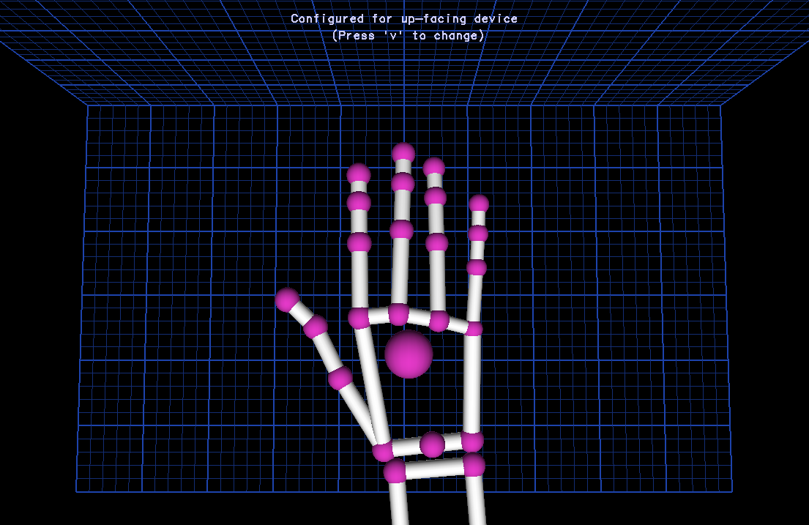
There is only one hand inside Leap Motion's
sight range. The distance between the index,
middle, ring and pinky fingers should be
minimal, i.e. the fingers should touch
eachother's laterals.

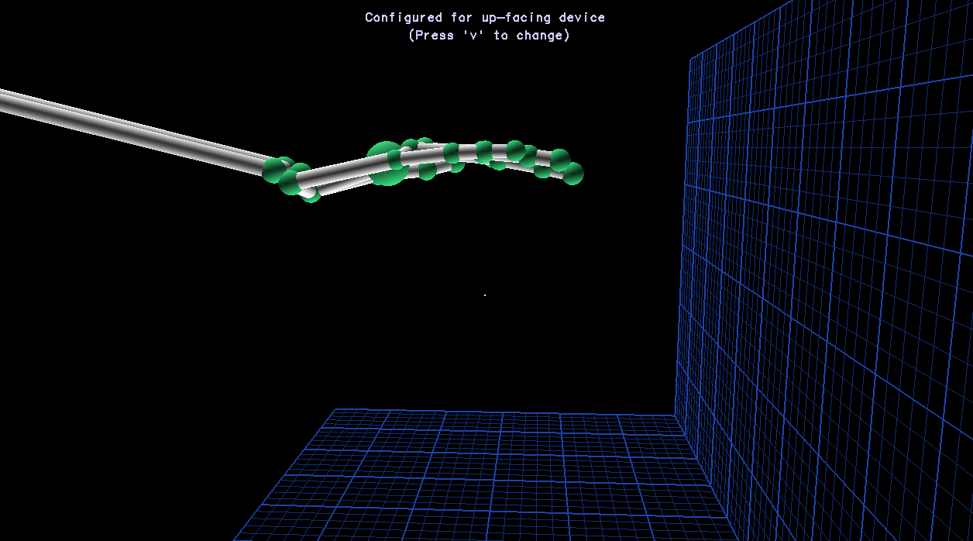
The palm stays as straight as possible, without
bending it downwards or closing the fist.

6.1.2. Click and double-click

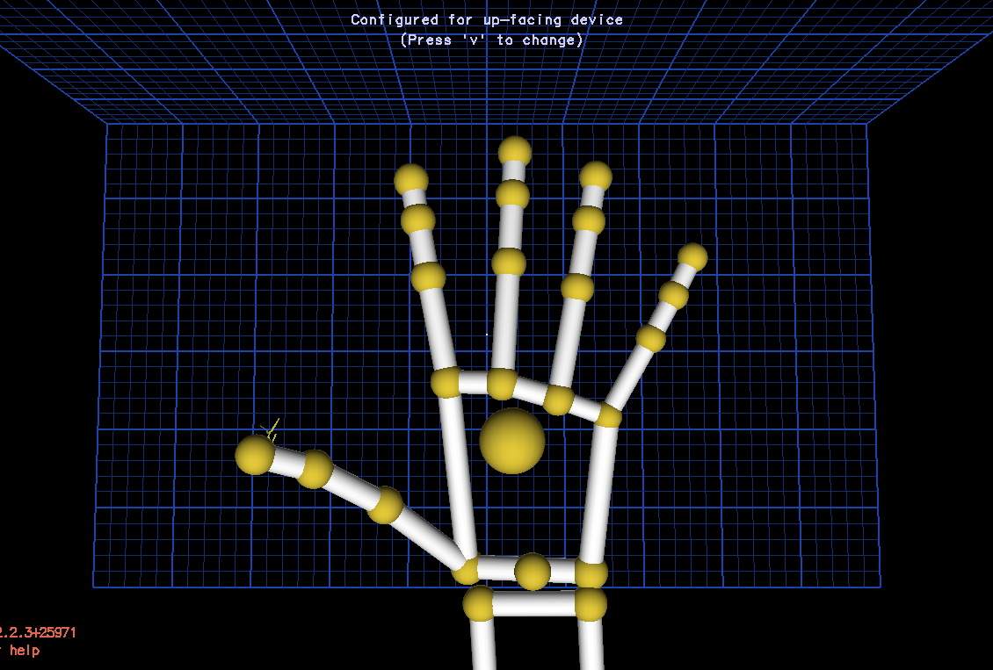
The fingers are extended as much as the user
can, but without it getting uncomfortable.

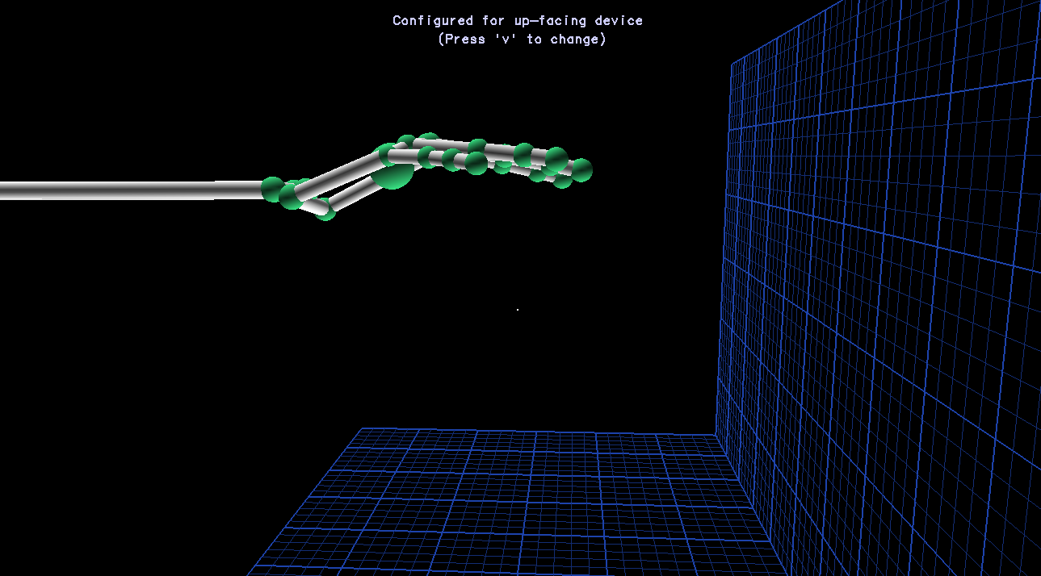
The palm stays as straight as possible.

6.1.3. Drag and drop
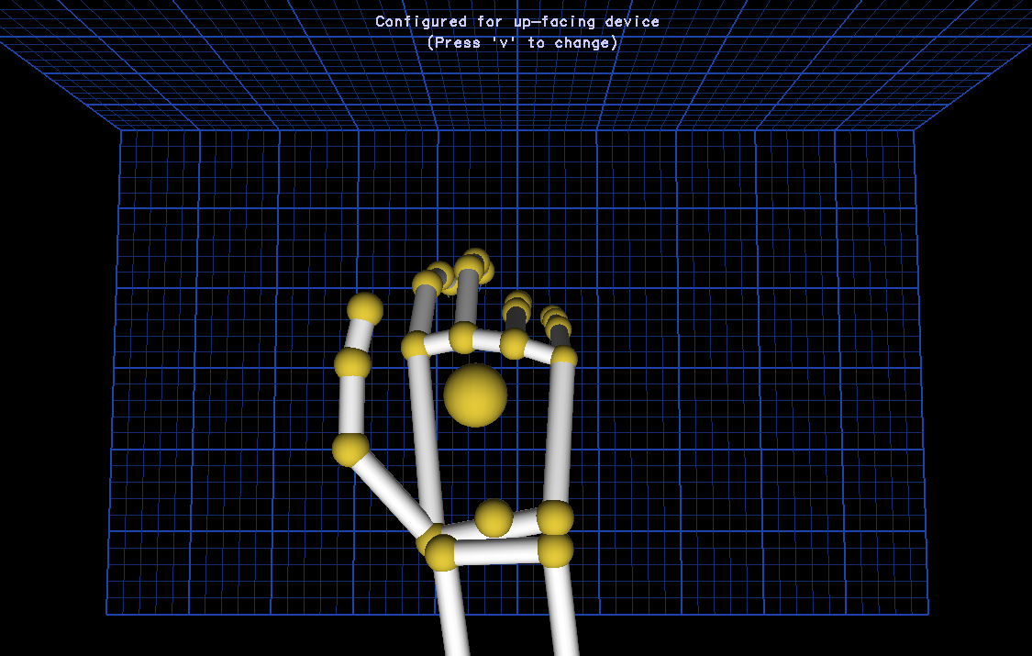
The user will move the fingers down, so they
will touch the inside of the palm. It will look
like clenching the fist. The hand should not
change position too much, considering that
the application follows the center of the palm
as the main coordinate.

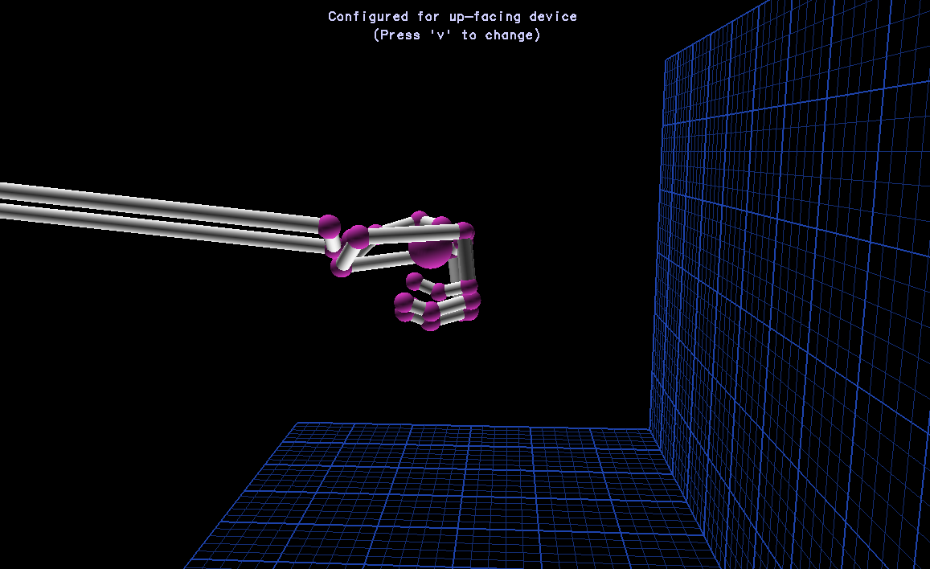
All fingers touch the palm.

6.1.4. Scroll
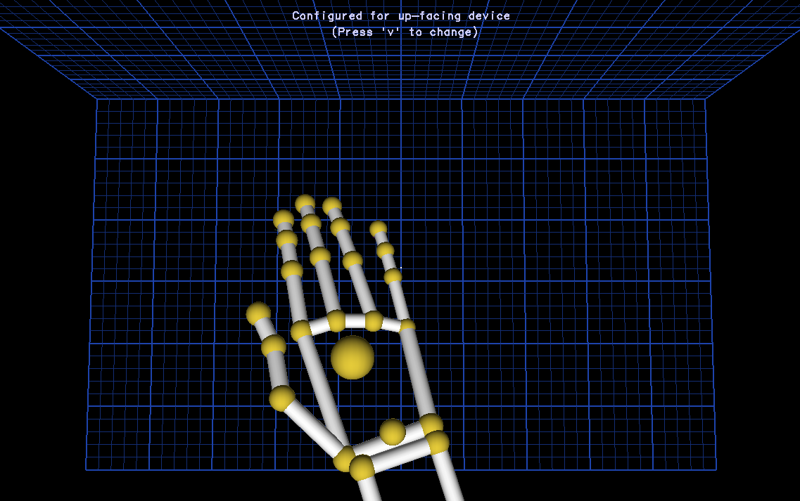
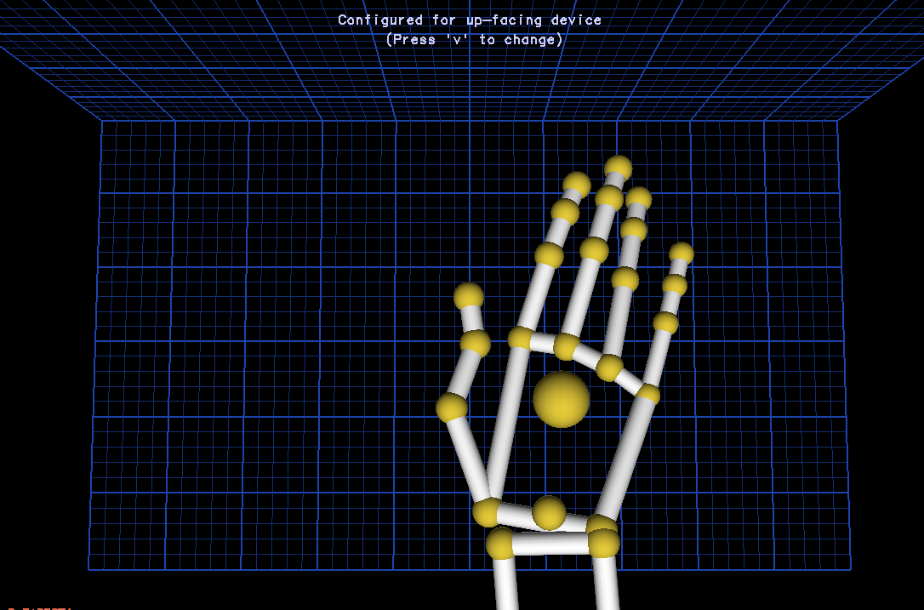

When scrolling in either direction, the user executes small circles in the same direction with the hand. The fingers of the hand are close together, touching one another.

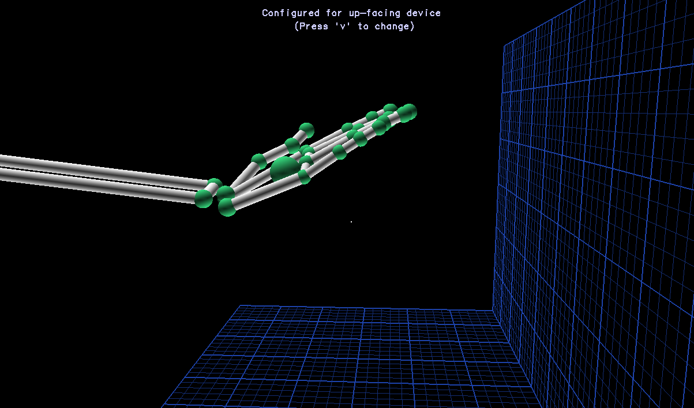
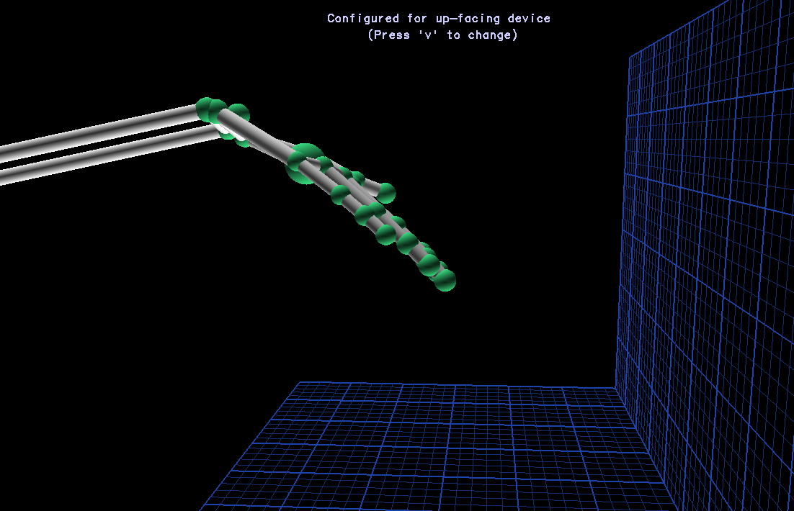

6.1.5. Right click
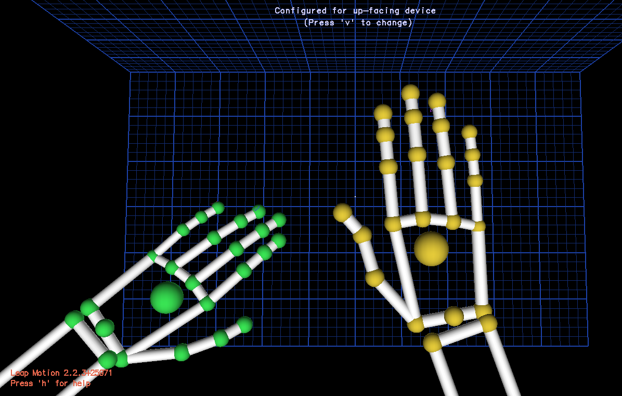
Right click happens when the other
hand comes briefly inside the device's
sight range. The user will not move the
right hand, because the coordinate at
which the right-click will fire is the
coordinate of the center of the right
palm.

Bibliography
[1] - Novák, V., Perfilieva, I. and Močkoř, J. (1999) Mathematical principles of fuzzy logic Dodrecht: Kluwer Academic.
[2] - http://www.webopedia.com/TERM/F/fuzzy_logic.html
[3] - http://en.wikipedia.org/wiki/Propositional_variable
[4] - http://en.wikipedia.org/wiki/Logical_connective
[5] - http://en.wikipedia.org/wiki/Logic_gate
[6] - http://en.wikipedia.org/wiki/Well-formed_formula#cite_note-1
[7] - http://en.wikipedia.org/wiki/Propositional_formula

