

Chapter 4 Product Development
Second Skin Sport smart sports biomechanics platform
Chapter 4 presents the product design, core functions, technology foundation, prototype implementation, and possible improvements of Second Skin Sport. The product is designed as an integrated sports-IoT platform: an ESP32-C3 wearable patch collects movement data, the backend processes and stores the signal, and the web application turns the results into dashboards, reports, and coaching recommendations.

4.1 Product Development Overview
Second Skin Sport addresses a practical gap in sports training: athletes and coaches need objective movement evidence during training, but conventional observation often cannot quantify landing impact, jump timing, balance, trunk stability, or fatigue. The product therefore combines a small wearable sensor, real-time data transport, biomechanical signal processing, role-based dashboards, and an AI coaching layer in one workflow.
The implemented product follows a layered development approach. The wearable device is the data source, the browser provides direct Bluetooth access and visualization, the Spring Boot backend provides secure APIs and domain processing, and the database preserves sessions, sensor samples, and performance statistics. This separation allows the prototype to be demonstrated with live Bluetooth data while keeping the architecture ready for multi-athlete and production deployments.

4.2 Product Design

4.2.1 User centered product structure
The interface is organized around three user roles. Athletes receive personal dashboards, activity history, sensor views, and performance reports. Coaches receive squad-level monitoring, athlete status, fatigue indicators, and tactical rotation support. Administrators manage users, roles, device records, and system operations. The role-based structure prevents unrelated functions from cluttering each user experience.

4.2.2 End to end architecture
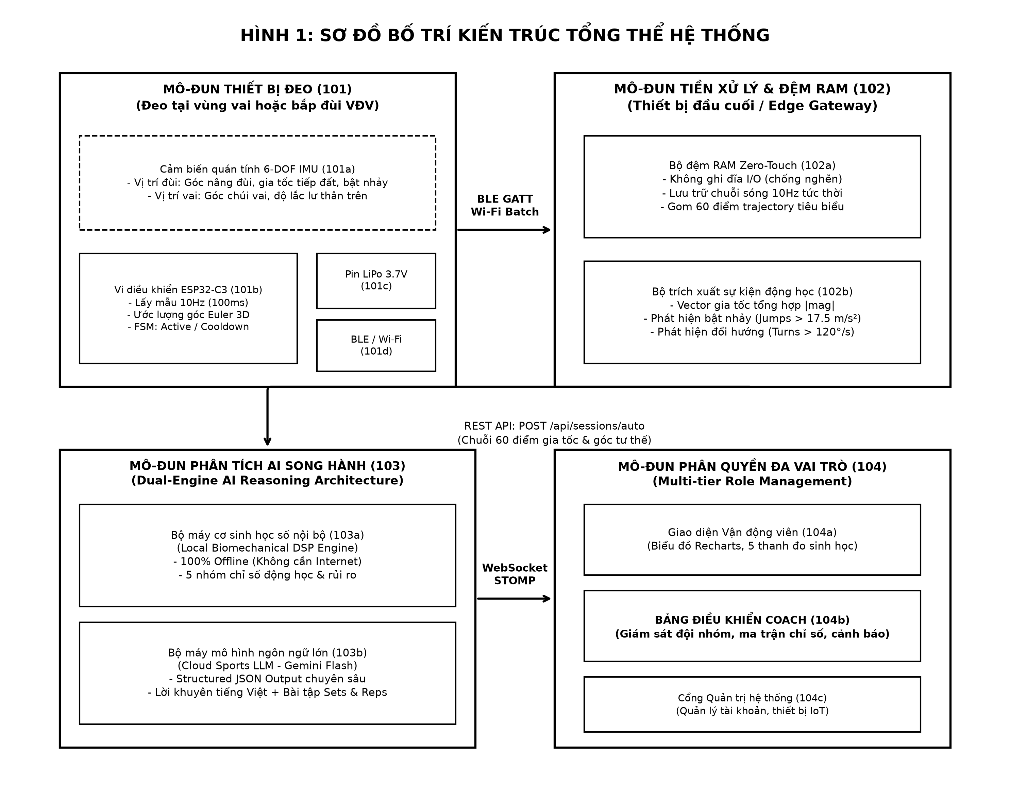
Figure 4.1. Second Skin Sport product architecture
At the edge, the ESP32-C3 SuperMini reads a six-degree-of-freedom MPU-6050 inertial measurement unit through I2C. The browser can connect to the patch using Web Bluetooth and display telemetry without requiring a separate gateway. For Wi-Fi workflows, the device can package samples into a batch and send them to POST /api/v1/sensor/batches. The backend then validates the request, stores sensor data, detects movement events, and publishes real-time updates through STOMP WebSocket topics.

4.2.3 Key product components
Component | Design role | Output
Wearable patch | ESP32-C3 and MPU-6050 attached to the athlete | Six-axis motion samples and battery state
Web application | React and Vite single page application | Live dashboards, device management, reports, and settings
Backend service | Spring Boot layered service with REST and WebSocket APIs | Validation, processing, authorization, persistence, and realtime events
Data and AI layer | JPA repositories, DSP feature extraction, and Gemini/local analysis | Performance metrics, biomechanical features, and coaching recommendations

4.3 Core Functions

4.3.1 Device connectivity and live telemetry
The Sensors screen manages direct Web Bluetooth discovery, connection, disconnection, and telemetry. Connection status is derived from the actual BLE lifecycle rather than from a static device list. When the device is disconnected, the navigation bar, sidebar, device card, and live stream state are updated together so that the interface does not report a false online state. Battery level and firmware information are shown only when supported by live device data.

4.3.2 Sensor data processing
The backend receives accelerometer and gyroscope values using consistent units: acceleration in m/s2 and angular velocity in degrees per second. Sensor batches are persisted in the database and passed through the jump detection service. The detection state machine identifies takeoff, flight, and landing phases, then estimates flight time, jump height, and landing impact. A bounded realtime buffer keeps the frontend responsive during continuous telemetry.

4.3.3 Athlete analytics and reports
Athlete dashboards summarize training sessions, average speed, distance, jump count, calories, and performance score. Statistics can be filtered by sport and time range. The report workflow focuses on data from the selected period, including aggregated performance, activity and movement results, the biomechanical metrics extracted from the recent sessions, and AI-generated interpretation. Reports can be exported in CSV and PDF formats for sharing or review.

4.3.4 Coach and administrator functions
The coach dashboard supports squad monitoring, fatigue evaluation, high-impact landing awareness, and tactical rotation suggestions. The administrator area supports user provisioning, role management, and account status control. These functions are protected by Spring Security role-based access control so that athlete, coach, and administrator workflows remain separate.

4.3.5 Authentication and privacy
Authentication uses JWT access tokens with a refresh-token cookie configured as HttpOnly and SameSite. The frontend keeps the short-lived access token in memory, while long-lived session information is not exposed as a collection of user credentials in local storage. Passwords are protected with BCrypt, and the system exposes only DTOs at the API boundary.

4.4 Technology Foundation
Layer | Technology used | Purpose in the product
Embedded hardware | ESP32-C3, MPU-6050, Arduino IDE or ESP-IDF | Motion capture, BLE GATT telemetry, and optional Wi-Fi batch transmission
Frontend | React 19, Vite, React Router, Recharts, Lucide React | Role-based SPA, realtime views, charts, and responsive interaction
Backend | Java 21, Spring Boot 3.2, Spring Security 6 | REST APIs, authentication, business services, and validation
Realtime communication | Web Bluetooth API and STOMP WebSocket | Direct device connection and server-published telemetry
Persistence | Spring Data JPA, Hibernate, SQL Server or H2 | Sessions, sensor samples, devices, users, teams, and statistics
AI and signal processing | Local DSP feature extractor and Google Gemini 1.5 Flash | Biomechanical scoring, explanations, and actionable coaching

The technology choices balance prototype speed with a path to production. React and Web Bluetooth make the live device experience visible in a browser. Spring Boot provides a familiar service boundary for REST, WebSocket, and database access. The dual-engine analysis design keeps a local fallback available when a cloud AI request is unavailable or an API key is not configured.

4.5 Prototype Implementation

4.5.1 Prototype workflow
- The athlete opens the Sensors screen and scans for the Second Skin ESP32 device.
- The browser establishes a BLE GATT connection and receives motion notifications from the custom characteristic.
- The frontend updates live sensor cards and charts while limiting the displayed buffer to a practical maximum.
- At the same time, completed or batch sessions can be sent to the backend for persistence and deeper processing.
- The backend detects movement events, produces statistics, and makes the results available to athlete and coach dashboards.
- After a session, the report page presents the selected time window and can request an AI interpretation of the accumulated evidence.

4.5.2 Prototype validation
The prototype was developed around testable boundaries rather than a single demonstration screen. Frontend component tests cover registration and role-oriented views, while the backend is organized into controller, service, repository, security, and processing layers. The build process validates the React production bundle and Maven compilation. Hardware simulation support in the firmware also allows the data pipeline to be exercised when an MPU-6050 board is not yet available or is not connected correctly.
Validation area | Prototype evidence | Current interpretation
Connectivity | BLE discovery, connect, disconnect, and live status propagation | Suitable for direct browser demonstration
Signal processing | Jump state machine and biomechanical feature extraction | Provides the core analytical path; thresholds require field calibration
Security | JWT, BCrypt, RBAC, refresh cookie, DTO boundaries | Provides a safer baseline for multi-role access
Reporting | Seven-day aggregation, AI analysis, CSV and PDF export | Supports athlete review and coach communication
Resilience | Local DSP fallback and firmware simulation mode | Allows development and demo without continuous cloud or hardware availability

4.6 Possible Improvements
The current prototype establishes the product flow, but several improvements are recommended before large-scale deployment. These improvements should be prioritized according to data quality, athlete safety, reliability, and operating cost.

4.6.1 Hardware and measurement quality
- Add a guided calibration procedure for sensor orientation, zero bias, and attachment position before each session.
- Validate landing-impact and jump-height thresholds with a labelled dataset collected from multiple athletes and sports.
- Improve enclosure design, skin contact, charging, waterproofing, and secure attachment so the patch remains stable during high-intensity movement.
- Add firmware-level packet sequence numbers, timestamps, and reconnect buffering to make missing samples measurable and recoverable.

4.6.2 Analytics and AI
- Replace fixed heuristic thresholds with athlete-specific baselines that adapt to body mass, sport, position, and training history.
- Add confidence scores and data-quality warnings so coaches can distinguish a reliable metric from a result affected by poor attachment or packet loss.
- Store AI explanations alongside the source statistics and model version to improve traceability and repeatability.
- Expand the labelled training set for landing softness, bilateral symmetry, trunk stability, cadence, and explosiveness before using the scores for medical or high-stakes decisions.

4.6.3 Platform and operations
- Move production secrets and mail credentials to a managed secret store and keep environment-specific configuration outside the repository.
- Use a production database with backups, retention policies, indexes for time-series queries, and monitoring for batch ingestion latency.
- Add end-to-end tests for the BLE lifecycle, report export, refresh-token rotation, and disconnection recovery.
- Introduce observability dashboards for WebSocket connections, sensor packet loss, failed AI requests, and report generation time.

4.7 Chapter Summary
Second Skin Sport is developed as a complete product ecosystem rather than as an isolated sensor demo. Its product design connects a wearable ESP32-C3 and MPU-6050 patch to a React user experience, a Spring Boot processing and security layer, persistent training data, and a dual-engine AI coaching workflow. The prototype already demonstrates the essential path from movement capture to realtime feedback and period-based reporting. The next development stage should focus on calibration, field validation, data quality, operational security, and longitudinal athlete baselines so that the platform can move from a functional prototype toward dependable sports performance use.

