SPLUNK SIEM LAB
Security Event Monitoring and Investigation
Cybersecurity Portfolio Project
Prepared by: Oarabetse Molatuli
Qualification: Higher Certificate in Cyber Security (NQF Level 5)
Tool Used: Splunk Enterprise 10.6.1.1
Project Focus: Security Monitoring | Log Analysis | Incident Investigation | Blue Team Operations
Year: 2026

TABLE OF CONTENTS

Project Overview
Lab Environment and Setup
2.1 Lab Environment
2.2 Creating the Sample Log File
Data Ingestion
3.1 Uploading the Sample Log File
3.2 Configuring the Source Type
3.3 Verifying the Uploaded Events
Security Event Investigation
4.1 Investigating Failed Login Attempts
4.2 Investigating the Source IP Address
4.3 Summarizing Security Events
Successful Login Investigation and Event Comparison
5.1 Investigating Successful Login Activity
5.2 Viewing Successful Login Details
5.3 Comparing Failed and Successful Login Activity
Security Monitoring Dashboard
6.1 Creating the Dashboard
6.2 Dashboard Panels
Findings and Conclusion
7.1 Key Findings
7.2 Conclusion

PROJECT OVERVIEW

his project involved using Splunk Enterprise to practise Security Information and Event Management (SIEM) activities.
The aim was to learn how to upload and analyse security logs, investigate failed and successful login attempts, identify source IP addresses, recognise account lockout events, and create a dashboard to visualise security activity.
A set of fictional security events was created for this exercise. The events were uploaded into Splunk and analysed using Search Processing Language (SPL).
This practical exercise helped develop foundational skills in security monitoring, log analysis and investigation from a Blue Team perspective.

LAB ENVIRONMENT SETUP

2.1 LAB ENVIRONMENT
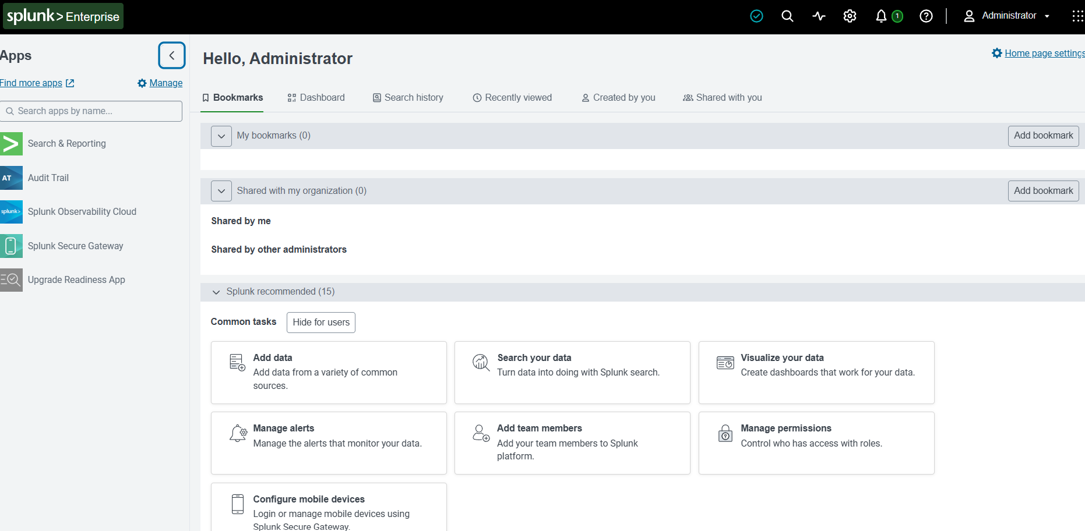
The practical exercise was conducted on a Windows laptop with Splunk Enterprise version 10.6.1.1 installed locally. The Splunk web interface was accessed through a web browser.
The default main index was used to store and search the uploaded security events.
Splunk Enterprise welcome page after successful sign-in.

2.2 CREATING THE SAMPLE LOG FILES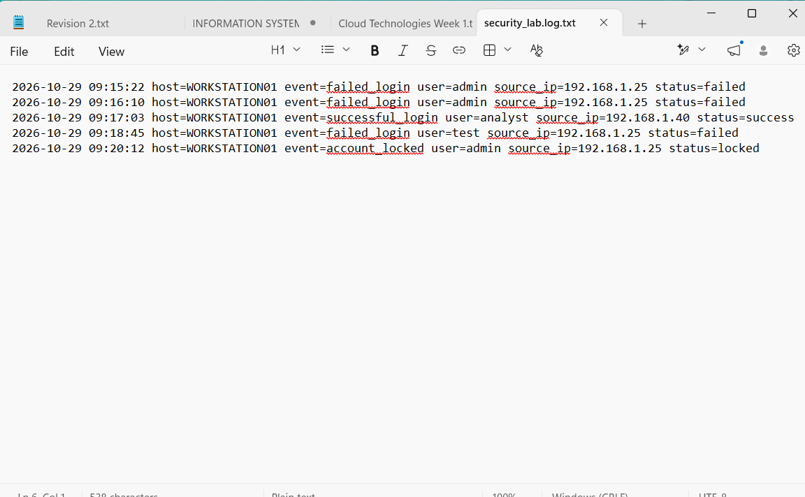
A sample security log file named security_lab.log.txt was created using Notepad. The file contained five fictional security events.
The events included:
Three failed login attempts for the admin account.
One successful login for the analyst account.
One account lockout event for the admin account.
Each event included a timestamp, host, event type, username, source IP address and login status.
These sample events were created specifically for this training exercise and do not represent real user activity or a real security incident.

DATA INGESTION

3.1 UPLOADING THE SAMPLE LOG FILE
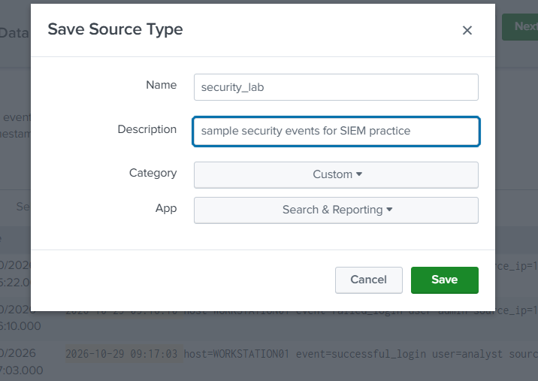
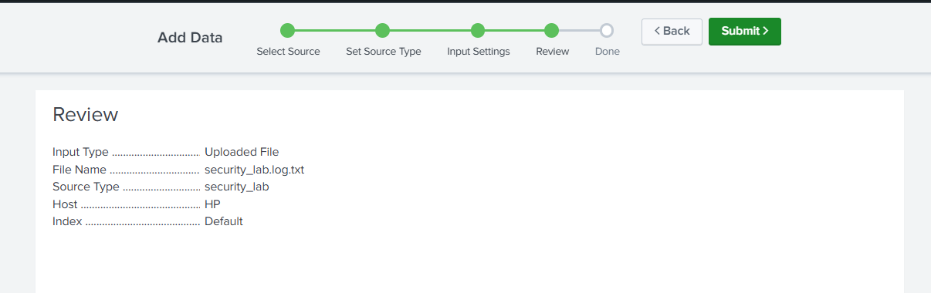
Uploading the Sample Log File
The sample log file was uploaded into Splunk using the Add Data option. The Upload method was selected, and the file security_lab.log.txt was chosen from the laptop.

3.2 CONFIGURING THE SOURCE TYPE
A custom source type named security_lab was created. The description was set to “Sample security events for SIEM practice”, and the Custom category was selected.
The default main index was used. After the upload was completed, Splunk confirmed that the data had been successfully uploaded.

3.3 VERIFYING THE UPDATED EVENTS
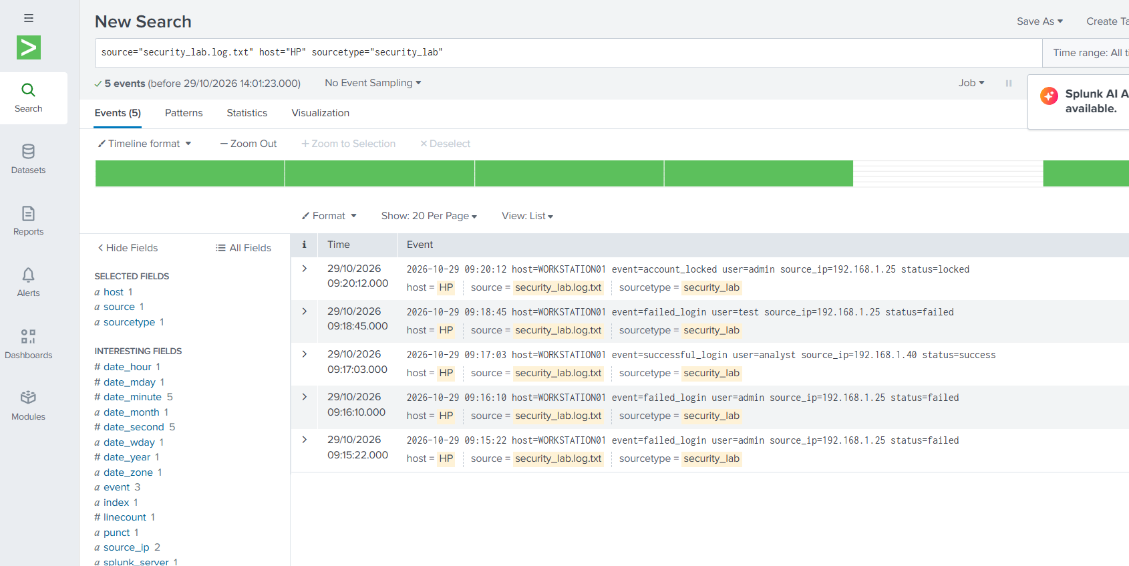
The uploaded data was opened in Splunk Search. Five events were displayed, consisting of three failed login attempts, one successful login and one account lockout event.

SECURITY EVENT INVESTIGATION

4.1INVESTIGATING FAILED LOGIN ATTEMPTS

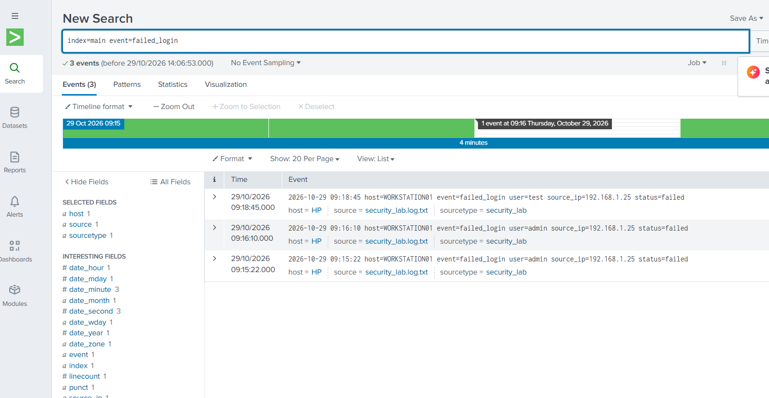
A search was performed in Splunk to identify failed login attempts in the uploaded security log data.
The following Search Processing Language (SPL) query was used:
index=main event=failed_login
The search returned three failed login events. All three attempts were associated with the admin account and originated from the same source IP address, 192.168.1.25.

4.2 INVESTIGATING THE SOURCE IP ADDRESS

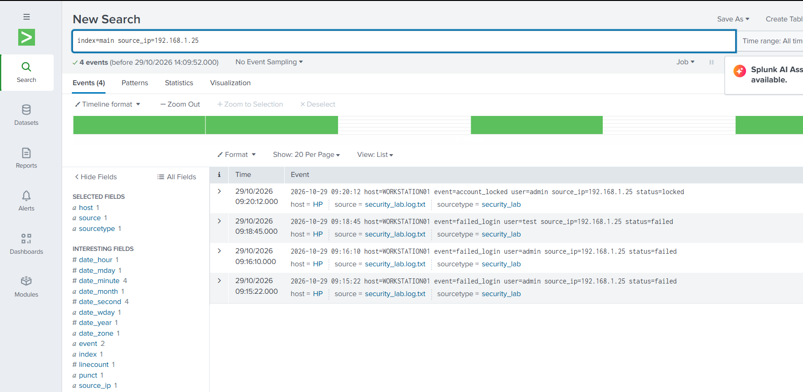
A second search was performed to investigate all events associated with the source IP address 192.168.1.25.
The following SPL query was used:
Lindex=main source_ip=192.168.1.25
The search returned four events: three failed login attempts and one account lockout event. This showed that the same IP address was associated with repeated failed login activity and the account lockout.

4.3 SUMMARISING SECURITY EVENTS
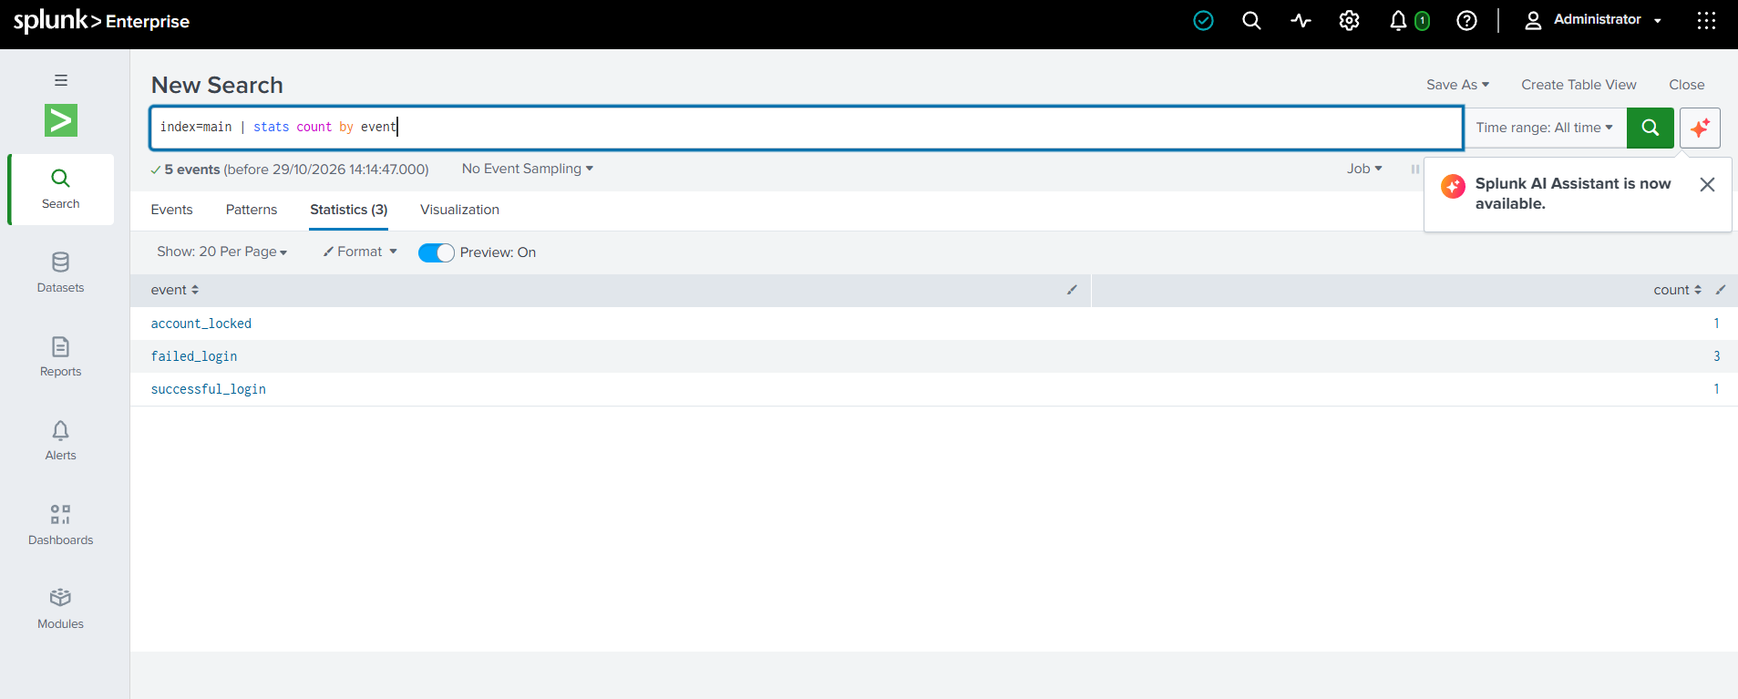
The following SPL query was used to count the different types of security events:
index=main | stats count by event
The results showed three failed login events, one account lockout event and one successful login event.

SUCCESSFUL LOGIN INVESTIGATION AND EVENT COMPARISON
5.1 INVESTIGATION SUCCESSFUL LOGIN ACTIVITY
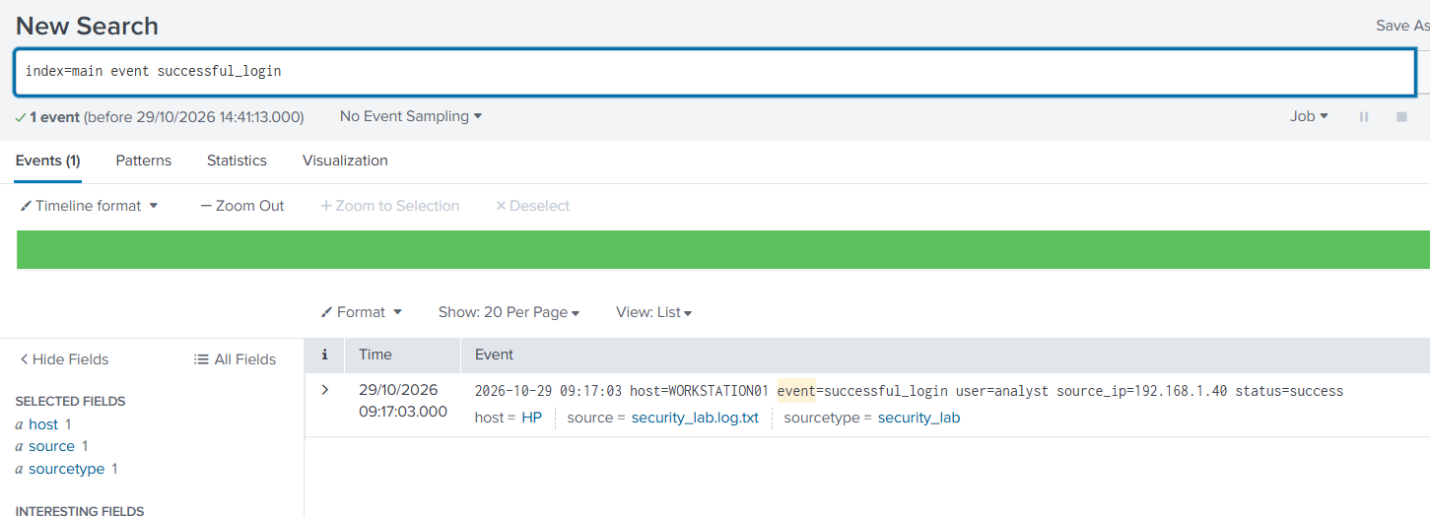
A search was performed to identify successful login activity in the sample security logs.
The following Search Processing Language (SPL) query was used:
index=main event=successful_login
The search returned one successful login event. The event was associated with the analyst account and originated from the source IP address 192.168.1.40.

5.2 VIEWING SUCCESSFUL LOGIN DETAILS
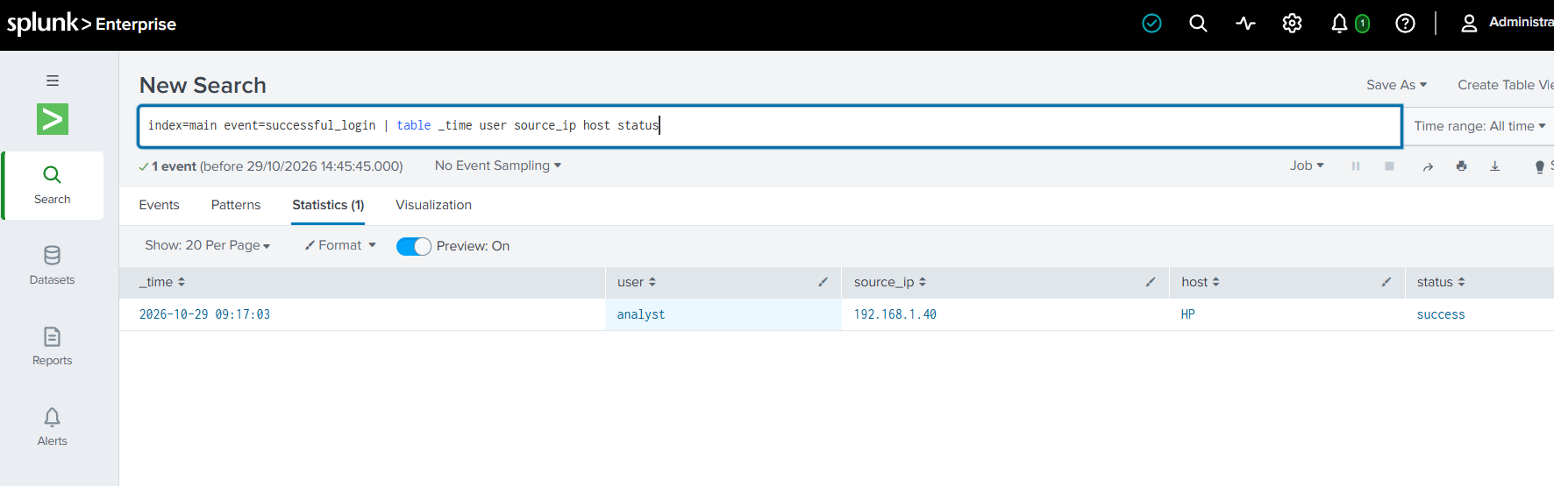

A table was created to display important details about the successful login event.
The following SPL query was used:
index=main event=successful_login | table _time user source_ip host status
The results displayed the event timestamp, username, source IP address, host and login status.

5.3 COMPARING FAILED AND SUCCESSFUL LOGIN ACTIVITY
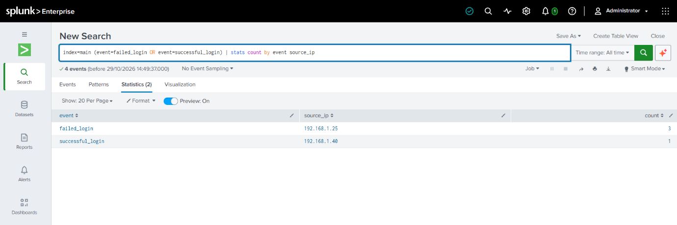
A comparison was performed to examine failed and successful login events based on their event types and source IP addresses.
The following SPL query was used:
index=main (event=failed_login OR event=successful_login) | stats count by event source_ip
The results showed three failed login attempts from 192.168.1.25 and one successful login from 192.168.1.40. This comparison helped distinguish the different login activities recorded in the sample data.

SECURITY MONITORING DASHBAORD

6.1 CREATING THE DASHBOARD
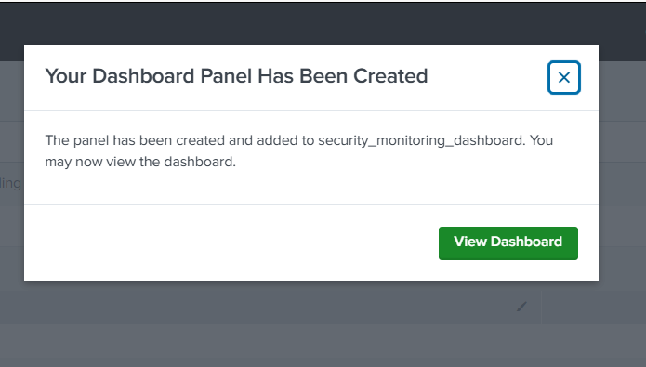
A Security Monitoring Dashboard was created in Splunk using Dashboard Studio. The dashboard was designed to provide a visual summary of the security events contained in the sample log data.
The dashboard included panels showing the total number of each event type and failed login activity over time.

6.2 DASHBAORD PANELS
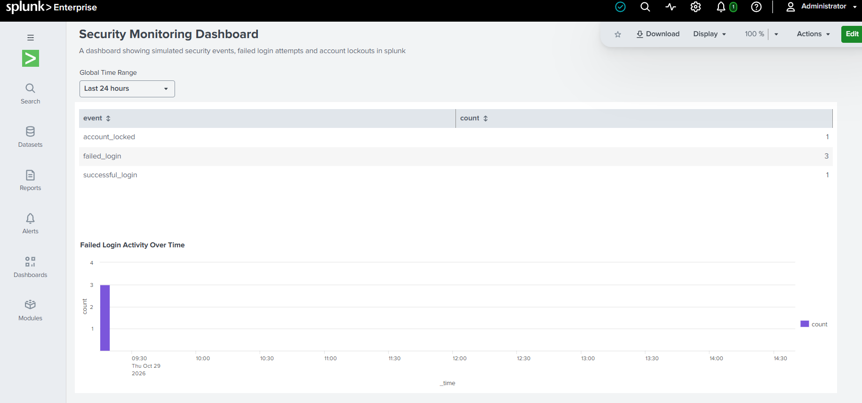
The dashboard contained two panels:
Security Event Summary: Displayed the number of failed login attempts, successful logins and account lockout events.
Failed Login Activity Over Time: Displayed the failed login events in a timechart visualization.
The dashboard made it easier to view and understand the security events in one place.

FINDINGS AND CONCLUSION

7.1 KEY FINDINGS
The analysis of the sample security logs produced the following findings:
Five security events were successfully uploaded and analysed in Splunk.
Three failed login attempts were recorded for the admin account.
The failed login attempts originated from the same source IP address, 192.168.1.25.
One account lockout event was recorded for the admin account.
One successful login event was recorded for the analyst account from 192.168.1.40.
A dashboard was created to display the event summary and failed login activity over time.
These findings demonstrated how Splunk can be used to search, organize and visualize security log data.

7.2 CONCLUSION
This project provided practical experience using Splunk Enterprise as a Security Information and Event Management (SIEM) tool.
Through this exercise, I gained experience uploading security logs, creating searches using Search Processing Language (SPL), investigating login activity, examining source IP addresses and creating a security monitoring dashboard.
The project strengthened my foundational understanding of security monitoring, log analysis and incident investigation from a Blue Team perspective.
Although the exercise used fictional sample events, it provided an opportunity to practise skills that are relevant to entry-level Security Operations Centre (SOC) roles.

