# Exploring market opportunities in Africa (AFRO)

Pfizer has distributed its COVID-19 vaccines to most WHO regions, but AFRO has received a limited supply, as demonstrated by chart 1. Unfortunately, this region also has the world's lowest vaccination rate, as depicted in chart 2. These two data points may be linked, highlighting the urgent need for increased vaccine access in AFRO.

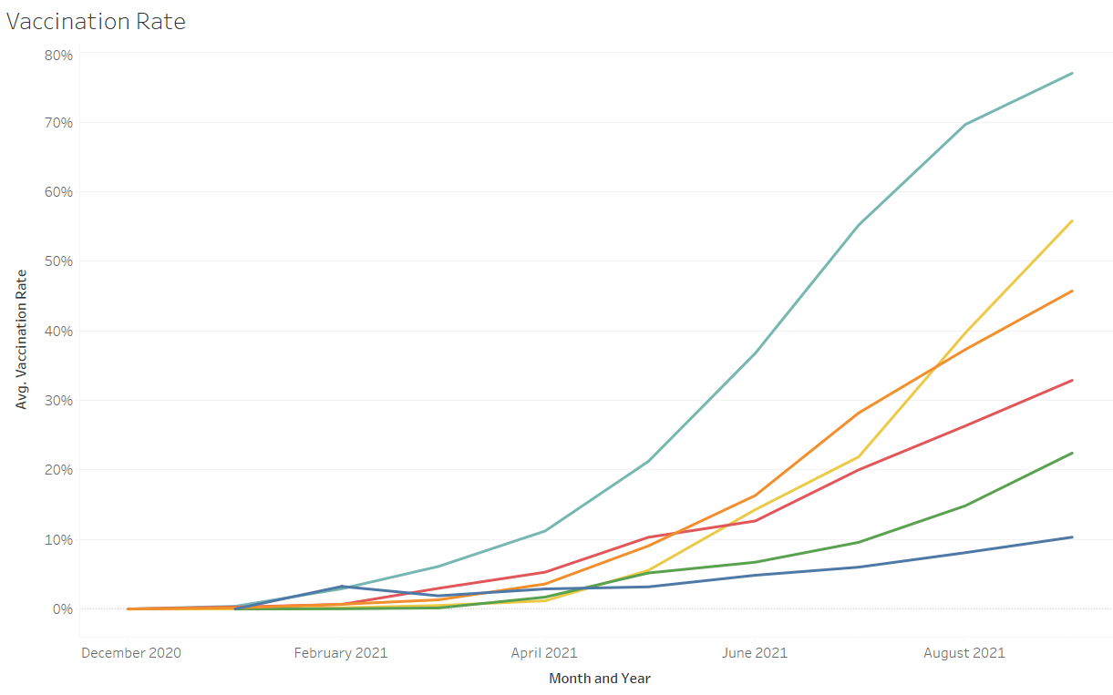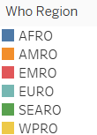

Chart 2

AFRO is lagging behind other regions in terms of COVID-19 vaccination rates, despite being hit by the pandemic later than most countries. With the first wave not hitting until July 2020, there is an opportunity to proactively promote preventive campaigns through vaccination in these countries.

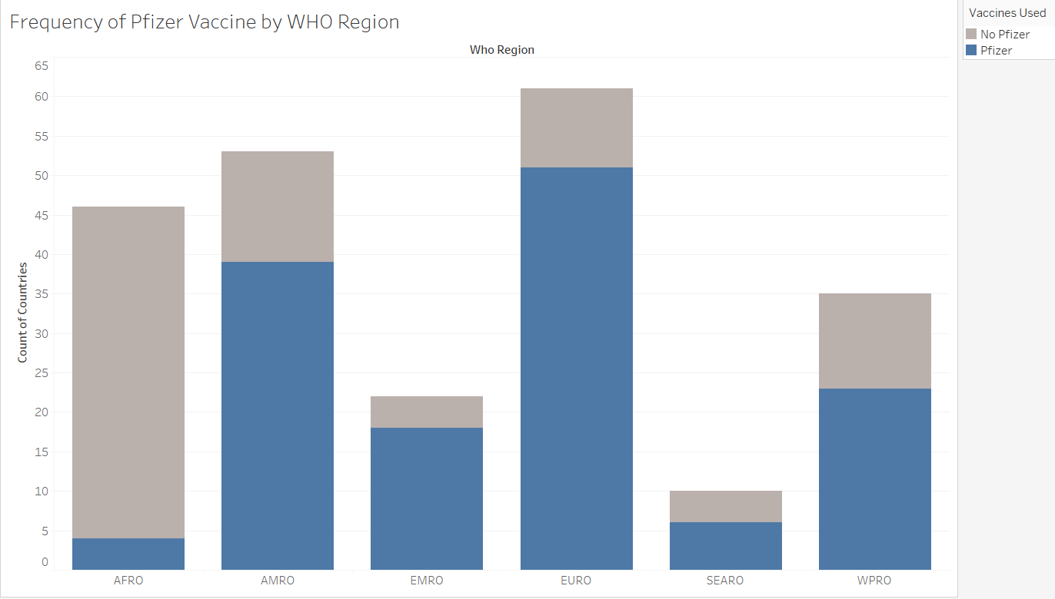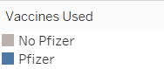

Chart 1

An analysis of global death rates across WHO regions reveals that South Africa, Namibia, and Seychelles have the highest mortality rates in the AFRO region. However, these countries also rank among the top 10 economies in the region, presenting a significant market opportunity for Pfizer to expand its operations and contribute to improving the healthcare landscape in these countries.

Upon analyzing the vaccination rates for the top three countries with the highest mortality rates in the AFRO region, South Africa and Namibia have the highest potential for vaccine supply as their vaccination rates in September 2021 were 12.08% and 5.11% respectively. In contrast, Seychelles, which reported a vaccination rate of 71.3% in the same month, may not be as high of a priority for vaccine supply.

There are different ways in which Pfizer could get involved to deliver vaccines to this region like the COVAX mechanism (XXX citation).

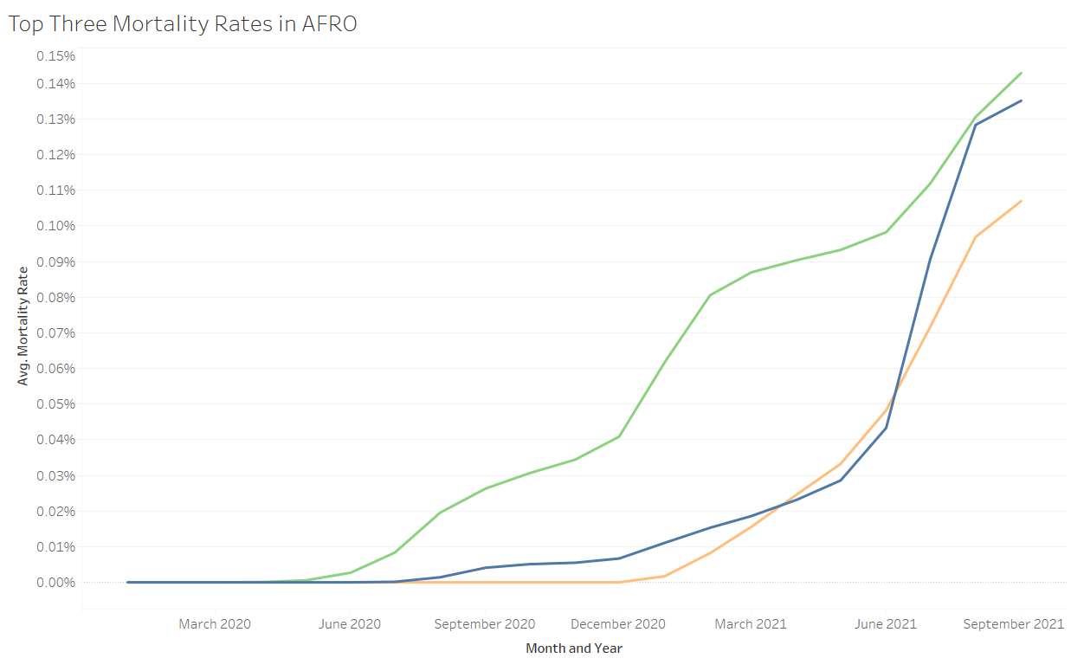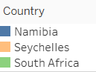

Chart 3

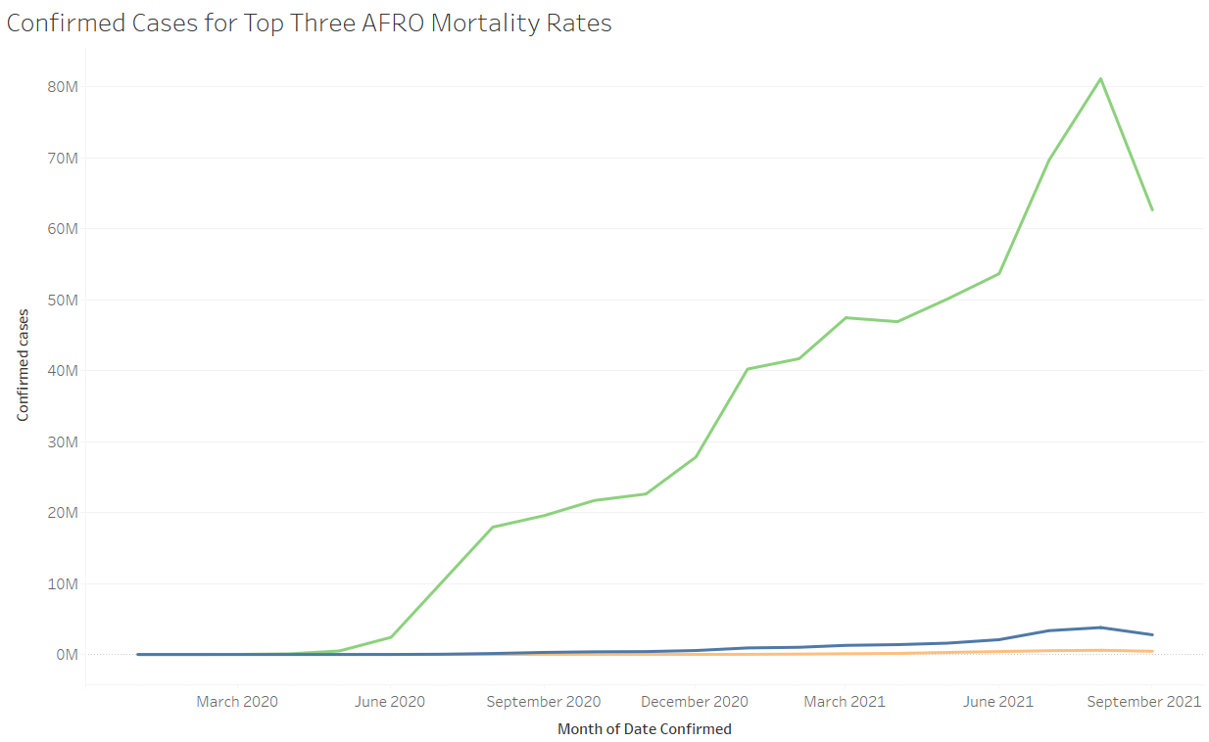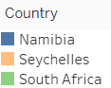

Chart 4

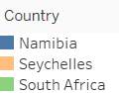

Chart 5

*Limitations*

The analysis presented above only includes data from January 2020 to September 2021. It is important to note that this analysis has the 3 main limitations. First, it doesn’t incorporate data for the production capacity and it’s assuming that Pfizer has enough production capacity to supply the AFRO region.

References

“List of Country Codes by Alpha-2, Alpha-3 Code (ISO 3166).” Iban.com, 2019, [www.iban.com/country-codes](http://www.iban.com/country-codes).

“[GDP per capita (current US$) - Africa](https://data.worldbank.org/indicator/NY.GDP.PCAP.CD)”. The World Bank, 2021,

<https://data.worldbank.org/indicator/NY.GDP.PCAP.CD?locations=A9&most_recent_value_desc=true>

Stephanie J Salyer et al., “The first and second waves of the COVID-19 pandemic in Africa: a cross-sectional study”, The Lancet, Volume 397, Issue 10281, 2021, Pages 1265-1275