Dispatch No. 300 | 21 May 2019

**Ugandans support gender equality, but women participation in governance still trails**

**Afrobarometer Dispatch No.   | Liberty Christopher**

**Summary (Acts as introduction (with a few references), summary of findings (topline, no specific %s, and interpretation (what does it mean?)**

Women have a right to engage in their country’s political processes, vote in elections, be elected to government office, serve on boards, and participate in civic activities that will affect their lives, families, and their communities. Ensuring that girls and women participate in political activities in their country is a necessary step to achieving the United Nations’ (2019) Sustainable Development Goal No. 5: “Achieve gender equality and empower all women and girls.”

In Uganda, government efforts to promote gender equality include a National Gender Policy

(2007), a Gender and Equity Strategy for Social Protection (2018), and a variety of program interventions emphasizing women’s empowerment, such as the Uganda Women Entrepreneurship Programme, Labour Works Program, and Youth Livelihood Program (Uganda Bureau of Statistics, 2019). But despite notable efforts, women still lag behind men in access to

political and socio-economic opportunities. Women remain vulnerable to gender-based

violence, own fewer assets than men, make up just 35% of Parliament, and are less likely than

men to have paid employment (28% vs. 46%) (Uganda Bureau of Statistics, 2017a, 2017b, 2019;

Gabola et al., 2018; Wyrod, 2008).

According to the latest Afrobarometer survey, most Ugandans endorse gender equality and say

the government has done a good job of promoting opportunities for women. A majority think

gender equality has been achieved when it comes to getting an education and a job. But a

sizeable share of the population would still prioritize men when jobs are scarce, and almost onefifth of women still report experiencing gender-based discrimination.

The feminist movement has most certainly brought about major changes for women including more freedom, fairness in the workplace and more equal social standing. However, one cannot help but notice that women are not only underrepresented in the political sphere but are sometimes prohibited from participating in active elective politics. <https://au.int/sites/default/files/newsevents/conceptnotes/38737-cn-concept_note-_high_level_forum_on_the_launch_of_the_initiative_wgpp.pdf>

<https://www.idea.int/sites/default/files/publications/african-union-mechanisms-to-foster-gender-mainstreaming-and-ensure-womens-political-participation.pdf>

<https://africa.cgtn.com/2020/10/18/african-women-enjoying-increasing-participation-in-politics-au/>

In an attempt to empower women and enhance their participation in elective politics, the 1995 Constitution of Uganda in Article 78(b) created special interest parliamentary positions reserved for women at the district level. In spite of the creation of these quotas, women are still marginalized in politics and their participation has not been brought to the fore.

a number of violent attacks have disrupted Tunisia’s traditional tranquility. Two political assassinations in 2013 (Al Jazeera, 2013) were followed in 2015 by Islamic State (ISIL) attacks at the Bardo Museum, a Sousse beach resort, and downtown Tunis, killing 72 people (BBC News, 2017). In 2016, ISIL fighters seeking to establish an “emirate” in southern Tunisia killed 18 security-service members and civilians before being repulsed (Arab Weekly, 2019).

A period of relative calm ended last October with a suicide bombing that injured 15 people, mainly police officers (BBC News, 2018). The country remains under a state of emergency imposed in 2015 and extended again in April 2019 (Business News, 2019) amid political tensions ahead of elections late this year and intermittent protests against government economic policies (Middle East Monitor, 2019a, 2019b). An additional security concern is posed by Tunisians who left to fight with ISIL and have since returned (Meko, 2018).

Against this background, how do ordinary Tunisians perceive their personal safety and public security?

Findings from the most recent Afrobarometer survey show that while security is an important issue for Tunisians, far fewer citizens consider it a top priority than did in 2015. Few Tunisians think their personal safety from crime and violence has improved, and most say the government is doing a poor job of reducing crime. But most trust the army to protect the country against external and internal security threats, and most are willing to sacrifice some personal freedoms in the name of security.

For policy makers and civil society, these findings point to a need for strategies to increase citizens’ feeling of personal safety without requiring them to sacrifice personal freedoms.

**Afrobarometer surveys**

Afrobarometer directs a pan-African, nonpartisan research network that conducts public attitude surveys on democracy, governance, economic conditions, and related issues in African countries. Seven rounds of surveys were completed in up to 38 countries between 1999 and 2018. Round 8 surveys in 2019/2020 are planned in at least 35 countries. Afrobarometer conducts face-to-face interviews in the language of the respondent’s choice with nationally representative samples.

The Afrobarometer team in [country], led by [NP], interviewed [1,200/2,400] adult [citizens of this country] in [month year]. A sample of this size yields country-level results with a margin of error of +/-3 [or +/-2] percentage points at a 95% confidence level. Previous surveys were conducted in [country] in [years].

**Key findings**

* Crime and security ranks fourth among the most important problems that Tunisians want their government to address, but the proportion of citizens who see it as a priority problem has dropped by half since 2015, from 43% to 21%.
* Four in 10 Tunisians (42%) say they felt unsafe in their neighbourhood at least “several times” during the previous year, a slight increase from 2013 (38%). One in seven (14%) say they feared crime in their home, a significant improvement compared to 2013 (37%).
* Six in 10 Tunisians (61%) say the government is doing a poor job of reducing crime – an improvement in citizens’ assessment compared to 2013 (73%).
* Most Tunisians say the armed forces “often” or “always” keep the country safe from security threats (83%) and are professional and respectful of the rights of all citizens (78%). A far smaller majority (57%) say they get the training and equipment they need to be effective.
* To protect public security, a majority of Tunisians say the government should be able to impose curfews and set up special roadblocks (79%), regulate what is said in places of worship (74%), and monitor private communications (53%).
* Almost two-thirds of Tunisians say citizens who fought alongside ISIL should face legal consequences such as a trial (34%), execution (20%), or jail (11%), while about one-fourth (27%) say they should be rehabilitated.

**Security concerns in Tunisia**

Despite the country’s continuing state of emergency, Tunisians appear to be less concerned about security than they were a few years ago. When asked what they consider the most important problems that the government should address, about one in five citizens (21%) cite crime and security among their top priorities, just half as many as prioritized security in Afrobarometer surveys in 2015 (43%) and 2013 (40%) (Figure 1).

**Figure 1: Crime and security as most important problem** | Tunisia | 2013-2018

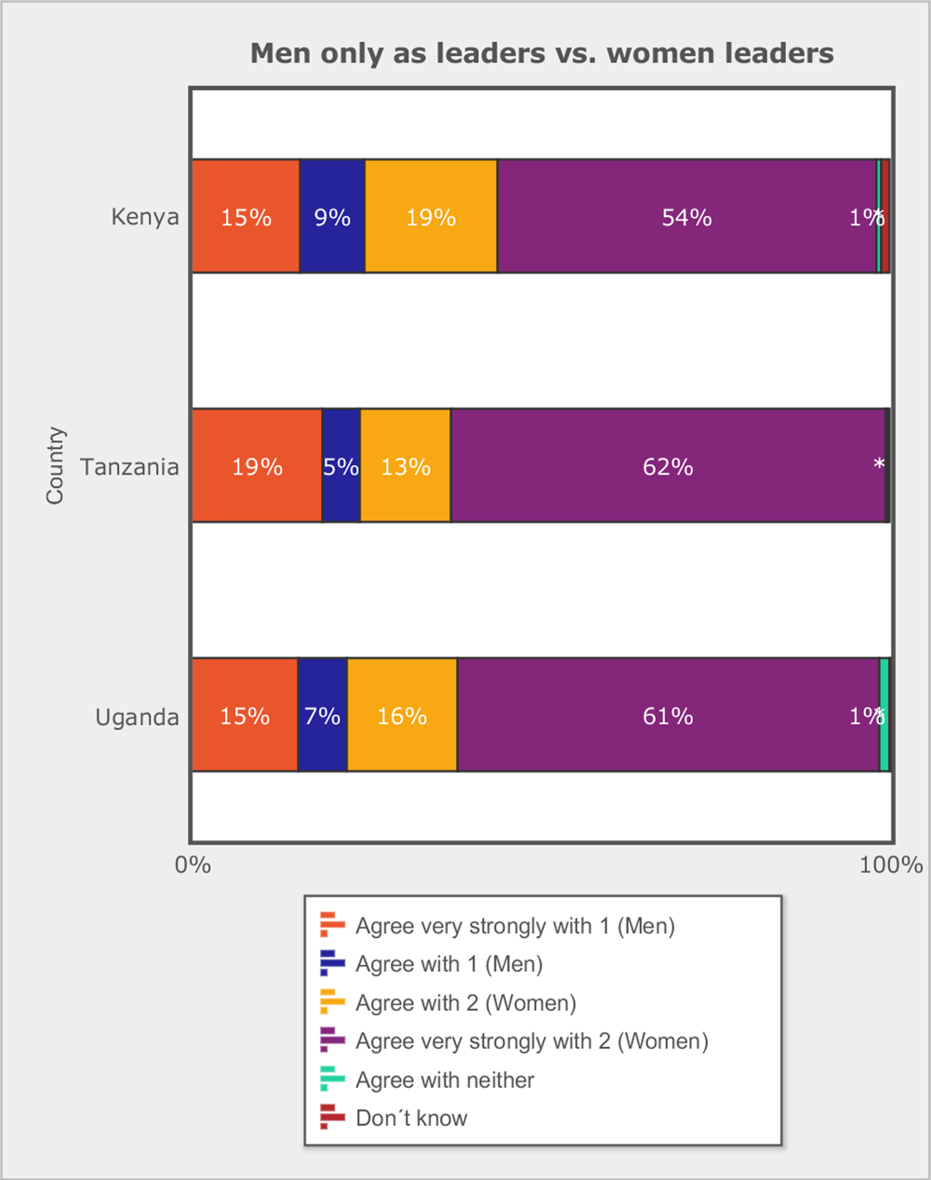

***Respondents were asked:*** *In your opinion, what are the most important problems facing this country that government should address? (Figure shows % of respondents who cite crime and security as one of up to three most important problems.)*

Crime and security has fallen from second place among Tunisians’ concerns in 2015 to fourth, after management of the economy (cited by 58% of respondents), unemployment (37%), and corruption (22%) (Figure 2).

**Figure 2: Most important problems the government should address** | Tunisia | 2018

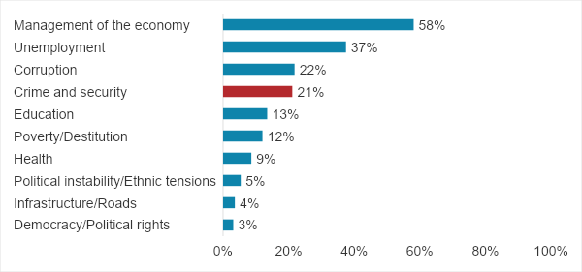

***Respondents were asked:*** *In your opinion, what are the most important problems facing this country that government should address? (Up to three responses per respondent were recorded.)*

**Personal safety and experience with violence**

With regard to personal safety, four in 10 Tunisians (42%) say they felt unsafe in their neighbourhood “several times,” “many times,” or “always” during the previous year, a marginal increase compared to 2013 (38%). On the other hand, only one in seven (14%) say they feared crime in their home at least “several times,” a 23-percentage-point improvement compared to 2013 (37%) (Figure 3).

**Figure 3: Unsafe in the neighborhood and home** | Tunisia | 2013-2018

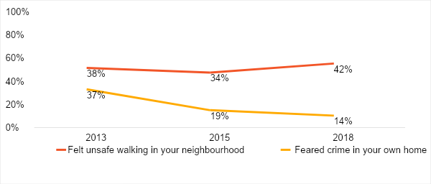

***Respondents were asked****: Over the past year, how often, if ever, have you or anyone in your family:*

*Felt unsafe walking in your neighbourhood?*

*Feared crime in your own home?*

*(% who say “several times,” “many times,” or “always”)*

Only a quarter (25%) of Tunisians say their personal safety from crime and violence has improved compared to “a few years ago,” while seven in 10 say it has gotten “worse” or “much worse” (38%) or has remained the same (32%) (Figure 4).

**Figure 4: Perceived personal safety compared to a few years ago** | Tunisia | 2018

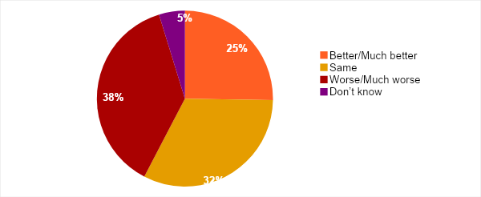

***Respondents were asked:*** *Please tell me if the following things are worse or better now than they were a few years ago, or are they about the same: Your personal safety from crime and violence?*

Afrobarometer also sought to know whether Tunisians had experienced or feared violence in various settings. About one in 20 or fewer say they experienced violence among people in their neighbourhood (6%), during a political rally (4%), during public protests or marches (4%), or in attacks by political or religious extremists (2%). About three in 10 (30%-32%) say they feared (but didn’t experience) violence in each of these settings (Figure 5).

**Figure 5: Feared or experienced violence in the past two years** | Tunisia | 2018

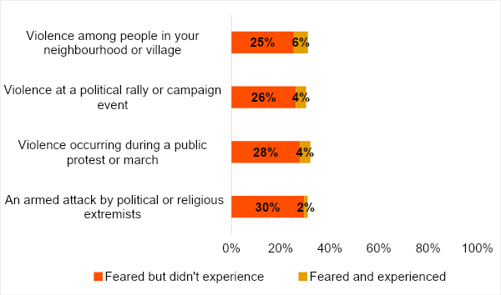

***Respondents were asked:*** *Please tell me whether, in the past two years, you have ever personally feared any of the following types of violence? [If yes:] Have you actually personally experienced this type of violence in the past two years?*

**State performance on security**

Only one-third (32%) of Tunisians say the government is performing “fairly well” or “very well” in reducing crime (Figure 6). Six in 10 (61%) describe the government’s performance as “fairly” or “very” bad, although this is an improvement from 2013 (73%).

However, seven in 10 Tunisians (71%) think it is “somewhat likely” or “very likely” that the police will take action when they report crime (Figure 7).

**Figure 6: Government performance in reducing crime** | Tunisia | 2013-2018

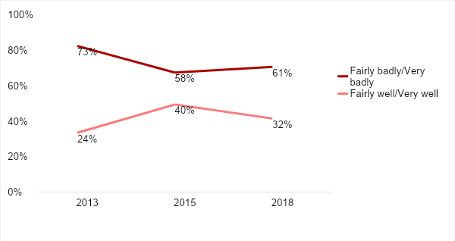

***Respondents were asked:*** *How well or badly would you say the current government is handling the following matters, or haven’t you heard enough to say: Reducing crime?*

**Figure 7: Police responsiveness to reported crime** | Tunisia | 2018

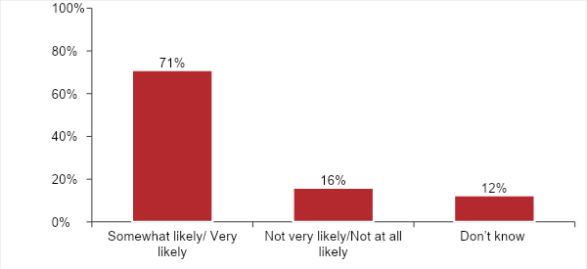

***Respondents were asked:*** *How likely is it that you could get someone to take action if you went to a government office or other public institution to report the following problems, or haven’t you heard enough to say: If you went to the local police to report a crime?*

Citizens give the military high marks for its performance in ensuring the security of the country. More than eight in 10 (83%) say the armed forces “often” or “always” keep the country safe from external and internal security threats, and more than three-fourths (78%) say they “often” or “always” act professionally and respect the rights of all citizens. But a far smaller majority (57%) of citizens say the armed forces “often” or “always” get the training and equipment they need to be effective (Figure 8).

**Figure 8: Perceptions of the armed forces** | Tunisia | 2018

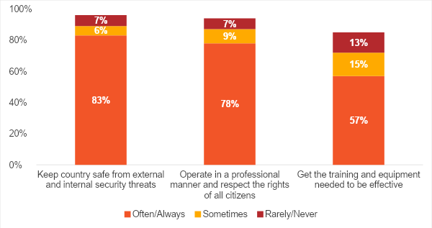

***Respondents were asked:*** *In your opinion, to what extent do the armed forces of our country:*

*Keep our country safe from external and internal security threats?*

*Operate in a professional manner and respect the rights of all citizens?*

*Get the training and equipment needed to be effective?*

**Do Tunisians accept less freedom in the name of security?**

Even if citizens’ concerns about security have decreased somewhat compared to 2015, a majority of Tunisians appear willing to accept some limitations on personal freedoms in exchange for public security (Figure 9). More than three-fourths (79%) of respondents say that if public security is threatened, the government should be able to impose curfews and set up special roadblocks to prevent people from moving around. Similarly, 74% “agree” or “agree very strongly” that the government should have the right to regulate what is said in places of worship if public security is at risk.

Support for government monitoring of private communications is much less strong, but still, a majority (53%) say it should be able to monitor mobile phones and other communications to make sure that people are not plotting violence.

**Figure 9: Freedom vs. security** | Tunisia | 2018

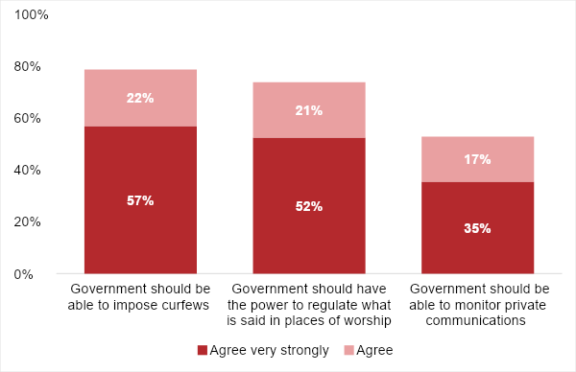

***Respondents were asked****:*

*Which of the following statements is closest to your view?*

*Statement 1: Even if faced with threats to public security, people should be free to move about the country at any time of day or night.*

*Statement 2: When faced with threats to public security, the government should be able to impose curfews and set up special roadblocks to prevent people from moving around.*

*Which of the following statements is closest to your view?*

*Statement 1:  Freedom of religion and worship are absolute, meaning that government should never limit what is said in a place of worship.*

*Statement 2: Government should have the power to regulate what is said in places of worship, especially if preachers or congregants threaten public security.*

*Which of the following statements is closest to your view?.*

*Statement 1: Government should be able to monitor private communications, for example on mobile phones, to make sure that people are not plotting violence.*

*Statement 2: People should have the right to communicate in private without a government agency reading or listening to what they are saying.*

**Best way to deal with Tunisians who fought with ISIL**

In 2017, an estimated 6,000 Tunisians left the country to join the Islamic State (ISIL) (Bremmer, 2017). As the terrorist group crumbled, many returned home, and are seen as a potential security risk (Meko, 2018; Mintner, 2019). When asked how the government should deal with these returned fighters, almost two-thirds of Tunisians say they should face legal consequences, ranging from being tried in court (34%) or being jailed (11%) to being executed (20%). About one in four respondents (27%) say they should be rehabilitated, while only 3% say they should be “left alone” (Figure 10).

**Figure 10: How should government deal with Tunisians who fought with ISIL?**

| Tunisia | 2018

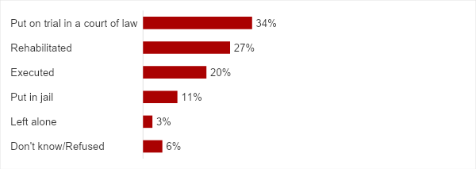

**Respondents were asked: In your opinion, how should our government deal with Tunisians who return to the country after fighting alongside Islamic State (ISIL)?**

**Conclusion**

The most recent Afrobarometer survey suggests that Tunisians are less concerned about security now than they were in the violent year of 2015. Still, the issue of crime and security remains high among citizens’ priority problems, and only a quarter of Tunisians think their personal safety has improved. However, most Tunisians give the military high marks on protecting the country, and most would accept limitations on their freedom of movement, their right to private communication, and their religious liberty to help ensure public safety.

For policy makers and civil society, these findings point to a need for strategies to increase citizens’ feeling of personal safety without requiring them to sacrifice personal freedoms.

**References**

Al Jazeera. (2013).[Who killed Tunisia's Chokri Belaid?](https://www.aljazeera.com/indepth/features/2013/09/201394183325728267.html) 12 September..

Arab Weekly. (2019). [Tunisian security forces stymie jihadists’ effort to forge new ‘emirate.’](https://thearabweekly.com/tunisian-security-forces-stymie-jihadists-effort-forge-new-emirate) 5 January..

BBC News. (2017). [Tunisia profile – timeline. A chronology of key events](https://www.bbc.com/news/world-africa-14107720). 1 November..

BBC News. (2018). Tunis attack: Woman blows herself up in Tunisia. <https://www.bbc.com/news/world-africa-46017905>.

Bremmer, I. (2017). [The top 5 countries where ISIS gets its foreign recruits](http://time.com/4739488/isis-iraq-syria-tunisia-saudi-arabia-russia/). 14 April.

Meko, T. (2018). [Now that the Islamic State has fallen in Iraq and Syria, where are all its fighters going?](https://www.washingtonpost.com/graphics/2018/world/isis-returning-fighters/) Washington Post..

Middle East Monitor. (2019a). [Tunisia protests against ‘government policies.’](https://www.middleeastmonitor.com/20190405-tunisia-protests-against-government-policies/) 5 April.

**[ Author’s Name ]** is [title] for [organisation] in [location]. Email: [address].

**[ Author’s Name ]** is [title] for [organisation] in [location]. Email: [address].

Afrobarometer, a nonprofit corporation with headquarters in Ghana, directs a pan-African, non-partisan research network. Regional coordination of national partners in about 35 countries is provided by the Ghana Center for Democratic Development (CDD-Ghana), the Institute for Justice and Reconciliation (IJR) in South Africa, and the Institute for Development Studies (IDS) at the University of Nairobi in Kenya. Michigan State University (MSU) and the University of Cape Town (UCT) provide technical support to the network.

Financial support for Afrobarometer Round 8 has been provided by the Swedish International Development Cooperation Agency (SIDA), the Mo Ibrahim Foundation, the Open Society Foundations, the William and Flora Hewlett Foundation, and the U.S. Agency for International Development (USAID) via the U.S. Institute of Peace.

Donations help Afrobarometer give voice to African citizens. Please consider making a contribution (at www.afrobarometer.org) or contact Felix Biga (felixbiga@afrobarometer.org) to discuss institutional funding.

Follow our releases on #VoicesAfrica. Image result for facebook iconImage result for twitter icon

                             /Afrobarometer                  @Afrobarometer

**Afrobarometer Dispatch No. X | XX Month 2017**