Overview
This notebook allows example reinsurance structures to be input in OED format and ran against the development version of the Oasis financial engine.
Launch
Click run_test.ipynb from the Files area of the jupyter binder interface.
Getting started
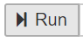
Run through each of the 10 steps in the notebook consecutively. It displays the input files for a particular reinsurance example (Steps 3-6), runs the direct insurance and reinsurance loss calculations for a particular loss scenario (Steps 7-8) and displays the direct insurance loss results (Step 9) and reinsurance net loss results (Step 10+).
Examples library
There is an examples folder in the Files area of the jupyter binder interface and each example has a set of OED files representing a simple reinsurance structure applied to a 4 location, 2 policy, 2 account programme. The worked example comparison calculations are in the spreadsheet examples/ExampleComparisonCalculation.xlsx.
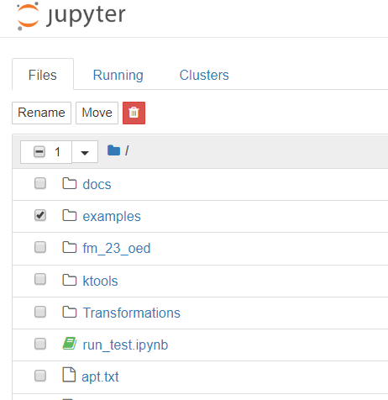
Running a particular example
In Step 2 of the notepad select a particular example, e.g. multiple_QS_2, by typing the file location name (shown in red text) and run the example through to the end.
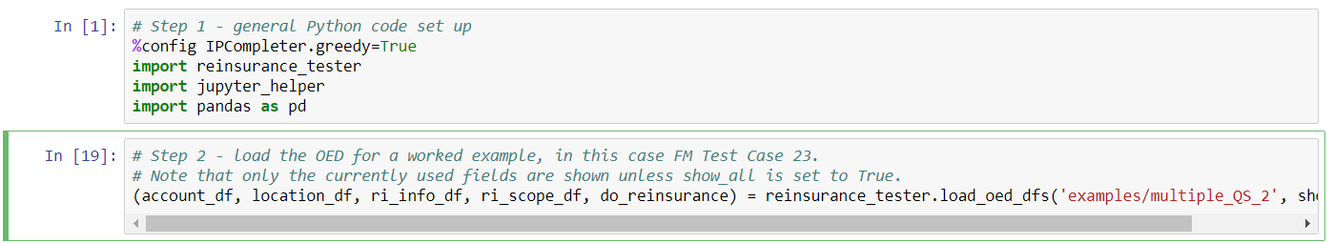
You can make changes to the example input files by editing directly in the grid in Steps 3-6, and then rerun the calculation. (Changes not persisted).
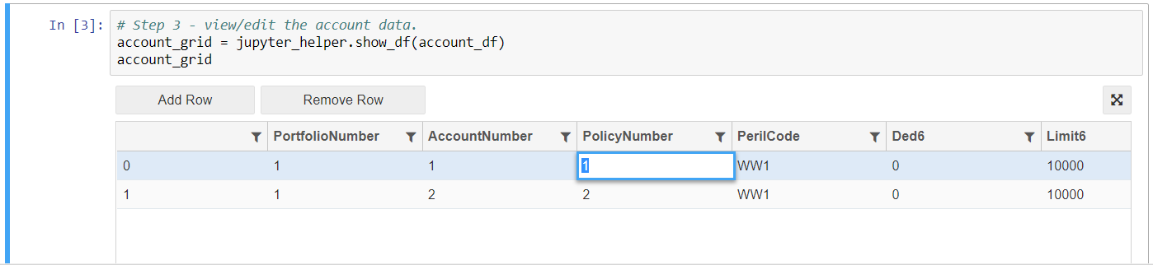

Viewing results
Step 8 tells you what loss results are available to view (highlighted in blue).
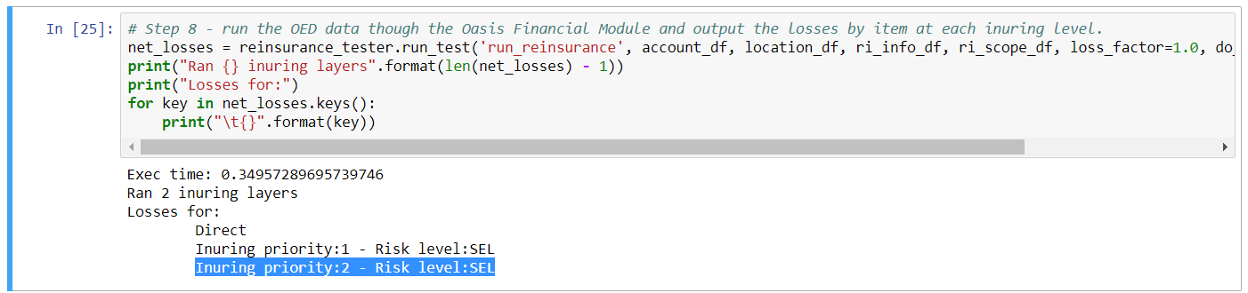
To view a particular set of results you must copy the relevant text (E.g. ‘Inuring priority:2 – Risk level:SEL’) for one of the outputs into the “key” value in Step 10, or create a new step.
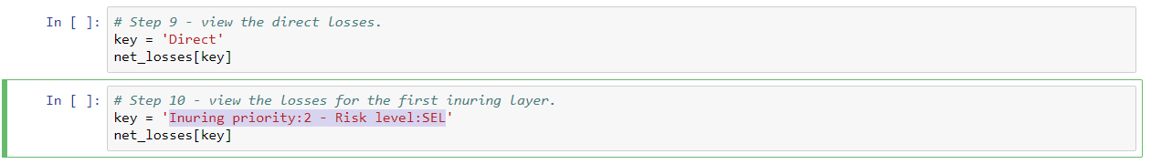
Issue tracking
Issues can be viewed and reported in the ReinsuranceTestTool github repository here;
https://github.com/OasisLMF/ReinsuranceTestTool/issues

Uploading files
We are currently working on making it easier to add your own OED files, but for now you can edit the existing ones directly in the notebook, or you can upload your own to the jupyter binder directory (bit fiddly but it works).

Troubleshooting
If the notebook appears to hang or lose connection, close the window and relaunch. You can shutdown running instances under the Running tab in the jupyter binder interface.
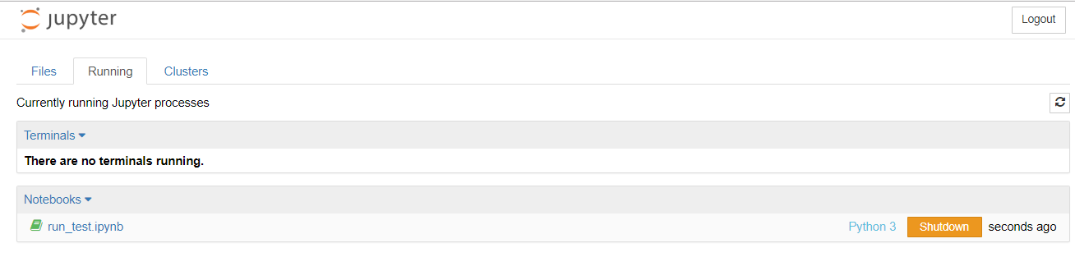
The fall back is to relaunch the binder from the github repository.

