Overview
This notebook allows example reinsurance structures to be input in OED format and ran against the development version of the Oasis financial engine.
Launch
Click run_test.ipynb from the Files area of the jupyter binder interface.
Getting started
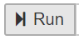
Run through each of the 10 steps in the notebook consecutively. Steps 1-2 is initialisation, file upload (optional) and example selection. Steps 3-6 display the input files for the selected reinsurance example. Steps 7-8 run the direct insurance and reinsurance net loss calculations for a particular loss scenario and Step 9 + displays the results.
Examples library
There is an examples folder in the Files area of the jupyter binder interface and each example has a set of OED files representing a simple reinsurance structure applied to a 4 location, 2 policy, 2 account programme. The worked example comparison calculations are in the spreadsheet examples/ExampleComparisonCalculation.xlsx.
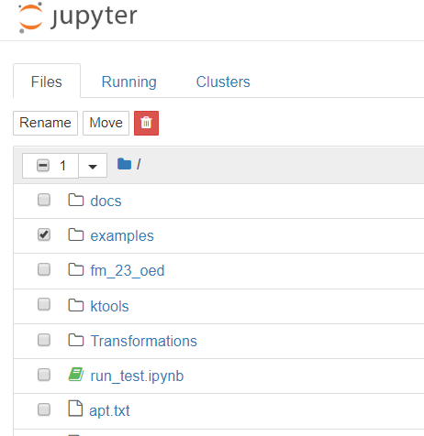
Running a particular example
In Step 2 of the notepad select a particular example, e.g. multiple_QS_2, by typing the file location name (shown in red text) and run the example through to the end.
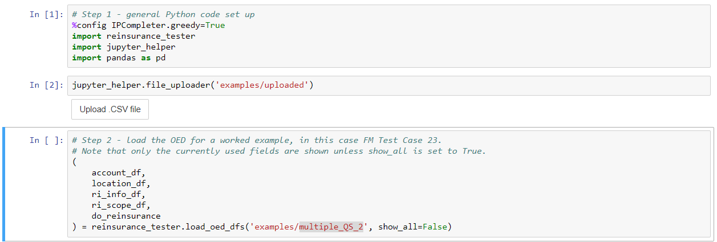
You can make changes to the example input files by editing directly in the grid in Steps 3-6, and then rerun the calculation. (Changes not persisted).
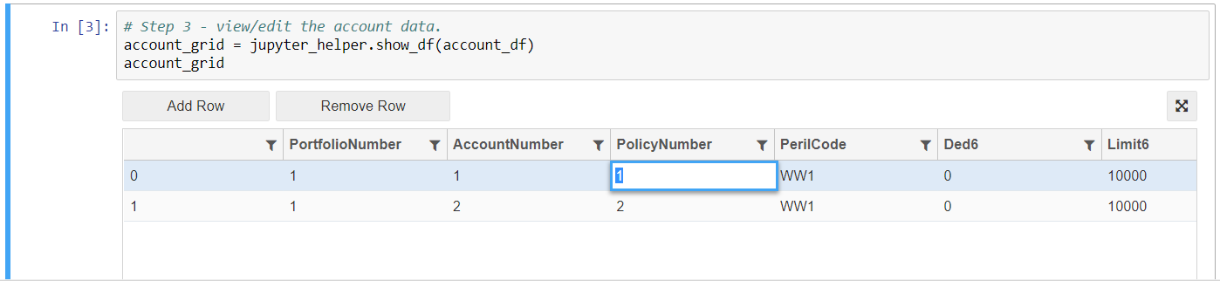

Viewing results
Step 8 tells you what loss results are available to view (highlighted in blue).
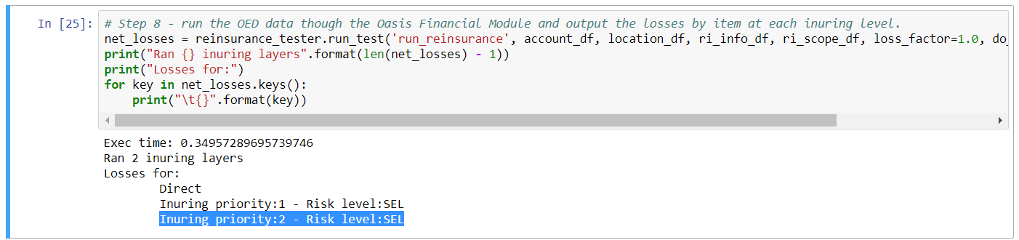
To view a particular set of results you must copy the relevant text (E.g. ‘Inuring priority:2 – Risk level:SEL’) for one of the outputs into the “key” value in Step 10, or create a new step.
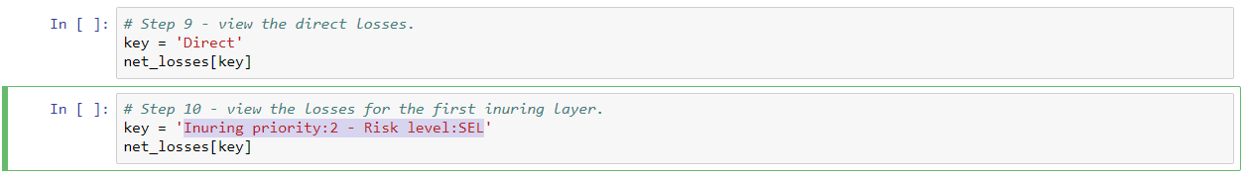
Issue tracking
Issues can be viewed and reported in the ReinsuranceTestTool github repository here;
https://github.com/OasisLMF/ReinsuranceTestTool/issues

Uploading input files
In Step 1 there is an optional file upload utility which enables you to load input files directly from your local machine. Click the Upload .CSV file button to launch a file browser window and select each file one by one.
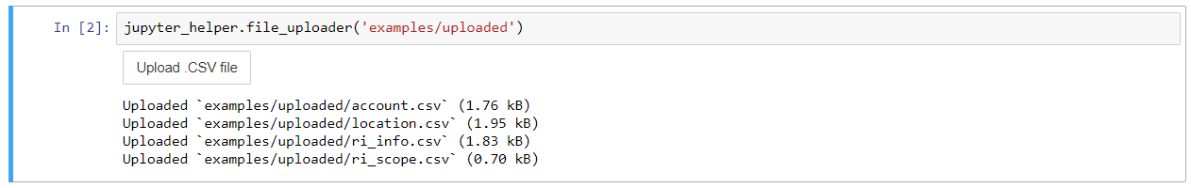
The file formats must conform to the OED specification and be named;
- location.csv
- account.csv
- ri_info.csv
- ri_scope.csv
After you have uploaded your files, in Step 2, enter the file location as ‘examples/uploaded’ to run the uploaded files.
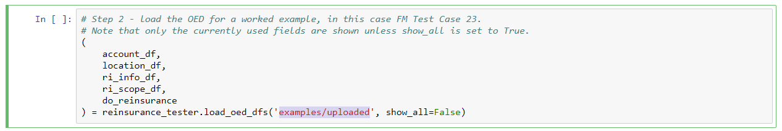
Uploaded files are not persisted, which means you must upload them again if you restart your notepad session.
Troubleshooting
If the notebook appears to hang or lose connection, close the window and relaunch. You can shutdown running instances under the Running tab in the jupyter binder interface.
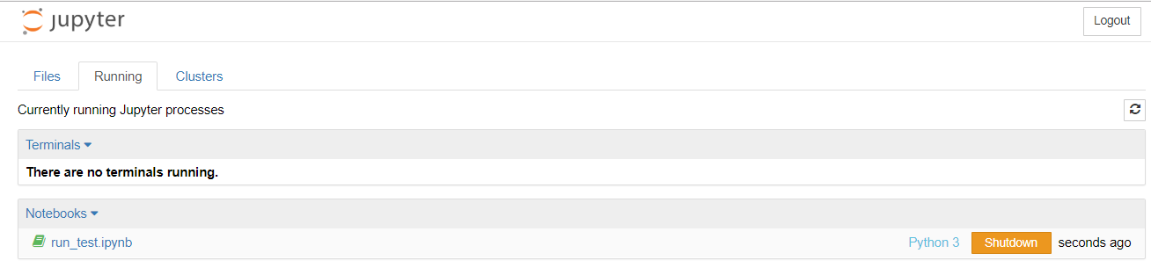
The fall back is to relaunch the binder from the github repository.

