**Objective**: To test opportunity for AGV surveying in New ware-house LopBuri

**Date**: 8-9 July 2024

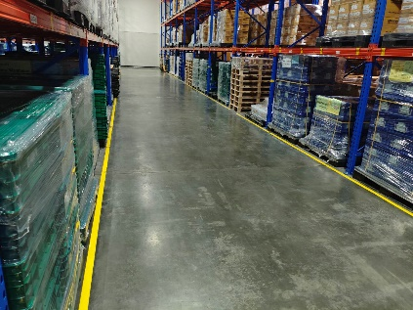**Location**: New ware-house block 36

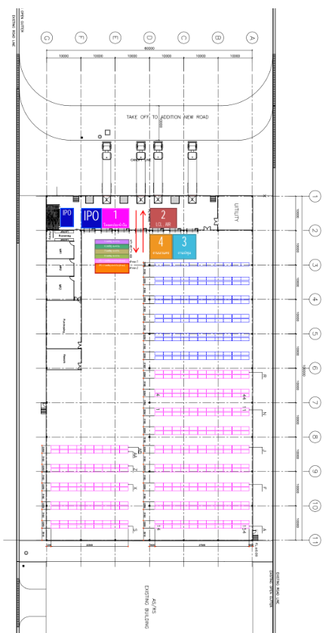

**Equipment**: AGV MICKY50

**Specification:**

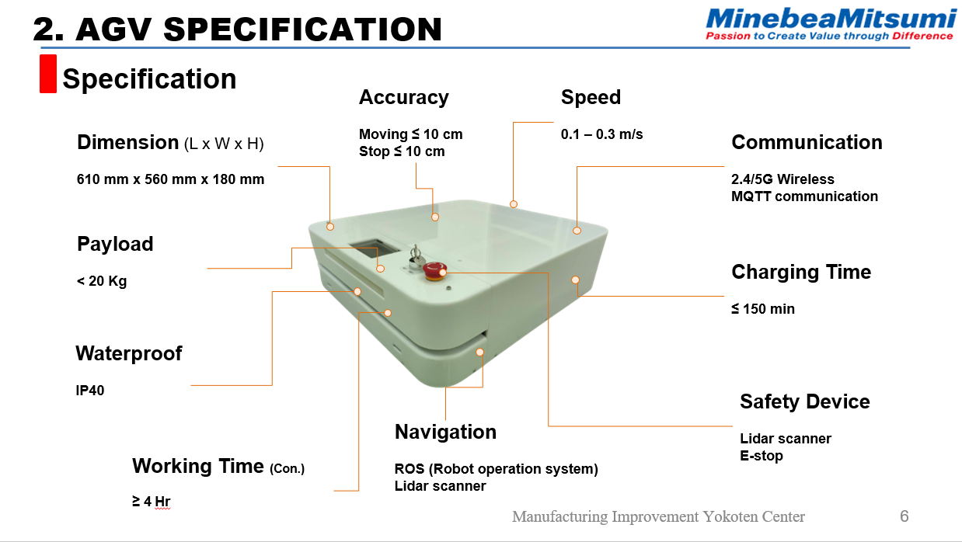

**Topic:**

1. Creating Map and difference map pattern for testing.
2. Testing condition and result.
3. Problem.
4. Conclusion.
5. **Creating Map and difference map pattern for testing.**

For this test, we tested at New-Warehouse. Which is always rack being moved therefore the test has different maps for different test times as follows:

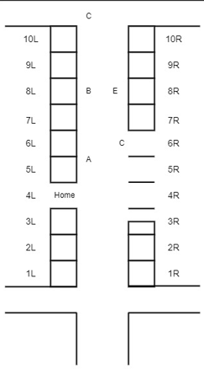 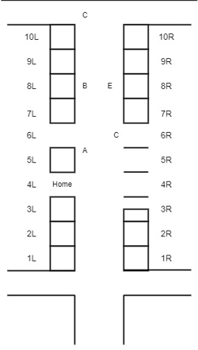 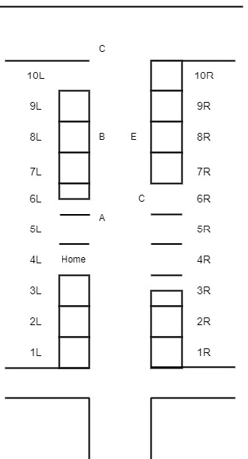

1. Morning 08-07-2024 (B) Evening 08-07-2024 (C) 09-07-2024

Picture 1 Map layout for New-Ware House Block 36

From the picture 1. Rack was moved from old state that rack 6L moved on evening 08-07-2024 and rack 5L moved on 09-07-2024 that effect to AGV moving and we explain in topic 3 problem. However, for this test we use map that created on Morning 08-07-2024 for data collection as below:

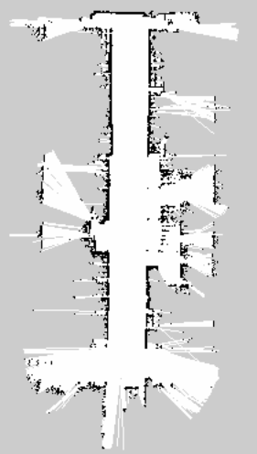

Picture 2. Map for AGV create on Morning 08-07-2024

1. **Testing condition and result.**
   1. **Testing moving AGV to Position by using Web Application.**

We use React for design Web Application using ROSLIB to communicate between React and ROS.

**Testing condition:**

* Control AGV by touch button on the screen for every button.
* Record moving data.

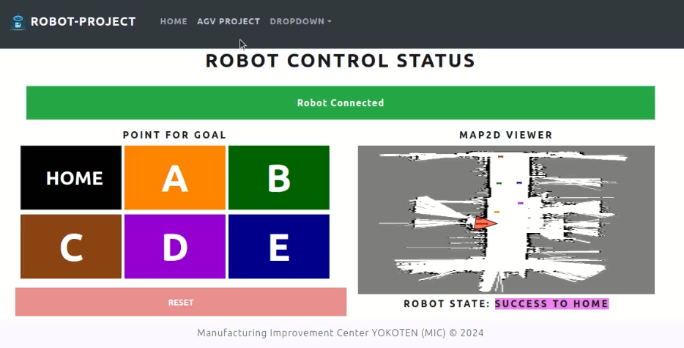

Picture 3. Web Application page for control AGV

**Testing Result:**

|  |  |  |  |  |  |  |
| --- | --- | --- | --- | --- | --- | --- |
| Start/Goal | Home | A | B | C | D | E |
| Home | ✅ | ✅ | ✅ | ✅ | ✅ | ✅ |
| A | ✅ | ✅ | ✅ | ✅ | ✅ | ✅ |
| B | ✅ | ✅ | ✅ | ✅ | ✅ | ✅ |
| C | ✅ | ✅ | ✅ | ✅ | ✅ | ✅ |
| D | ✅ | ✅ | ✅ | ✅ | ✅ | ✅ |
| E | ✅ | ✅ | ✅ | ✅ | ✅ | ✅ |

Table 1. Testing result for moving from start point to goal point

From picture 3 and table 1. User can control AGV by touching button that need to be goal of AGV on the screen. For the result, we found that AGV is able to move to every point as the command from user (Video Link: https://youtu.be/6zdblH6UEzM)

**2.2 Avoidance person standing in the front of AGV (AGV move to front direction of person).**

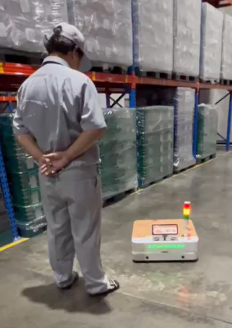 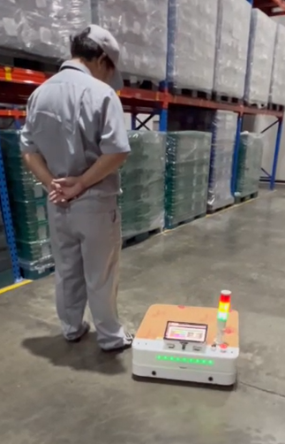 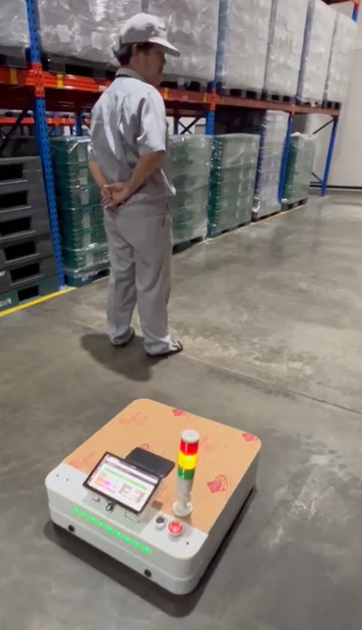

Picture 4. Avoidance Person standing in the front of AGV

(Video Link: https://youtu.be/ZW2OfCaQo_c)

From the picture 3. AGV can avoid stationary person by moving around them from the rear direction effectively with distance about 10-30 cm that is acceptable distance for working.

* 1. **Avoidance person moving to the front of AGV (AGV move to front direction of person).**

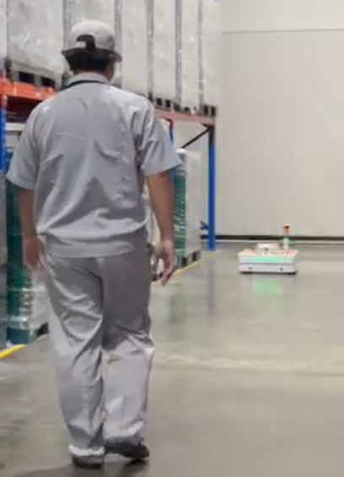 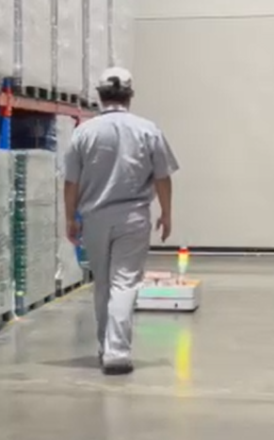 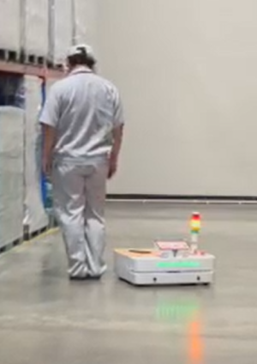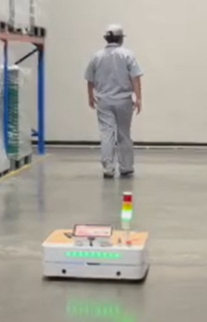

Picture 5. Avoidance Person moving to the front of AGV

(Video Link: https://youtu.be/vzY4oO30h_Q )

From the picture 5. AGV can avoid stationary person by moving around them from the rear direction effectively with distance about 10-30 cm that is acceptable distance for working. But worker has to stop in the front of AGV for AGV avoid pass worker.

* 1. **Record data on database**

For testing record data into data base, we tested by sent command to AGV move in the loop (Home -> A -> B -> C -> D -> E -> Home) as picture 6.



Picture 6. Moving path for AGV

The result shown in table below:

|  |  |  |  |  |  |
| --- | --- | --- | --- | --- | --- |
| No | Point | Duration (sec) | Distance (m) | Speed (m/s) | Battery Usage (Volt) |
| 1 | H -> A -> B -> C -> D -> E -> H | 195 | 47.4748 | 0.243461 | 0.0088252 |
| 2 | H -> A -> B -> C -> D -> E -> H | 198 | 48.25178 | 0.243696 | 0.0088252 |
| 3 | H -> A -> B -> C -> D -> E -> H | 160 | 47.25153 | 0.295322 | 0.0087252 |
| 4 | H -> A -> B -> C -> D -> E -> H | 158 | 47.22039 | 0.298863 | 0.008722 |
| 5 | H -> A -> B -> C -> D -> E -> H | 163 | 47.33342 | 0.290389 | 0.0087333 |
| 6 | H -> A -> B -> C -> D -> E -> H | 152 | 44.18583 | 0.290696 | 0.0084186 |
| 7 | H -> A -> B -> C -> D -> E -> H | 157 | 47.07347 | 0.299831 | 0.0087073 |
| 8 | H -> A -> B -> C -> D -> E -> H | 157 | 47.16607 | 0.300421 | 0.0087166 |
| 9 | H -> A -> B -> C -> D -> E -> H | 165 | 48.33975 | 0.292968 | 0.008834 |
| 10 | H -> A -> B -> C -> D -> E -> H | 155 | 47.12492 | 0.304032 | 0.0087125 |
| 11 | H -> A -> B -> C -> D -> E -> H | 156 | 47.18808 | 0.302488 | 0.0087188 |
| 12 | H -> A -> B -> C -> D -> E -> H | 157 | 47.16187 | 0.300394 | 0.0087162 |
| 13 | H -> A -> B -> C -> D -> E -> H | 156 | 47.14883 | 0.302236 | 0.0087149 |
| 14 | H -> A -> B -> C -> D -> E -> H | 155 | 46.91258 | 0.302662 | 0.0086913 |
| 15 | H -> A -> B -> C -> D -> E -> H | 157 | 47.13765 | 0.30024 | 0.0087138 |
| 16 | H -> A -> B -> C -> D -> E -> H | 162 | 47.08385 | 0.290641 | 0.0087084 |
| 17 | H -> A -> B -> C -> D -> E -> H | 158 | 47.10374 | 0.298125 | 0.0087104 |
| 18 | H -> A -> B -> C -> D -> E -> H | 155 | 47.00343 | 0.303248 | 0.0087003 |
| 19 | H -> A -> B -> C -> D -> E -> H | 166 | 47.98152 | 0.289045 | 0.0087982 |
| 20 | H -> A -> B -> C -> D -> E -> H | 157 | 47.03757 | 0.299602 | 0.0087038 |
| 21 | H -> A -> B -> C -> D -> E -> H | 158 | 47.57304 | 0.301095 | 0.0087573 |
| 22 | H -> A -> B -> C -> D -> E -> H | 176 | 48.56578 | 0.275942 | 0.0088566 |
| 23 | H -> A -> B -> C -> D -> E -> H | 162 | 47.0709 | 0.290561 | 0.0087071 |
| 24 | H -> A -> B -> C -> D -> E -> H | 175 | 48.46345 | 0.276934 | 0.0088463 |
| 25 | H -> A -> B -> C -> D -> E -> H | 201 | 52.35454 | 0.26047 | 0.0082355 |
| 26 | H -> A -> B -> C -> D -> E -> H | 177 | 48.40992 | 0.273502 | 0.008841 |
| 27 | H -> A -> B -> C -> D -> E -> H | 163 | 46.94986 | 0.288036 | 0.008695 |
| 28 | H -> A -> B -> C -> D -> E -> H | 161 | 47.29936 | 0.293785 | 0.0087299 |
| 29 | H -> A -> B -> C -> D -> E -> H | 161 | 47.26748 | 0.293587 | 0.0087267 |
| 30 | H -> A -> B -> C -> D -> E -> H | 159 | 47.22845 | 0.297034 | 0.0087228 |
| 31 | H -> A -> B -> C -> D -> E -> H | 158 | 47.13038 | 0.298294 | 0.008713 |
| 32 | H -> A -> B -> C -> D -> E -> H | 158 | 47.05443 | 0.297813 | 0.0087054 |
| 33 | H -> A -> B -> C -> D -> E -> H | 166 | 47.41601 | 0.285639 | 0.0087416 |
| 34 | H -> A -> B -> C -> D -> E -> H | 162 | 47.14916 | 0.291044 | 0.0087149 |
| 35 | H -> A -> B -> C -> D -> E -> H | 162 | 47.14375 | 0.291011 | 0.0087144 |
| 36 | H -> A -> B -> C -> D -> E -> H | 159 | 47.08354 | 0.296123 | 0.0087084 |
| 37 | H -> A -> B -> C -> D -> E -> H | 175 | 48.52739 | 0.277299 | 0.0088527 |
| 38 | H -> A -> B -> C -> D -> E -> H | 163 | 47.36106 | 0.290559 | 0.0087361 |
| 39 | H -> A -> B -> C -> D -> E -> H | 160 | 46.8898 | 0.293061 | 0.008689 |
| 40 | H -> A -> B -> C -> D -> E -> H | 162 | 47.14685 | 0.29103 | 0.0087147 |
| 41 | H -> A -> B -> C -> D -> E -> H | 169 | 47.08771 | 0.278626 | 0.0087088 |
| 42 | H -> A -> B -> C -> D -> E -> H | 178 | 47.73237 | 0.268159 | 0.0087732 |
| 43 | H -> A -> B -> C -> D -> E -> H | 170 | 49.01134 | 0.288302 | 0.0089011 |
| 44 | H -> A -> B -> C -> D -> E -> H | 166 | 48.20652 | 0.290401 | 0.0088207 |
| Average | | 165.3953 | 47.48419 | 0.28947 | 0.008750184 |

Table 2 Data for data collection

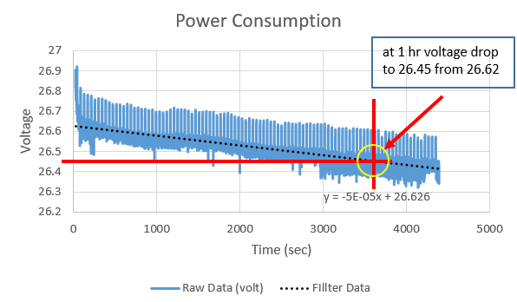

Picture 7 voltage remain VS Time

From Table 2 and picture 7., it is shown that within one moving loop, the AGV has an average distance of 47.48 meters, using 164.54 seconds per round and power consuming 0.00875 volts (approximately 15 Ah) with an average speed of 0.289 m/s, which is less than the worker's speed (approximately 0.5-1 m/s). For continuous operation with one battery change, the total distance the AGV can cover is about 4,134.30 meters or about 4 hours. Additionally, for continuous operation over one day (8 hours), the AGV can move a distance of about 8268.6 meters and requires two battery changes per day (150 minutes total changing time).

From table 2, data recorded and added into database.

1. **Problem**

While testing we found problem for difference map below:

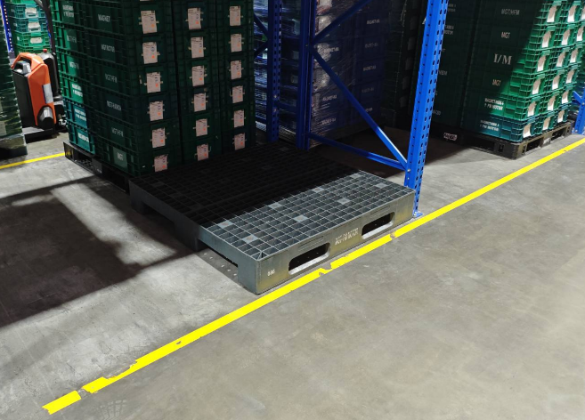 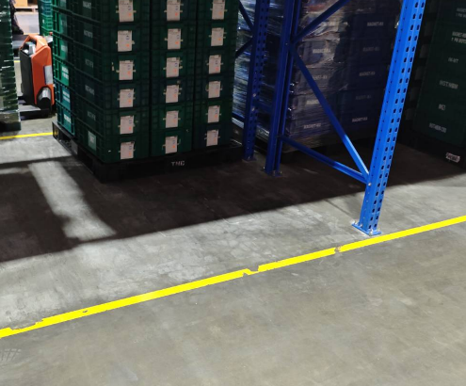

Picture 10 rack at area 5L

As picture 1 (B) and (C), the rack 5L was removed from that area, testing result shown that 2/5 (40%) times. AGV will move to point A1 instead of A (Picture 11) because the reference area on the left is missing causing the Lidar to malfunction that mistake and make AGV collision with obstacles.



**A1**

Picture 11 mistake Area

1. **Conclusion**

The AGV MICKY50 demonstrated reliable performance under controlled conditions using the created map from the morning of 08-07-2024. It successfully navigated between predefined points (Home, A, B, C, D, E) using a web application interface integrated with ROSLIB for communication with ROS. The tests confirmed:

Mapping and Navigation: The AGV effectively utilized the morning map of 08-07-2024 to navigate through the warehouse, demonstrating flexibility in adapting to different layouts.

Obstacle Avoidance: It demonstrated effective obstacle avoidance when encountering stationary and moving persons, maintaining a safe distance of 10-30 cm, which is suitable for operational safety.

Data Collection and Analysis: Recorded data on movement points, duration, and distance for both testing days were logged into the database, providing valuable insights into operational metrics.

Within one moving loop, the AGV has an average distance of 47.48 meters, using 164.54 seconds per round and consuming 0.00475 volts (approximately 15 Ah) with an average speed of 0.289 m/s, which is less than the worker's speed (approximately 0.5-1 m/s). For continuous operation with one battery change, the total distance the AGV can cover is about 4,134.30 meters or about 4 hours. Additionally, for continuous operation over one day (8 hours), the AGV can move a distance of about 8268.6 meters and requires two battery changes per day (150 minutes total changing time)

The primary challenge observed was the sensitivity of AGV navigation to changes in the environment, specifically when racks were moved (as observed with Rack 5L). This led to navigation errors due to outdated map references, resulting in potential collisions or navigation to incorrect points