CS: Tactics Game Development Document

Alpha 0.1.0

Alex Allen

08/19/2025

Table of Contents

High-Level Overview 3

Game Summary 3

Genre & Core Mechanics 4

Target Platforms 4

Audience 4

Gameplay Mechanics 5

Core Gameplay Mechanics 5

Turn Structure In-Depth 6

Controls 7

Winning/Losing Conditions 7

Key Gameplay Features 8

Economy 9

Operators 10

Progression and Ranking System 10

User interface / User Experience 12

# High-Level Overview

## Game Summary

CS: Tactics is a turn-based top-down strategy game using maps inspired by popular game series Counter Strike. It is a competitive multiplayer game in a 1v1 chess style matchup. This game will allow each player to control 5 operatives on the board. In each game, the players will alternate playing each side. One side the “Terrorists” will have the mission objective to plant the bomb or kill all enemy operatives. The “Counter Terrorists” have the mission objective to defend the bomb site until the end of the round, or to kill all enemy combatants.

This game will have an economy where players will earn money throughout and at the end of the round. This money can be used to buy equipment and weapons that help them achieve victory in the next round. Players will start each round with a countdown. In that countdown they will choose the equipment that each of their operatives will use for that round. If an operative survives the round, they will keep all unused equipment and currently equipped weapons into the next round.

## Genre & Core Mechanics

This is a real time strategy game that is turn-based and round based. Every round there is a certain amount of turns that each team gets. When everyone is out of turns, the round ends. If the bomb was planted and the rounds end, the terrorist win. If all operatives of a team is killed before the turns are out, the round will end prematurely.

The economy of this game is calculated based on round condition for that team (win/lose) and how many kills they got in a round. This will be a best of 16. With the first team reaching 9 rounds, wins.

Players will be rewarded with xp and ELO. There calculated ELO will allow them to match with similar skilled players. There will be a global ranking system with named ranks as milestones for how far up the ELO ladder they have gotten. ELO will reset per season typically lasting 3-4 months each.

## Target Platforms

CS: Tactics will be a web-based game that can be played on all PC platforms.

## Audience

Anyone that enjoys the Counter Strike 2 maps, the strategy that is used in Warhammer, economy-based strategy games, chess, and top-down tactics games.

# Gameplay Mechanics

## Core Gameplay Mechanics

Figure : The Core Loop for matchmaking

Figure : Gameplay loop per round in game

## Turn Structure In-Depth

Each team starts the beginning of every round being able to purchase equipment for their 5 models. Any equipment they had last round and survived, they keep. Each team has a universal fund. Using this universal fund the player can buy for each individual model a primary weapon, secondary weapon, equipment, kits, and armor. This part of the round is 30 seconds in length. After this 30 seconds has ended, the player can no longer purchase equipment for their models. This initiates the start of that round. For every round, the counter terrorists get the first move. They can move each model in this turn their total or less their total move distance. Ending their turn allows the terrorists to initiate their first move of the round. They can also move the total or less their distance per model. There is only a limited number of turns in a round. If the terrorists fail to plant the bomb in the boundary of this turn cap, they forfeit the round and income for that round.

Once a terrorist is in the designated spot they would like to plant the bomb, they can spend one of their action points to plant the bomb. During the bomb planting phase, the terrorists have to successfully defend the bomb planter for one full round. If the bomb planter is killed during this period, the bomb is not planted. If the bomb is planted, the turn cap for that round is adjusted to allow counter terrorists time to retake the bomb site and defuse the bomb. The bomb location is unknown to the counter terrorists until one of their models are within a certain radius of the bomb. If the counter terrorists fail to defuse the bomb, they forfeit the round and receive a reduced income.

Any models within a certain radius of the bomb are killed due to the explosion.

Once a counter terrorist have locate the bomb, they can spend an action point for that turn to initiate the bomb defusal process. If the model defusing the bomb has a defuse kit it will take one turn to defuse the bomb. If the model using the defuse action does not possess a defuse kit, it will take a total of two turns to defuse the bomb.

If a model is planting or defusing, they are unable to shoot, use utility, or move for the duration of the bomb plant and defuse process.

* Each Round has a total of 15 turns
* If the bomb is planted, the turn cap is now 7 turns to defuse the bomb.
* Terrorists that are alive at the end of the round when the bomb was not planted, they will receive money only for insurgents lost in that round

## Controls

**Buy Phase**

* Left click a model and a buy menu will appear.
* Left clicking a category or item in that buy menu will either purchase that equipment or inform the player they don’t have enough money
* Right clicking their equipment in the toolbar of the selected operator will sell that equipment (unless it is carried over from the round before)

**Attack Phase**

* Left click the operator and double left click the location on the map that you would like them to move to.
* Left click and hold an operator and drag in the direction for angle of attack
* Left click to select an operator and press shift to pull up utility radial. Left click the utility you would like to use. An area of effect will show up. Point and click where you would like to throw the utility using the area of effect.
* In the utility radial, you can switch weapons by selecting its corresponding radial location on the utility radial

## Winning/Losing Conditions

**Counter Terrorists**

* Lose Conditions
  + All Friendly Operators have been killed
  + Terrorists have successfully detonated the bomb
* Win Conditions
  + All Enemy Operators have been killed
  + There is no more remaining turns in the round
  + The bomb has been defused

**Terrorists**

* Lose Conditions
  + All Friendly Operators have been killed
  + There is no more remaining turns in the round
  + The bomb has been defused
* Win Conditions
  + All Enemy Operators have been killed
  + The Bomb has been detonated

## Key Gameplay Features

**Utility**

* **Flashbangs:** can be thrown 30 units max, stuns those in radius for that turn
* **Smokes:** can be thrown 80 units max, negating field of vision through smoke. Lasts 4 turns
* **Molotov:** can be thrown 10 units max, burns those in Molotov, lasts for 2 turns
* **Defuse Kit:** decreases amount of time it takes to defuse the bomb
* **Armor:** Increases base health

**Weapons**

**Both Teams:**

* **AWP:** $4700, highest accuracy, highest base damage, 1 use per turn
* **Desert Eagle:** $800,low accuracy, high base damage, 3 uses per turn

**Counter Terrorists:**

* **M4A4:** $3000, high accuracy, medium base damage, 3 uses per turn
* **M4a1s:** $3000, high accuracy, medium base damage, does not show operator on map, 2 uses per turn
* **FAMAS:** $2000, medium accuracy, medium-low base damage, 2 uses per turn
* **USP-S:** $300, high accuracy, medium-low base damage, 2 uses per turn
* **MP9:** $1200, high accuracy, low base damage, 3 uses per turn

**Terrorists:**

* **AK-47:** $2700, high accuracy, high base damage, 3 Uses per turn
* **Glock-18:** $300, low accuracy, low base damage, 5 uses per turn
* **ASVAL:** $2800, high accuracy, medium-low base damage, does not show operator on map, 2 uses per turn
* **Galil:** $1500, low accuracy, medium crit rate, medium crit damage, medium-low base damage, 4 uses per turn
* **MAC-10:** $1200, low accuracy, low base damage, 4 uses per turn

## Economy

**Loss Bonuses:**

* $7000 after first round lost in a row
* $9500 after 2nd round lost in a row
* $12000 after 3rd round lost in a row
* $14,500 after 4th round lost in a row
* $17,000 after 5th round lost in a row

**Win Streak (if a team wins 2 rounds in a row):**

* $7500 after losing
* $10000 after losing
* $12500 after losing
* $15,000 after losing

**Kill and Objective Bonuses:**

* $300 per weapon kill
* $600 for bomb plant
* $600 for bomb defusal
* -$1500 for every terrorist still alive after round end

## Operators

* 100 Health
* 5 per team
* Carry one rifle and one pistol
* Start with the corresponding team pistol
* Can carry up to 4 utility

## Progression and Ranking System

**Ranks:**

1. Mercenary I (1,000 - 2,999)
2. Mercenary II (3,000 - 4,999)
3. Mercenary III (5,000 – 6,999)
4. Mercenary IV (7,000 – 8,999)
5. Mercenary Special Forces (9,000 – 10,999)
6. Seasoned Mercenary I (11,000 – 12,999)
7. Seasoned Mercenary II (13,000 – 14,999)
8. Contractor I (15,000 – 16,999)
9. Contractor II (17,000 – 18,999)
10. Career Killer (19,000 – 20,999)
11. Delta I (21,000 – 22,999)
12. Delta II (23,000 – 24,999)
13. Delta Elite (25,000 – 26,999)
14. Special Operations Master (27,000 – 28,999)
15. Death Squad (29,000 – 30,999)
16. Legend (31,000 – 32,999)
17. Lethal (33,000 – 34,999)
18. The Global Threat (35,000 – $∞$)

**Profile Level:**

* Levels 1-50
* Prestiges:
  + Call to Arms 1
  + Call to Arms 2
  + Call to Arms 3
  + Call to Arms 4
  + Eagle 1
  + Eagle 2
  + Eagle 3
  + Eagle 4
  + Supremacy
  + Grand Supremacy

# User interface / User Experience

Figure : Homepage of the website/portal

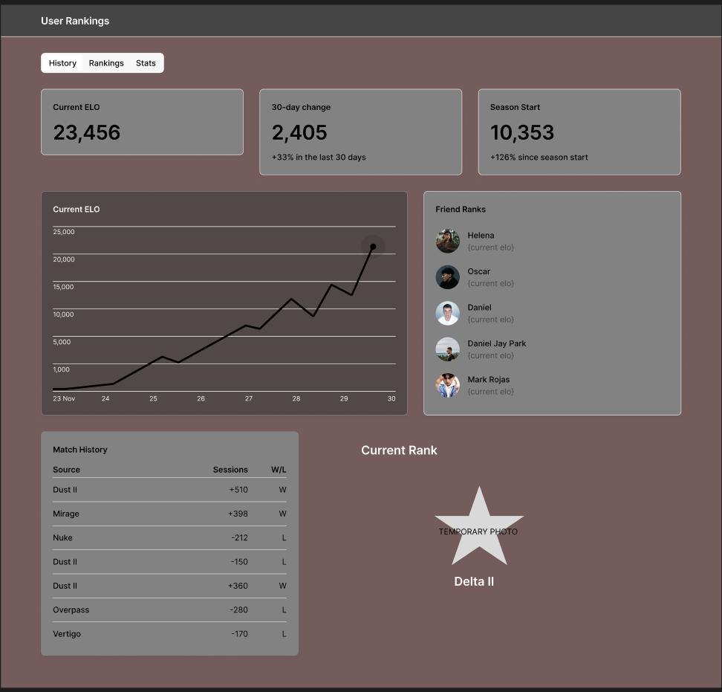

Figure : User rankings page on website/portal

# Technical Requirements

## Platforms:

This game will be a web-based game. Everything you will interact with will be through the website. It is designed for all platforms that support desktop based web formats. (Windows, Linux, MAC)

## Backend Technologies:

**C# for Server Logic:** C# will be the primary language for the server and game logic and update players on the moves being made. This will all be done server sided to help mitigate cheating and update discrepancies.

**ASP.NET CORE IDENTITY:** Used for logging users in and providing secure user profile editing.

**COSMOS DB:** Storing player stats and allowing for a wide range of scalability and accessibility through the azure and .net SDK. Also to be used for persistent storage.

**AZURE BLOB STORAGE:** Easy to use with C#, scalable, and secure.

**ASP.NET WEB API:** Used for general networking and connectivity. To communicate game update and player data throughout live matches and when a player wants to check their stats.

# Art Style and References

This project will take heavy inspiration from Counter Strike 2. Using the same map layouts but with a lower resolution for a lightweight web-based application.

# Audio

This project will use audio samples from counter strike 2. To make the game feel as close to the real game as possible except in a top-down mode.

# Monetization

This project is declared as an educational endeavor and should not be modified under any circumstances while using counter strike 2 intellectual property. This is simply a resume filler project.

# Development Cycle

## Roadmap / Lifecycle:

|  |  |  |
| --- | --- | --- |
| Step | Estimated Duration | Milestone/Goal |
| 1. Define Game Design & Requirements | 3-5 days | Complete design doc and MVP feature list |
| 2. Setup Development Environment | 2-3 days | Tools installed, repo/solution created |
| 3. Bootstrap Backend Solution | 1 week | ASP.NET API scaffold, models in place, DB setup |
| 4. Prototype Real-Time Communication | 1 week | SignalR hub up, basic real-time tests working |
| 5. Design Database Schema | 3-4 days | Schema drawn, migrations tested |
| 6. Develop Core APIs | 2 weeks | Auth, game creation, moves, stats endpoints live |
| 7. Build Frontend Starter | 1 week | Basic UI: login, lobby, game board wired up |
| 8. Establish Testing Pipeline | 3-5 days | Unit/integration test suite for backend |
| 9. Plan Deployment & DevOps | 1 week | Docker, CI/CD pipeline, test cloud deployment |
| 10. Iterate & Expand Features | 3+ weeks (ongoing) | Additional features, polish, optimization |

## Stretch Features:

* Adding ability to play bots
* Soundtrack
* Customization Features
* Localization