**CP1406 - Assignment 1 - Project Plan**

**Name:** Oliver Atkinson

**Goals**

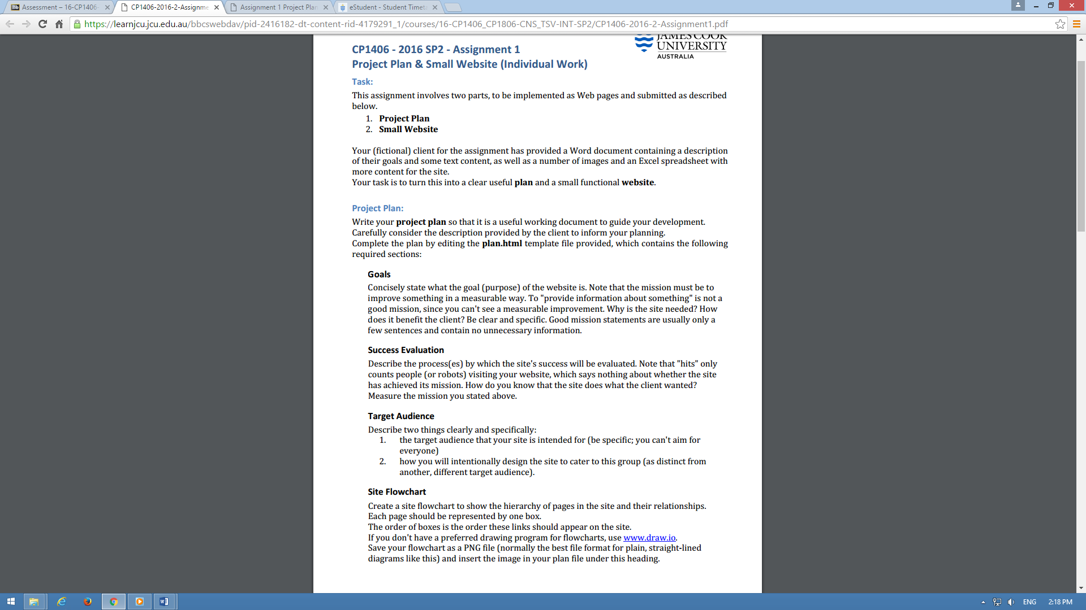The goal of the website’s introduction is to improve the business of Slammer’s Beach Volleyball. This is hoped to be achieved by increasing the number of customers by at least 50% through promotion of a variety of services and enabling those interested to sign up to events online. The website is designed to be targeted to the 15-30 year old age demographic.

**Success Evaluation**

The website is required to increase the number of customers by at least 50% to have had the intended effect. The number of customers should be monitored weekly to monitor the success of the website. Secondarily, the age demographic of the new customers will give indication whether the target audience is being reached by the site.

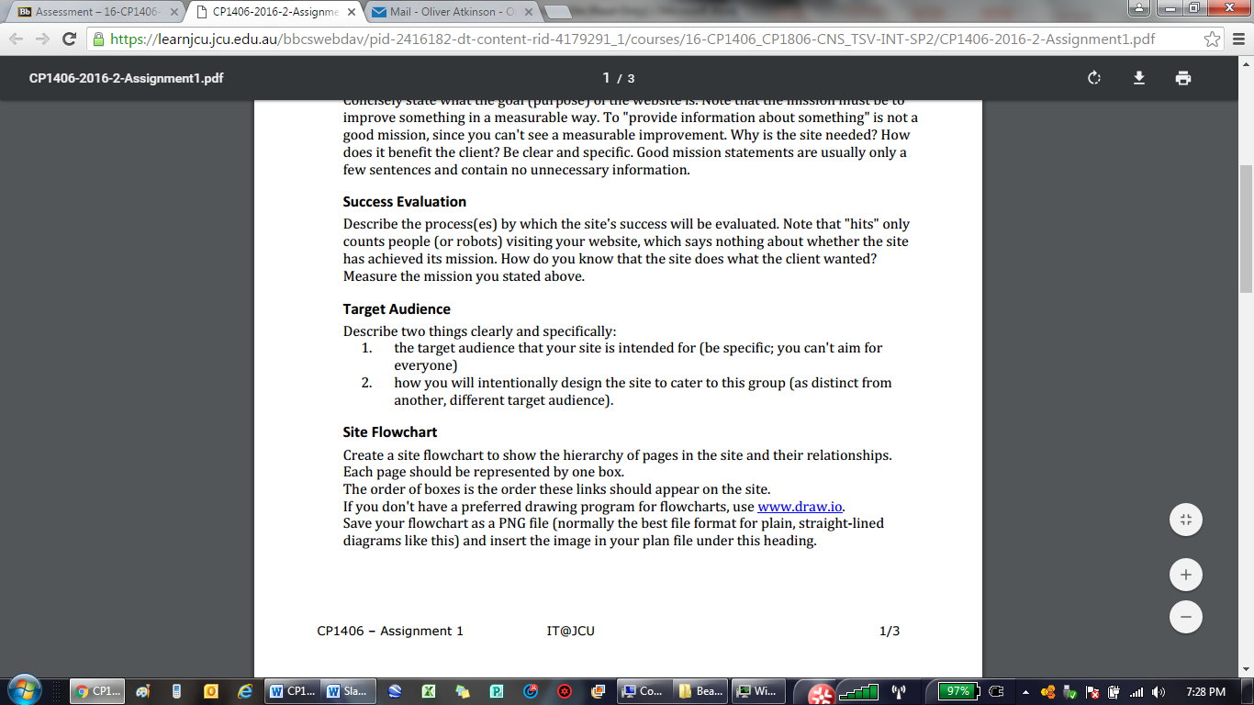**Target Audience**

The website’s designed to encourage 15-30 year olds to sign up and partake in the events the club provides. The site will cater to the demographic through a variety of design choices. Younger people tend to have a shorter attention span and skim read majority of paragraphs set in front of them. Multiple highlighted prompts to sign up will help teens get straight to the point and engage with the club rather than having to navigate through multiple pages to find the sign up page. The immediate call to action doesn’t let the young demographic lose interest before they can invest in the site. The colour scheme would be another factor to attract teens-young adults alike. Some vibrant colours would give the younger audience a younger, energised vibe from the club as opposed to some dull colour pallet which could be extracted from a birth certificate. Pages which are more based on displaying information such as history of the club/sport will not be the main focus in the navigation. The order/positioning of the navigation will prioritise (appear first from left to right) what the younger audience would be more interested in. This means pages which the older customers are more inclined to click on will only be slightly inconvenienced as the accessibility of the pages won’t be affected, but will require an extra second of scanning to find. This is how the demographic can be catered to without having to edit the content itself.

**Site Flowchart**

Home, Who can Play, About Volleyball, Contact, Links, Announcements, Sign-up, Playing Guidelines,

**GitHub Repository**

[Enter your repo name and edit the URL here. Make sure your GitHub repo is public.](http://github.com/...)