Kopplung S7 <-> EasyControl 4.0 SmaDoTec GmbH

1. Only global DBs can be accessed.
2. The optimized block access must be turned off.
3. The access level must be “full” and the “connection mechanism” must allow GET/PUT.
4. Allow full access

TIA-Portal
Projekansicht öffnen
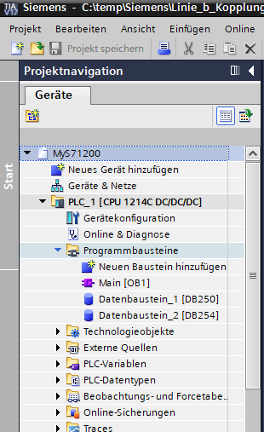

- Only global DBs can be accessed.

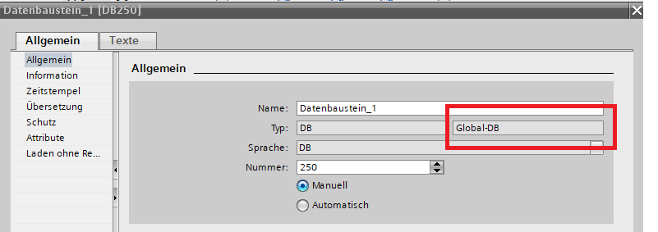

2. The optimized block access must be turned off.
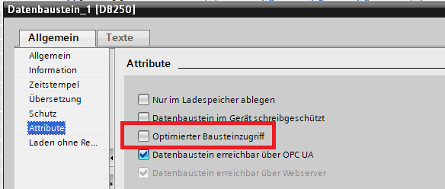

3. The access level must be “full” and the “connection mechanism” must allow GET/PUT.

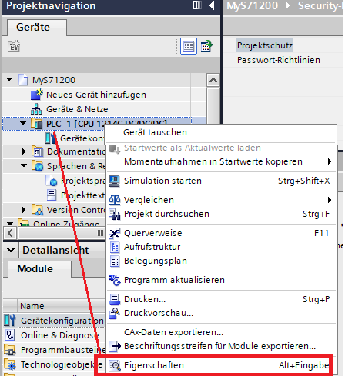

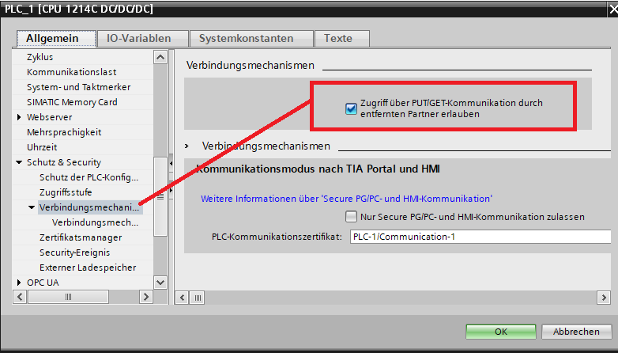
4. Allow full access

