Soft(ware)Ball
Players and Teams
Soft(ware)Ball is played with a team of, at least, 6 players + 1 referee.
When number of players is 12 or more + 1 referee, it is better to have 2 teams.
When number of players is 21 or more + 1 referee, it is better to have 3 teams.

Game parts
Each team needs the following items:
- a ball !
- A set of 7 ground marks
Each of them displays an alphabet character (from 'A' to 'G')
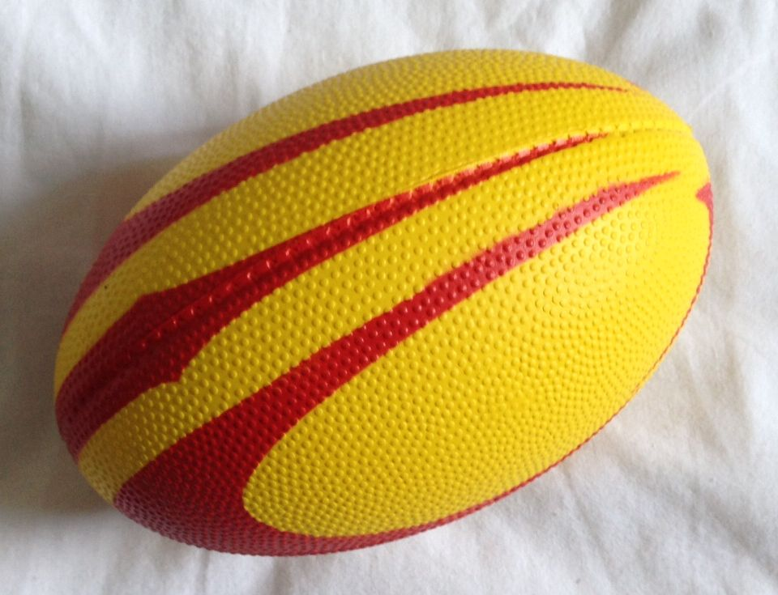
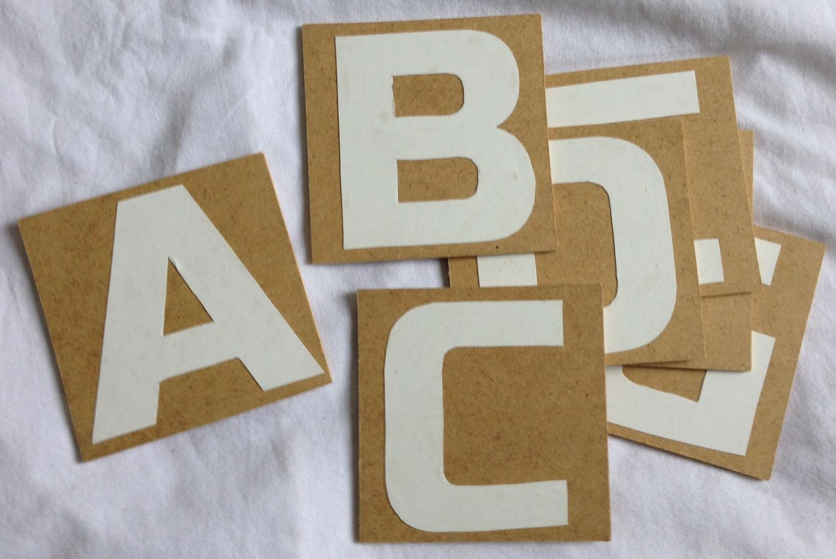
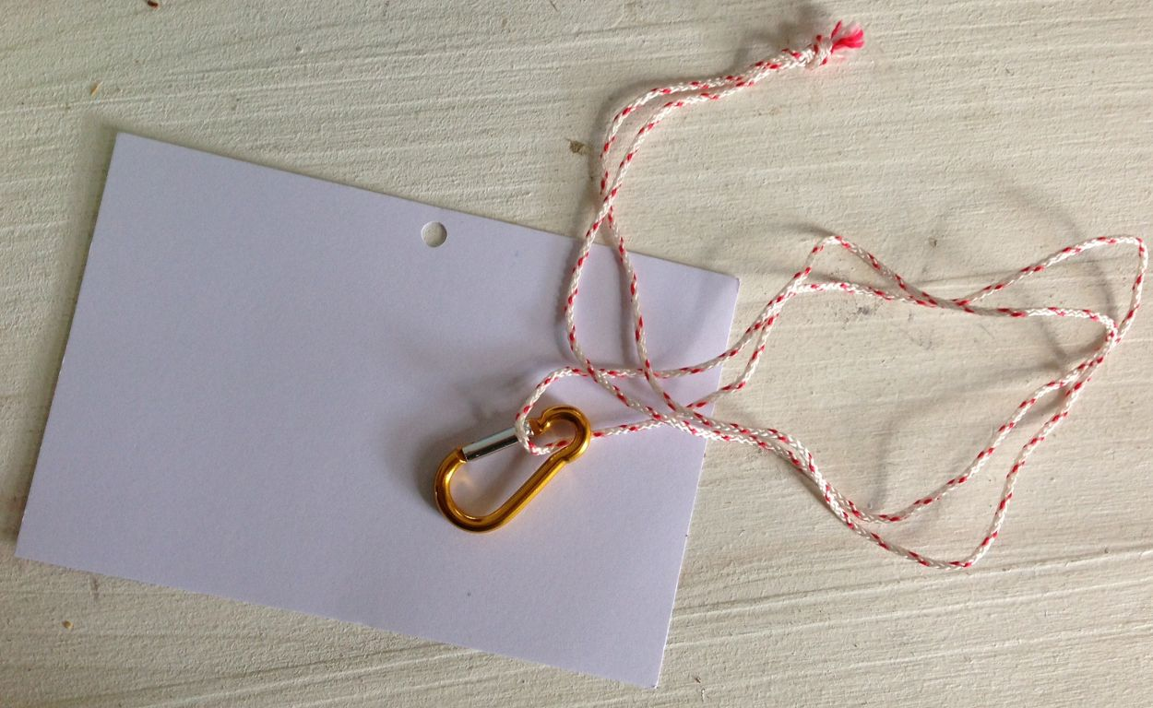
- A set of program cards (white paper A6 format)
- A means of tying/untying a program card to each player (clothespin, carabiner...)
- A means of quickly identifying each player with a name (sticker...)
This is not needed when players know each other very well. However, there should be no ambiguity: all names in a given team shall be different.

For each game in 6 innings, each team also needs:
- A score sheet
- The 6 cards describing each inning for the chosen game

Referee's role

At the beginning of the game, the referee gives the card for inning #1 to each team and starts the clock. There is no official duration for the game. For a beginners team and an easy game sequence, a typical duration would be about 30 minutes.

When a team is ready to propose a solution for the current inning, the solution is shown to the referee who validates it, updates the score sheet and gives the card for the next inning.
When the time is over, the referee declares the game is over.

Upon players request, the referee can allow new program actions and states, while keeping in mind that programmable components cannot read, write, compute or talk.
Examples of new actions and states : raise the arm of <actor>, lower the arm of <actor>, hit the head of <actor>, clap, jump, be face to face with <actor>, be in front of <actor>, be behind <actor>, have arm up, have arm down...

