Open-source CRM solutions for Healthcare

Customer relationship management (CRM) is a technology for managing all your company’s relationships and interactions with customers and potential customers. The goal is simple: Improve business relationships to grow your business. A CRM system helps companies stay connected to customers, streamline processes, and improve profitability.

* **Health-Care-System :**

Health-care-system is an open source CRM project that manages relation between the patient and hospital, the project build on Spring Microservice platform.

The project is built for large hospitals to manage a numerous patient's database.

It uses Oracle SQL and Java.

GitHub Link :

https://github.com/iankurgarg/Healthcare-Management-System.

* **Bitrix24 :**

Bitrix24 is probably the most popular free CRM available in the market today. This platform allows you to organize and track interaction with potential or existing clients, partners, agents and other contacts. It is fully customizable self-hosted editions of Bitrix24 with source code.

**Features :**

* **It has reports and sales funnels.**
* **CRM dashboards.**
* **Invoices and bills management.**
* **Sales targets and quotas.**
* **Mobile CRM.**
* **Emails to clients.**
* **Calls to clients.**
* **Access Rights and Roles in CRM.**
* **Works easily on both Android and iOS.**
* **Allows you to collaborate better with your colleagues.**

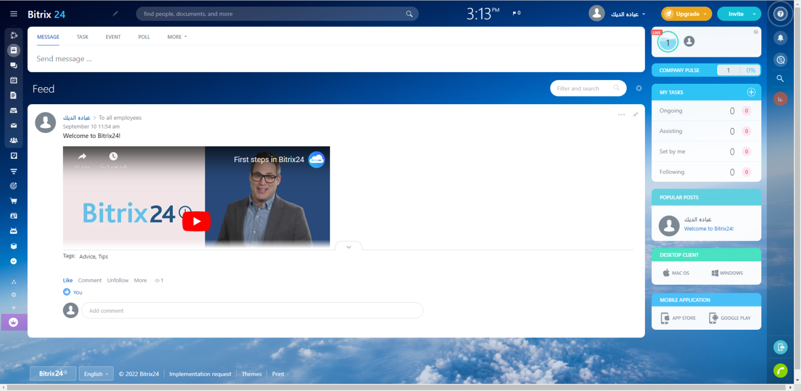

**GitHub Link :**

**https://github.com/topics/bitrix24**

* **Mend :**

**Mend is a lightweight Healthcare CRM, Mend is an efficient software that can be a fully integrated telehealth and patient engagement platform that allows patients and providers to connect through tablets, computers, and smartphones.**

**Mend allows users to increase patient volume and automate their workflow while increasing revenue and saving time.**

**Features:**

* **Support audio/video and messaging.**
* **Has screen sharing and canvas, mobile capability.**
* **Support multilingual patient education.**
* **It is come to improve its marketing and slash transaction costs.**

**In 2014, Mend started its mission to expand access to healthcare by using digital tools to connect patients with a team of healthcare providers.**

**But the demand for efficiency and connectivity in healthcare is constantly growing. Rising costs of care and inefficiencies threaten patient outcomes and the stability of healthcare organizations all over the United States. We have responded to this need by taking Mend tools and services nationwide.**

**Today, thousands of providers, practices, and institutions across more than 89 specialties use Mend to see more patients, speed up the time to visit, and increase practice revenue.**

**GitHub Link :**

**https://github.com/ecom-research/CRM-LTR**

* **Moss : (Mozilla Open Source Support)**

**Another open-source that is suitable for eCommerce, CRM, Healthcare industry. The best thing about Moss is that it is an easy and flexible CRM for Healthcare and more.**

**Moss is written in HTML, JavaScript, and SCSS.**

**Features:**

* **MOSS provides many Enterprises-ready features.**
* **MOSS is definitely powerful, but much harder to scope.**
* **you can use it for building an enterprise resource planning (ERP) system to enhance customer service.**
* **It is come to improve its marketing and slash transaction costs.**

**GitHub Link :**

**https://github.com/djdivesh007/moss-multipurpose-ecommerce-admin-template**