[Trust name]
Business case: robot-assisted surgery programme
1 robot, Platform D: single-port (purchase), exploratory
Prepared by | [Name, role]
Senior responsible owner | [Name, role]
Clinical lead | [Name, role]
Finance lead | [Name, role]
Date | 28 October 2026
Version | Draft 0.1
Status | Draft: assumptions awaiting specialty review
DRAFT. Generated by the Robotic Programme Decision Tool, engine version 0.6.1. 42 of the 44 assumptions in the register (Appendix D) are placeholders, assumptions or only partly sourced, and none has yet been reviewed by the relevant specialty. The figures must not be used for approval until that review is complete.

Contents

[Right-click and choose Update Field to show the contents.]

1. Executive summary
This business case seeks approval for a robot-assisted surgery programme at [Trust name]: 1 robot (Platform D), operating 12 of 18 available sessions per fortnight across 5 list types on the two-week theatre template.
It is presented as an investment in quality, access and capacity, not as a cost-saving proposal. The case sets out first what the investment buys for patients, then what it costs per outcome, then the extra cost to the trust over five years, and the guardrails that keep spending efficient.
This platform is exploratory. Comparative evidence is limited and mostly from outside the UK, UK use is low, and the price used is illustrative. The figures below are indicative only.

What the programme delivers for patients each year (year 3, steady state)
Patient consequence | Number per year
Robotic operations | 340
Open operations avoided | 63
Bed-days released | 245
Conversions to open surgery avoided | 0.5
Major complications avoided | 2.7
Returns to theatre avoided | 0.4
Readmissions avoided | 0.4
Extra elective operations the released beds could support | 61

Cost per outcome (five years)
Measure | Extra cost to the trust
Per robotic operation | £4,108
Per open operation avoided | £22,170
Per bed-day released | £6,047
Per serious event avoided (complication, return to theatre or readmission) | £429,590

Each ratio divides the whole five-year extra cost by one consequence, so they must not be added. Neither 30-day cost avoided nor tariff income is deducted, so the ratios measure NHS resources used.

Five-year cost to the trust
£ (thousands) | Year 1 | Year 2 | Year 3 | Year 4 | Year 5 | Total
Extra cost to the trust (revenue) | 1,238 | 1,255 | 1,321 | 1,311 | 1,301 | 6,425

Tariff: the income line counts only the difference over what the trust would earn for the same patients without the robot, entered per procedure, and assumes those patients would otherwise be treated at this trust. It appears in the trust's cash case only. It is a transfer within the NHS, so it is excluded from the economic view (net present cost) and from the cost per outcome. No extra tariff income has been entered for this case.
Capital: £2,000,000 in total, of which £2,000,000 is funded by the trust and £0 is assumed from central funds. Revenue cost includes depreciation and public dividend capital on the trust-funded capital, so capital and revenue must not be added.
Over five years the programme would also avoid about £487,872 of 30-day costs, mostly bed-days (1,063). These are not deducted: they release capacity, not cash, unless beds or staff are removed or reused. They are shown in the economic case.
Break-even: none. At this case mix each extra case adds more cost than it avoids at 30 days, so higher volume lowers the cost per case but never reaches break-even.

Spending guardrails
Check | Result | Status
Robotic cases per robot per year | 340 | Green
Robot utilisation (booked sessions) | 67% | Red
Share of robotic cases displacing open surgery (advisory) | 19% | Amber
Lists less than 75% full | 1 | Amber
Instrument price basis | Standard discount, 15% off list | Amber
Platform price | Illustrative | Red
Platform evidence base | Exploratory | Amber
Benefit assumptions changed from defaults | 0 | Green

Recommendation
[Board recommendation to be completed by the senior responsible owner.] The board is asked to approve the preferred option subject to completion of the specialty review of assumptions, a formal price quote, an instrument price no higher than £2,125 per case, and a benefits realisation review at 12 months.

2. Strategic case

2.1 Case for change
[Describe [Trust name]'s current position: surgical waiting lists, current minimal access rates by specialty, workforce and training needs, and any existing robotic provision.]
Robot-assisted surgery is expanding across the NHS. NICE's early value assessment of robot-assisted surgery for soft tissue procedures (HTE21, April 2025) allows these systems to be used while further evidence is generated, and asks centres to collect data on costs, activity, conversion to open surgery, rates of minimal access surgery and outcomes. Robotic prostatectomy was outside its scope because it is established NHS practice. This programme commits to that data collection through its 12-month review.
National implementation guidance from NHS England and GIRFT (July 2025) asks that robotic programmes be high volume and fully used on all working days, approved through a full business case with regional stakeholders, overseen by a steering committee, and planned with capital replacement in mind. It also says that provision for recruiting and training surgical first assistants or surgical care practitioners should be built into the business case. This case is structured to follow that guidance.

2.2 Specialties and priorities
The programme includes specialties that NHS England has signalled as priorities for robotic access: none scheduled in this configuration. Other procedures scheduled are Single-port radical prostatectomy, Single-port kidney surgery (partial nephrectomy, pyeloplasty), Single-port transoral surgery (head and neck), Single-port transanal surgery (local excision of rectal lesions), Single-port thoracic surgery (lung and mediastinal resection).

2.3 Objectives
- Deliver about 340 robotic operations a year by year 3.
- Avoid about 63 open operations a year in patients who would otherwise have had open surgery.
- Release about 245 bed-days a year.
- Keep booked robot utilisation at or above 85% (currently planned at 67%).
- Report outcomes at 12 months against this case and to the NICE evidence generation plan.

3. Economic case

3.1 Method
The appraisal is a 30-day cost-consequence analysis. Costs are set alongside patient consequences (open operations avoided, bed-days, conversions, complications, returns to theatre and readmissions) without combining them into quality-adjusted life-years. Robust one-year quality-of-life data comparing robotic, laparoscopic and open surgery are not available for most procedures, so quality-adjusted life-years would have to be assumed rather than measured. Longer-term functional, oncological and hernia outcomes are not modelled.
For each specialty, the analysis asks what would have happened to the same patients without a robot (open or laparoscopic surgery, or robotic surgery at another centre in one sensitivity scenario) and applies the 30-day differences to that mix. The headline is the extra cost to the trust with no deduction for 30-day cost avoided. The economic view (section 3.7) deducts cost avoided and uses discounted cash at the HM Treasury Green Book rate of 3.5%, with capital in year 0 and residual value credited at year 5. Activity above 700 robotic cases per robot per year is flagged as an advisory guardrail; it is not cut.
Activity comes from a two-week theatre template: each session's list type and its major, medium and minor cases are mapped to procedures (Appendix A), counted over the fortnight and extrapolated to a year. Where annual demand is entered, delivered cases are limited to demand and any shortfall is reported.

3.2 Options appraised
Option | Utilisation | Cases (yr 3) | Bed-days (yr 3) | 5-year extra cost | Per bed-day released | Net present cost
Option 0: no robot | n/a | 0 | 0 | £0 | n/a | £0
Option 1: 1 robot | 67% | 340 | 245 | £6.42M | £6,047 | £5.38M
Option 2: 2 robots | 33% | 340 | 245 | £9.35M | £8,803 | £8.06M

Preferred option: 1 robot. Option 0 avoids all programme costs but delivers none of the patient consequences above.

3.3 Platform comparison
A single-port platform is appraised on its own eligible case mix (transoral, transanal, urological and thoracic procedures), with its own counterfactuals that include multi-port robotic surgery. It is therefore not compared line by line with multi-port platforms.

3.4 Comparison with a benchmark programme
The benchmark describes a multi-port programme and is not shown for a single-port platform.

3.5 Sensitivity analysis
Each assumption is moved on its own to a low and a high value while everything else, including the list plan, stays at the base case. Bars are ordered by how much they move the result. Ranges are placeholders for expert review. The first chart shows the five-year extra cost, which clinical assumptions barely affect; the second shows the extra cost per bed-day released, which they drive.
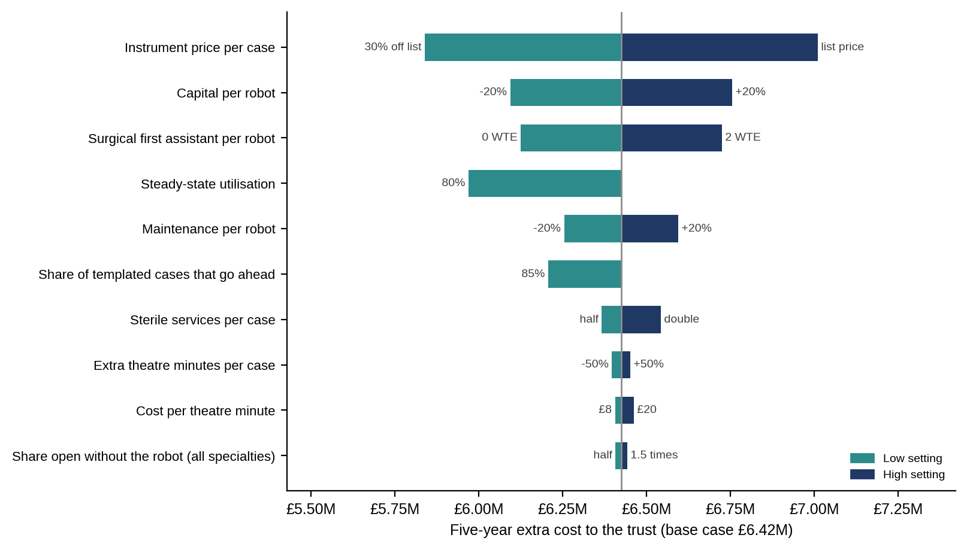
Figure 1. One-way sensitivity: five-year extra cost to the trust.
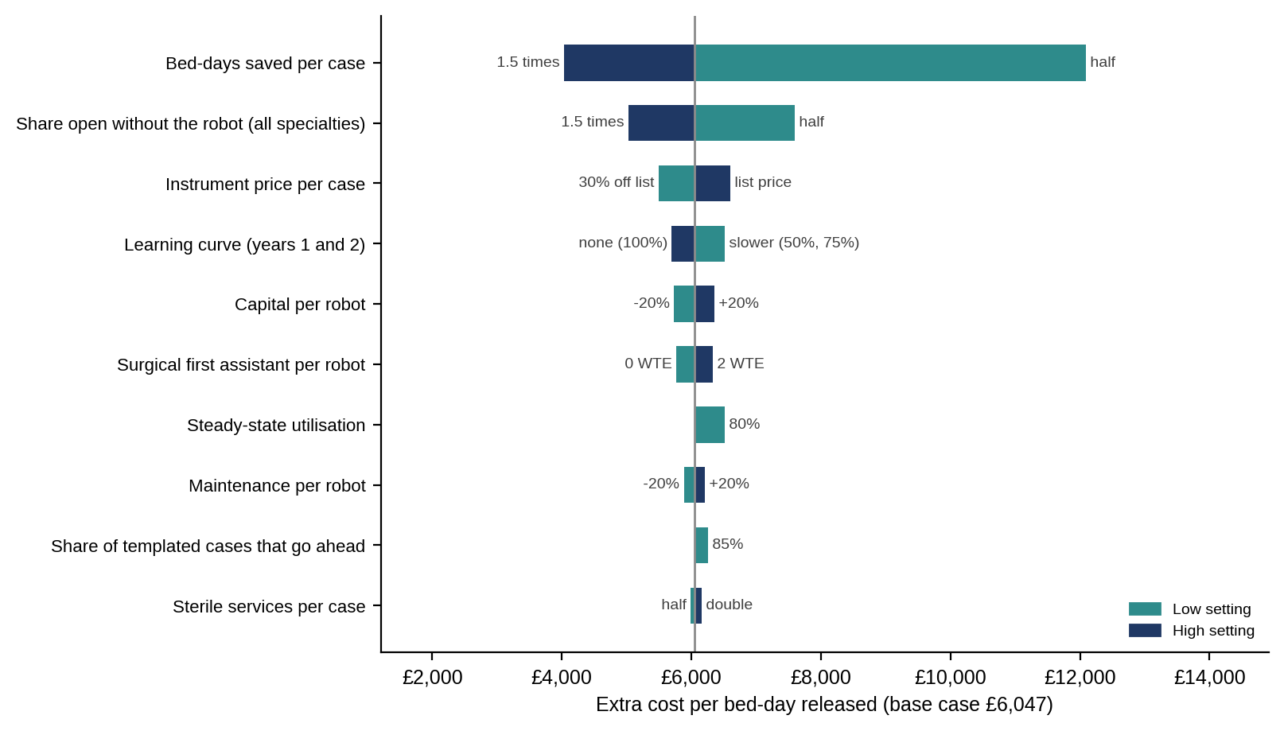
Figure 2. One-way sensitivity: extra cost per bed-day released.
Assumption | Low | High | Extra cost at low | Extra cost at high
Instrument price per case | 30% off list | list price | £5,838,347 | £7,011,347
Capital per robot | -20% | +20% | £6,094,133 | £6,755,562
Surgical first assistant per robot | 0 WTE | 2 WTE | £6,124,847 | £6,724,847
Steady-state utilisation | 80% | 100% | £5,968,811 | £6,424,847
Maintenance per robot | -20% | +20% | £6,254,847 | £6,594,847
Share of templated cases that go ahead | 85% | 100% | £6,207,033 | £6,424,847
Sterile services per case | half | double | £6,366,197 | £6,542,147
Extra theatre minutes per case | -50% | +50% | £6,397,109 | £6,452,585
Cost per theatre minute | £8 | £20 | £6,406,355 | £6,461,831
Share open without the robot (all specialties) | half | 1.5 times | £6,407,164 | £6,442,531

Assumption | Low | High | Per bed-day at low | Per bed-day at high
Bed-days saved per case | half | 1.5 times | £12,094 | £4,031
Share open without the robot (all specialties) | half | 1.5 times | £7,594 | £5,028
Instrument price per case | 30% off list | list price | £5,495 | £6,599
Learning curve (years 1 and 2) | slower (50%, 75%) | none (100%) | £6,513 | £5,699
Capital per robot | -20% | +20% | £5,736 | £6,358
Surgical first assistant per robot | 0 WTE | 2 WTE | £5,765 | £6,329
Steady-state utilisation | 80% | 100% | £6,520 | £6,047
Maintenance per robot | -20% | +20% | £5,887 | £6,207
Share of templated cases that go ahead | 85% | 100% | £6,260 | £6,047
Sterile services per case | half | double | £5,992 | £6,157
Extra theatre minutes per case | -50% | +50% | £6,021 | £6,073
Cost per theatre minute | £8 | £20 | £6,029 | £6,082

Scenarios
Scenario | 5-year extra cost | Per bed-day released | Per open operation avoided | Net present cost
Base case (as configured) | £6.42M | £6,047 | £22,170 | £5.38M
No 30-day benefit | £6.42M | n/a | £22,170 | £5.82M
All benefits halved | £6.42M | £12,094 | £22,170 | £5.60M
All benefits 1.5 times | £6.42M | £4,031 | £22,170 | £5.16M
Instruments: supplier list price | £7.01M | £6,599 | £24,194 | £5.91M
Instruments: volume discount, 30% off list | £5.84M | £5,495 | £20,146 | £4.86M
Central capital £1,000,000 per robot | £5.60M | £5,269 | £19,317 | £5.38M
Central capital £2,000,000 per robot | £4.77M | £4,491 | £16,464 | £5.38M

3.6 Break-even
Break-even: none. At this case mix each extra case adds more cost than it avoids at 30 days, so higher volume lowers the cost per case but never reaches break-even. The search is limited to the volume the programme could actually deliver: every available session filled at the planned cases per session.
Measure (steady state, per year) | Value
Planned robotic cases | 340
Maximum deliverable cases | 510
Extra cost less 30-day cost avoided at the planned volume | £1,208,232
Extra cost less 30-day cost avoided at the maximum volume | £1,531,991
Break-even volume | not reached

3.7 Economic view (net of 30-day cost avoided)
Measure | Value
Net present cost to the NHS (5 years, 3.5%) | £5.38M
30-day cost avoided over five years | £487,872
Net cost per robotic operation | £3,796
Net cost per open operation avoided | £20,486
Net cost per bed-day released | £5,588

The net present cost counts capital in full in year 0 whoever pays it, so it does not change with central capital. 30-day cost avoided is an economic value: it becomes cash only if beds or staff are removed or the released capacity is used for income-earning activity.

3.8 Benefits not valued in cash
- Wider access to minimal access surgery for patients who would otherwise have open surgery.
- Surgical training and recruitment and retention of surgeons and theatre teams.
- Ergonomic benefit to surgeons.
- Capacity released by shorter stays, available for further elective activity.

4. Commercial case

4.1 Procurement route
[State the procurement route, for example the national framework for robotic medical equipment managed by NHS Supply Chain, or a competitive tender, and the evaluation criteria.] Four payment models have been compared on identical terms: outright purchase, lease, managed service and per-procedure fee.

4.2 Price inputs used
Item | Value
Platform | Platform D: single-port (purchase), exploratory
Procurement model | Purchase
Capital per robot | £2,000,000
Trade-in credit | £0
Central capital per robot | £0
Asset life | 7 years
Maintenance per robot per year | £170,000
Instrument price per case | £2,125 (standard discount, 15% off list)
Price basis | Illustrative only. Instruments set about £1,000 per case above multi-port, reflecting reported extra instrument and drape costs of $1,170 to $1,820 per case (AUA 2022); capital not published

4.3 Negotiating targets
Target (net of 30-day cost avoided) | Instrument price per case needed
Current assumption | £2,125
Supplier list price | £2,500
Net cost of £1,500 per bed-day released | not achievable
Budget neutral at 30 days | not achievable

Prices are calculated at the planned steady-state volume and count 30-day cost avoided. 'Not achievable' means the target cannot be met even at zero instrument cost.

4.4 Contract protections sought
- Instrument price fixed or capped for the contract term.
- Uptime guarantee with service credits.
- Training and proctoring included for an agreed number of surgeons and theatre staff.
- Upgrade, replacement and trade-in terms defined in advance.
- Contract volumes stated clearly as per robot or per contract.
- Data access for the 12-month review and NICE evidence generation.

5. Financial case
The table shows the extra income and expenditure cost to [Trust name] by year. Depreciation and public dividend capital apply to trust-funded capital only. Nothing is deducted for 30-day cost avoided, which is shown below the table for information.
£ (thousands) | Year 1 | Year 2 | Year 3 | Year 4 | Year 5 | Total
Platform | 521 | 511 | 501 | 491 | 481 | 2,504
Instruments | 506 | 650 | 722 | 722 | 722 | 3,324
Sterile services | 18 | 23 | 26 | 26 | 26 | 117
Surgical first assistant | 60 | 60 | 60 | 60 | 60 | 300
Extra theatre time | 8 | 11 | 12 | 12 | 12 | 55
Implementation and training | 75 | 0 | 0 | 0 | 0 | 75
Theatre works | 50 | 0 | 0 | 0 | 0 | 50
Extra cost to the trust | 1,238 | 1,255 | 1,321 | 1,311 | 1,301 | 6,425

Tariff: the income line counts only the difference over what the trust would earn for the same patients without the robot, entered per procedure, and assumes those patients would otherwise be treated at this trust. It appears in the trust's cash case only. It is a transfer within the NHS, so it is excluded from the economic view (net present cost) and from the cost per outcome.
For information (not cash) | Year 1 | Year 2 | Year 3 | Year 4 | Year 5 | Total
30-day cost avoided | 59 | 91 | 113 | 113 | 113 | 488
Extra cost less cost avoided | 1,179 | 1,164 | 1,208 | 1,198 | 1,188 | 5,937

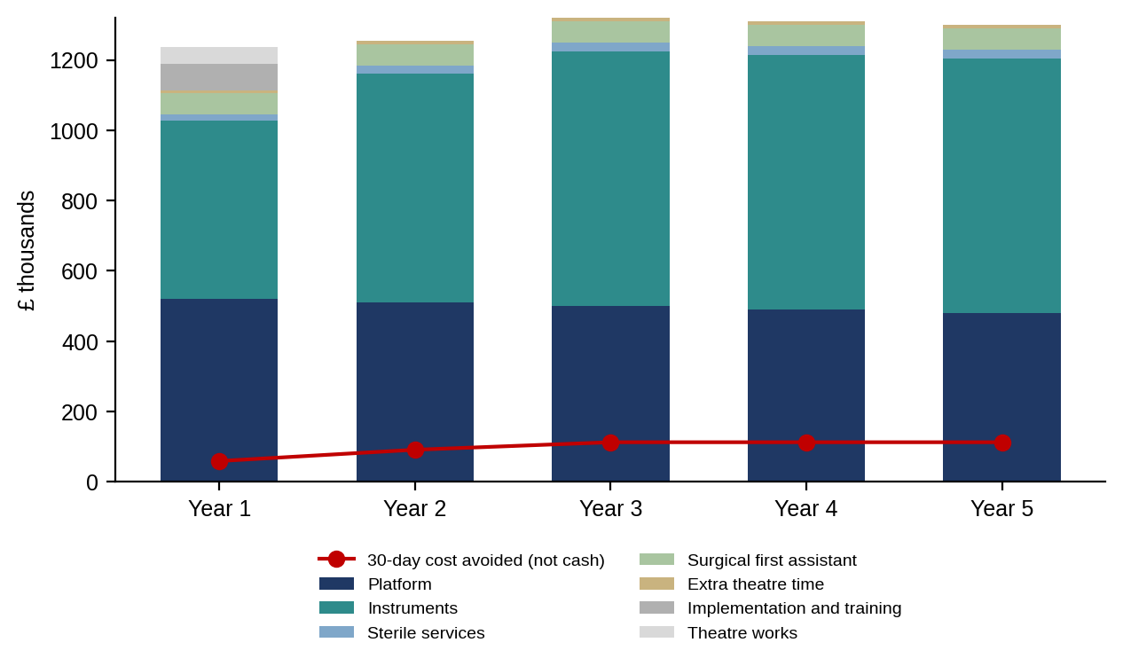
Figure 3. Extra cost to the trust by year, with 30-day cost avoided shown for comparison.
Capital: £2,000,000 in total, of which £0 is assumed from central funds. [Confirm the capital source, the revenue budget holder, VAT treatment and the capital replacement plan.]

6. Management case

6.1 Two-week theatre template
The template (pre-filled from demand, standard day) covers 14 days, Monday to Sunday twice, with AM, PM and evening sessions on each robot. Standard hours are weekday AM and PM, with Friday PM kept for maintenance; evening and weekend sessions count only when used. 12 of 18 available sessions per fortnight are booked (67%). The fortnight is extrapolated to 45 operating weeks a year, and 100% of templated cases are assumed to go ahead.
Procedure | Sessions per fortnight | Cases on template (year) | Demand (year) | Cases delivered | Unmet demand
Single-port radical prostatectomy | 5.0 | 158 | 150 | 150 | 0
Single-port kidney surgery (partial nephrectomy, pyeloplasty) | 2.0 | 68 | 60 | 60 | 0
Single-port transoral surgery (head and neck) | 1.0 | 45 | 40 | 40 | 0
Single-port transanal surgery (local excision of rectal lesions) | 2.0 | 68 | 50 | 50 | 0
Single-port thoracic surgery (lung and mediastinal resection) | 2.0 | 45 | 40 | 40 | 0

All demand entered is scheduled.

Robot 1: two-week template
 | AM | PM | Evening
Week 1 Mon | Colorectal: transanal (single-port): 2 minor | Colorectal: transanal (single-port): 1 minor
Week 1 Tue | Urology: prostate (single-port): 2 medium | Urology: prostate (single-port): 1 medium
Week 1 Wed | Head and neck: transoral (single-port): 2 major | Thoracic (single-port): 1 major
Week 1 Thu | Unbooked | Unbooked
Week 1 Fri | Unbooked | Maintenance
Week 2 Mon | Urology: prostate (single-port): 2 medium | Urology: prostate (single-port): 1 medium
Week 2 Tue | Urology: kidney (single-port): 2 medium | Urology: kidney (single-port): 1 medium
Week 2 Wed | Thoracic (single-port): 1 major | Urology: prostate (single-port): 1 medium
Week 2 Thu | Unbooked | Unbooked
Week 2 Fri | Unbooked | Maintenance

Saturdays and Sundays are shown only where a session is in use.

6.2 Governance, workforce and training
- [Name the robotic steering committee, its executive chair and reporting line.] The committee approves every new indication and owns delivery of this business case (GIRFT 2025).
- Each specialty names a clinical benefit owner and robotic lead, and agrees a credentialing and proctoring pathway.
- A surgical first assistant or surgical care practitioner is funded at 1 whole-time equivalent per robot.
- Learning curve allowed for: benefits are scaled to 75% in year 1 and 90% in year 2.
- Utilisation ramps from 70% in year 1 to 90% in year 2 and 100% from year 3.

6.3 Benefits realisation at 12 months
Measure | Planned (year 1) | Actual | Source
Robotic operations | 238 |  | Theatre system
Utilisation in year 1 | 47% |  | Theatre system
Open operations avoided | 44 |  | Local audit
Bed-days released | 129 |  | Patient administration system
Conversions to open surgery | Track rate |  | Operation notes
Returns to theatre within 30 days | Track rate |  | Local audit
Readmissions within 30 days | Track rate |  | Patient administration system
Extra cost to the trust | £1,237,756 |  | Finance
Instrument cost per case | £2,125 |  | Finance

6.4 Key risks
Risk | Mitigation
Robot under-used | Protected sessions in job plans; shared list for smaller specialties; quarterly utilisation review.
Too few trained surgeons to fill the lists | Training plan by specialty agreed before go-live; proctoring funded.
Instrument prices rise | Price cap in contract; review at renewal.
Benefits smaller than assumed | Sensitivity analysis shown; specialty review of assumptions; 12-month review against plan.
Laparoscopic cases moved to the robot with little benefit | Monitor the share of cases displacing open surgery.
Training delays | Phased start by specialty; proctoring agreed in advance.

Appendix A. Clinical assumptions by specialty
Reductions are robotic versus the comparator, at 30 days, per case. 'Share' is the proportion of these patients who would have had that comparator without the robot. All values are best-available estimates pending specialty review; any changes from the defaults are listed in Appendix C.
Specialty | Without the robot | Share | Bed-days saved | Conversions avoided | Complications avoided | Returns to theatre avoided | Readmissions avoided | Extra minutes
Single-port radical prostatectomy | Multi-port robot | 90% | 0.5 | 0.0% | 0.0% | 0.0% | 0.0% | -15
Single-port radical prostatectomy | Open | 10% | 2 | 0.0% | 2.0% | 0.5% | 0.5% | 0
Single-port kidney surgery (partial nephrectomy, pyeloplasty) | Multi-port robot | 60% | 0.5 | 0.0% | 0.0% | 0.0% | 0.0% | 0
Single-port kidney surgery (partial nephrectomy, pyeloplasty) | Open | 30% | 2 | 0.0% | 3.0% | 0.5% | 0.5% | 20
Single-port kidney surgery (partial nephrectomy, pyeloplasty) | Conventional minimal access | 10% | 0.3 | 3.0% | 0.5% | 0.0% | 0.0% | 15
Single-port transoral surgery (head and neck) | Conventional minimal access | 60% | 0.5 | 0.0% | 1.0% | 0.0% | 0.0% | 20
Single-port transoral surgery (head and neck) | Multi-port robot | 10% | 0.3 | 0.0% | 0.0% | 0.0% | 0.0% | 0
Single-port transoral surgery (head and neck) | Open | 30% | 3 | 0.0% | 5.0% | 1.0% | 1.0% | 30
Single-port transanal surgery (local excision of rectal lesions) | Conventional minimal access | 80% | 0.2 | 0.0% | 1.0% | 0.0% | 0.0% | 20
Single-port transanal surgery (local excision of rectal lesions) | Open | 20% | 0.5 | 0.0% | 2.0% | 0.5% | 0.0% | 30
Single-port thoracic surgery (lung and mediastinal resection) | Conventional minimal access | 80% | 0.3 | 1.0% | 0.0% | 0.0% | 0.0% | 20
Single-port thoracic surgery (lung and mediastinal resection) | Open | 20% | 2.5 | 0.0% | 5.0% | 0.5% | 1.0% | 0

Rationale and sources
Specialty | Counterfactual rationale | Evidence
Single-port radical prostatectomy | Without a single-port robot, most would have multi-port robotic surgery. | Versus multi-port: shorter stay and more same-day discharge, no difference in 30-day complications (umbrella review, J Robot Surg 2026; NSQIP analysis, World J Urol 2026). Theatre time difference is a placeholder.
Single-port kidney surgery (partial nephrectomy, pyeloplasty) | Mixed: multi-port robot where available, otherwise open partial nephrectomy. | Same-day discharge 83% v 17% after partial nephrectomy in one single-surgeon series (Urology 2021); otherwise placeholders.
Single-port transoral surgery (head and neck) | Counterfactual is transoral laser or multi-port TORS, or open access; non-surgical treatment not modelled. | CE marked for transoral surgery January 2024; prospective series of 47 patients with no conversions. Effect sizes are best-available estimates.
Single-port transanal surgery (local excision of rectal lesions) | Without the robot, most would have conventional transanal endoscopic surgery; some open transanal excision. | Feasibility series and preclinical work only; effect sizes are best-available estimates.
Single-port thoracic surgery (lung and mediastinal resection) | Most would have video-assisted thoracoscopic surgery; some open thoracotomy. | Early international series only; effect sizes are best-available estimates.

How the theatre template maps to procedures
Each session on the template has a list type and a number of major, medium and minor cases. The table shows which procedure each tier counts as, and the split where a tier covers several procedures. 'Not modelled' cases are costed but carry no 30-day benefit. Changes from the defaults are listed in Appendix C.
List type | Tier | Counts as
Urology: prostate (single-port) | Medium | Single-port radical prostatectomy 100%
Urology: kidney (single-port) | Medium | Single-port kidney surgery (partial nephrectomy, pyeloplasty) 100%
Head and neck: transoral (single-port) | Major | Single-port transoral surgery (head and neck) 100%
Colorectal: transanal (single-port) | Minor | Single-port transanal surgery (local excision of rectal lesions) 100%
Thoracic (single-port) | Major | Single-port thoracic surgery (lung and mediastinal resection) 100%
Any other list type or tier |  | Not modelled

Tariff: extra income per robotic case (cash case only)
Procedure | Extra income per case | Source
Single-port radical prostatectomy | £0 | No robotic price difference identified: £0.
Single-port kidney surgery (partial nephrectomy, pyeloplasty) | £0 | No robotic price difference identified: £0.
Single-port transoral surgery (head and neck) | £0 | No robotic price difference identified: £0.
Single-port transanal surgery (local excision of rectal lesions) | £0 | No robotic price difference identified: £0.
Single-port thoracic surgery (lung and mediastinal resection) | £0 | No robotic price difference identified: £0.

Appendix B. Unit costs and programme settings
Input | Value | Note
Excess bed-day | £400 | Excess ward bed-day placeholder (single-trust FOI, 2023/24: £379 including ward costs and overheads, rounded up). The national average elective inpatient cost per bed-day was £1,198 in 2024/25, but this includes treatment costs and overstates the value of a day saved at the end of a stay. Bed-days are cost avoided, not cash released, and are not deducted from the extra cost to the trust.
Return to theatre (non-ward) | £6,000 | Best-available estimate pending specialty review (placeholder).
Major complication (non-ward) | £4,000 | Best-available estimate pending specialty review (placeholder).
Readmission (full spell) | £2,500 | Best-available estimate pending specialty review (placeholder).
Conversion to open (non-ward) | £1,000 | Best-available estimate pending specialty review (placeholder).
Extra theatre minute | £12 | Costed by default, which is conservative. Placeholder.
Sterile services per robotic case | £75 | Placeholder; replace with the local sterile services charge.
Surgical first assistant | 1 WTE per robot at £60,000 | National guidance says provision should be built into the business case (GIRFT 2025); cost is a placeholder. Use local pay rates.
Theatre works per robot (one-off) | £50,000 | Placeholder; confirm with estates.
Implementation, training and proctoring per robot | £75,000 | One-off, year 1. Placeholder.
Operating weeks per year | 45
Sessions per robot per week | 9 | One slot kept for maintenance.
Cases per robot per year: advisory level | 700 | Amber guardrail above this level; activity is not cut.
Minimum list fill | 75% | Lists below this fill are flagged.
Maximum cases per session | 3 | Template entries above this are flagged.
Share of templated cases that go ahead | 100% | Allows for cancellations. Placeholder.
Discount rate | 3.5% | HM Treasury Green Book.
Public dividend capital | 3.5% | On average net book value.

Length-of-stay reductions include stay caused by complications, so complication and return-to-theatre costs exclude ward days to avoid double counting.

Appendix C. Model checks
Engine version 0.6.1. The calculation engine is covered by an automated test suite including hand-calculated cases and an independent re-calculation of all cost avoided.
No clinical assumptions or unit costs were changed from the defaults.

Warnings raised by the tool
- Platform D: single-port (purchase), exploratory: the price is illustrative; enter the trust's quote.
- Single-port transanal surgery (local excision of rectal lesions): the template schedules 68 cases a year but demand is 50, so its lists would be only 74% full.
- Booked utilisation 67% is below the 75% threshold: consider fewer robots or more specialties.
- 6 open sessions per fortnight left unbooked on the template.

Appendix D. Assumptions register
Every input the case depends on, with its source, evidence grade, status and the person who must sign it off. 10 assumption; 1 partly sourced; 25 placeholder; 2 sourced; 6 trust input. No entry has yet been reviewed by the relevant specialty.
Assumption | Value | Source | Status | Owner
Single-port radical prostatectomy: annual demand (robotic cases) | 150 | Trust activity data (preset values are placeholders) | Trust input | [Urology clinical benefit owner]
Single-port radical prostatectomy: what patients would have without the robot | multi-port robot 90%, open 10% | Versus multi-port: shorter stay and more same-day discharge, no difference in 30-day complications (umbrella review, J Robot Surg 2026; NSQIP analysis, World J Urol 2026). Theatre time difference is a placeholder. | Placeholder | [Urology clinical benefit owner]
Single-port radical prostatectomy: 30-day differences | See Appendix A | Versus multi-port: shorter stay and more same-day discharge, no difference in 30-day complications (umbrella review, J Robot Surg 2026; NSQIP analysis, World J Urol 2026). Theatre time difference is a placeholder. | Placeholder | [Urology clinical benefit owner]
Single-port kidney surgery (partial nephrectomy, pyeloplasty): annual demand (robotic cases) | 60 | Trust activity data (preset values are placeholders) | Trust input | [Urology clinical benefit owner]
Single-port kidney surgery (partial nephrectomy, pyeloplasty): what patients would have without the robot | multi-port robot 60%, open 30%, conventional minimal access 10% | Same-day discharge 83% v 17% after partial nephrectomy in one single-surgeon series (Urology 2021); otherwise placeholders. | Placeholder | [Urology clinical benefit owner]
Single-port kidney surgery (partial nephrectomy, pyeloplasty): 30-day differences | See Appendix A | Same-day discharge 83% v 17% after partial nephrectomy in one single-surgeon series (Urology 2021); otherwise placeholders. | Placeholder | [Urology clinical benefit owner]
Single-port transoral surgery (head and neck): annual demand (robotic cases) | 40 | Trust activity data (preset values are placeholders) | Trust input | [Head and neck clinical benefit owner]
Single-port transoral surgery (head and neck): what patients would have without the robot | conventional minimal access 60%, multi-port robot 10%, open 30% | CE marked for transoral surgery January 2024; prospective series of 47 patients with no conversions. Effect sizes are best-available estimates. | Placeholder | [Head and neck clinical benefit owner]
Single-port transoral surgery (head and neck): 30-day differences | See Appendix A | CE marked for transoral surgery January 2024; prospective series of 47 patients with no conversions. Effect sizes are best-available estimates. | Placeholder | [Head and neck clinical benefit owner]
Single-port transanal surgery (local excision of rectal lesions): annual demand (robotic cases) | 50 | Trust activity data (preset values are placeholders) | Trust input | [Colorectal clinical benefit owner]
Single-port transanal surgery (local excision of rectal lesions): what patients would have without the robot | conventional minimal access 80%, open 20% | Feasibility series and preclinical work only; effect sizes are best-available estimates. | Placeholder | [Colorectal clinical benefit owner]
Single-port transanal surgery (local excision of rectal lesions): 30-day differences | See Appendix A | Feasibility series and preclinical work only; effect sizes are best-available estimates. | Placeholder | [Colorectal clinical benefit owner]
Single-port thoracic surgery (lung and mediastinal resection): annual demand (robotic cases) | 40 | Trust activity data (preset values are placeholders) | Trust input | [Thoracic clinical benefit owner]
Single-port thoracic surgery (lung and mediastinal resection): what patients would have without the robot | conventional minimal access 80%, open 20% | Early international series only; effect sizes are best-available estimates. | Placeholder | [Thoracic clinical benefit owner]
Single-port thoracic surgery (lung and mediastinal resection): 30-day differences | See Appendix A | Early international series only; effect sizes are best-available estimates. | Placeholder | [Thoracic clinical benefit owner]
Two-week theatre template | Standard day, pre-filled from demand | Trust theatre plan | Trust input | [Theatres lead]
Major, medium and minor tiers: which procedure each counts as | See Appendix A | Clinical lead's mapping (v0.6); medium tier for prostate, kidney and bladder lists | Assumption | [Clinical lead]
Maximum cases per session | 3 | Clinical lead's default; adjustable | Assumption | [Clinical lead]
Share of templated cases that go ahead | 100% | None found (cancellations and under-runs) | Placeholder | [Theatres lead]
Cases that map to no modelled procedure | Costed, no 30-day benefit | Project team decision (conservative) | Assumption | [Project team]
Extra tariff income, all other procedures | £0 | No robotic price difference identified: £0. Not checked per HRG. | Placeholder | [Finance lead]
Tariff: patients would otherwise be treated at this trust | Assumed | If they would otherwise go to another provider, the trust gains the whole tariff and that provider loses it: a transfer, not a gain to the NHS | Assumption | [Finance lead]
Tariff: payment mechanism and market forces factor | Not modelled | Elective income may be paid under aligned payment and incentive (fixed plus variable) rather than full unit prices; the market forces factor is not applied | Placeholder | [Finance lead]
Excess bed-day (cost avoided, not cash) | £400 | Single-trust FOI 2023/24 (£379); national context: UK Parliament written answer UIN 100046, December 2025 (elective bed-day £1,198, 2024/25) | Placeholder | [Finance lead]
Return to theatre (non-ward) | £6,000 | None found | Placeholder | [Finance lead]
Major complication (non-ward) | £4,000 | None found | Placeholder | [Finance lead]
Readmission (full spell) | £2,500 | None found | Placeholder | [Finance lead]
Conversion to open (non-ward) | £1,000 | None found | Placeholder | [Finance lead]
Extra theatre minute | £12 | None found | Placeholder | [Finance lead]
Sterile services per robotic case | £75 | None found; sterilisation requirements are listed for consideration in system choice (GIRFT 2025) | Placeholder | [Finance lead]
Platform price basis | Platform D: single-port (purchase), exploratory | Illustrative only. Instruments set about £1,000 per case above multi-port, reflecting reported extra instrument and drape costs of $1,170 to $1,820 per case (AUA 2022); capital not published | Placeholder | [Procurement lead]
Instrument price per case | £2,125 | US single-centre average about $1,500 per case; single-port extra $1,170 to $1,820 (AUA 2022 abstract MP32-10) | Placeholder | [Procurement lead]
Instrument discounts (15% standard, 30% volume) | 15% and 30% | None found | Placeholder | [Procurement lead]
Sessions per robot per week; operating weeks | 9; 45 | Programmes should be fully used on all working days (GIRFT 2025) | Assumption | [Senior responsible owner]
Utilisation ramp (years 1 to 5) | 70%, 90%, 100%, 100%, 100% | None found | Assumption | [Senior responsible owner]
Learning curve on benefits (years 1 to 5) | 75%, 90%, 100%, 100%, 100% | None found | Assumption | [Senior responsible owner]
Implementation, training and proctoring per robot | £75,000 | None found; GIRFT 2025 asks the business case to consider proctoring arrangements, including funding | Placeholder | [Senior responsible owner]
Theatre works per robot (one-off) | £50,000 | None found | Placeholder | [Estates lead]
Surgical first assistant or care practitioner | 1 WTE per robot at £60,000 | NHS England and GIRFT, Implementation of robotic-assisted surgery in England, July 2025 (provision should be built into the business case); cost is a placeholder | Partly sourced | [Theatres lead]
Robotic cases per robot per year: advisory level | 700 | Project team decision (amber guardrail above this level, not a cut) | Assumption | [Project team]
Minimum list fill before a list is created | 75% | Project team decision (matches the utilisation guardrail) | Assumption | [Project team]
Benchmark programme volume | 550 cases per robot per year | Assumption set by the project team. No published per-robot benchmark was found. For context, UK NHS trusts reported 36,209 robotic procedures on 212 systems in 2024 (about 171 per system). That study grouped trusts by annual volume, with 500 to 750 procedures a year as its high-volume category (Donald et al, Surg Endosc 2026). | Assumption | [Project team]
Discount rate (economic case) | 3.5% | HM Treasury Green Book (3.5% discount rate) | Sourced | [Finance lead]
Public dividend capital | 3.5% | DHSC policy rate | Sourced | [Finance lead]

Appendix E. References
- National Institute for Health and Care Excellence. Robot-assisted surgery for soft tissue procedures: early value assessment. HealthTech guidance 742 (HTE21). London: NICE, April 2025.
- NHS England, Getting It Right First Time. Implementation of robotic-assisted surgery (RAS) in England. London: NHS England, July 2025.
- Donald N, Sebastian J, Preziosi G. National adoption of robotic-assisted surgery in the United Kingdom: a decade of growth, distribution and speciality trends (2014-2024). Surg Endosc 2026; 40: 4358-67.
- HM Treasury. The Green Book: central government guidance on appraisal and evaluation. London: HM Treasury, 2022.
- HM Treasury. Guide to developing the project business case (Five Case Model). London: HM Treasury, 2018.
- Does the pre-conversion platform matter? A comparison of laparoscopic and robotic converted to open colectomies. Surg Endosc 2024. doi:10.1007/s00464-024-11079-0.
- Trastulli S, Cirocchi R, Desiderio J, et al. Robotic versus laparoscopic approach in colonic resections for cancer and benign diseases: systematic review and meta-analysis. PLoS One 2015; 10: e0134062.
- National Bowel Cancer Audit. State of the Nation report 2025. London: Healthcare Quality Improvement Partnership, 2025.
- Clark TJ, Saridogan E. Is there still need for a further randomised controlled trial on the route of hysterectomy for benign disease? Facts Views Vis Obgyn 2021; 13: 103-05.
- Robotic surgery in emergency general surgery: an overview of UK practice. World J Emerg Surg 2025. doi:10.1186/s13017-025-00658-8.
- UK Parliament. Hospital beds: costs. Written question UIN 100046, answered 22 December 2025.
- Kishore, Khairnar MR, Burton E, Sidana A, Saini S. Single-port vs. multi-port robotic radical prostatectomy: an umbrella review of meta-analyses. J Robot Surg 2026; 20: 821.
- Wallace BK, Dishong DM, Cohen AJ. Single-port robotic prostatectomy is associated with higher same-day discharge and reduced length of stay: a NSQIP analysis. World J Urol 2026 (published online Sept 10).
- Abaza R, Murphy C, Bsatee A, Brown DH Jr, Martinez O. Single-port robotic surgery allows same-day discharge in majority of cases. Urology 2021; 148: 159-65.
- Single port robotic urologic surgery: fewer ports, higher costs. American Urological Association Annual Meeting 2022 (abstract MP32-10).
- [Add local and national references as required.]

