Parking Lot Management System
By Yousef Waleed Said - Sherif elbanna - Obai Ashraf - Youssef elnad
1. Introduction
The Parking Lot Management System is a Java-based desktop application developed using Swing GUI. The system simulates a real-world parking lot where vehicles can be added, removed, searched, and displayed along with their entry time and parking duration.
This project demonstrates Object-Oriented Programming (OOP) concepts such as classes, objects, encapsulation, and data management using Array List.
Figure 1: Main GUI Window
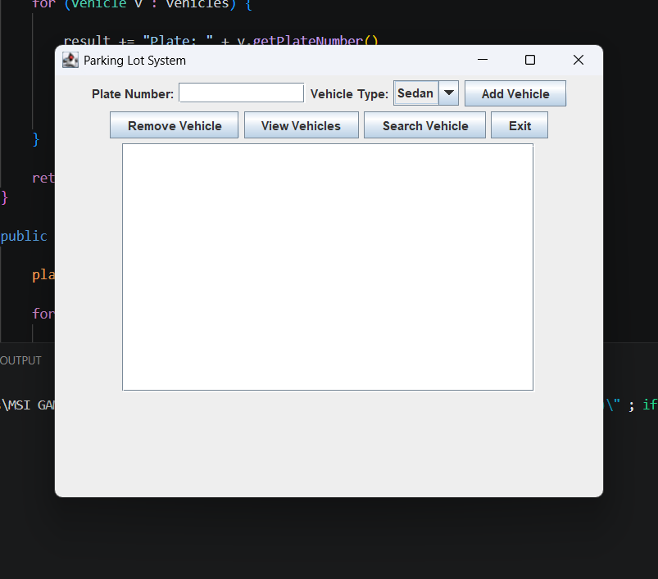

2. Objectives
The main objectives of this project are:
- To manage vehicle entry and exit in a parking system.
- To calculate parking duration automatically.
- To compute parking fees based on vehicle type.
- To provide an interactive GUI for users.
- To apply OOP principles in a real-world simulation.

3. System Overview
The system consists of three main components:
3.1 Vehicle Class
Represents a vehicle with the following attributes:
- Plate number
- Type (Sedan, SUV, Truck)
- Entry time
Figure 2: Vehicle Class Code
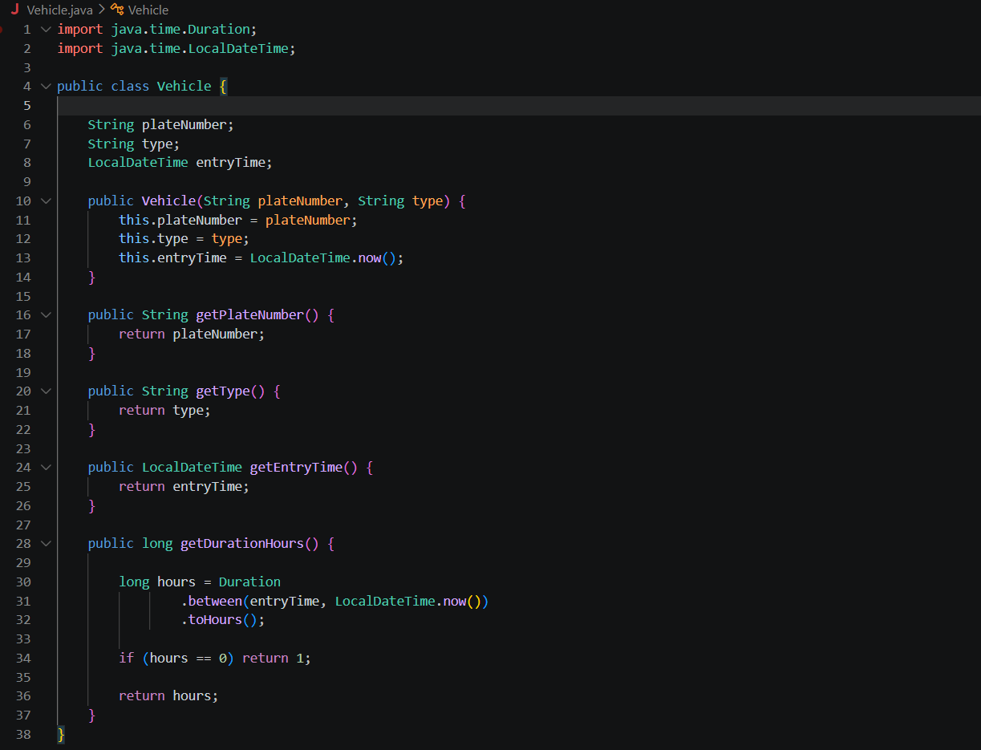

3.2 ParkingLot Class
Handles all system logic including:
- Adding vehicles
- Removing vehicles
- Searching vehicles
- Calculating fees
- Viewing all parked vehicles
Figure 3: Parking Lot Class Code
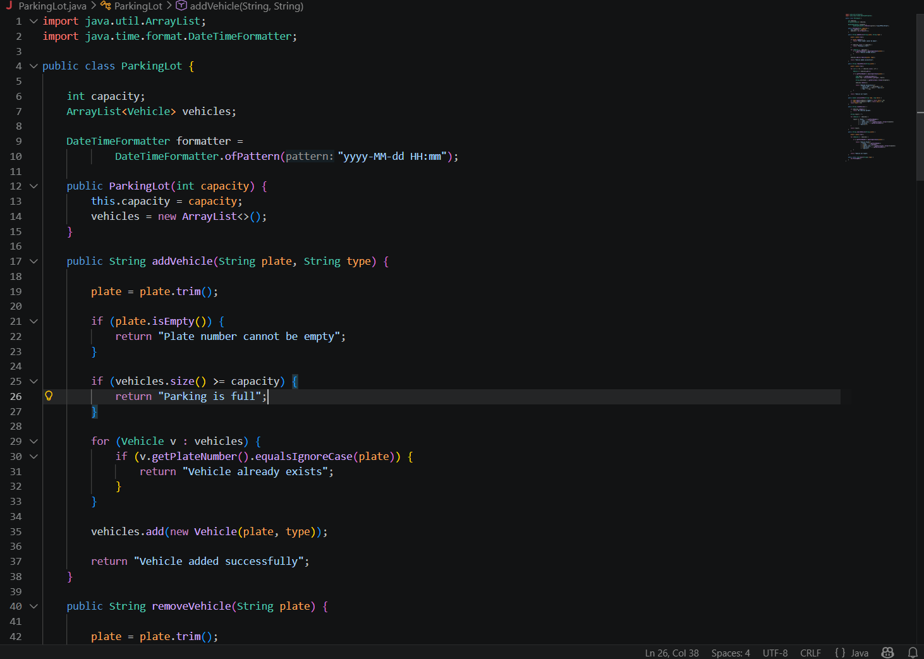

3.3 ParkingGUI Class
Provides a graphical user interface using Java Swing for user interaction.
Features:
- Input vehicle data
- Buttons for operations
- Display output area
Figure 4: GUI Implementation Code
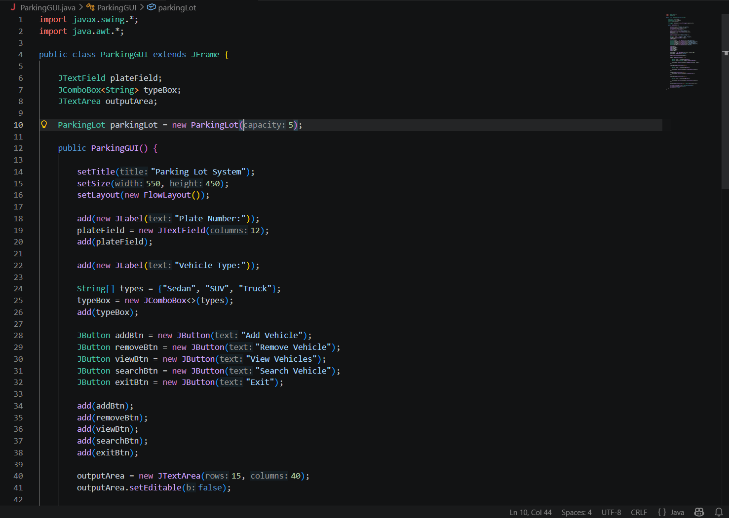

4. Features
4.1 Add Vehicle
Users can add a vehicle by entering plate number and selecting type.
Figure 5: Add Vehicle Example
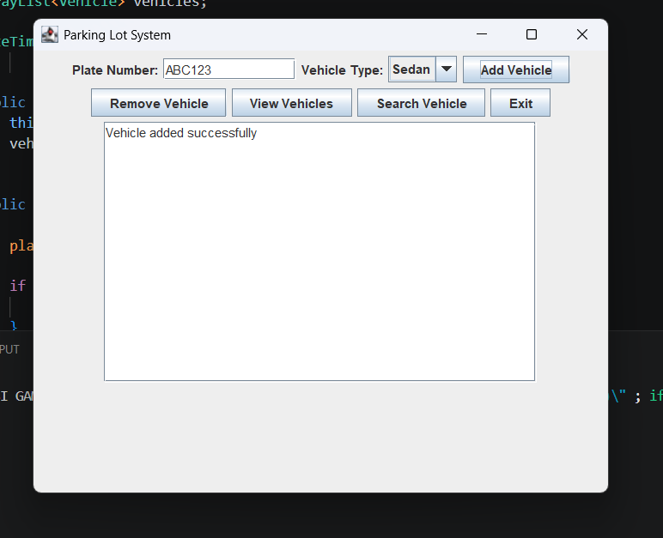

4.2 Remove Vehicle
Removes a vehicle and displays parking duration and fee.
Figure 6: Remove Vehicle Result
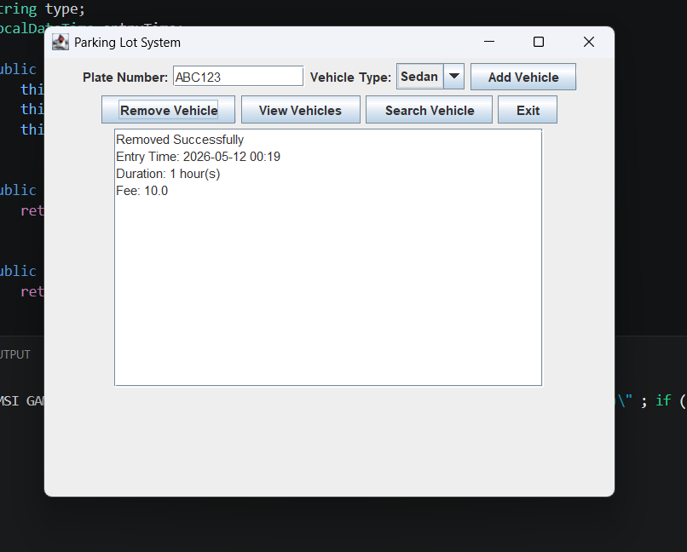

4.3 Search Vehicle
Searches for a specific vehicle using plate number.
Figure 7: Search Result
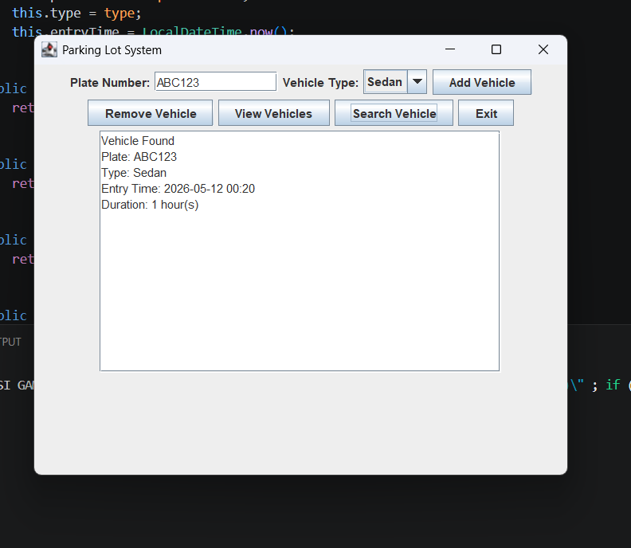

4.4 View Vehicles
Displays all currently parked vehicles with details.
Figure 8: View Vehicles Output
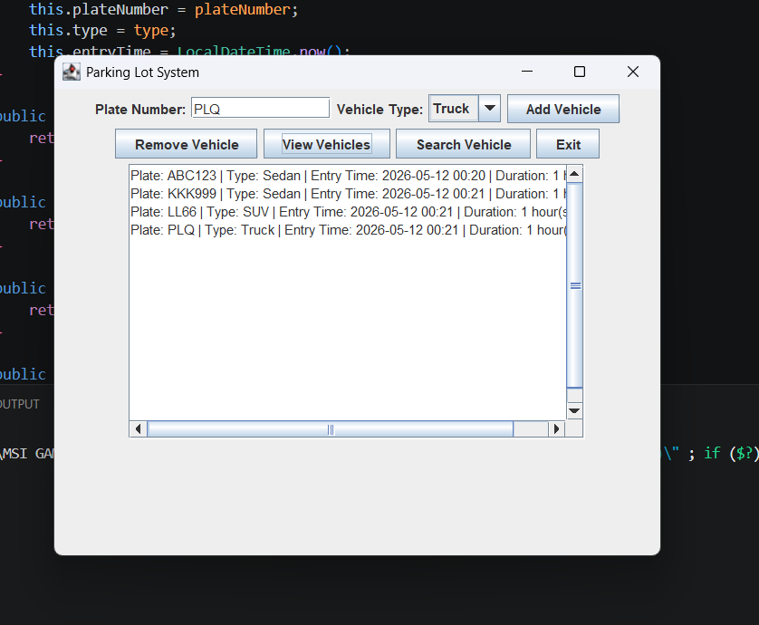
5. Error Handling
The system includes input validation and basic error handling:
- Empty plate number validation
- Duplicate vehicle prevention
- Parking capacity check
- Exception handling for runtime errors
Figure 9: Error Message Example
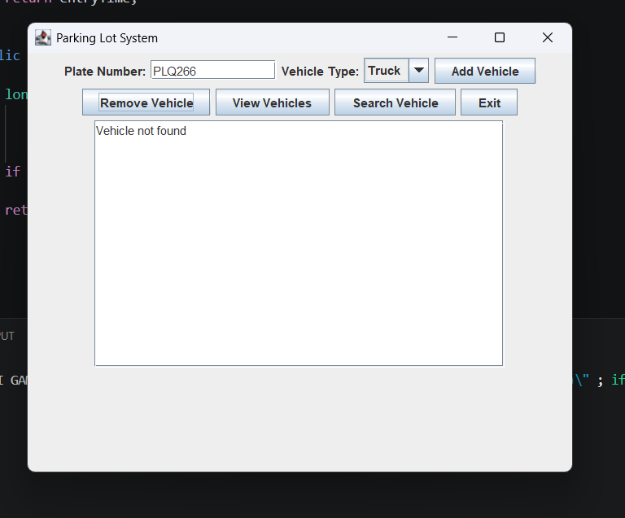

6. Fee Calculation
Parking fees are calculated based on vehicle type and duration:
- Sedan: 10 per hour
- SUV: 15 per hour
- Truck: 20 per hour

7. Technologies Used
- Java Programming Language
- Swing (GUI)
- ArrayList (Data Storage)
- LocalDateTime (Time Tracking)

8. Conclusion
The Parking Lot Management System successfully simulates a real-world parking environment using Java. It demonstrates strong use of OOP concepts and provides a user-friendly interface for managing vehicles efficiently.

9. Future Improvements
Possible enhancements include:
- Using database storage instead of ArrayList
- Adding login system
- Improving UI using JTable
- Generating automatic receipts

